Supplementary Data, Figure S1. An incidence map depicting the average number of Dirofilaria immitis positive cases per clinic using data collected from veterinary practices across the United States of America. Retrieved from the American Heartworm Society, 2025.

Supplementary Data, Figure S2. A prevalence depicting the estimated prevalence of Dirofilaria immitis using data collected by multiple veterinary diagnostic companies. Retrieved from the Companion Animal Parasite Council, 2025.

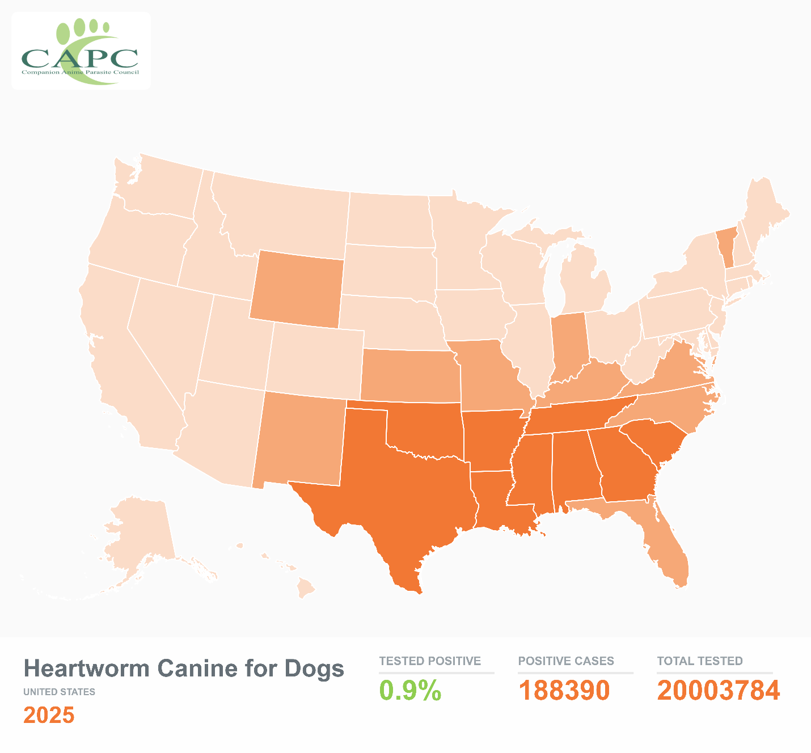

Supplementary Files, Table S1. Summary of demographic characteristics of the sampled dog population from Albuquerque, New Mexico (n=402).
Demographics | No. (%)
Age
Juvenile  (≤1 year old) | 120 (29.9)
Adult  (>1– 7 years old) | 259 (64.4)
Senior  (>7 years old) | 23 (5.7)
Sex
Female | 193 (48.0)
Male | 209 (52.0)
AKC Breed groups
Herding group |  | 88 (21.9)
Hound group |  | 16 (4.0)
Non-sporting group |  | 32 (8.0)
Sporting group |  | 18 (4.5)
Terrier group |  | 101 (25.1)
Toy group |  | 92 (22.9)
Working group |  | 41 (10.2)
Miscellaneous |  | 12 (3.0)
Unknown |  | 2 (0.5)
Coat Color
Single |  | 132 (32.8)
Mixed |  | 270 (67.2)

