Ecology of mosquitoes in Scottish wetlands and confirmation of Culex pipiens biotype molestus and pipiens/molestus hybrids in Scotland – Supplementary information 1
Authors: Georgia Kirby^{1,3}, Rebecca E. Brown¹, Meshach Lee¹, Jean-Philippe Parvy², Susanne Krabbendam¹, Emilie Pondeville², Colin Johnston³, Jolyon M. Medlock³, Alexander G.C. Vaux³, Luca Nelli¹, Francesco Baldini¹ & Heather M. Ferguson¹
¹ School of Biodiversity, One Health and Veterinary Medicine, University of Glasgow, Glasgow, UK
² MRC-University of Glasgow Centre for Virus Research, Glasgow, UK
³ Medical Entomology & Zoonoses Ecology, UK Health Security Agency, Porton Down, UK

Table S1. British mosquito species ecology and functional groups, adapted from Medlock et al 2024.
Functional group | Oviposition site | Overwintering stage | Preferred host type | Generations | Species
1a | Water (vegetation) | Larvae | Mammals | Univoltine | Cq. richiardii
1b | Water | Larvae | Mammals | Multivoltine | An. claviger
1c | Water | Adult | Mammals | Multivoltine | An. maculipennis s.l.  Cs. annulata  Cs. subochrea
1d | Water | Adult | Birds | Multivoltine | Cx. pipiens s.l.
2a | Land | Eggs | Mammals | Univoltine | Ae. annulipes  Ae. cantans  Ae. punctor  Ae. leucomelas*
2b | Land | Eggs | Mammals | Multivoltine | Ae. cinereus  Ae. caspius  Ae. detritus  Ae. dorsalis*
2c | Land (tree holes) | Eggs (larvae) | Mammals | Multivoltine | Ae. geniculatus  An. plumbeus
2d | Land | Larvae (eggs) | Birds | Univoltine | Cs. morsitans
*Species found in the present study that had not previously been classified due to rarity in Britain.

Table S2. List of sampling sites and associated wetland habitats. Abbreviations: RSPB: Royal Society for the Protection of Birds. NNR: National nature reserve. SWT: Scottish Wildlife Trust. WWT: Wildfowl and Wetlands Trust.
Site name | Coordinates | Wetland habitat(s) | Number of adult traps | Number of aquatic habitats sampled | Nearest weather station (miles from site)
Broubster Leans RSPB | 58.519573, -3.655115 | Wet grassland | 2 | 7 | Strathy East (12.3)
Caerlaverock NNR | 54.97132, -3.501884 | Saltmarsh, reedbeds | 2 | 4 | Dumfries, Crichton Royal No 2 (6.1)
Findhorn Bay | 57.638778, -3.579944 | Saltmarsh | 2 | 5 | Kinloss (0.8)
Gailes Marsh SWT | 55.586333, -4.656946 | Pond | 1 | 1 | Darvel, Hillview (14.7)
Knockan Crag NNR | 58.031583, -5.072472 | Blanket bog | 2 | 5 | Achiltibuie No 2 (9.6)
Knockshinnoch Lagoons SWT | 55.397753, -4.19001 | Reedbeds | 1 | 3 | Forrest Lodge, Burnhead (18.4)
Loch Ard Forest | 56.168986, -4.382 | Wet woodland | 1 | 4 | Gartocharn, Portnellan Farm (11.3)
Loch Fleet NNR | 57.937972, -4.071667 | Saltmarsh, wet grassland | 2 | 5 | Tain Range (9.2)
Loch Leven NNR | 56.191325, -3.403406 | Reedbeds | 1 | 0 | Auchtermuchty, Rossie (10.8)
Loch of Kinnordy RSPB | 56.67268, -3.043799 | Reedbeds, wet woodland | 2 | 6 | Braemar No 2 (26.1)
Montrose Basin SWT | 56.699444, -2.488721 | Saltmarsh | 1 | 1 | Fettercairn, Glensaugh No 2 (13.2)
Oldhall Pond SWT | 55.591914, -4.638779 | Pond | 1 | 4 | Darvel, Hillview (13.9)
Possil Marsh SWT | 55.903908, -4.263889 | Reedbeds, wet woodland | 2 | 7 | Glasgow, Bishopton (10.4)
RSPB Insh Marshes | 57.076333, -4.016 | Reedbeds | 1 | 2 | Dalwhinnie No 2
RSPB Loch Leven | 56.178615, -3.356729 | Wet grassland, reedbeds | 2 | 2 | Auchtermuchty, Rossie (9.9)
RSPB Loch Lomond | 56.054985, -4.511525 | Wet grassland | 2 | 7 | Gartocharn, Portnellan Farm (2.2)
RSPB Nigg Bay | 57.733111, -4.005528 | Wet grassland, saltmarsh | 2 | 6 | Dunrobin Castle Gardens (17)
Shewalton Wood SWT | 55.583861, -4.635778 | Wet woodland | 1 | 13 | Darvel, Hillview (13.9)
Shian Wood SWT | 56.520889, -5.410417 | Saltmarsh, wet woodland | 2 | 3 | Dunstaffnage (4.9)
Tentsmuir NNR | 56.426333, -2.872139 | Reedbeds, pond | 2 | 2 | Leuchars (3.4)
The Saltings | 55.92394, -4.464363 | Saltmarsh | 1 | 1 | Glasgow, Bishopton (2.9)
WWT Caerlaverock | 54.976611, -3.483964 | Reedbeds, pond | 2 | 11 | Dumfries, Crichton Royal No 2 (6.2)

Table S3. Mosquito abundance and sampling effort by site. Trapping night is defined as the total number of nights for which a single trap at the site was run throughout the sampling period, and is therefore doubled if two traps were present at the site. Larval dips is defined as the total number of dips taken from aquatic habitats at the site throughout the sampling period.
Site name | Number of trapping nights | Number of adult mosquitoes collected | Total larval dips | Number of mosquito larvae collected
Loch of Kinnordy RSPB | 12 | 653 | 72 | 29
WWT Caerlaverock | 16 | 203 | 109 | 228
Possil Marsh SWT | 9 | 192 | 98 | 93
Shewalton Wood SWT | 7 | 173 | 107 | 18
Findhorn Bay | 12 | 155 | 45 | 15
Caerlaverock NNR | 16 | 135 | 29 | 5
Broubster Leans RSPB | 4 | 99 | 57 | 55
The Saltings | 7 | 54 | 23 | 0
Oldhall Pond SWT | 7 | 51 | 41 | 0
Montrose Basin SWT | 6 | 47 | 27 | 2
Tentsmuir NNR | 8 | 46 | 24 | 112
RSPB Loch Lomond | 12 | 45 | 105 | 155
Knockshinnoch Lagoons SWT | 5 | 31 | 29 | 119
Loch Ard Forest | 6 | 15 | 42 | 5
Loch Fleet NNR | 12 | 11 | 69 | 3
RSPB Insh Marshes | 6 | 10 | 30 | 17
Gailes Marsh SWT | 2 | 8 | 6 | 0
Loch Leven NNR | 2 | 7 | 0 | 0
Shian Wood SWT | 8 | 6 | 42 | 0
RSPB Loch Leven | 8 | 5 | 36 | 0
RSPB Nigg Bay | 10 | 5 | 93 | 4
Knockan Crag NNR | 8 | 0 | 39 | 0

Table S4. Definitions of aquatic habitat categories.
Habitat type | Description | Number of representative habitats
Reedbed | The water/ waterlogged area surrounding a collection of reeds (Phragmites spp.). | 9
Ditch | A constructed narrow channel that may be permanently or occasionally filled with rainwater. | 18
Pool | A small, discrete, natural body of water with a maximum area of 2m². Water may be permanent or transient. Includes puddles. | 35
Pond | A discrete permanent body of fresh still water with an area between 2m² and 2 ha². | 10
Marsh | Waterlogged areas in wetlands dominated by grasses and sedges. | 16
Bog | Waterlogged areas in peatlands dominated by mosses. | 3
Artificial | Any rain-filled artificial container made of plastic, metal, concrete or clay. | 8
Exposed | Habitats in open areas without shade from sunlight. | 54
Partially shaded | Habitats in areas with patchy shelter. Some parts of the habitat are sometimes exposed to sunlight. | 26
Shaded | Habitats in completely sheltered areas which are never exposed to sunlight. | 19

Text S1: Molecular identification of Culex specimens
For all intact adult Cx. pipiens s.l./ Cx. torrentium specimens (n = 198), DNA was extracted from legs manually pulverised into 20µl of squishing buffer (10mM Tris-HCl, 1mM EDTA, 25mM NaCl) and 200g/ml proteinase K. This solution was incubated at 37ºC for 20 minutes and then inactivated by incubation at 95ºC for two minutes. The resulting DNA concentrations were checked using a Nanodrop.
PCR to identify Culex biotypes followed the method described in [1]. PCR products were visualised on a 2% agarose gel with SYBR Safe (Invitrogen). The size of the amplified product was approximately 200 bp for Cx. p. pipiens and 250 bp for Cx. p. molestus. Hybrids yielded two bands, one at 200 bp and one at 250 bp. Specimens that did not amplify were subjected to a second PCR cycle to confirm whether they were Cx. torrentium, following the method described in [2] with the PCR cycle conditions adapted to the following: three minutes at 95ºC, followed by 40 cycles of 95 ºC (30 seconds), 55ºC (30 seconds), 72ºC (40 seconds), then ten minutes at 72ºC. PCR products were again visualised on a 2% agarose gel stained with SYBR Safe. Culex pipiens s.l. yielded a band approximately 610 bp in size while Cx. torrentium bands measured approximately 416 bp. Positive Cx. p. pipiens, Cx. p. molestus and Cx. torrentium controls were obtained from colonies at the MRC-University of Glasgow Centre for Virus Research, Glasgow [3].

Table S5. Summary of terms tested in models. * denotes interaction between two variables. Where possible, an interaction between wetland type and previous rainfall was tested in adult abundance models to account for the possibility that the suitability of different wetland types may be mediated by the volume of rainfall. Rainfall with a three-week lag was chosen, as exploratory analysis indicated that the effect of rainfall on abundance is most evident at this interval.
Model | Response variable | Response unit | Fixed effects | Random effects | Distribution
1 | Total adult mosquito abundance | Number of adult mosquitoes per trap night | Latitude, longitude, wetland type, mean temperature during trapping period, total rainfall during trapping period, mean temperature lag⁻², total rainfall lag⁻², temperature lag⁻³, total rainfall lag⁻³, temperature lag⁻⁴, total rainfall lag⁻⁴, wetland type * total rainfall lag⁻³ | Date of collection, site | Negative binomial
2 | Culex pipiens s.l. adult abundance | Number of adult Cx. pipiens s.l. per trap night | Latitude, longitude, wetland type, mean temperature during trapping period, total rainfall during trapping period, mean temperature lag⁻², total rainfall lag⁻², temperature lag⁻³, total rainfall lag⁻³, temperature lag⁻⁴, total rainfall lag⁻⁴, wetland type * total rainfall lag⁻³ | Date of collection, site | Negative binomial
3 | Anopheles claviger adult abundance | Number of adult An. claviger per trap night | Latitude, longitude, wetland type, mean temperature during trapping period, total rainfall during trapping period, mean temperature lag⁻², total rainfall lag⁻², temperature lag⁻³, total rainfall lag⁻³, temperature lag⁻⁴, total rainfall lag⁻⁴, wetland type * total rainfall lag⁻³ | Date of collection, site | Negative binomial
4 | Aedes detritus adult abundance | Number of adult Ae. detritus per trap night | Latitude, longitude, mean temperature during trapping period, total rainfall during trapping period, mean temperature lag⁻², total rainfall lag⁻², temperature lag⁻³, total rainfall lag⁻³, temperature lag⁻⁴, total rainfall lag⁻⁴ | Date of collection, site | Poisson
5 | Probability of finding Culex pipiens s.l/ Culex torrentium larvae | Presence/ absence of Cx. pipiens s.l/ Cx. torrentium larvae | Latitude, longitude, mean ambient temperature, ambient temperature lag⁻², total rainfall lag⁻², ambient temperature lag⁻³, total rainfall lag⁻³, exposure, vegetation cover | Date of collection, site | Binomial
6 | Probability of finding Culiseta annulata larvae | Presence/ absence of Cs. annulata larvae | Latitude, longitude, mean ambient temperature, mean temperature lag⁻², total rainfall lag⁻², ambient temperature lag⁻³, total rainfall lag⁻³, exposure, vegetation cover | Date of collection, site | Binomial
7 | Probability of finding Culex pipiens s.l/ Culex torrentium larvae (hydrochemical variables subset) | Presence/ absence of Cx. pipiens s.l/ Cx. torrentium larvae | Latitude, longitude, mean ambient temperature, ambient temperature lag⁻², total rainfall lag⁻², ambient temperature lag⁻³, total rainfall lag⁻³, exposure, vegetation cover, water temperature, pH | Date of collection, site | Binomial
8 | Probability of finding Culiseta annulata larvae (hydrochemical variables subset) | Presence/ absence of Cs. annulata larvae | Latitude, longitude, mean ambient temperature, ambient temperature lag⁻², total rainfall lag⁻², ambient temperature lag⁻³, total rainfall lag⁻³, exposure, vegetation cover, depth, water temperature, pH, conductivity | Date of collection, site | Binomial
9 | Culex pipiens s.l/ Culex torrentium larval density | Number of Cx. pipiens s.l/ Cx. torrentium larvae per dip | Ambient temperature lag⁻², ambient temperature lag⁻³, exposure, vegetation cover | Date of collection, site | Negative binomial
10 | Culiseta annulata larval density | Number of Cs. annulata larvae per dip | Latitude, longitude, ambient temperature lag⁻², ambient temperature lag⁻³, exposure, vegetation cover | Date of collection, site | Negative binomial

Text S2: Summary of microclimatic conditions during study period
Relative to the 1991-2020 period (data obtained from the Met Office), mean and maximum temperatures across Scotland in May were typical but minimum temperatures were anomalously high, reaching 2.5ºC higher than normal in the western and northern Highlands. May rainfall was lower than average, with areas of the west Highlands experiencing under 33% of average monthly rainfall. June was hotter than average, with maximum temperatures across most of the country up to 3.5ºC higher, particularly in the west. Rainfall in June was largely normal. Temperatures in July were mostly normal but were up to 1.5ºC cooler than average in the south and east. July rainfall was higher than normal, particularly in the south where it reached 175% of the average monthly rainfall. Microclimatic variables in August were mostly normal but rainfall was around 75% of the normal volume in the south west and minimum temperatures across the country were up to 1.5ºC higher than normal. September was highly anomalous, with mean and maximum temperatures up to 2.5ºC higher than normal, particularly in the south and west, and rainfall up to 200% higher than average in areas of the south.
Table S6. Microclimatic variables at each site during the sampling period. Mean values include ± 95% confidence interval.
Site name | Mean temperature (ºC) | Total rainfall (mm)
Broubster Leans RSPB | 13.14 ± 0.47 | 361.95
Caerlaverock NNR | 14.98 ± 0.42 | 483.71
Findhorn Bay | 14.47 ± 0.49 | 276.97
Gailes Marsh SWT | 14.42* ± 0.47 | 325.2*
Knockan Crag NNR | 14.06* ± 0.51 | 303.13*
Knockshinnoch Lagoons SWT | 13.72 ± 0.43 | 812.8
Loch Ard Forest | 14.78 ± 0.39 | 553.28
Loch Fleet NNR | 13.46 ± 0.45 | 304.35
Loch Leven NNR | 14.1 ± 0.41 | 306.55
Loch of Kinnordy RSPB | 12.4 ± 0.43 | 343
Montrose Basin SWT | 12.84 ± 0.44 | 444.97
Oldhall Pond SWT | 14.42* ± 0.47 | 325.2*
Possil Marsh SWT | 14.81 ± 0.39 | 467.4
RSPB Insh Marshes | 12.55 ± 0.44 | 406
RSPB Loch Leven | 14.1 ± 0.41 | 306.55
RSPB Loch Lomond | 14.78 ± 0.39 | 553.28
RSPB Nigg Bay | 13.67 ± 0.43 | 372.18
Shewalton Wood SWT | 14.42* ± 0.47 | 325.2*
Shian Wood SWT | 14.91 ± 0.38 | 593.6
Tentsmuir NNR | 14.17 ± 0.42 | 285.67
The Saltings | 14.81 ± 0.39 | 467.4
WWT Caerlaverock | 14.98 ± 0.42 | 483.71
*missing data from September

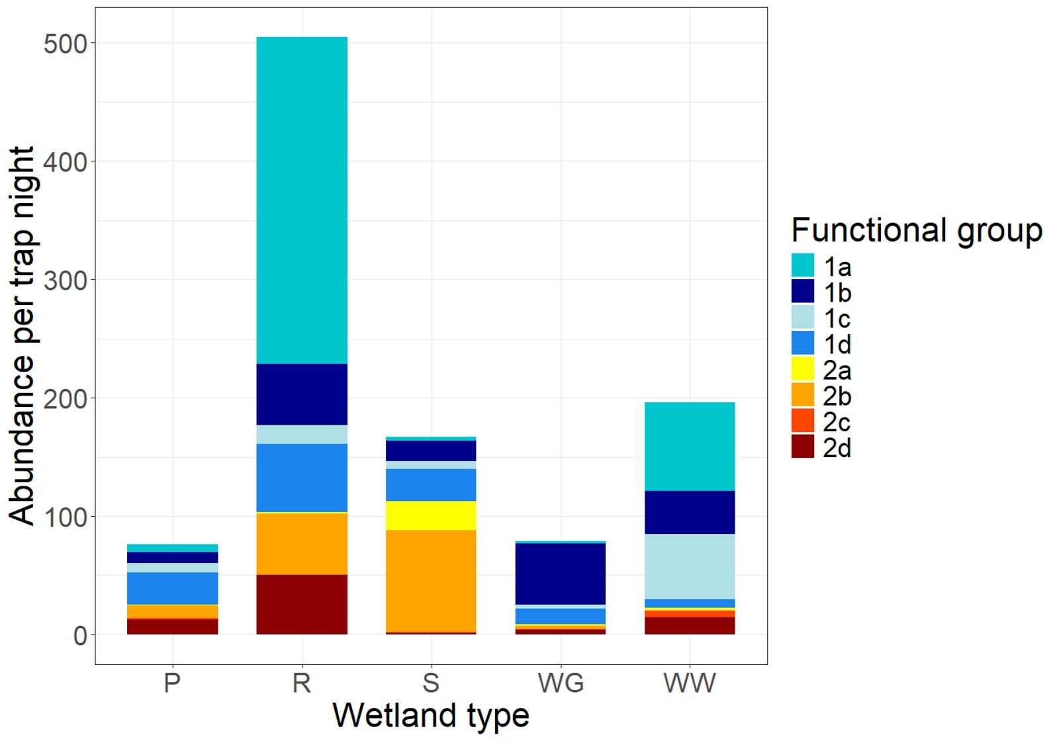
Figure S1. Total abundance of adult mosquito functional groups by wetland type. Abbreviations: P = Pond, R = Reedbed, S = Saltmarsh, WG = Wet Grassland, WW = Wet Woodland. Functional groups are based on the categories defined in [4]. Here, 1a (water-ovipositing mammalophilic univoltine species that overwinter as larvae) (n = 689) represents Coquillettidia richiardii (100%); 1b (water-ovipositing mammalophilic multivoltine species that overwinter as larvae) (n = 333) represents Anopheles claviger (100%); 1c (water-ovipositing mammalophilic multivoltine species that overwinter as adults) (n = 171) represents Culiseta annulata (95.3%), Anopheles maculipennis s.l. (4.1%) and Culiseta subochrea (0.6%); 1d (water-ovipositing ornithophilic multivoltine species that overwinter as adults) (n = 257) represents Culex pipiens s.l. (100%); 2a (land-ovipositing mammalophilic univoltine species that overwinter as eggs) (n = 60) represents Aedes leucomelas (83.3%) Aedes punctor (11.7%), Aedes cantans (3.3%) and Aedes annulipes (1.7%); 2b (land-ovipositing mammalophilic multivoltine species that overwinter as eggs) (n = 466) represents Aedes detritus (62.4%), Aedes caspius (21.1%), Aedes cinereus (8.9%) and Aedes dorsalis (7.6%); 2c (tree hole-ovipositing mammalophilic multivoltine species that overwinter as eggs or larvae) (n = 16) represents Anopheles plumbeus (93.8%) and Aedes geniculatus (6.2%); 2d (land-ovipositing ornithophilic univoltine species that overwinter as larvae or eggs) (n = 122) represents Culiseta morsitans (100%).

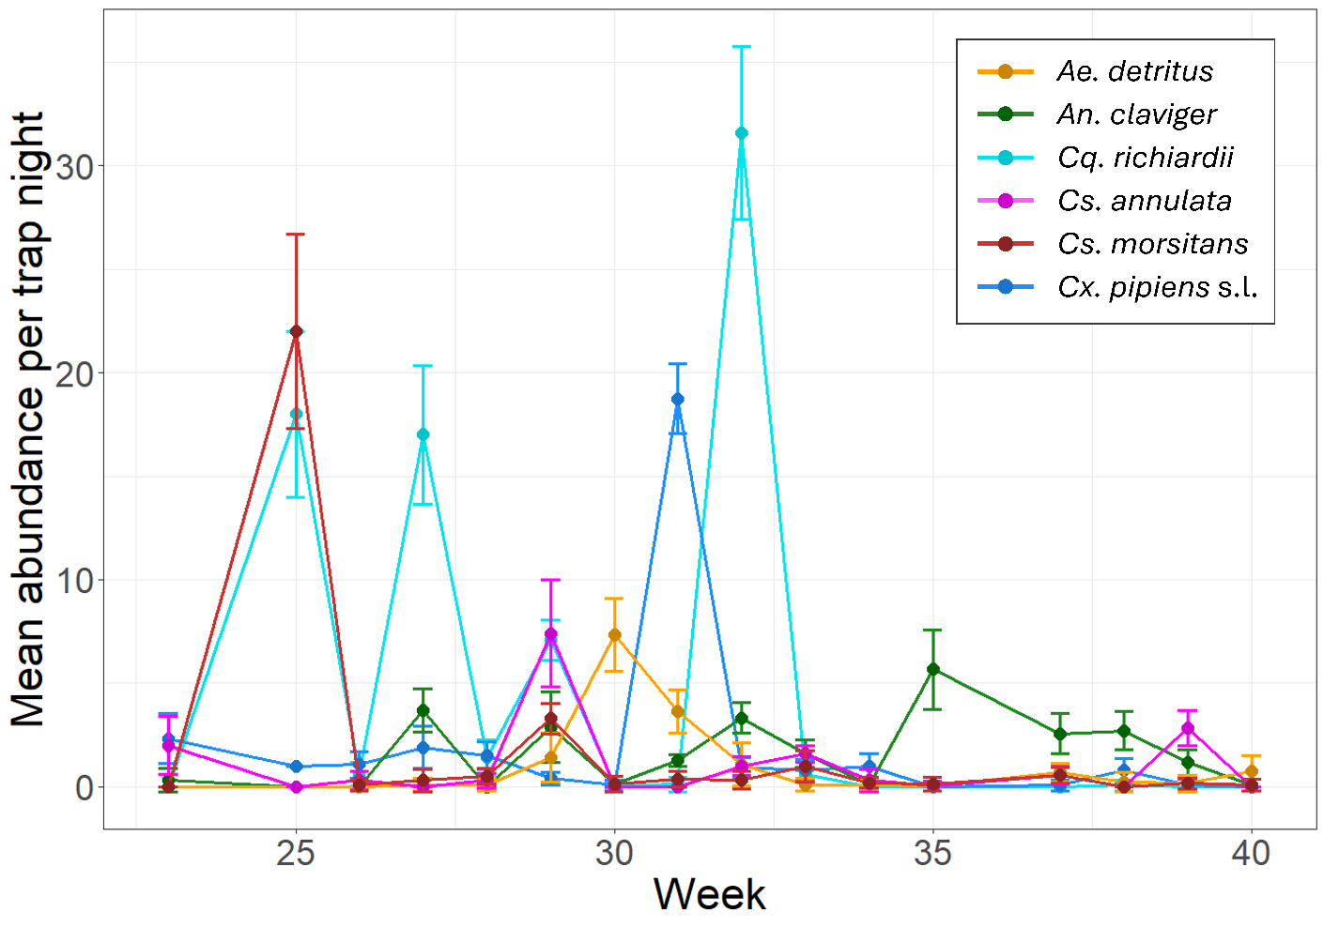
Figure S2. Mean weekly abundance of selected adult mosquito species at wetland sites between June and October 2023. Error bars indicate standard error.

Table S7. Summary of statistical significance of terms tested in adult abundance models. Chi-square (χ²) and p values are shown for each variable as obtained through likelihood ratio testing. * denotes interaction between two variables.
Variable | χ² | p-value
Total mosquito abundance
Latitude | 0.224 | 0.636
Longitude | 3.176 | 0.075
Wetland type | 2.788 | 0.594
Mean temperature during trapping period | 5.344 | 0.021
Total rainfall during trapping period | 0.829 | 0.363
Mean temperature during trapping period lag⁻² | 0.508 | 0.476
Total rainfall during trapping period lag⁻² | 0.489 | 0.484
Mean temperature during trapping period lag⁻³ | 0.03 | 0.862
Total rainfall during trapping period lag⁻³ | 6.304 | 0.012
Mean temperature during trapping period lag⁻⁴ | 1.137 | 0.286
Total rainfall during trapping period lag⁻⁴ | 1.385 | 0.239
Wetland type * total rainfall during trapping period lag⁻³ | 3.396 | 0.494
Culex pipiens s.l. abundance
Latitude | 4.551 | 0.033
Longitude | 3.261 | 0.071
Wetland type | 4.918 | 0.296
Mean temperature during trapping period | 3.941 | 0.047
Total rainfall during trapping period | 0.152 | 0.697
Mean temperature during trapping period lag⁻² | 0.001 | 0.981
Total rainfall during trapping period lag⁻² | 0.013 | 0.909
Mean temperature during trapping period lag⁻³ | 2.122 | 0.145
Total rainfall during trapping period lag⁻³ | 1.248 | 0.264
Mean temperature during trapping period lag⁻⁴ | 1.616 | 0.204
Total rainfall during trapping period lag⁻⁴ | 0.001 | 0.992
Wetland type * total rainfall during trapping period lag⁻³ | 6.936 | 0.139
Anopheles claviger abundance
Latitude | 0.508 | 0.476
Longitude | 5.628 | 0.018
Wetland type | 1.681 | 0.794
Mean temperature during trapping period | 0.125 | 0.724
Total rainfall during trapping period | 4.017 | 0.045
Mean temperature during trapping period lag⁻² | 2.902 | 0.088
Total rainfall during trapping period lag⁻² | 0.694 | 0.405
Mean temperature during trapping period lag⁻³ | 0.966 | 0.326
Total rainfall during trapping period lag⁻³ | 7.327 | 0.007
Mean temperature during trapping period lag⁻⁴ | 3.286 | 0.07
Total rainfall during trapping period lag⁻⁴ | 1.534 | 0.215
Wetland type * total rainfall during trapping period lag⁻³ | 8.24 | 0.083
Aedes detritus abundance
Latitude | 2.44 | 0.118
Longitude | 2.765 | 0.096
Mean temperature during trapping period | 1.843 | 0.175
Total rainfall during trapping period | 0.251 | 0.617
Mean temperature during trapping period lag⁻² | 1.21 | 0.271
Total rainfall during trapping period lag⁻² | 0.254 | 0.614
Mean temperature during trapping period lag⁻³ | 1.339 | 0.247
Total rainfall during trapping period lag⁻³ | 1.105 | 0.293
Mean temperature during trapping period lag⁻⁴ | 2.036 | 0.154
Total rainfall during trapping period lag⁻⁴ | 14.263 | <0.000

Table S8. Co-occurrence of larval species/ groups. Numbers indicate the number of collections in which species co-occurred. Numbers in brackets indicate the number of sites at which species co-occurred.
Species | Cx. pipiens s.l./ torrentium | Cs. annulata | An. claviger | Cs. morsitans | Ae. detritus/ leucomelas
Culex pipiens s.l./ Culex torrentium | NA | 4(4) | 0 | 0 | 0
Culiseta annulata | 4(4) | NA | 3(3) | 1(1) | 0
Anopheles claviger | 0 | 3(3) | NA | 0 | 0
Culiseta morsitans | 0 | 1(1) | 0 | NA | 0
Aedes detritus/ Aedes leucomelas | 0 | 0 | 0 | 0 | NA

Table S9. Summary of mean habitat characteristics of collected larval species. Mean values include ± 95% confidence interval.
Species | Salinity (ppt) | Water temperature (ºC) | Depth (cm) | Exposure | pH | Conductivity (µS/cm) | Vegetation cover (%)
Culex pipiens s.l./ Culex torrentium | 0.1 ± 0.06 | 17.74 ± 1.21 | 8.27 ± 2.8 | Exposed | 6.83 ± 0.18 | 0.35 ± 0.14 | 42.63 ± 15.47
Culiseta annulata | 0.16 ± 0.07 | 16.38 ± 0.83 | 13.1 ± 7.11 | Shaded | 6.86 ± 0.14 | 0.49 ± 0.16 | 62.68 ± 11.91
Anopheles claviger | 0.23 ± 0.11 | 15.72 ± 1.34 | 10.26 ± 5.05 | Exposed | 6.92 ± 0.25 | 0.69 ± 0.2 | 54.23 ± 17.75
Culiseta morsitans | 0.03 ± 0.04 | 14.12 ± 0.8 | 8.56 ± 2.15 | Partially shaded | 6.55 ± 0.21 | 0.22 ± 0.13 | 65.4 ± 34.52
Aedes detritus/ Aedes leucomelas | 15 ± 0.49 | 16.67 ± 6.31 | 9.87 ± 5.93 | Exposed | 6.89 ± 0.37 | 19.47 ± 1.03 | 43.3 ± 51.03
Table S10. Summary of statistical significance of terms tested in larval presence and density models. Chi-square (χ²) and p values are shown for each variable as obtained through likelihood ratio testing. * denotes interaction between two variables.
Variable | χ² | p-value
Probability of finding Culex pipiens s.l./ Culex torrentium larvae
Latitude | 0.303 | 0.582
Longitude | 0.065 | 0.8
Mean ambient temperature | 1.476 | 0.224
Ambient temperature lag⁻² | 3.366 | 0.067
Total rainfall lag⁻² | 0.781 | 0.377
Ambient temperature lag⁻³ | 0.021 | 0.885
Total rainfall lag⁻³ | 0.169 | 0.681
Exposure | 4.959 | 0.084
Vegetation cover | 3.313 | 0.069
Probability of finding Culiseta annulata larvae
Latitude | 2.469 | 0.116
Longitude | 2.397 | 0.122
Mean ambient temperature | 0.247 | 0.619
Ambient temperature lag⁻² | 0.063 | 0.802
Total rainfall lag⁻² | 0.405 | 0.525
Ambient temperature lag⁻³ | 0.197 | 0.657
Total rainfall lag⁻³ | 0.5 | 0.479
Exposure | 13.245 | 0.001
Vegetation cover | 8.716 | 0.003
Probability of finding Culex pipiens s.l/ Culex torrentium larvae (hydrochemical variables subset)
Latitude | 1.667 | 0.197
Longitude | 0.005 | 0.944
Mean ambient temperature | 1.652 | 0.199
Ambient temperature lag⁻² | 0.065 | 0.8
Total rainfall lag⁻² | 1.982 | 0.159
Ambient temperature lag⁻³ | 0.28 | 0.597
Total rainfall lag⁻³ | 0.697 | 0.404
Exposure | 5.547 | 0.062
Vegetation cover | 4.423 | 0.035
Water temperature | 8.183 | 0.004
pH | 0.011 | 0.916
Probability of finding Culiseta annulata larvae (hydrochemical variables subset)
Latitude | 3.228 | 0.072
Longitude | 1.799 | 0.18
Mean ambient temperature | 0.615 | 0.433
Ambient temperature lag⁻² | 0.587 | 0.444
Total rainfall lag⁻² | 0.741 | 0.389
Ambient temperature lag⁻³ | 0.622 | 0.43
Total rainfall lag⁻³ | 0.015 | 0.903
Exposure | 8.756 | 0.013
Vegetation cover | 4.294 | 0.038
Water temperature | 2.029 | 0.154
pH | 0.021 | 0.886
Conductivity | 4.265 | 0.039
Culex pipiens s.l/ Culex torrentium larval density
Ambient temperature lag⁻² | 2.691 | 0.101
Ambient temperature lag⁻³ | 0.017 | 0.897
Exposure | 5.265 | 0.072
Vegetation cover | 2.602 | 0.107
Culiseta annulata larval density
Latitude | 2.9 | 0.089
Longitude | 1.035 | 0.309
Ambient temperature lag⁻² | 0.294 | 0.588
Ambient temperature lag⁻³ | 0.114 | 0.736
Exposure | 11.113 | 0.004
Vegetation cover | 3.429 | 0.064

1 Bahnck, C.M. and Fonseca, D.M. (2006) Rapid assay to identify the two genetic forms of Culex (Culex) pipiens L. (Diptera: Culicidae) and hybrid populations. Am J Trop Med Hyg 75, 251-255
2 Smith, J.L. and Fonseca, D.M. (2004) Rapid assays for identification of members of the Culex (Culex) pipiens complex, their hybrids, and other sibling species (Diptera: culicidae). Am J Trop Med Hyg 70, 339-345
3 Parvy, J.-P., Brass, D.P., Preston, B., Carmichael, R., Kerrigan, D., Kirby, G., Brown, R., White, S.M., Ferguson, H.M., Pondeville, E. (In Press) Field Colonisation and Temperature-Driven Variation in Life-History Traits of the West Nile Virus Vector Culex pipiens at Its Northern European Limit. Parasites & Vectors
4 Medlock, J.M., et al. (2024) Mosquito diversity and abundance in English wetlands – empirical evidence to guide predictions for wetland suitability for mosquitoes (Diptera: Culicidae). Journal of the European Mosquito Control Association 42, 3-29

