Additional file 2.
Tables S5–S11. Summary of GLMM results for all snails (Tables S5–S8) and for A. balthica (Tables S9–S11).
Figs. S12–S13. Host richness and abundance (A, B) and trematode richness and overall prevalence (%) (C, D) in relation to site distance from the river mouth for all snails (Fig. S12) and for A. balthica (Fig. S13).
Fig. S14. Temporal changes in community composition (β-diversity) of trematodes in A. balthica.
Fig. S15. Distance decay of trematode communities in A. balthica along the stream.
Fig. S16. Prevalence of trematode species in the respective snail species identified in this study.
Table S12. Trematode-host associations included in analyses on host-specificity in this study.
Fig. S17. Maximum likelihood (ML) phylogram based on the cox1 mtDNA alignment for gastropod hosts included in analyses on host-specificity.
Tables S13–S14. Regional and global phylogenetic host specificity (PD, SES-PD) and geographic host specificity (β-specificity) of trematodes, with resulting classifications.

Table S5. Summary of GLMM results for snail abundance.
Family: | nbinom2 (log)
Formula: | Host_abundance ~ Year + Season + Distance + (1 | Year/Location_name)
AIC |  | BIC |  | logLik |  | -2*log(L) |  | df.resid
564.9 |  | 585.2 |  | -273.5 |  | 546.9 |  | 61
R2m R2c
delta 0.3187099 0.4553826
lognormal 0.3655075 0.5222485
trigamma 0.2610092 0.3729382
Fixed effects:
 |  |  | Estimate |  | Std. Error |  | z-value | P-value | Sign.
(Intercept) |  |  | 2.72319 |  | 0.57855 |  | 4.707 | 2.51e-06 | ***
Year2024 |  |  | -0.29601 |  | 0.55667 |  | -0.532 | 0.594
Year2025 |  |  | -0.36162 |  | 0.56643 |  | -0.638 | 0.695
SeasonSpring |  |  | -0.96874 |  | 0.27277 |  | -3.551 | 0.0001 | ***
SeasonSummer |  |  | -0.02650 |  | 0.00826 |  | -0.339 | 0.795
Distance |  |  | 0.02650 |  | 0.00826 |  | 3.209 | 0.001 | **
Contrast |  |  | Ratio |  | Std. Error |  | z-ratio | P-value | Sign.
Autumn/Spring |  |  | 2.635 |  | 0.719 |  | 2.551 | 0.001 | **
Autumn/Summer |  |  | 1.091 |  | 0.279 |  | 0.339 | 0.939
Spring/Summer |  |  | 0.414 |  | 0.114 |  | -3.191 | 0.004 | **

Table S6. Summary of GLMM results for snail species richness.
Family: | poisson (log)
Formula: | Host_richness ~ Year + Season + Distance + (1 | Year/Location_name)
AIC |  | BIC |  | logLik |  | -2*log(L) |  | df.resid
236.6 |  | 254.5 |  | -110.3 |  | 220.6 |  | 62
R2m R2c
delta 0.1232129 0.1232194
lognormal 0.1435784 0.1435859
trigamma 0.1024036 0.1024090
Fixed effects:
 |  |  | Estimate |  | Std. Error |  | z-value | P-value | Sign.
(Intercept) |  |  | 1.078699 |  | 0.418594 |  | 2.577 | 0.009 | **
Year2024 |  |  | -0.111526 |  | 0.400111 |  | -0.297 | 0.780
Year2025 |  |  | -0.282539 |  | 0.407137 |  | -0.649 | 0.488
SeasonSpring |  |  | -0.467880 |  | 0.211282 |  | -2.215 | 0.029 | *
SeasonSummer |  |  | 0.003586 |  | 0.178823 |  | 0.020 | 0.984
Distance |  |  | 0.004696 |  | 0.004670 |  | 1.006 | 0.315
Contrast |  |  | Ratio |  | Std. Error |  | z-ratio | P-value | Sign.
Autumn/Spring |  |  | 1.597 |  | 0.337 |  | 2.214 | 0.069
Autumn/Summer |  |  | 0.996 |  | 0.178 |  | -0.020 | 0.999
Spring/Summer |  |  | 0.624 |  | 0.132 |  | -2.236 | 0.065

Table S7. Summary of GLMM results for overall trematode prevalence.
Family: | binomial (logit)
Formula: | cbind(N_infected, N_hosts - N_infected) ~ Year + Season + Host_richness + Host_abundance + Distance + (1 | Year/Location_name)
AIC |  | BIC |  | logLik |  | -2*log(L) |  | df.resid
177.8 |  | 197.5 |  | -79.9 |  | 159.8 |  | 57
R2m R2c
theoretical 0.14373039 0.8390155
delta 0.08889569 0.5189220
Fixed effects:
 |  |  | Estimate |  | Std. Error |  | z-value | P-value | Sign.
(Intercept) |  |  | -2.711471 |  | 0.699731 |  | -3.875 | 0.0001 | ***
Year2025 |  |  | -0.303535 |  | 0.445275 |  | -0.682 | 0.495
SeasonSpring |  |  | -0.497801 |  | 0.438191 |  | -1.136 | 0.256
SeasonSummer |  |  | -0.366345 |  | 0.276845 |  | -1.323 | 0.186
Host_richness |  |  | -0.149168 |  | 0.110834 |  | -1.346 | 0.178
Host_abundance |  |  | 0.009084 |  | 0.005182 |  | 1.753 | 0.080 | .
Distance |  |  | 0.008218 |  | 0.015280 |  | 0.538 | 0.591
Contrast |  |  | Ratio |  | Std. Error |  | z-ratio | P-value | Sign.
Autumn/Spring |  |  | 1.645 |  | 0.721 |  | 1.136 | 0.492
Autumn/Summer |  |  | 1.442 |  | 0.399 |  | 1.323 | 0.382
Spring/Summer |  |  | 0.877 |  | 0.352 |  | -0.327 | 0.943
Table S8. Summary of GLMM results for trematode species richness.
Family: | poisson (log)
Formula: | Trem_richness ~ Year + Season + Host_richness + Host_abundance + Distance  + (1 | Year/Location_name)
AIC |  | BIC |  | logLik |  | -2*log(L) |  | df.resid
160.0 |  | 179.7 |  | -71.0 |  | 142.0 |  | 57
R2m R2c
delta 0.3559962 0.3560015
lognormal 0.4516491 0.4516558
trigamma 0.2415007 0.2415043
Fixed effects:
 |  |  | Estimate |  | Std. Error |  | z-value | P-value | Sign.
(Intercept) |  |  | -1.579431 |  | 0.552509 |  | -2.859 | 0.004 | **
Year2025 |  |  | -0.079615 |  | 0.276037 |  | -0.288 | 0.773
SeasonSpring |  |  | 0.116925 |  | 0.444835 |  | 0.263 | 0.793
SeasonSummer |  |  | 0.177636 |  | 0.301913 |  | 0.588 | 0.556
Host_richness |  |  | 0.135918 |  | 0.107085 |  | 1.269 | 0.204
Host_abundance |  |  | 0.028453 |  | 0.004285 |  | 6.640 | 3.13e-11 | ***
Distance |  |  | 0.003566 |  | 0.009589 |  | 0.372 | 0.710
Contrast |  |  | Ratio |  | Std. Error |  | z-ratio | P-value | Sign.
Autumn/Spring |  |  | 0.890 |  | 0.396 |  | -0.263 | 0.963
Autumn/Summer |  |  | 0.837 |  | 0.253 |  | -0.588 | 0.826
Spring/Summer |  |  | 0.941 |  | 0.386 |  | -0.148 | 0.988

Table S9. Summary of GLMM results for snail abundance (A. balthica only).
Family: | nbinom2 (log)
Formula: | Host_abundance_AB ~ Year + Season + Distance + (1 | Year/Location_name)
AIC |  | BIC |  | logLik |  | -2*log(L) |  | df.resid
474.8 |  | 493.9 |  | -228.4 |  | 456.8 |  | 53
R2m R2c
delta 0.3759275 0.4831438
lognormal 0.4393286 0.5646271
trigamma 0.2935242 0.3772387
Fixed effects:
 |  |  | Estimate |  | Std. Error |  | z-value | P-value | Sign.
(Intercept) |  |  | -0.11993 |  | 1.08314 |  | -0.111 | 0.912 | ***
Year2024 |  |  | 1.98296 |  | 1.06521 |  | 1.862 | 0.063
Year2025 |  |  | 1.63024 |  | 1.07164 |  | 1.521 | 0.128
SeasonSpring |  |  | -0.46956 |  | 0.33013 |  | -1.442 | 0.155
SeasonSummer |  |  | 0.33863 |  | 0.32591 |  | 1.039 | 0.299
Distance |  |  | 0.03361 |  | 0.01035 |  | 3.248 | 0.001 | **
Contrast |  |  | Ratio |  | Std. Error |  | z-ratio | P-value | Sign.
Autumn/Spring |  |  | 1.599 |  | 0.528 |  | 1.422 | 0.329
Autumn/Summer |  |  | 0.713 |  | 0.232 |  | -1.039 | 0.552
Spring/Summer |  |  | 0.446 |  | 0.150 |  | -2.395 | 0.044

Table S10. Summary of GLMM results for overall trematode prevalence (A. balthica only).
Family: | binomial (logit)
Formula: | cbind(N_infected_AB, N_hosts_AB - N_infected_AB) ~ Year + Season + Distance + Mean_size_AB + N_hosts_AB + Host_richness + (1 | Year/Location_name)
AIC |  | BIC |  | logLik |  | -2*log(L) |  | df.resid
163.9 |  | 184.9 |  | -72.0 |  | 143.9 |  | 50
R2m R2c
theoretical 0.3758093 0.769123
delta 0.2333500 0.477569
Fixed effects:
 |  |  | Estimate |  | Std. Error |  | z-value | P-value | Sign.
(Intercept) |  |  | -4.583194 |  | 1.548156 |  | -2.960 | 0.003 | **
Year2025 |  |  | 0.028897 |  | 0.391012 |  | 0.074 | 0.941
SeasonSpring |  |  | -1.009682 |  | 0.437335 |  | -2.309 | 0.021 | *
SeasonSummer |  |  | -0.711769 |  | 0.278996 |  | -2.551 | 0.011 | *
Distance |  |  | 0.011917 |  | 0.014438 |  | 0.825 | 0.409
Mean_size_AB |  |  | 0.173065 |  | 0.105503 |  | 1.640 | 0.100 | .
N_hosts_AB |  |  | 0.002572 |  | 0.004715 |  | 0.545 | 0.585
Host_richness |  |  | -0.007525 |  | 0.112774 |  | -0.067 | 0.947
Contrast |  |  | Ratio |  | Std. Error |  | z-ratio | P-value | Sign.
Autumn/Spring |  |  | 2.745 |  | 1.200 |  | 2.309 | 0.055
Autumn/Summer |  |  | 2.038 |  | 0.568 |  | 2.551 | 0.029
Spring/Summer |  |  | 0.742 |  | 0.325 |  | -0.681 | 0.775
Table S11. Summary of GLMM results for trematode species richness (A. balthica only).
Family: | poisson (log)
Formula: | Trem_richness_AB ~ Year + Season + Distance + Mean_size_AB + N_hosts_AB + Host_richness + (1 | Year/Location_name)
AIC |  | BIC |  | logLik |  | -2*log(L) |  | df.resid
145.3 |  | 166.3 |  | -62.7 |  | 125.3 |  | 50
R2m R2c
delta 0.4051693 0.4051863
lognormal 0.5012469 0.5012679
trigamma 0.2851353 0.2851472
Fixed effects:
 |  |  | Estimate |  | Std. Error |  | z-value | P-value | Sign.
(Intercept) |  |  | -3.116375 |  | 0.932292 |  | -3.343 | 0.0008 | ***
Year2025 |  |  | 0.017971 |  | 0.311978 |  | 0.058 | 0.954
SeasonSpring |  |  | -0.639876 |  | 0.491667 |  | -1.301 | 0.193
SeasonSummer |  |  | 0.316446 |  | 0.318039 |  | -0.995 | 0.320
Distance |  |  | 0.013611 |  | 0.011375 |  | 1.197 | 0.231
Mean_size_AB |  |  | 0.150604 |  | 0.067080 |  | 2.245 | 0.025 | *
N_hosts_AB |  |  | 0.024799 |  | 0.004461 |  | 5.559 | 2.72e-08 | ***
Host_richness |  |  | 0.106962 |  | 0.101948 |  | 1.049 | 0.294
Contrast |  |  | Ratio |  | Std. Error |  | z-ratio | P-value | Sign.
Autumn/Spring |  |  | 1.896 |  | 0.932 |  | 1.301 | 0.394
Autumn/Summer |  |  | 1.372 |  | 0.436 |  | 0.995 | 0.580
Spring/Summer |  |  | 0.724 |  | 0.343 |  | -0.682 | 0.774

Fig. S12. Host richness and abundance of all snails (A, B) and trematode richness and overall prevalence (%) (C, D) in relation to site distance from the river mouth. Points represent raw data of individual sampling events (site × month). Colored lines depict loess-estimated smoothing functions per year (2023-2025), with shaded areas indicating 95% confidence intervals.
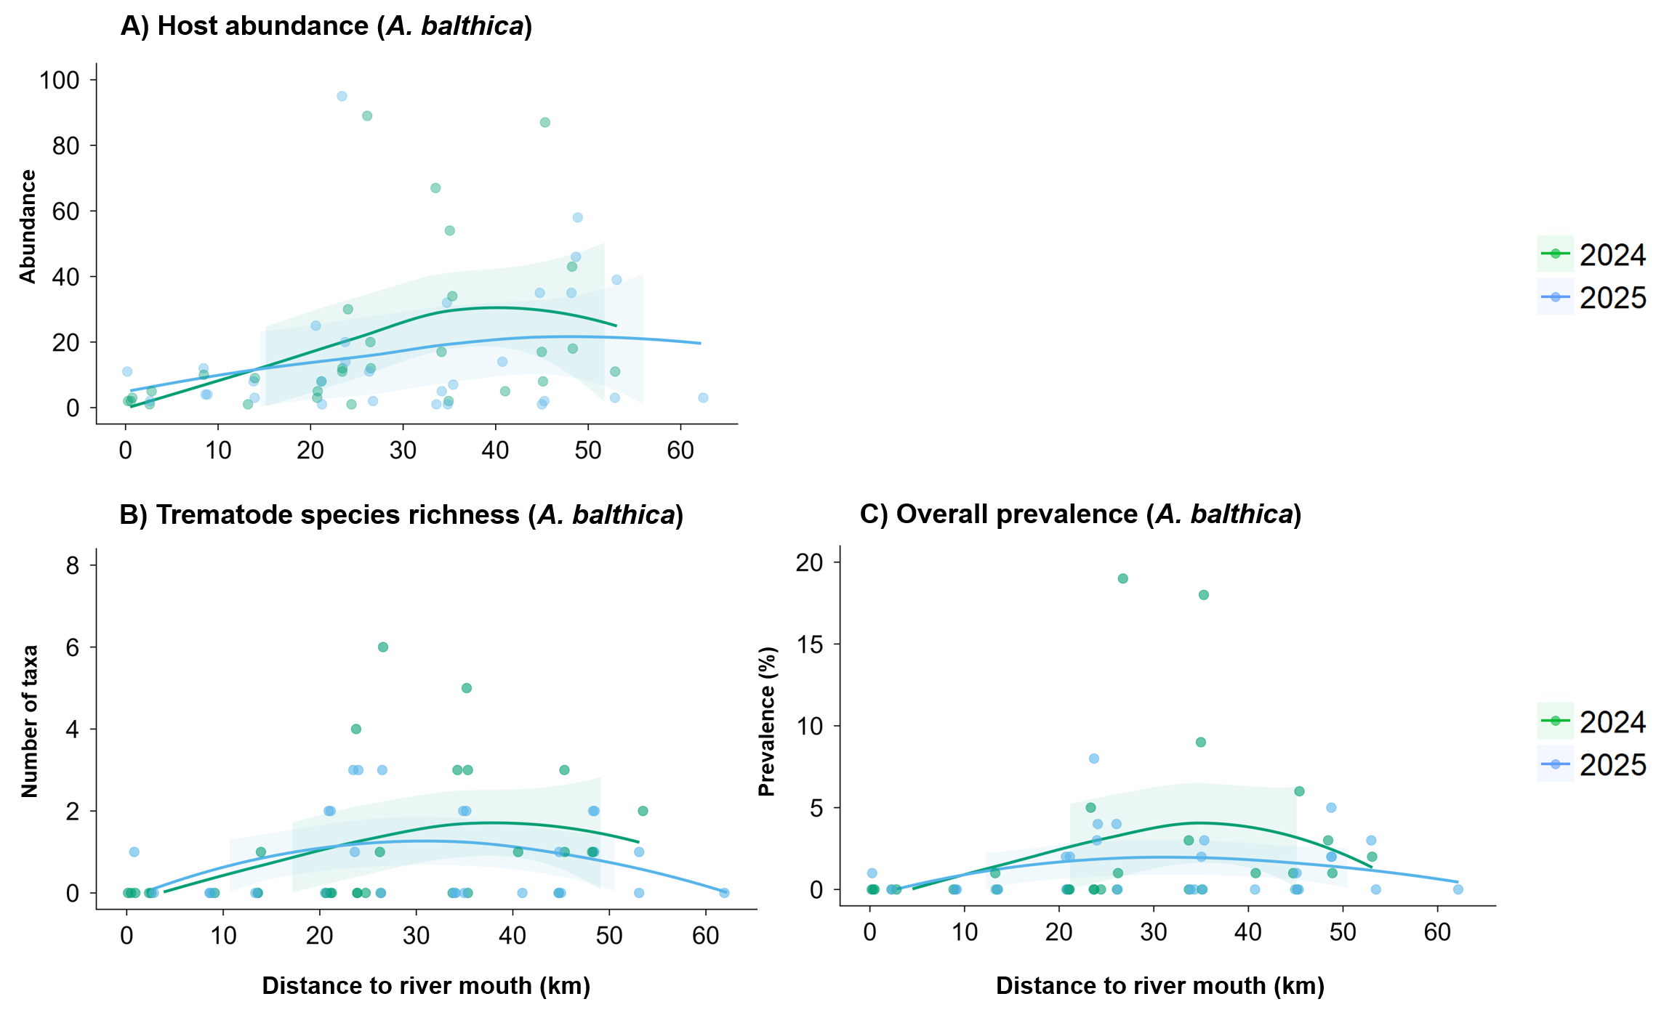Fig. S13. Abundance of all snails (A. balthica) (A) and trematode richness and overall prevalence (%) in A. balthica (B, C) in relation to site distance from the river mouth. Points represent raw data of individual sampling events (site × month). Colored lines depict loess-estimated smoothing functions per year (2024-2025), with shaded areas indicating 95% confidence intervals.
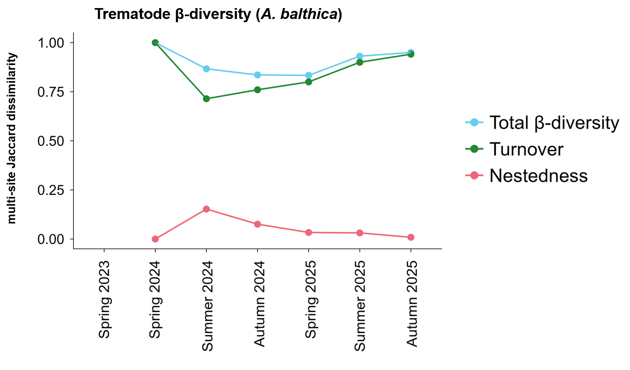
Fig. S14. Temporal changes in community composition (β-diversity) of trematodes in A. balthica based on multi-site Jaccard dissimilarity among sampling sites. Total β-diversity (β_{JAC}) is partitioned into species turnover (β_{JTU}) and nestedness-resultant dissimilarity (β_{JNE}), where turnover reflects species replacement among sites and nestedness reflects the extent to which species-poor communities constitute subsets of species-rich communities.
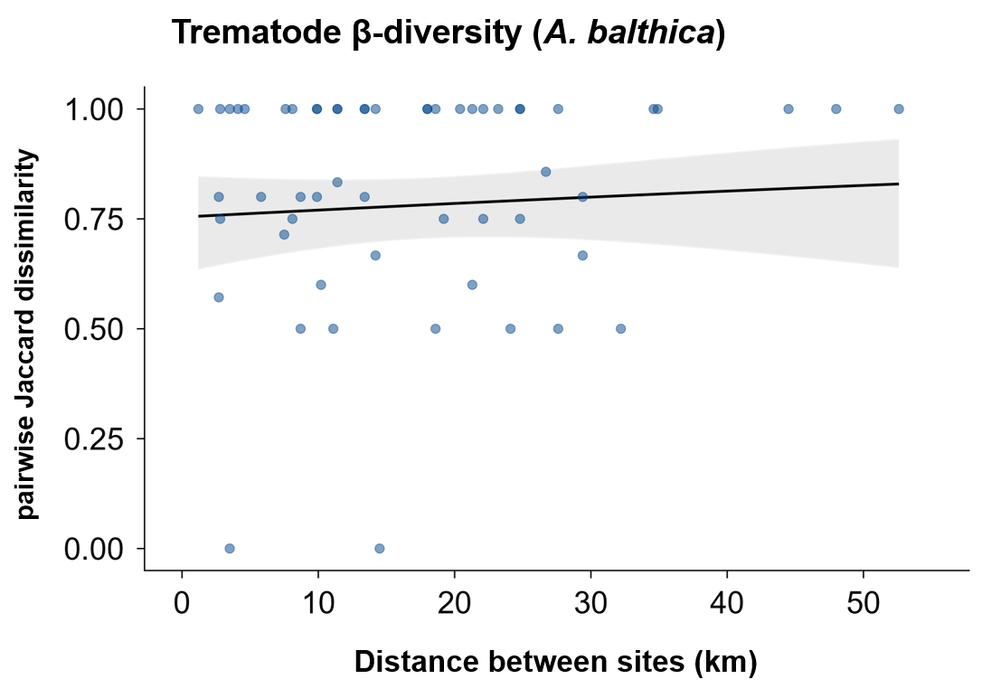
Fig. S15. Distance decay of trematode communities in A. balthica along the stream. Individual points represent pairwise Jaccard dissimilarity between sites within the same sampling time point. The solid line depicts predicted pairwise dissimilarity from mixed-effect models, with shaded areas indicating 95 % confidence intervals. No significant effect was detected for distance decay of trematode communities (p = 0.51).
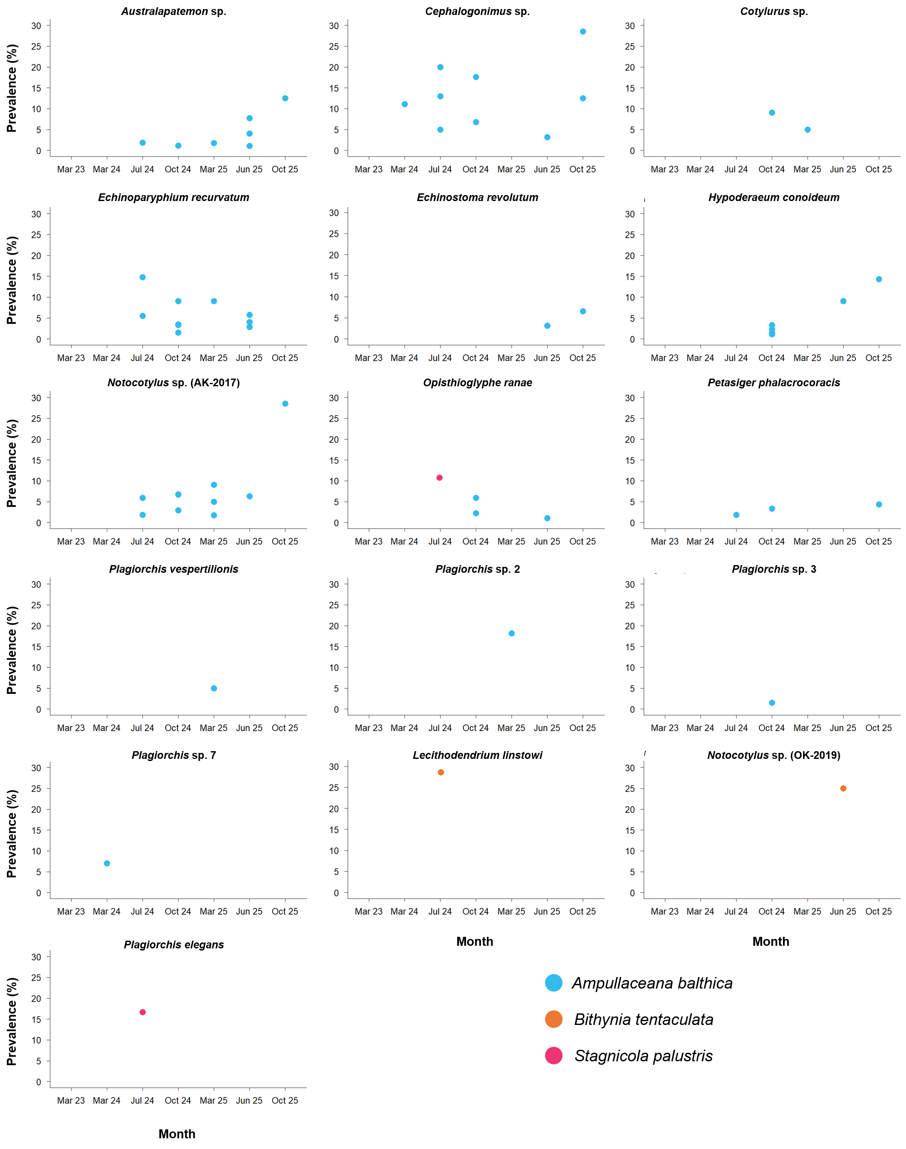
Fig. S16. Prevalence of trematode species in the respective snail species identified in this study. Individual data points represent site × month combinations of the respective trematode species. Panels are sorted by snail host and then alphabetically.

Table S12. Trematode-host associations included in analyses on host-specificity in this study. Trematode-host associations included in local analyses are indicated in bold.
Trematode family and species | Location | Country | Accession number | Genetic marker | Host species | Accession number | References
Cephalogonimidae
Cephalogonimus sp. EM-2024 | River Emscher | Germany | PX970442 | cox1 | A. balthica | PZ235457 ^{b} | This study
Cephalogonimus sp. EM-2024 | River Boye | Germany | PX637233 | cox1 | A. balthica | PX919754 ^{b} | Hüsken et al. (2026)
Cephalogonimus sp. EM-2024 | River Rotbach | Germany | PV605649 | cox1 | A. balthica | PX919754 ^{c} | Hüsken et al. (2025, 2026)
Echinostomatidae
Echinoparyphium recurvatum | River Emscher | Germany | PX993635 | nad1 | A. balthica | PZ235457 ^{b} | This study
Echinoparyphium recurvatum | River Boye | Germany | PX648493 | nad1 | A. balthica | PX919754 ^{b} | Hüsken et al. (2026)
Echinoparyphium recurvatum | River Boye | Germany | PX648497 | nad1 | S. palustris | PX919753 ^{b} | Hüsken et al. (2026)
Echinoparyphium recurvatum | River Boye | Germany | PX648502 | nad1 | P. carinatus | PX919748 ^{b} | Hüsken et al. (2026)
Echinoparyphium recurvatum | – | Iceland | MZ404647 | nad1 | A. balthica | KM067657 ^{c} | Bolotov et al. (2017), Pantoja et al. (2021), Aksenova et al. (2024)
Echinoparyphium recurvatum | – | Finland | MZ404650 | nad1 | A. balthica | KM067657 ^{c}
Echinoparyphium recurvatum | – | Finland | MZ404655 | nad1 | M. glutinosa | ON603541 ^{c}
Echinoparyphium recurvatum | Lake Takvatn | Norway | KY513265 | nad1 | A. balthica | KM067657 ^{c} | Bolotov et al. (2017), Soldánová et al. (2017)
Echinoparyphium recurvatum | Pen Ponds | England | ON653266 | nad1 | R. auricularia | ON653347 ª | Enabulele et al. (2023)
Echinoparyphium recurvatum | Tundry Pond | England | ON653270 | nad1 | R. auricularia | ON653351 ª | Enabulele et al. (2023)
Echinoparyphium recurvatum | Hill Pond | England | ON653272 | nad1 | R. auricularia | ON653353 ª | Enabulele et al. (2023)
Echinoparyphium recurvatum | Queen's River | England | ON653273 | nad1 | A. balthica | ON653354 ª | Enabulele et al. (2023)
Echinoparyphium recurvatum | Peg Pond | England | ON653280 | nad1 | A. balthica | ON653361 ª | Enabulele et al. (2023)
Echinoparyphium recurvatum | Rams Paddock Pond | England | ON653285 | nad1 | A. balthica | ON653366 ª | Enabulele et al. (2023)
Echinoparyphium recurvatum | Wildlife Pond | England | ON653296 | nad1 | A. balthica | ON653377 ª | Enabulele et al. (2023)
Echinostoma revolutum | River Emscher | Germany | PX993642 | nad1 | A. balthica | PZ235457 ^{b} | This study
Echinostoma revolutum | River Boye | Germany | PX648495 | nad1 | A. balthica | PX919754 ^{b} | Hüsken et al. (2026)
Echinostoma revolutum | – | Iceland | MZ404671 | nad1 | A. balthica | KM067657 ^{c} | Bolotov et al. (2017), Pantoja et al. (2021)
Echinostoma revolutum | Pen Ponds | England | ON653232 | nad1 | R. auricularia | ON653313 ª | Enabulele et al. (2023)
Echinostoma revolutum | Tundry Pond | England | ON653241 | nad1 | A. balthica | ON653322 ª | Enabulele et al. (2023)
Echinostoma revolutum | Hill Pond | England | ON653231 | nad1 | R. auricularia | ON653312 ª | Enabulele et al. (2023)
Echinostoma revolutum | Peg Pond | England | ON653236 | nad1 | A. balthica | ON653317 ª | Enabulele et al. (2023)
Echinostoma revolutum | Rams Paddock Pond | England | ON653238 | nad1 | A. balthica | ON653319 ª | Enabulele et al. (2023)
Echinostoma revolutum | Bury Lake | England | ON653233 | nad1 | R. auricularia | ON653314 ª | Enabulele et al. (2023)
Echinostoma revolutum | Wildlife Pond | England | ON653240 | nad1 | A. balthica | ON653321 ª | Enabulele et al. (2023)
Echinostoma revolutum | Wildlife Pond | England | ON653242 | nad1 | S. palustris | ON653323 ª | Enabulele et al. (2023)
Echinostoma revolutum | Hengsteysee | Germany | KC618461 | nad1 | S. palustris | PX919753 ^{b} | Georgieva et al. (2013)
Echinostoma revolutum | Hengsteysee | Germany | KC618454 | nad1 | L. stagnalis | PX919755 ^{b} | Georgieva et al. (2013)
Echinostoma revolutum | Baldeneysee | Germany | KP065652 | nad1 | L. stagnalis | PX919755 ^{b} | Georgieva et al. (2014)
Echinostoma revolutum | Baldeneysee | Germany | KP065649 | nad1 | L. stagnalis | PX919755 ^{b} | Georgieva et al. (2014)
Echinostoma revolutum | Pond Hluboky´ u Hamru | Czech Republic | KP065657 | nad1 | L. stagnalis | PX919755 ^{b} | Georgieva et al. (2014)
Echinostoma revolutum | Krausenbechhofen | Germany | KP065656 | nad1 | L. stagnalis | PX919755 ^{b} | Georgieva et al. (2014)
Echinostoma revolutum | Lake Huumojärvi, Oulu | Finland | KP065655 | nad1 | L. stagnalis | PX919755 ^{b} | Georgieva et al. (2014)
Hypoderaeum conoideum | River Emscher | Germany | PX993646 | nad1 | A. balthica | PZ235457 ^{b} | This study
Hypoderaeum conoideum | River Boye | Germany | PX648499 | nad1 | A. balthica | PX919754 ^{b} | Hüsken et al. (2026)
Hypoderaeum conoideum | River Boye | Germany | PX648505 | nad1 | S. palustris | PX919753 ^{b} | Hüsken et al. (2026)
Hypoderaeum conoideum | River Boye | Germany | PX648494 | nad1 | L. stagnalis | PX919755 ^{b} | Hüsken et al. (2026)
Hypoderaeum conoideum | – | Finland | MZ404681 | nad1 | L. stagnalis | OP084803 ^{c} | Pantoja et al. (2021), Aksenova et al. (2024)
Hypoderaeum conoideum | Tundry Pond | England | ON653297 | nad1 | R. auricularia | ON653378 | Enabulele et al. (2023)
Hypoderaeum conoideum | Rams Paddock Pond | England | ON653298 | nad1 | A. balthica | ON653379 | Enabulele et al. (2023)
Petasiger phalacrocoracis | River Emscher | Germany | PZ225369 | ITS1-5.8S-ITS2 | A. balthica | PZ235457 ^{b} | This study
Petasiger phalacrocoracis | Lake Furesoe | Denmark | MW001053 | ITS1-5.8S-ITS2 | A. balthica | PX919754 ^{c} | Duan et al. (2021), Hüsken et al. (2026)
Petasiger phalacrocoracis | Lake Esrum | Denmark | MW001052 | ITS1-5.8S-ITS2 | A. balthica | PX919754 ^{c} | Duan et al. (2021), Hüsken et al. (2026)
Petasiger phalacrocoracis | Luchegorsk | Russia | OR037388 | ITS1-5.8S-ITS2 | P. fontinalis | MW600069 ^{c} | Menabit (2021),  Vainutis et al. (2023)
Lecithodendriidae
Lecithodendrium linstowi | River Emscher | Germany | PX972837 | 28S rDNA | B. tentaculata | PZ235464 ^{b} | This study
Lecithodendrium linstowi | River Boye | Germany | PX641056 | 28S rDNA | B. tentaculata | PZ235464 ^{c} | Hüsken et al. (2026)
Lecithodendrium linstowi | K2 | Germany | MN726965 | 28S rDNA | B. tentaculata | MN720141 ^{b} | Schwelm et al. (2020)
Lecithodendrium linstowi | Queen's River | England | MF498821 | 28S rDNA | A. balthica | MF498822 ª | Enabulele et al. (2018)
Lecithodendrium linstowi | Lough Corrib | Ireland | PP849700 | 28S rDNA | B. tentaculata | MW138435 ^{c} | Katokhin et al. (2020), Faltýnková et al. (2024)
Notocotylidae
Notocotylus sp.  AK-2017 | River Emscher | Germany | PX972838 | 28S rDNA | A. balthica | PZ235457 ^{b} | This study
Notocotylus sp.  AK-2017 | River Boye | Germany | PX641062 | 28S rDNA | A. balthica | PX919754 ^{b} | Hüsken et al. (2026)
Notocotylus sp.  AK-2017 | River Boye | Germany | PX641066 | 28S rDNA | S. palustris | PX919753 ^{b} | Hüsken et al. (2026)
Notocotylus sp.  AK-2017 | Lake Takvatn | Norway | KY513158 | 28S rDNA | A. balthica | KM067657 ^{c} | Bolotov et al. (2017), Soldánová et al. (2017)
Notocotylus sp.  OK-2019 | River Emscher | Germany | PX972842 | 28S rDNA | B. tentaculata | PZ235464 ^{b} | This study
Notocotylus sp.  OK-2019 | K4 | Germany | MN726957 | 28S rDNA | B. tentaculata | MN720141 ^{b} | Schwelm et al. (2020)
Notocotylus sp.  OK-2019 | Lough Corrib | Ireland | PP849713 | 28S rDNA | B. tentaculata | MW138435 ^{c} | Katokhin et al. (2020), Faltýnková et al. (2024)
Plagiorchiidae
Plagiorchis elegans | River Emscher | Germany | PX970448 | cox1 | S. palustris | PZ235481 ^{b} | This study
Plagiorchis elegans | River Boye | Germany | PX637202 | cox1 | L. stagnalis | PX919755 ^{b} | Hüsken et al. (2026)
Plagiorchis elegans | River Boye | Germany | PX637216 | cox1 | S. palustris | PX919753 ^{b} | Hüsken et al. (2026)
Plagiorchis elegans | Lough Mask | Ireland | MW520066 | cox1 | S. fuscus | LN515539 ^{c} | Schniebs et al. (2016), Kudlai et al. (2021), Aksenova et al. (2024)
Plagiorchis elegans | Lough Mask | Ireland | MW519475 | cox1 | L. stagnalis | OP084803 ^{c}
Plagiorchis elegans | Lough Corrib | Ireland | MW519476 | cox1 | S. fuscus | LN515539 ^{c}
Plagiorchis elegans | Lake Konnevesi | Finland | MW519480 | cox1 | L. stagnalis | OP084803 ^{c}
Plagiorchis elegans | Danube near Gabcikovo | Slovakia | KJ533400 | cox1 | L. stagnalis | PP203064 ^{c} | Zikmundová et al. (2014), Schols et al. (2024)
Plagiorchis elegans | Pond Bohdanecsky | Czech Republic | KJ533413 | cox1 | L. stagnalis | PP203064 ^{c} | Zikmundová et al. (2014), Schols et al. (2024)
Plagiorchis elegans | Pond Hluboky u Hamru | Czech Republic | KJ533414 | cox1 | L. stagnalis | PP203064 ^{c} | Zikmundová et al. (2014), Schols et al. (2024)
Plagiorchis elegans | Milada | Czech Republic | PP396751 | cox1 | L. stagnalis | PP203064 ^{c} | Kundid et al. (2024), Schols et al. (2024)
Plagiorchis sp. 2 | River Emscher | Germany | PX970449 | cox1 | A. balthica | PZ235457 ^{b} | This study
Plagiorchis sp. 2 | River Boye | Germany | PX637213 | cox1 | A. balthica | PX919754 ^{b} | Hüsken et al. (2026)
Plagiorchis sp. 2 | Lake Takvatn | Norway | KY513249 | cox1 | A. balthica | KM067657 ^{c} | Bolotov et al. (2017), Soldánová et al. (2017)
Plagiorchis sp. 2 | Lake Konnevesi | Finland | MW519490 | cox1 | A. balthica | KM067657 ^{c} | Bolotov et al. (2017), Kudlai et al. (2021)
Plagiorchis sp. 2 | Lake Myvatn | Iceland | MW519486 | cox1 | A. balthica | KM067657 ^{c} | Bolotov et al. (2017), Kudlai et al. (2021)
Plagiorchis sp. 2 | Lake Raudavatn | Iceland | MW520071 | cox1 | A. balthica | KM067657 ^{c} | Bolotov et al. (2017), Kudlai et al. (2021)
Plagiorchis sp. 3 | River Emscher | Germany | PX970450 | cox1 | A. balthica | PZ235457 ^{b} | This study
Plagiorchis sp. 3 | River Boye | Germany | PX637207 | cox1 | A. balthica | PX919754 ^{b} | Hüsken et al. (2026)
Plagiorchis sp. 3 | Lake Takvatn | Norway | KY513256 | cox1 | A. balthica | KM067657 ^{c} | Bolotov et al. (2017), Soldánová et al. (2017)
Plagiorchis sp. 3 | Lough Corrib | Ireland | MW520076 | cox1 | A. balthica | KM067657 ^{c} | Bolotov et al. (2017), Kudlai et al. (2021)
Plagiorchis sp. 3 | Lake Raudavatn | Iceland | MW520077 | cox1 | A. balthica | KM067657 ^{c} | Bolotov et al. (2017), Kudlai et al. (2021)
Plagiorchis sp. 3 | Medard | Czech Republic | PP396791 | cox1 | A. balthica | PX919754 ^{c} | Kundid et al. (2024), Hüsken et al. (2026)
Plagiorchis sp. 7 | River Emscher | Germany | PX970451 | cox1 | A. balthica | PZ235457 ^{b} | This study
Plagiorchis sp. 7 | River Boye | Germany | PX637214 | cox1 | A. balthica | PX919754 ^{b} | Hüsken et al. (2026)
Plagiorchis sp. 7 | Lake Takvatn | Norway | KY513264 | cox1 | A. balthica | KM067657 ^{c} | Bolotov et al. (2017), Soldánová et al. (2017)
Plagiorchis sp. 7 | Lough Corrib | Ireland | MW520083 | cox1 | A. balthica | KM067657 ^{c} | Bolotov et al. (2017), Kudlai et al. (2021)
Plagiorchis vespertilionis | River Emscher | Germany | PX970454 | cox1 | A. balthica | PZ235457 ^{b} | This study
Plagiorchis vespertilionis | River Boye | Germany | PX637226 | cox1 | A. balthica | PX919754 ^{b} | Hüsken et al. (2026)
Plagiorchis vespertilionis | Medard | Czech Republic | PP396795 | cox1 | A. balthica | PX919754 ^{c} | Vinarski et al. (2011), Bolotov et al. (2017), Kundid et al. (2024), Hüsken et al. (2026)
Plagiorchis vespertilionis | Barbora | Czech Republic | PP396758 | cox1 | R. auricularia | FR797878 ^{c}
Plagiorchis vespertilionis | Otakar | Czech Republic | PP396760 | cox1 | R. auricularia | FR797878 ^{c}
Plagiorchis vespertilionis | Most | Czech Republic | PP396784 | cox1 | A. lagotis | KM067625 ^{c}
Strigeidae
Cotylurus sp.  lineage II | River Emscher | Germany | PX970444 | cox1 | A. balthica | PZ235457 ^{b} | This study
Cotylurus sp.  lineage II | River Boye | Germany | PX637219 | cox1 | A. balthica | PX919754 ^{b} | Hüsken et al. (2026)
Cotylurus sp.  lineage II | – | Poland | OM949025 | cox1 | R. auricularia | FR797878 ^{c} | Vinarski et al. (2011), Pyrka et al. (2022)
Cotylurus sp.  lineage II | – | Poland | OM949022 | cox1 | R. labiata | HG932227 ^{c} | Vinarski et al. (2014), Pyrka et al. (2022)
Australapatemon sp.  (Australapatemon cf. burti) | River Emscher | Germany | PX637227 | cox1 | A. balthica | PZ235457 ^{b} | This study
Australapatemon sp.  (Australapatemon cf. burti) | River Boye | Germany | PX637227 | cox1 | A. balthica | PX919754 ^{b} | Hüsken et al. (2026)
Australapatemon sp.  (Australapatemon cf. burti) | River Boye | Germany | – | – | S. palustris | PX919753 ^{b} | Hüsken et al. (2026)
Australapatemon sp.  (Australapatemon cf. burti) | River Boye | Germany | – | – | L. stagnalis | PX919755 ^{b} | Hüsken et al. (2026)
Australapatemon sp.  (Australapatemon cf. burti) | River Boye | Germany | PX637228 | cox1 | P. carinatus | PX919748 ^{b} | Hüsken et al. (2026)
Telorchiidae
Opisthioglyphe ranae | River Emscher | Germany | PX972843 | 28S rDNA | A. balthica | PX919754 ^{b} | This study
Opisthioglyphe ranae | River Emscher | Germany | PV248801 | 28S rDNA | S. palustris | PZ235481 ^{c} | Hüsken et al. (2025, 2026)
Opisthioglyphe ranae | River Boye | Germany | PX641055 | 28S rDNA | S. palustris | PX919753 ^{b} | Hüsken et al. (2026)
ª Exact host association, ^{b} Representative host from the same study, ^{c} Representative host from a different study.

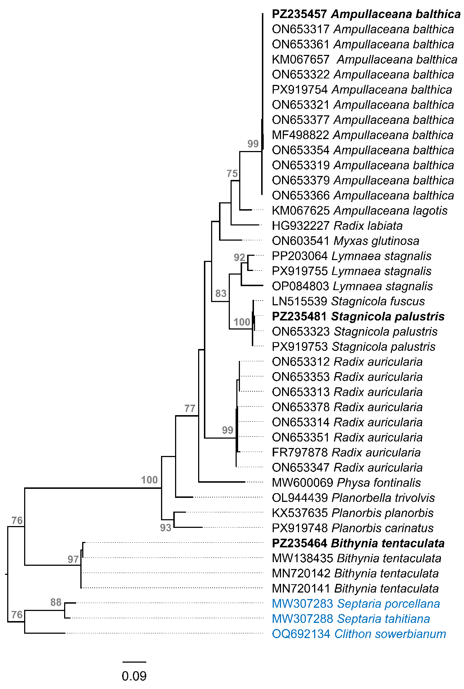
Fig. S17. Maximum likelihood (ML) phylogram based on the cox1 alignment (42 sequences, 434 bp, K3Pu+F+I+G4) for gastropod hosts included in analyses on host-specificity. Node support values >75 (1,000 bootstrap replicates) are shown in grey. Sequences generated in this study are presented in bold. Scale bar indicates the expected number of substitutions per site, outgroups are indicated in blue.
Table S13. Local phylogenetic host specificity (PD, SES-PD) and geographic host specificity (β-specificity) of trematodes, with resulting classifications. Trematode taxa were classified as phylogenetic specialists (SES-PD ≤ -1), generalists (SES-PD ≥ 1), or intermediate. Trematode taxa were classified into geographic host specialist, intermediate, and generalist categories based on tertiles of β-specificity values.
Trematode family and species | No. locations | No. host species | PD | SES-PD | Sign. | SES-PD classification | β-specificity | β-specificity classification
Cephalogonimidae
Cephalogonimus sp. EM-2024 | 2 | 1 | 0 | -1.32 | n.s. | Specialist | 0 | Specialist
Echinostomatidae
Echinoparyphium recurvatum | 2 | 4 | 0.78 | -0.78 | n.s. | Intermediate | 0.75 | Generalist
Echinostoma revolutum | 2 | 1 | 0 | -1.32 | n.s. | Specialist | 0 | Specialist
Hypoderaeum conoideum | 2 | 3 | 0.44 | -1.22 | n.s. | Specialist | 0.77 | Generalist
Petasiger phalacrocoracis | 1 | 1 | 0 | – | – | Specialist | 0 | Specialist
Lecithodendriidae
Lecithodendrium linstowi | 2 | 1 | 0.02 | -1.27 | n.s. | Specialist | 0 | Specialist
Notocotylidae
Notocotylus sp. AK-2017 | 2 | 2 | 0.35 | -0.88 | n.s. | Intermediate | 0.5 | Intermediate
Notocotylus sp. OK-2019 | 1 | 1 | 0 | – | – | Specialist | 0 | Specialist
Plagiorchiidae
Plagiorchis elegans | 2 | 2 | 0.18 | -1.35 | n.s. | Specialist | 0.5 | Intermediate
Plagiorchis sp. 2 | 2 | 1 | 0 | -1.29 | n.s. | Specialist | 0 | Specialist
Plagiorchis sp. 3 | 2 | 1 | 0 | -1.28 | n.s. | Specialist | 0 | Specialist
Plagiorchis sp. 7 | 2 | 1 | 0 | -1.25 | n.s. | Specialist | 0 | Specialist
Plagiorchis vespertilionis | 2 | 1 | 0 | -1.31 | n.s. | Specialist | 0 | Specialist
Strigeidae
Cotylurus sp. lineage II | 2 | 1 | 0 | -1.30 | n.s. | Specialist | 0 | Specialist
Australapatemon cf. burti | 2 | 4 | 0.78 | -0.84 | n.s. | Intermediate | 0.75 | Generalist
Telorchiidae
Opisthioglyphe ranae | 2 | 2 | 0.36 | -0.95 | n.s. | Intermediate | 0.5 | Intermediate
Table S14. Global phylogenetic host specificity (PD, SES-PD) and geographic host specificity (β-specificity) of trematodes, with resulting classifications. Trematode taxa were classified as phylogenetic specialists (SES-PD ≤ -1), generalists (SES-PD ≥ 1), or intermediate. Trematode taxa were classified into geographic host specialist, intermediate, and generalist categories based on tertiles of β-specificity values.
Trematode family and species | No. locations | No. host species | PD | SES-PD | Sign. | SES-PD classification | β-specificity | β-specificity classification
Cephalogonimidae
Cephalogonimus sp. EM-2024 | 3 | 1 | 0 | – | – | Specialist | 0 | Specialist
Echinostomatidae
Echinoparyphium recurvatum | 12 | 6 | 1.01 | -3.4 | n.s. | Specialist | 0.91 | Generalist
Echinostoma revolutum | 16 | 4 | 0.69 | -4.70 | n.s. | Specialist | 0.93 | Generalist
Hypoderaeum conoideum | 5 | 4 | 0.67 | -1.71 | n.s. | Specialist | 0.87 | Generalist
Petasiger phalacrocoracis | 4 | 2 | 0.42 | -0.83 | n.s. | Intermediate | 0.72 | Generalist
Lecithodendriidae
Lecithodendrium linstowi | 5 | 2 | 1.13 | 0.04 | n.s. | Intermediate | 0.73 | Generalist
Notocotylidae
Notocotylus sp. AK-2017 | 3 | 2 | 0.35 | -1.43 | n.s. | Specialist | 0.50 | Intermediate
Notocotylus sp. OK-2019 | 3 | 1 | 0.02 | -1.80 | n.s. | Specialist | 0 | Specialist
Plagiorchiidae
Plagiorchis elegans | 9 | 3 | 0.30 | -2.22 | n.s. | Specialist | 0.84 | Generalist
Plagiorchis sp. 2 | 6 | 1 | 0.002 | -1.80 | n.s. | Specialist | 0 | Specialist
Plagiorchis sp. 3 | 7 | 1 | 0.002 | -1.87 | n.s. | Specialist | 0 | Specialist
Plagiorchis sp. 7 | 4 | 1 | 0.002 | -1.72 | n.s. | Specialist | 0 | Specialist
Plagiorchis vespertilionis | 6 | 3 | 0.40 | -1.26 | n.s. | Specialist | 0.88 | Generalist
Strigeidae
Cotylurus sp. lineage II | 4 | 3 | 0.46 | 1.13 | n.s. | Intermediate | 0.84 | Generalist
Australapatemon cf. burti | 2 | 4 | 0.78 | -0.84 | n.s. | Intermediate | 0.75 | Generalist
Telorchiidae
Opisthioglyphe ranae | 2 | 2 | 0.36 | -0.97 | n.s. | Intermediate | 0.5 | Intermediate

References
Aksenova, O.V., Vinarski, M.V., Itagaki, T., Ohari, Y., Oshida, T., Kim, S.K., Lee, J.H., Kondakov, A.V., Khrebtova, I.S., Soboleva, A.A., Travina, O.V., Sokolova, S.E., Palatov, D.M., Bespalaya, Y.V., Vikhrev, I., Gofarov, M.Y., Bolotov, I.N. (2014). Taxonomy and trans-Beringian biogeography of the pond snails (Gastropoda: Lymnaeidae) of East Asia: an integrative view. Zool J Linn Soc, 201, zlae083. https://doi.org/10.1093/zoolinnean/zlae083.
Bolotov, I.N., Aksenova, O.V., Bespalaya, Y.V., Gofarov, M.Y., Kondakov, A.V., Paltser, I.S., Stefansson, A., Travina, O.V., Viarski, M.V. (2017). Origin of a divergent mtDNA lineage of a freshwater snail species, Radix balthica, in Iceland: cryptic glacial refugia or a postglacial founder event?. Hydrobiologia 787, 73–98. https://doi.org/10.1007/s10750-016-2946-9.
Duan, Y., Al-Jubury, A., Kania, P.W., Buchmann, K. (2021). Trematode diversity reflecting the community structure of Danish freshwater systems: molecular clues. Parasites Vectors, 14, 43. https://doi.org/10.1186/s13071-020-04536-x.
Enabulele, E.E., Lawton, S.P., Walker, A.J., Kirk, R.S. (2018). Molecular and morphological characterization of the cercariae of Lecithodendrium linstowi (Dollfus, 1931), a trematode of bats, and incrimination of the first intermediate snail host, Radix balthica. Parasitology, 145, 307–312. https://doi.org/10.1017/S0031182017001640.
Enabulele, E.E., Lawton, S.P., Walker, A.J., Kirk, R.S. (2023). Molecular epidemiological analyses reveal extensive connectivity between Echinostoma revolutum (sensu stricto) populations across Eurasia and species richness of zoonotic echinostomatids in England. PLOS ONE, 18, e0270672. https://doi.org/10.1371/journal.pone.0270672.
Faltýnková, A., O'Dwyer, K., Pantoja, C., Jouet, D., Skírnisson, K., Kudlai, O. (2024). Trematode species diversity in the faucet snail, Bithynia tentaculata at the western edge of its native distribution, in Ireland. J Helminthol, 98, e52. https://doi.org/10.1017/S0022149X24000397.
Georgieva, S., Faltýnková, A., Brown, R., Blasco-Costa, I., Soldánová, M., Sitko, J., Scholz, T., Kostadinova, A. (2014). Echinostoma 'revolutum' (Digenea: Echinostomatidae) species complex revisited: species delimitation based on novel molecular and morphological data gathered in Europe. Parasites Vectors, 7, 520. https://doi.org/10.1186/s13071-014-0520-8.
Georgieva, S., Selbach, C., Faltýnková, A., Soldánová, M., Sures, B., Skírnisson, K., Kostadinova, A. (2013). New cryptic species of the 'revolutum' group of Echinostoma (Digenea: Echinostomatidae) revealed by molecular and morphological data. Parasites Vectors, 6, 64. https://doi.org/10.1186/1756-3305-6-64.
Gordy, M.A., Locke, S.A., Rawlings, T.A., Lapierre, A.R., Hanington, P.C. (2017). Molecular and morphological evidence for nine species in North American Australapatemon (Sudarikov, 1959): a phylogeny expansion with description of the zygocercous Australapatemon mclaughlini n. sp. Parasitol Res, 116, 2181–2198. https://doi.org/10.1007/s00436-017-5523-x.
Hüsken, A., Schwelm, J., Rückert, S., Sures, B. (2025). Intermediate insights: tracing trematodes infecting amphibians via their first intermediate snail hosts. Parasites Vectors, 18, 285. https://doi.org/10.1186/s13071-025-06920-x.
Hüsken, A., Schwelm, J., Sures, B. (2026). Land use drives trematode dynamics in a restored stream system. Curr Res Parasitol Vector Borne Dis 9, 100357. https://doi.org/10.1016/j.crpvbd.2026.100357.
Johnson, P.T.J., Calhoun, D.M., Achatz, T.J., Greiman, S.E., Gestos, A., Keeley, W.H. (2024). Outbreak of parasite-induced limb malformations in a declining amphibian species in Colorado. Int J Parasitol Parasit Wildl, 24, 100965. https://doi.org/10.1016/j.ijppaw.
2024.100965.
Katokhin, A.V., Kuzmenckin, D.V. (2020). Bithyniid Snails of Northern Eurasia. Unpublished.
Kudlai, O., Pantoja, C., O’Dwyer, K., Jouet, D., Skírnisson, K., Faltýnková, A. (2021). Diversity of Plagiorchis (Trematoda: Digenea) in high latitudes: Species composition and snail host spectrum revealed by integrative taxonomy. J Zool Syst Evol Res, 59, 937–962. https://doi.org/10.1111/jzs.12469.
Kundid, P., Pantoja, C., Janovcová, K., Soldánová, M. (2024). Molecular diversity of the genus Plagiorchis Lühe, 1899 in snail hosts of Central Europe with evidence of new lineages. Diversity, 16, 158. https://doi.org/10.3390/d16030158.
Menabit, S. (2021). Direct submission.
Nakao, M., Sasaki, M. (2021). Trematode diversity in freshwater snails from a stopover point for migratory waterfowls in Hokkaido, Japan: An assessment by molecular phylogenetic and population genetic analyses. Parasitol Int, 83, 102329. https://doi.org/10.1016/j.parint.2021.102329.
Pantoja, C., Faltýnková, A., O’Dwyer, K., Jouet, D., Skírnisson, K., Kudlai, O. (2021). Diversity of echinostomes (Digenea, Echinostomatidae) in their snail hosts at high latitudes. Parasite, 28, 59. https://doi.org/10.1051/parasite/2021054.
Pyrka, E., Kanarek, G., Gabrysiak, J., Jeżewski, W., Cichy, A., Stanicka, A., et al. (2022). Life history strategies of Cotylurus spp. Szidat, 1928 (Trematoda, Strigeidae) in the molecular era - Evolutionary consequences and implications for taxonomy. Int J Parasitol Parasit Wildl, 18, 201–211. https://doi.org/10.1016/j.ijppaw.2022.06.002.
Schniebs, K., Glöer, P., Vinarski, M., Hundsdörfer, A. (2016). A barcode pitfall in Palearctic Stagnicola specimens (Mollusca: Lymnaeidae): Incongruence of mitochondrial genes, a nuclear marker and morphology. North-West J Zool, 12, 239–254.
Schols, R., Smitz, N., Vanderheyden, A., Huyse, T. (2024). Expanding the swimmer's itch pool of the Benelux: a first record of the neurotropic Trichobilharzia regenti and potential link to human infection. Parasites Vectors, 17, 126. https://doi.org/10.1186/s13071-024-06218-4.
Schwelm, J., Kudlai, O., Smit, N.J., Selbach, C., Sures, B. (2020). High parasite diversity in a neglected host: larval trematodes of Bithynia tentaculata in Central Europe. J Helminthol, 94, e120. https://doi.org/10.1017/S0022149X19001093.
Soldánová, M., Georgieva, S., Roháčová, J., Knudsen, R., Kuhn, J.A., Henriksen, E.H., et al. (2017). Molecular analyses reveal high species diversity of trematodes in a sub-Arctic lake. Int J Parasitol, 47, 327–345. https://doi.org/10.1016/j.ijpara.2016.12.008.
Svinin, A.O., Chikhlyaev, I.V., Bashinskiy, I.W., Osipov, V.V., Neymark, L.A., Ivanov, A.Y., et al. (2023). Diversity of trematodes from the amphibian anomaly P hotspot: Role of planorbid snails. PLOS ONE, 18, e0281740. https://doi.org/10.1371/journal.pone.
0281740.
Vainutis, K., Andreev, M., Voronova, A., Zyumchenko, N. (2023). Direct submission.
Vinarski, M.V., Schniebs, K., Glöer, P., Hundsdörfer, A. (2011). The taxonomic status and phylogenetic relationships of the genus Aenigmomphiscola Kruglov and Starobogatov, 1981 (Gastropoda: Pulmonata: Lymnaeidae), J Nat Hist, 45, 2049–2068. http://dx.doi.org/10.1080/00222933.2011.574800.
Vinarski, M.V., Schniebs, K., Glöer, P., Nekhaev, I.O., Hundsdörfer, A. (2014). Geography rather than morphology explains the genetic diversity within the Lymnaea stagnalis s.l. complex (Mollusca, Gastropoda, Pulmonata) in Eurasia. Unpublished.
Zikmundová, J., Georgieva, S., Faltýnková, A., Soldánová, M., Kostadinova, A. (2014). Species diversity of Plagiorchis Lühe, 1899 (Digenea: Plagiorchiidae) in lymnaeid snails from freshwater ecosystems in central Europe revealed by molecules and morphology. Syst Parasitol, 88, 37–54. https://doi.org/10.1007/s11230-014-9481-8.

