Additional file 6. Analysis of HAT domain families by Batch CD-Search Tool.
Sequence analysis by Conserved Domain search of Hco_HATs. Triangles indicate position of amino acids involved in putative active site and metal or coenzyme binding site. The positions of the HAT superfamily domain, bromodomains, zinc.finger motifs and Supporting specific hits are displayed in the box below each sequence, the specific hits explanations are given bellow each analysis.

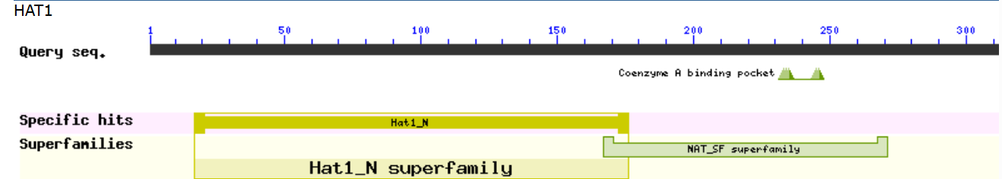
NAT_SF - (pfam00583) Acetyltransferase (GNAT) family

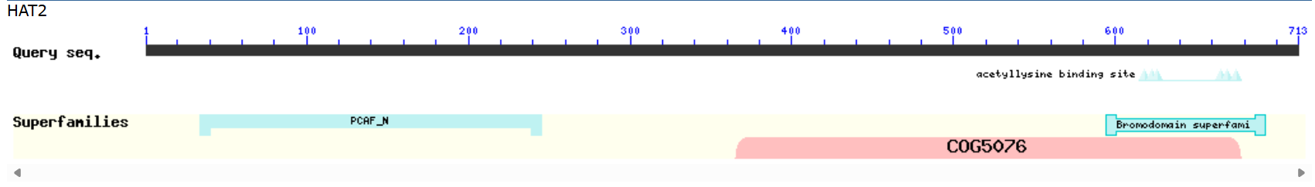
PCAF_N - (P300/CBP-associated factor) N-terminal domain
COG5076 - Transcription factor involved in chromatin remodeling, contains bromodomain

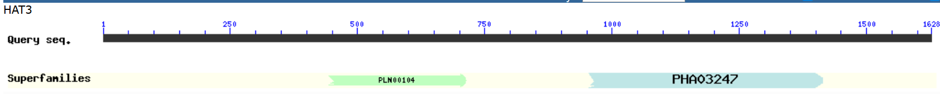
PLN00104 - MYST -like histone acetyltransferase
PHA03247 - large tegument protein UL36

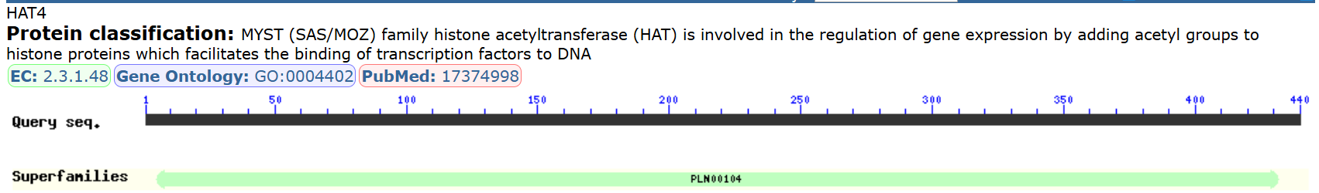
PLN00104 - MYST -like histone acetyltransferase
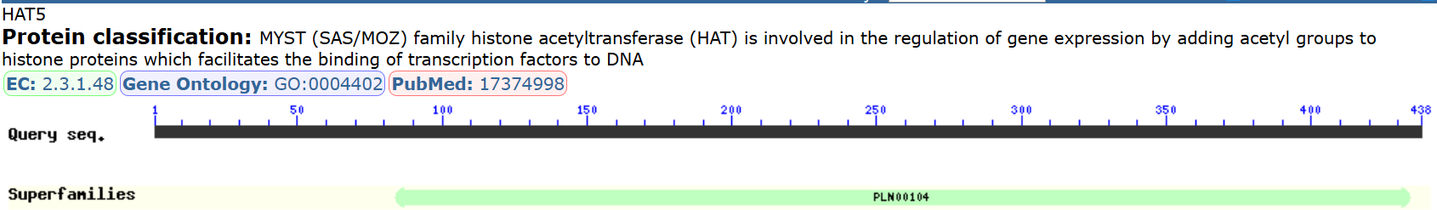

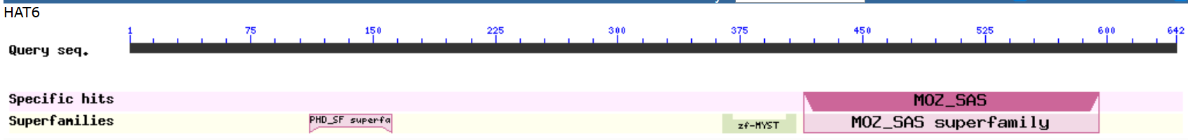
PHD_SF – (pfam00628) PHD-finger; interleaved type of Zn-finger chelating 2 Zn ions in a similar manner to that of the RING and FYVE domains
zf-MYST (pfam17772) MYST family zinc finger domain

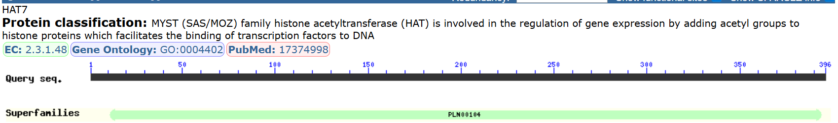

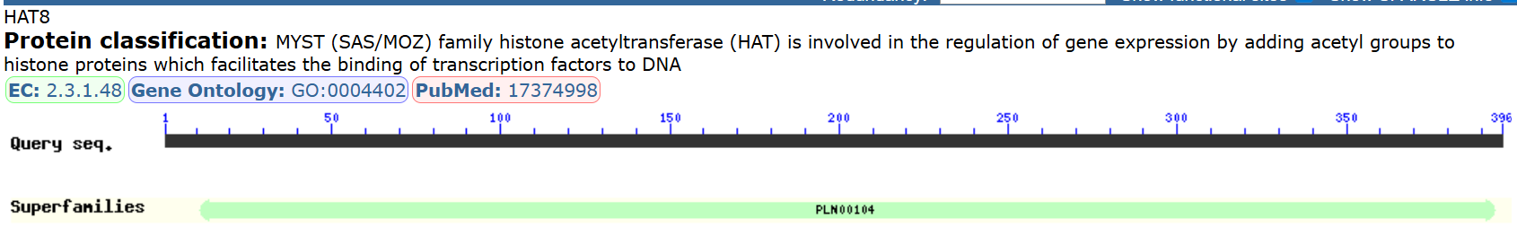

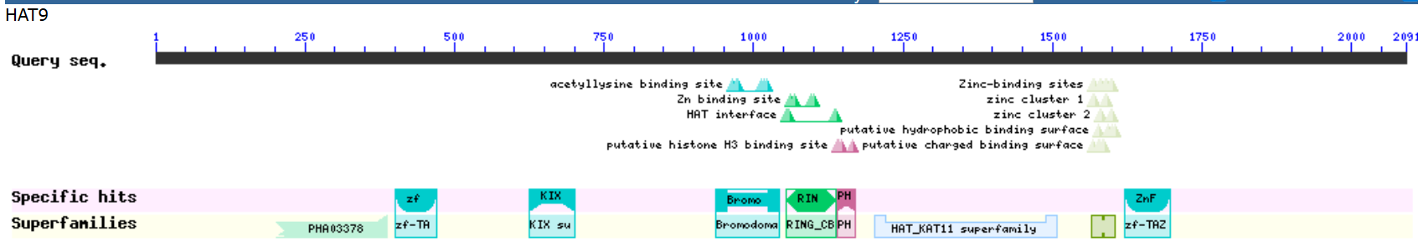 KIX domain; CBP and P300 bind to the CREB via a domain known as KIX. The KIX domain of CBP also binds to transactivation domains of other nuclear factors including Myb and Jun.

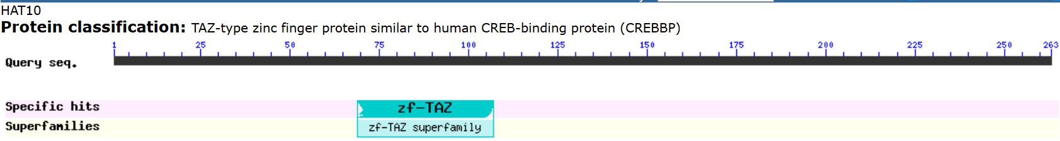
Zf-TAZ (pfam02135) TAZ zinc finger ;The TAZ2 domain of CBP binds to other transcription factors such as the p53 tumour suppressor protein, E1A oncoprotein, MyoD, and GATA-1. The zinc coordinating motif that is necessary for binding to target DNA sequences consists of HCCC.

