Supplementary information

Supplementary material 1:
Supplementary File S1: Full-length sequence of the pET-32a vector
Figure S1: Serum titer determination of recombinant SRS67 and SRS20A proteins. A. Serum titer of SRS67 protein. B. Serum titer of SRS20A protein.
Figure S2: Phylogenetic analysis, sequence similarity comparison and domain prediction of T. gondii SRS67 and SRS20A homologous sequences. A,B. Phylogenetic trees of SRS67 homologous sequences (nucleotide and amino acid). C,D. Phylogenetic trees of SRS20A homologous sequences (nucleotide and amino acid). E,F. Heatmaps of sequence identity matrix for SRS67 and SRS20A homologs (nucleotide and amino acid). Note: Amino acid sequence similarity matrix (left) and nucleotide sequence similarity matrix (right). G. Domain and 3D structure prediction of SRS67 homologous proteins. H. Domain and 3D structure prediction of SRS20A homologous proteins.
Figure S3: mRNA expression profiles of SRS67/SRS20A at different developmental stages in acute T. gondii RH strain and chronic PRU strain (partial data from ToxoDB). A. Transcriptional analysis of SRS67 in different T. gondii strains. B. Transcriptional analysis of SRS20A in different T. gondii strains.
Supplementary material 2:
Table S1: Immunization procedures for mice and rabbits
Table S2: Genetic distance of SRS67 based on nucleotide and amino acid sequences.
Table S3: Genetic distance of SRS20A based on nucleotide and amino acid sequences.
Table S4: Comparison of the antigenicity of partial invasion-related proteins of Toxoplasma gondii
Table S5: Comparison of the antigenicity of SRS67 and SRS20A proteins with some protozoa.

Supplementary Figures
Figure S1. Serum titer determination of recombinant SRS67 and SRS20A proteins. A. Serum titer of SRS67 protein. B. Serum titer of SRS20A protein.

Figure S2: Phylogenetic analysis, sequence similarity comparison and domain prediction of T. gondii SRS67 and SRS20A homologous sequences. A,B. Phylogenetic trees of SRS67 homologous sequences (nucleotide and amino acid). C,D. Phylogenetic trees of SRS20A homologous sequences (nucleotide and amino acid). E,F. Heatmaps of sequence identity matrix for SRS67 and SRS20A homologs (nucleotide and amino acid). Note: Amino acid sequence similarity matrix (left) and nucleotide sequence similarity matrix (right). G. Domain and 3D structure prediction of SRS67 homologous proteins. H. Domain and 3D structure prediction of SRS20A homologous proteins.

\
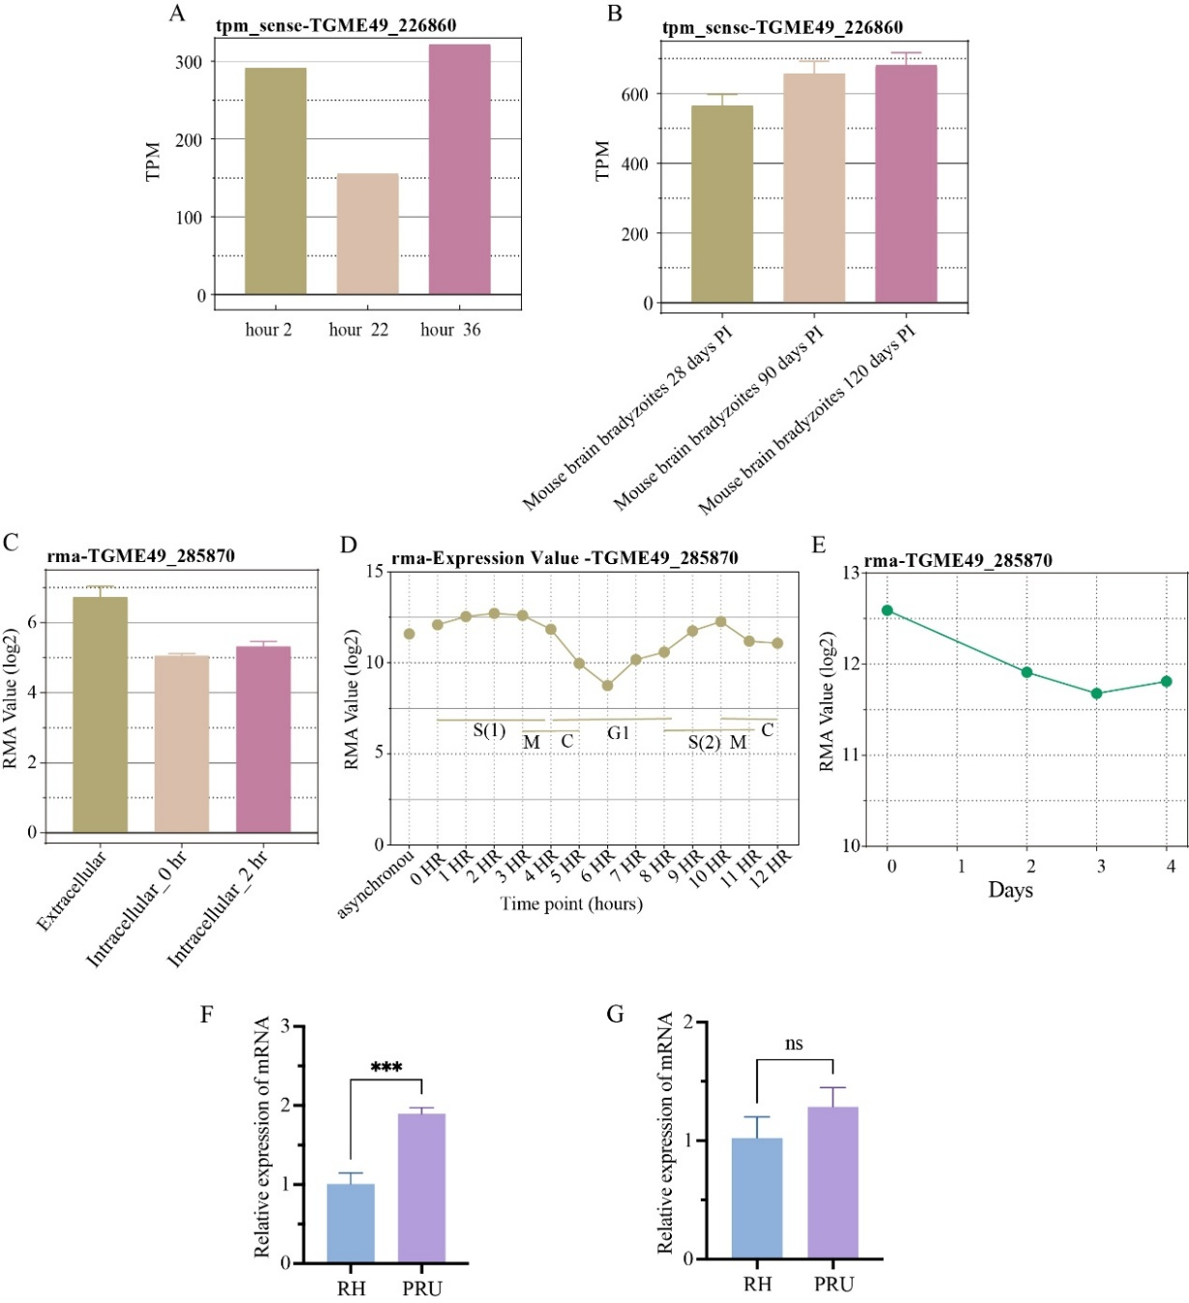

Figure S3: Transcriptional levels of SRS67 and SRS20A in T. gondii RH (acute) and PRU (chronic) strains. (A) Tachyzoite Transcriptome Time Series (RH). (B) Mouse brain bradyzoite transcriptomes at 28, 90, 120 days post infection. (C) Tachyzoite transcriptome during invasion (RH). (D) Cell Cycle Expression Profiles (RH). (E) Bradyzoite Differentiation (3-day time series)(Pru). (F) Transcriptional analysis of SRS67 in different T. gondii strains. (G) Transcriptional analysis of SRS20A in different T. gondii strains

