Supplementary information

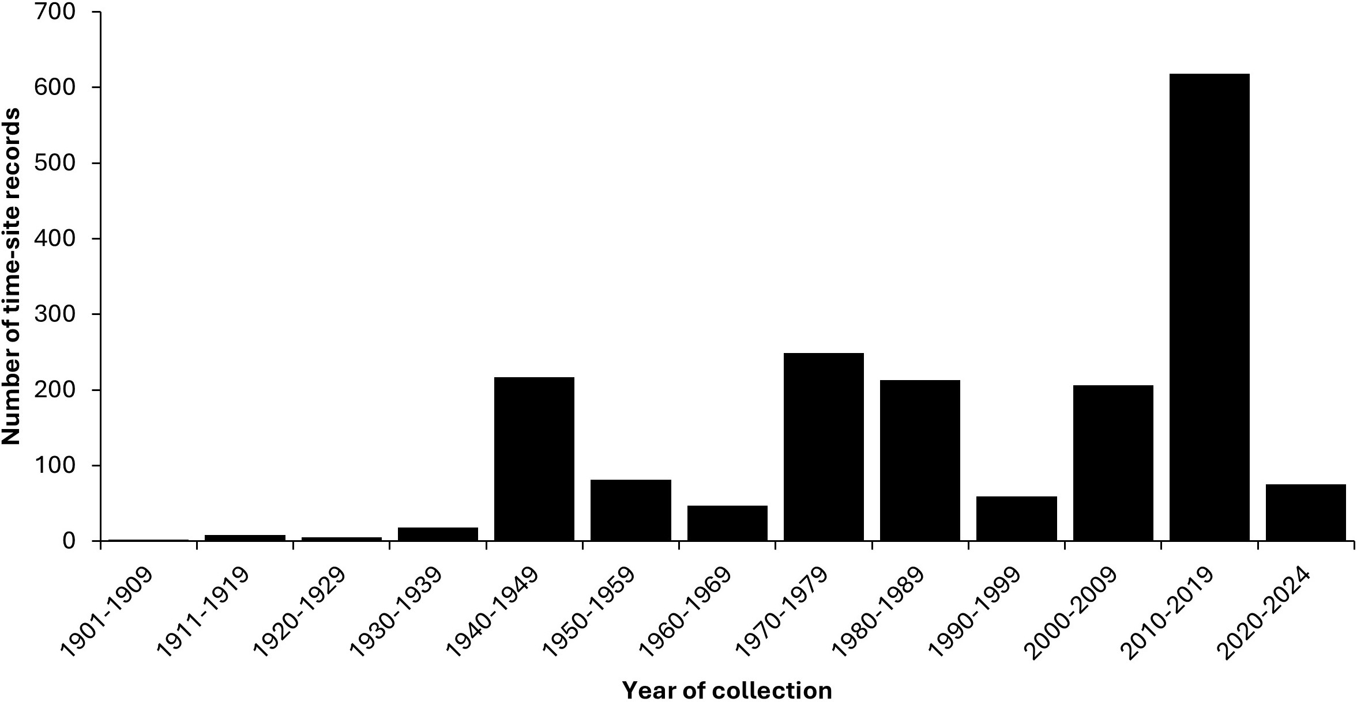
Figure S1: Summary of the number of time-site records against their 10-year time interval of collection. To note, the year of collection used in the graph is the year start of collection (1901-2024).

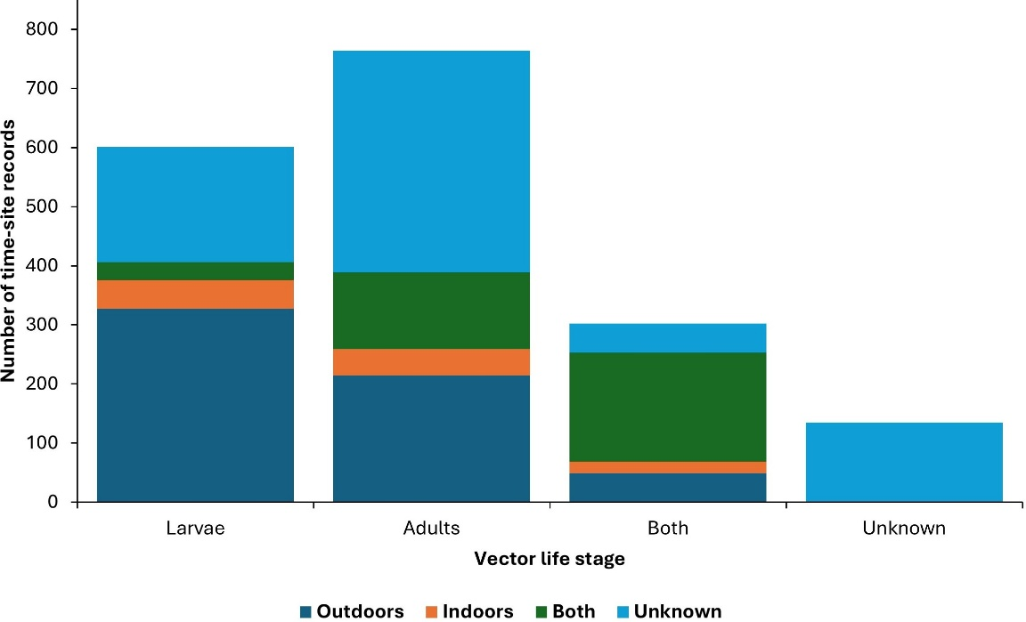
Figure S2: Summary of the number of time-site records against vector life stage and sampling locations. The legend represents the sampling location categories. The sampling location labelled “Unknown” represents time-site records where they did not state in the publications or online sources whether the Aedes species were collected outdoors, indoors or both. Vector life stage labelled as “Unknown” represents time-site records where they did not state where larval, adult or both species were collected.

Table S1: A summary of distribution of field collected Aedes species found infected with DENV and CHIKV in Kenya.
Aedes species | Arbovirus  detected | Location found | Role in transmission | References
Aedes aegypti | DENV, CHIKV | Kilifi, Kwale, Lamu, Maasai Mara, Mombasa, Shimba Hills, Ukunda | Principal vector | [9,11–13,31,32]
Aedes mcintoshi/Aedes lineatopennis | DENV, CHIKV | Kilifi, Kwale, Lamu | Possible secondary vector | [11]
Aedes ochraceus | DENV, CHIKV | Kilifi, Lamu | Possible secondary vector | [11]
Aedes tricholabis | DENV | Kilifi, Kwale, Maasai Mara, Mombasa | Possible secondary vector | [11,13]
Aedes pembaensis | DENV, CHIKV | Kilifi, Kwale, Mombasa | Possible secondary vector | [11]
Aedes tarsalis | DENV | Maasai Mara | Possible secondary vector | [13]
Aedes fryeri | DENV, CHIKV | Mombasa | Possible secondary vector | [11]
Aedes albicosta | DENV, CHIKV | Kilifi, Mombasa | Possible secondary vector | [11]
Aedes fulgens | DENV | Mombasa | Possible secondary vector | [11]

Table S2: Summary of other Aedes species in Kenya. To note Ae simpsoni s.l. contains locations where Ae. bromeliae was found as well as in location where the sibling species of Ae. simpsoni s.l. were not specified. The time used is the year start. The species indicated in the footnote had two or less, number of time-sites reported in both time periods.
Aedes specific species | Number of time-site records (unique locations) [date range]
Aedes specific species | <2000 | ≥2000
Aedes (Neomelaniconion) circumluteolus (Theobald, 1908) | 74 (64) [1942-1999] | 137 (91) [2003-2021]
Aedes (Stegomyia) simpsoni s.l. (Theobald, 1905) | 82 (55) [1924-1998] | 120 (79) [2004-2022]
Aedes (Mucidus) sudanensis (Theobald, 1908) | 12 (9) [1971-1988] | 138 (111) [2003-2019]
Aedes (Aedimorphus) quasiunivittatus (Theobald, 1901) | 68 (54) [1937-1989] | 58 (40) [2007-2021]
Aedes (Aedimorphus) cumminsi (Theobald, 1903) | 53 (39) [1936-1993] | 63 (53) [2004-2019]
Aedes (Stegomyia) metallicus (Edwards, 1912) | 57 (40) [1936-1993] | 54 (46) [2004-2021]
Aedes (Aedimorphus) dentatus (Theobald, 1904) | 31 (18) [1937-1999] | 67 (49) [2003-2021]
Aedes (Aedimorphus) hirsutus (Theobald, 1901) | 31 (22) [1937-1987] | 69 (61) [2007-2019]
Aedes (Fredwardsius) vittatus (Bigot, 1861) | 50 (41) [1936-1993] | 35 (30) [2004-2019]
Aedes (Mucidus) scatophagoides (Theobald, 1901) | 43 (34) [1936-1987] | 10 (7) [2015-2020]
Aedes (Stegomyia) africanus (Theobald, 1901) | 32 (25) [1936-1993] | 16 (13) [2004-2019]
Aedes (Stegomyia) bromeliae (Theobald, 1911) | 12 (11) [1940-1993] | 20 (11) [2010-2017]
Aedes (Polyleptiomyia) albocephalus (Theobald, 1903) | 40 (29) [1936-1979] | 3 (2) [2007-2009]
Aedes (Abuginosus) haworthi (Edwards, 1923) | 31 (23) [1941-1982] | 1 (1) [2004]
Aedes (Catageiomyia) argenteopunctatus (Theobald, 1901) | 26 (20) [1936-1979] | 4 (4) [2009-2019]
Aedes (Neomelaniconion) albothorax (Theobald, 1907) | 24 (19) [1941-1981] | 1 (1) [2018]
Aedes (Diceromyia) adersi (Edwards, 1917) | 24 (18) [1941-1974] | -
Aedes (Hopkinsius) ingrami (Edwards, 1930) | 21 (19) [1941-1993] | 3 (3) [2004-2019]
Aedes (Diceromyia) furcifer (Edwards, 1913) | 10 (7) [1941-1957] | 13 (11) [2008-2015]
Aedes (Stegomyia) deboeri (Edwards, 1926) | 20 (12) [1912-1983] | 2 (2) [2004]
Aedes (Pseudarmigeres) michaelikati (Cunningham van Someren, 1946) | 21 (17) [1941-1976] | -
Aedes (Stegomyia) soleatus (Edwards, 1941) | 19 (12) [1941-1977] | -
Aedes (Neomelaniconion) luridus (Mcintosh, 1971) | - | 15 (14) [2006-2010]
Aedes (Aedimorphus) gibbinsi (Edwards, 1935) | 4 (4) [1981] | 11 (7) [2007-2009]
Aedes (Aedimorphus) abnormalis (Theobald, 1909) | 14 (13) [1941-1973] | -
Aedes (Stegomyia) woodi (Edwards, 1922) | 12 (6) [1941-1954] | 2 (2) [2004]
Aedes (Aedimorphus) fowleri (Emmerez de Charmoy, 1908) | 13 (13) [1941-1981] | -
Ae. (Neomelaniconion) ellinorae (Edwards, 1941) | 12 (9) [1941-1967] | -
Aedes (Stegomyia) chaussieri (Edwards, 1923) | 1 (1) [1987] | 10 (10) [2009-2017]
Aedes (Albuginosus) capensis (Edwards, 1924) | 8 (8) [1942-1949] | 2 (2) [2004]
Aedes (Zavortinkius) longipalpis (Grünberg, 1905) | 3 (3) [1942-1949] | 6 (6) [2004-2014]
Aedes (Stegomyia) ledgeri (Huang, 1981) | 9 (6) [1941-1977] | -
Aedes (Mucidus) mucidus (Karsch, 1887) | 9 (6) [1941-1987] | -
Aedes (Stegomyia) keniensis (van Someren, 1946) | 8 (5) [1924-1993] | 1 (1) [2004]
Aedes (Ochelerotatus) mombasaensis (Mattingly, 1963) | 9 (6) [1912-1957] | -
Aedes (Vansomerenis) pulchrithorax (Edwards, 1939) | 8 (5) [1937-1971] | 1 (1) [2004]
Aedes (Stegomyia) luteocephalus (Newstead, 1907) | 3 (2) [1947-1993] | 5 (5) [2004-2012]
Aedes (Bifidistylus) lamborni (Edwards, 1923) | 8 (6) [1937-1981] | -
Aedes (Aedimorphus) leesoni (Edwards, 1932) | 8 (8) [1941] | -
Aedes (Stegomyia) apicoargenteus (Theobald, 1909) | 6 (5) [1941-1949] | 1 (1) [2004]
Aedes (Albuginosus) marshalli (Theobald, 1901) | 5 (4) [1942-1949] | 2 (2) [2009-2019]
Aedes (Stegomyia) bambusae (Edwards, 1935) | 4 (3) [1942-1949] | 1 (1) [2004]
Aedes (Stegomyia) subargenteus (Edwards, 1925) | 5 (3) [1941-1951] | -
Aedes (Categeomyia) phyllolabis (Edwards, 1929) | 5 (5) [1948-1981] | -
Aedes (Pseudarmigeres) natalensis (Edwards, 1930) | 5 (5) [1981-1982] | -
Aedes (Aedimorphus) calignosus (Graham, 1910) | 5 (5) [1981-1989] | -
Aedes (Stegomyia) dendrophilus (Edwards, 1921) | 4 (3) [1938-1976] | 1 (1) [2004]
Aedes (Aedimorphus) natronius (Edwards, 1932) | 5 (4) [1946-1951] | -
Aedes (Neomelaniconion) unidentatus (Mcintosh, 1971) | 5 (3) [1987-1999] | -
Aedes (Albuginosus) teesdalei (van Someren, 1954) | 5 (5) [1941-1976] | -
Aedes (Ochlerotatus) caballus (Theobald, 1912) | 4 (4) [1981] | -
Aedes (Albuginosus) ngong (van Someren, 1950) | 4 (4) [1941-1967] | -
Aedes (Catageomyia) pseudotarsalis (van Someren, 1946) | 4 (3) [1946-1971] | -
Aedes uniformis (Theobald, 1901) | 3 (3) [1975] | -
Aedes (Stegomyia) unilleatus (Theobald, 1906) | - | 3 (3) [2016]
Aedes (Aedimorphus) durbanensis (Theobald, 1903) | 2 (2) [1966] | 1 (1) [2014]
Aedes (Stegomyia) fraseri (Edwards, 1912) | 1 (1) [1942] | 2 (2) [2004]
Other species | See footnote* | See footnote*
* Number of time sites (unique locations) [date range]: Aedes (Hopkinsius) embuensis (Edwards, 1930); 2 (2) [1930-1967], Aedes (Pseudarmigeres) albomarginatus (Newstead, 1907); 2 (2) [1942-1949], Aedes (Catageomyia) filicis (Ingram and De Meillon, 1927); 1 (1) [1947], Aedes (Stegomyia) gandaensis (Huang, 2004); 2 (1) [1941-1953], Aedes gedeiensis; 2 (1) [1941-1953], Aedes cucumutedus; 2 (1) [1979-1980], Aedes (Stegomyia) mickevichae (Huang, 1988); 2 (1) [1960-1961], Aedes ethiopicus; 2 (2) [2019], Aedes (Aedimorphus) alboventralis (Theobald, 1910); 2 (2) [2004], Aedes (Aedimorphus) dalzieli (Theobald, 1910); 1 (1) [1993] & 1 (1) [2005], Aedes (Neomelaniconion) luteolateralis (Theobald, 1901); 2 (2) [2004-2007]; Aedes (Catageomyia) hopkinsi (Edwards, 1936); 1 (1) [1947], Aedes (Stegomyia) langata (Cunningham van Someren, 1946); 1 (1) [1947], Aedes (Aedimorphus) mattinglyi (Hamon and Rickenbach, 1954); 1 (1) [1971], Aedes (Stegomyia) njombiensis (Huang, 1997); 1 (1) [1947], Aedes (Albuginosus) stokesi (Evans, 1929); 1 (1) [1936], Aedes (Aedimorphus) subdentatus (Edwards, 1936); 1 (1) [1989], Aedes (Stegomyia) argenteus (Poiret, 1787); 1 (1) [1924], Aedes (Ochlerotatus) chelli (Edwards, 1915); 1 (1) [1911], Aedes conchobius; 1 (1) [1977], Aedes (Stegomyia) sampi (Huang, 2004); 1 (1) [1968], Aedes antennatus; 1 (1) [1981], Aedes palpis; 1 (1) [1993], Aedes (Ochlerotatus) caspius (Pallas, 1771); 1 (1) [2012], Aedes (Albuginosus) kennethi (Muspratt, 1956); 1 (1) [2004], Aedes straitipes; 1 (1) [2016]

