SUPPLEMENTARY FIGURES

FIGURE S1. A map showing the collection sites in the island of Bioko.
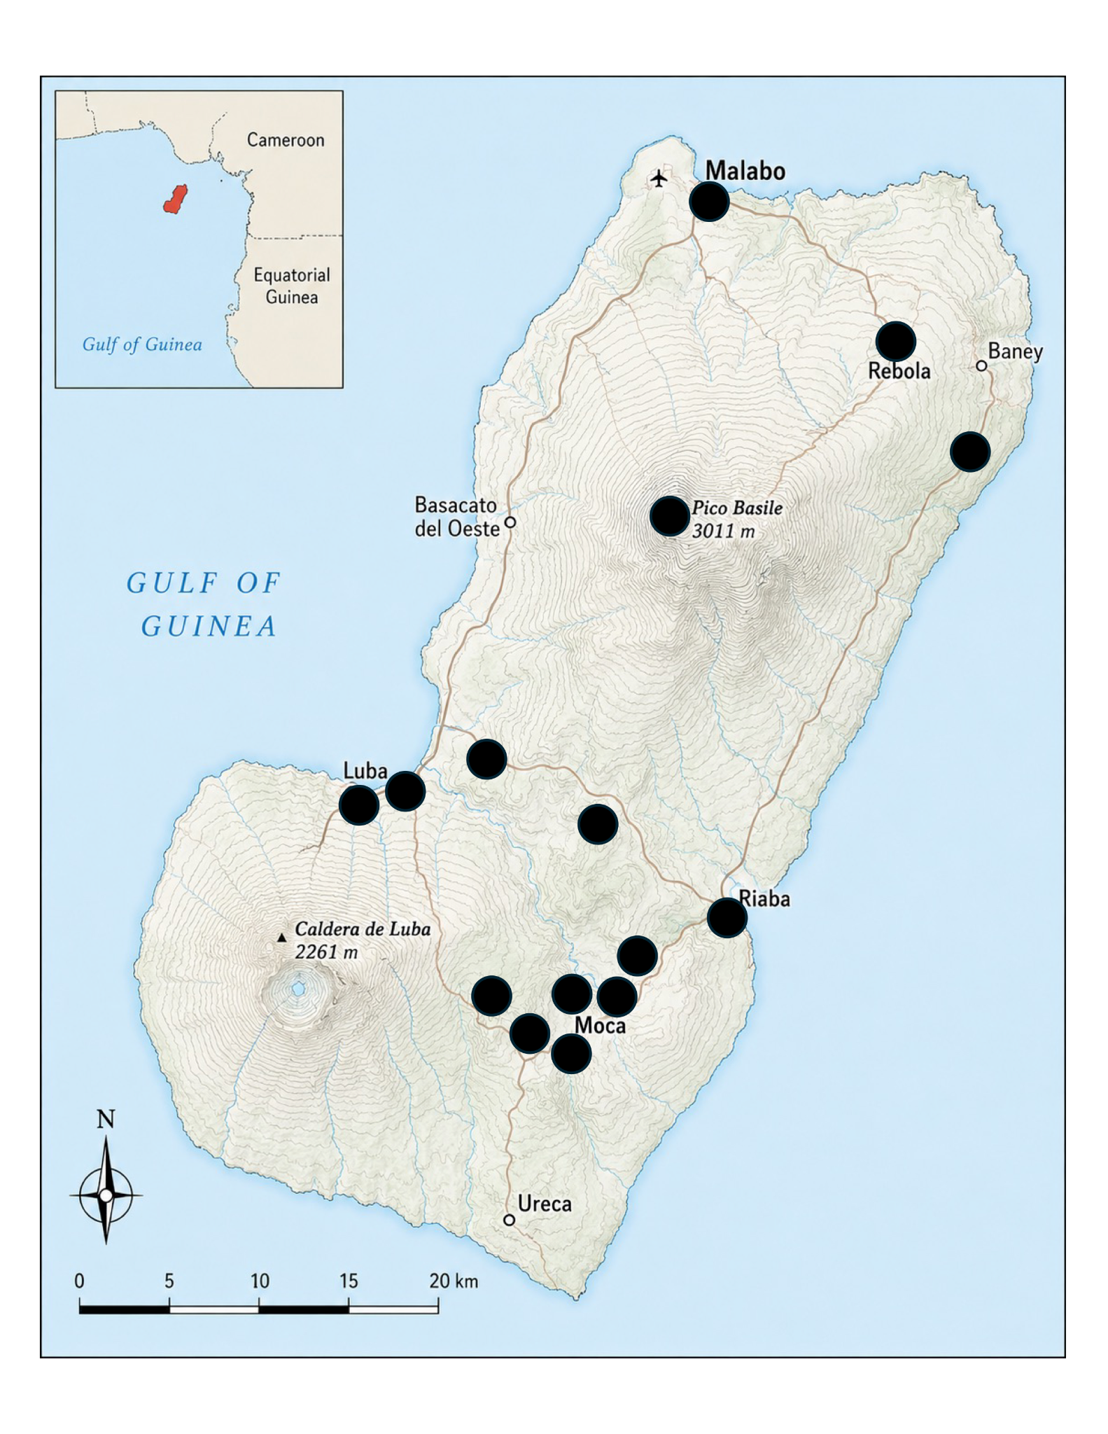
FIGURE S2. Elevational patterns of Aedes occurrence on Bioko Island. Presence–absence data were analyzed for Ae. albopictus immatures (A), Ae. albopictus adults (B), Ae. aegypti immatures (C), and Ae. aegypti adults (D). For each species and life stage, abundance counts were converted to a binomial response variable, with sites assigned a value of 1 when at least one individual was collected and 0 when no individuals were collected. Points show observed presence or absence at each sampled elevation, with slight vertical jitter to improve visibility. Lines show predicted probabilities of occurrence from generalized linear models with binomial error distributions and logit link functions. Shaded regions show 95% confidence intervals.
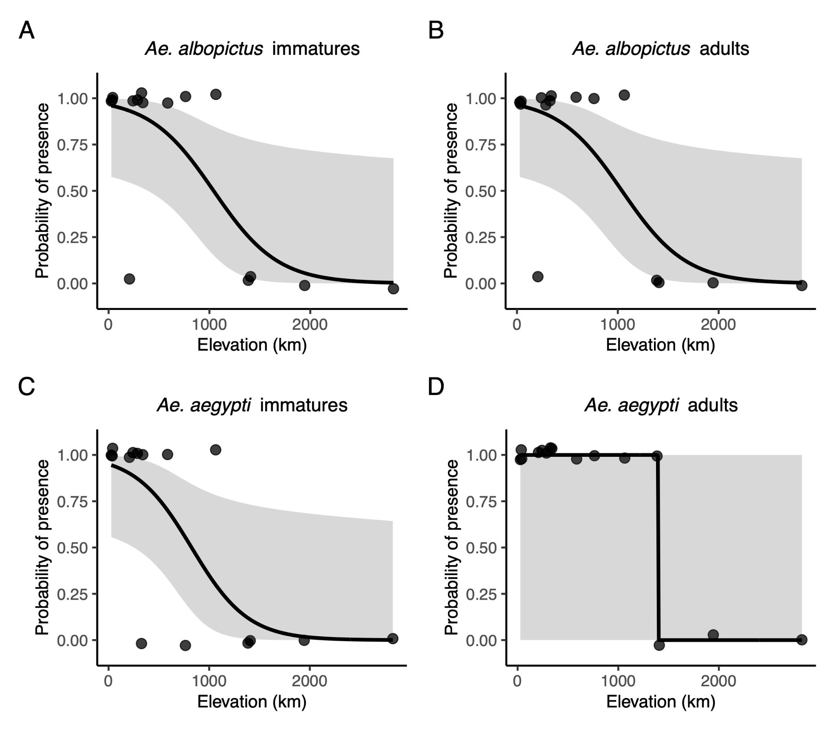

SUPPLEMENTARY TABLES
TABLE S1. Habitat description for immature stages at each location.

Island | Location | Altitude (m) | Habitat type | Details
Bioko | Riaba | 27.2 | Artificial | Tires
Bioko | Luba1 | 36 | Artificial | Plastic containers
Bioko | Ela Nguema | 40.5 | Artificial | Standing water
Bioko | Luba6 | 207.2 | Artificial | Plastic containers
Bioko | Bakake | 242.1 | Natural | Standing water (roadside)
Bioko | Rebola | 286.1 | Natural | Standing water (roadside)
Bioko | Rilaja | 327.1 | Natural | Standing water (roadside)
Bioko | Road6 | 339.7 | Natural | Standing water (roadside)
Bioko | Road5 | 586.4 | Artificial | Trash pile
Bioko | Road4 | 763.7 | Natural | Standing water (roadside)
Bioko | Loreto | 1064.4 | Natural | Lake
Bioko | Cascade | 1385.5 | Natural | Stream
Bioko | Nova Moka | 1408 | Artificial | Plastic containers
Bioko | Lago Biao | 1944.6 | Natural | Lake
Bioko | Basile | 2825.1 | Artificial | Plastic containers
ST | Airport1 | 6.9 | Artificial | Water buckets
ST | Pestana | 7.7 | Natural | Standing
ST | Lagarto | 12.9 | Artificial | Water buckets
ST | Morro Peixe | 12.9 | Natural | Stream
ST | Neves | 13.3 | Natural | Standing pools
ST | Sweet_GH | 13.4 | Artificial | Plastic container
ST | Praia_grande_1 | 14.4 | Natural | Standing water
ST | Santana2 | 15.1 | Artificial | Tire, plastic container
ST | Porto Alegre | 15.2 | Mixed | Plastic containers, standing water
ST | Grelados | 16 | Artificial | Tires, trash pile
ST | Santo Amaro 2 | 31.5 | Mixed | Standing water (roadside), plastic containers
ST | Santo Amaro | 46.7 | Mixed | Standing water (roadside), plastic containers
ST | SantRO | 75.5 | Artificial | Plastic containers
ST | Caue | 78.3 | Natural | Standing water
ST | Bobo Forro | 109.9 | Mixed | Trash pile, standing water (roadside)
ST | Trindade | 292.3 | Artificial | Tires, plastic containers
ST | Batepa1 | 475.7 | Artificial | Snail shells, tires
ST | Batepa2 | 478.3 | Artificial | tires
ST | Monte Café | 676.8 | Artificial | tires
ST | São Nicolau | 891.6 | Natural | Standing pools
ST | Bom Suceso | 1151.1 | Mixed | Planters, standing pools
ST | Trap10 | 1162.1 | Natural | Stream
ST | Fork | 1329.2 | Natural | Tree holes
ST | Lago Amelia | 1475.6 | Natural | Marsh, tree holes

TABLE S2. Number of specimens from two different species of Aedes collected on São Tomé and Bioko. ST: São Tomé. ‘Inmatures’ refers to the sum of larvae and pupae.

 |  |  | Ae. albopictus |  | Ae. aegypti
Island | Location | Altitude (m) | Immatures | Adults | Immatures | Adults
Bioko | Riaba | 27.2 | 28 | 52 | 50 | 102
Bioko | Luba1 | 36 | 11 | 45 | 41 | 83
Bioko | Ela Nguema | 40.5 | 23 | 44 | 42 | 76
Bioko | Luba6 | 207.2 | 0 | 0 | 9 | 28
Bioko | Bakake | 242.1 | 7 | 9 | 19 | 93
Bioko | Rebola | 286.1 | 14 | 39 | 25 | 5
Bioko | Rilaja | 327.1 | 3 | 26 | 0 | 2
Bioko | Road6 | 339.7 | 13 | 15 | 24 | 70
Bioko | Road5 | 586.4 | 9 | 17 | 21 | 58
Bioko | Road4 | 763.7 | 2 | 1 | 0 | 1
Bioko | Loreto | 1064.4 | 2 | 22 | 9 | 49
Bioko | Cascade | 1385.5 | 0 | 0 | 0 | 1
Bioko | Nova Moka | 1408 | 0 | 0 | 0 | 0
Bioko | Lago Biao | 1944.6 | 0 | 0 | 0 | 0
Bioko | Basile | 2825.1 | 0 | 0 | 0 | 0
ST | Airport1 | 6.9 | 106 | 69 | 214 | 98
ST | Pestana | 7.7 | 68 | 25 | 87 | 98
ST | Lagarto | 12.9 | 15 | 3 | 122 | 783
ST | Morro Peixe | 12.9 | 13 | 10 | 48 | 79
ST | Neves | 13.3 | 75 | 10 | 89 | 228
ST | Sweet_GH | 13.4 | 6 | 53 | 29 | 113
ST | Praia_grande_1 | 14.4 | 40 | 36 | 13 | 52
ST | Santana2 | 15.1 | 12 | 11 | 56 | 93
ST | Porto Alegre | 15.2 | 22 | 27 | 66 | 95
ST | Grelados | 16 | 34 | 18 | 96 | 102
ST | Santo Amaro 2 | 31.5 | 54 | 16 | 110 | 214
ST | Santo Amaro | 46.7 | 0 | 0 | 0 | 0
ST | Santana | 75.5 | 0 | 0 | 0 | 0
ST | Caue | 78.3 | 8 | 4 | 124 | 56
ST | Bobo Forro | 109.9 | 9 | 5 | 19 | 48
ST | Trindade | 292.3 | 2 | 2 | 19 | 47
ST | Batepa1 | 475.7 | 0 | 0 | 1 | 2
ST | Batepa2 | 478.3 | 0 | 0 | 0 | 0
ST | Monte Café | 676.8 | 0 | 1 | 0 | 0
ST | São Nicolau | 891.6 | 0 | 0 | 0 | 0
ST | Bom Suceso | 1151.1 | 0 | 0 | 0 | 0
ST | Trap10 | 1162.1 | 0 | 0 | 0 | 0
ST | Fork | 1329.2 | 0 | 0 | 0 | 0
ST | Lago Amelia | 1475.6 | 0 | 0 | 0 | 0

TABLE S3. Number of individuals per altitude used in the behavioral assay.

Island | Location name | Altitude | Species | Number of individuals
ST | airport1 | 6.9 | Ae. albopictus | 56
ST | airport1 | 6.9 | Ae. aegypti | 56
ST | Trindade | 292.3 | Ae. albopictus | 67
ST | Trindade | 292.3 | Ae. aegypti | 74
ST | Batepa | 475.7 | Ae. albopictus | 16
ST | Batepa | 475.7 | Ae. aegypti | 12
Bioko | Riaba | 27.2 | Ae. albopictus | 90
Bioko | Riaba | 27.2 | Ae. aegypti | 0
Bioko | Rebola | 286.1 | Ae. albopictus | 44
Bioko | Rebola | 286.1 | Ae. aegypti | 21
Bioko | road_6 | 339.7 | Ae. albopictus | 21
Bioko | road_6 | 339.7 | Ae. aegypti | 0
Bioko | Loreto | 1064.4 | Ae. albopictus | 23
Bioko | Loreto | 1064.4 | Ae. aegypti | 47

TABLE S4. Pairwise comparisons between parameters of the exponential functions. a: Intercept, b: rate of decay. W: Wilcoxon rank sum test with continuity correction.

Parameter 1 | Parameter 2 | W | P-value
a_{immatures Ae. albopictus-Bioko} | a_{adults Ae. albopictus-Bioko} | 1014 | < 0.001
b_{immatures Ae. albopictus-Bioko} | b_{adults Ae. albopictus-Bioko} | 598607 | < 0.001
a_{immatures Ae. aegypti-Bioko} | a_{adults Ae. aegypti-Bioko} | 12213 | < 0.001
b_{immatures Ae. aegypti-Bioko} | b_{adults Ae. aegypti-Bioko} | 902401 | < 0.001
a_{immatures Ae. albopictus-ST} | a_{adults Ae. albopictus-ST} | 958117 | < 0.001
b_{immatures Ae. albopictus-ST} | b_{adults Ae. albopictus-ST} | 836152 | < 0.001
a_{immatures Ae. aegypti-ST} | a_{adults Ae. aegypti-ST} | 624141 | < 0.001
b_{immatures Ae. aegypti-ST} | b_{adults Ae. aegypti-ST} | 904780 | < 0.001
a_{immatures Ae. albopictus-Bioko} | a_{immatures Ae. albopictus-ST} | 9 | < 0.001
b_{immatures Ae. albopictus-Bioko} | b_{immatures Ae. albopictus-ST} | 10 | < 0.001
a_{immatures Ae. aegypti-Bioko} | a_{immatures Ae. aegypti-ST} | 953 | < 0.001
b_{immatures Ae. aegypti-Bioko} | b_{immatures Ae. aegypti-ST} | 7926 | < 0.001
a_{adults Ae. albopictus-Bioko} | a_{adults Ae. albopictus-ST} | 63417 | < 0.001
b_{adults Ae. albopictus-Bioko} | b_{adults Ae. albopictus-ST} | 1313 | < 0.001
a_{adults Ae. aegypti-Bioko} | a_{adults Ae. aegypti-ST} | 7895 | < 0.001
b_{adults Ae. aegypti-Bioko} | b_{adults Ae. aegypti-ST} | 207619 | < 0.001

