Additional file 1
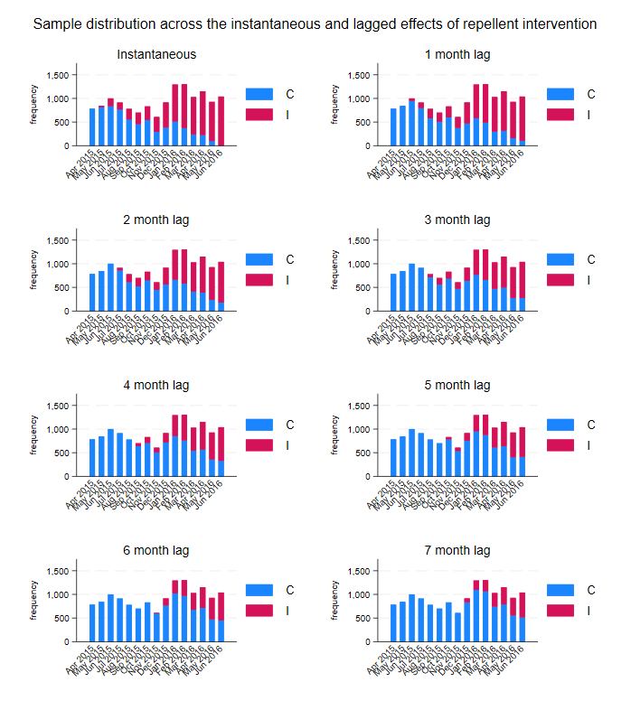
Fig. S1. Distribution of samples collected over time, coloured by intervention state for the instantaneous and lagged effects of repellent distribution. Shows the frequency of samples collected per month, with blue representing the control period (C), and red indicating the intervention (I; i.e., repellent) period.
Table S1. Instantaneous and cumulative effects of repellent use on gSG6-P1 IgG antibody levels (n=14,128 antibody measurements from N=10,857 participants).
Variable | Instantaneous |  |  |  |  | 1 month use |  |  |  |  | 2 months use |  |  |  |  | 3 months use
Variable | MD | 95%CI |  | p |  | MD | 95%CI |  | p |  | MD | 95%CI |  | p |  | MD | 95%CI |  | p
Intervention
No repellent | Ref. |  |  |  |  | Ref. |  |  |  |  | Ref. |  |  |  |  | Ref.
Repellent | 0.00 | -0.03 | 0.04 | 0.784 |  | 0.02 | -0.02 | 0.05 | 0.344 |  | 0.02 | -0.02 | 0.06 | 0.308 |  | 0.00 | -0.04 | 0.04 | 0.928
Risk group |  |  |  | *<0.001 |  |  |  |  | *<0.001 |  |  |  |  | *<0.001 |  |  |  |  | *<0.001
Village Resident | Ref. |  |  |  |  | Ref. |  |  |  |  | Ref. |  |  |  |  | Ref.
Migrant | -0.02 | -0.05 | 0.01 | 0.153 |  | -0.02 | -0.04 | 0.01 | 0.231 |  | -0.02 | -0.05 | 0.01 | 0.166 |  | -0.02 | -0.05 | 0.01 | 0.146
Forest Dweller | 0.05 | 0.03 | 0.07 | <0.001 |  | 0.05 | 0.03 | 0.07 | <0.001 |  | 0.05 | 0.03 | 0.07 | <0.001 |  | 0.05 | 0.04 | 0.07 | <0.001
Month | 0.06 | 0.03 | 0.09 | <0.001 |  | 0.06 | 0.03 | 0.09 | <0.001 |  | 0.06 | 0.03 | 0.09 | <0.001 |  | 0.06 | 0.03 | 0.09 | <0.001
Season |  |  |  | *0.005 |  |  |  |  | *0.006 |  |  |  |  | *0.005 |  |  |  |  | *0.005
Cool | Ref. |  |  |  |  | Ref. |  |  |  |  | Ref. |  |  |  |  | Ref.
Hot | -0.14 | -0.51 | 0.22 | 0.437 |  | -0.15 | -0.51 | 0.22 | 0.436 |  | -0.14 | -0.51 | 0.22 | 0.437 |  | -0.14 | -0.51 | 0.22 | 0.440
Rainy | -0.47 | -0.77 | -0.17 | 0.002 |  | -0.47 | -0.77 | -0.17 | 0.002 |  | -0.47 | -0.77 | -0.17 | 0.002 |  | -0.47 | -0.77 | -0.17 | 0.002
Random effect variances | var |  |  |  |  | var |  |  |  |  | var |  |  |  |  | var
Intercept: Month | 0.06 |  |  |  |  | 0.06 |  |  |  |  | 0.06 |  |  |  |  | 0.06
Intercept: Village | 0.02 |  |  |  |  | 0.02 |  |  |  |  | 0.02 |  |  |  |  | 0.02
Slope: Intervention | 0.01 |  |  |  |  | 0.01 |  |  |  |  | 0.02 |  |  |  |  | 0.02
Table shows estimated mean difference (MD), 95% confidence interval (95%CI), p-value (p), with random-effects variances. Mixed effects linear modelling estimating the association between the instantaneous and delayed (1-month intervals) distribution of repellent and anti-gSG6-P1 IgG levels, adjusting for temporality, season and risk group, with random-effects for village, month and village-specific heterogeneity in the effect of repellent.
*Indicates p-value for Wald joint tests for variables with >2 categories (risk group and season)

Variable | 4 months use |  |  |  |  | 5 months use |  |  |  |  | 6 months use |  |  |  |  | 7 months use
Variable | MD | 95%CI |  | p |  | MD | 95%CI |  | p |  | MD | 95%CI |  | p |  | MD | 95%CI |  | p
Intervention
No repellent | Ref. |  |  |  |  | Ref. |  |  |  |  | Ref. |  |  |  |  | Ref.
Repellent | 0.00 | -0.04 | 0.04 | 0.940 |  | 0.02 | -0.02 | 0.06 | 0.308 |  | 0.00 | -0.04 | 0.04 | 0.928 |  | 0.00 | -0.04 | 0.04 | 0.940
Risk group |  |  |  | *<0.001 |  |  |  |  | *<0.001 |  |  |  |  | *<0.001 |  |  |  |  | *<0.001
Village Resident | Ref. |  |  |  |  | Ref. |  |  |  |  | Ref. |  |  |  |  | Ref.
Migrant | -0.02 | -0.05 | 0.01 | 0.175 |  | -0.02 | -0.05 | 0.01 | 0.166 |  | -0.02 | -0.05 | 0.01 | 0.146 |  | -0.02 | -0.05 | 0.01 | 0.175
Forest Dweller | 0.05 | 0.03 | 0.07 | <0.001 |  | 0.05 | 0.03 | 0.07 | <0.001 |  | 0.05 | 0.04 | 0.07 | <0.001 |  | 0.05 | 0.03 | 0.07 | <0.001
Month | 0.06 | 0.03 | 0.09 | <0.001 |  | 0.06 | 0.03 | 0.09 | <0.001 |  | 0.06 | 0.03 | 0.09 | <0.001 |  | 0.06 | 0.03 | 0.09 | <0.001
Season |  |  |  | *0.005 |  |  |  |  | *0.005 |  |  |  |  | *0.005 |  |  |  |  | *0.005
Cool | Ref. |  |  |  |  | Ref. |  |  |  |  | Ref. |  |  |  |  | Ref.
Hot | -0.15 | -0.51 | 0.22 | 0.434 |  | -0.14 | -0.51 | 0.22 | 0.437 |  | -0.14 | -0.51 | 0.22 | 0.440 |  | -0.15 | -0.51 | 0.22 | 0.434
Rainy | -0.47 | -0.77 | -0.17 | 0.002 |  | -0.47 | -0.77 | -0.17 | 0.002 |  | -0.47 | -0.77 | -0.17 | 0.002 |  | -0.47 | -0.77 | -0.17 | 0.002
Random effect variances | var |  |  |  |  | var |  |  |  |  | var |  |  |  |  | var
Intercept: Month | 0.06 |  |  |  |  | 0.06 |  |  |  |  | 0.06 |  |  |  |  | 0.06
Intercept: Village | 0.02 |  |  |  |  | 0.02 |  |  |  |  | 0.02 |  |  |  |  | 0.02
Slope: Intervention | 0.02 |  |  |  |  | 0.02 |  |  |  |  | 0.03 |  |  |  |  | 0.03
Table shows estimated mean difference (MD), 95% confidence interval (95%CI), p-value (p), with random-effects variances. Mixed effects linear modelling estimating the association between the instantaneous and delayed (1-month intervals) distribution of repellent and anti-gSG6-P1 IgG levels, adjusting for temporality, season and risk group, with random-effects for village, month and village-specific heterogeneity in the effect of repellent.
*Indicates p-value for Wald joint tests for variables with >2 categories (risk group and season)

Table S2. Instantaneous and cumulative effects of repellent use on gSG6-P1 IgG antibody levels, modified by risk group (n=14,128 antibody measurements from N=10,857 participants).
Variable | Instantaneous |  |  |  |  | 1 month use |  |  |  |  | 2 months use |  |  |  |  | 3 months use
Variable | MD | 95%CI |  | p |  | MD | 95%CI |  | p |  | MD | 95%CI |  | p |  | MD | 95%CI |  | p
Intervention
No repellent | Ref. |  |  |  |  | Ref. |  |  |  |  | Ref. |  |  |  |  | Ref.
Repellent | 0.04 | 0.00 | 0.08 | 0.042 |  | 0.05 | 0.01 | 0.09 | 0.024 |  | 0.05 | 0.01 | 0.09 | 0.02 |  | 0.03 | -0.01 | 0.08 | 0.12
Risk group |  |  |  | *<0.001 |  |  |  |  | *<0.001 |  |  |  |  | *<0.001 |  |  |  |  | *<0.001
Village Resident | Ref. |  |  |  |  | Ref. |  |  |  |  | Ref. |  |  |  |  | Ref.
Migrant | 0.01 | -0.02 | 0.05 | 0.552 |  | 0 | -0.03 | 0.04 | 0.798 |  | 0 | -0.03 | 0.03 | 0.897 |  | 0 | -0.03 | 0.03 | 0.955
Forest Dweller | 0.08 | 0.05 | 0.10 | 0.000 |  | 0.07 | 0.05 | 0.1 | <0.001 |  | 0.07 | 0.05 | 0.09 | <0.001 |  | 0.07 | 0.05 | 0.09 | <0.001
Intervention X Risk group |  |  |  | *0.001 |  |  |  |  | *0.010 |  |  |  |  | *0.006 |  |  |  |  | *0.003
Village Resident | Ref. |  |  |  |  | Ref. |  |  |  |  | Ref. |  |  |  |  | Ref.
Migrant | -0.07 | -0.13 | -0.02 | 0.009 |  | -0.06 | -0.12 | 0 | 0.041 |  | -0.08 | -0.14 | -0.02 | 0.014 |  | -0.09 | -0.16 | -0.03 | 0.005
Forest Dweller | -0.06 | -0.09 | -0.02 | 0.001 |  | -0.05 | -0.08 | -0.01 | 0.007 |  | -0.05 | -0.08 | -0.01 | 0.007 |  | -0.05 | -0.09 | -0.01 | 0.008
Month | 0.06 | 0.03 | 0.09 | 0.000 |  | 0.06 | 0.03 | 0.09 | <0.001 |  | 0.06 | 0.03 | 0.09 | <0.001 |  | 0.06 | 0.03 | 0.09 | <0.001
Season |  |  |  | *0.005 |  |  |  |  | *0.006 |  |  |  |  | *0.005 |  |  |  |  | *0.005
Cool | Ref. |  |  |  |  | Ref. |  |  |  |  | Ref. |  |  |  |  | Ref.
Hot | -0.14 | -0.51 | 0.22 | 0.437 |  | -0.15 | -0.51 | 0.22 | 0.435 |  | -0.14 | -0.51 | 0.22 | 0.436 |  | -0.14 | -0.51 | 0.22 | 0.44
Rainy | -0.47 | -0.77 | -0.17 | 0.002 |  | -0.47 | -0.77 | -0.17 | 0.002 |  | -0.47 | -0.77 | -0.17 | 0.002 |  | -0.47 | -0.77 | -0.17 | 0.002
Random effect variances | var |  |  |  |  | var |  |  |  |  | var |  |  |  |  | var
Intercept: Month | 0.06 |  |  |  |  | 0.06 |  |  |  |  | 0.06 |  |  |  |  | 0.06
Intercept: Village | 0.02 |  |  |  |  | 0.02 |  |  |  |  | 0.02 |  |  |  |  | 0.02
Slope: Intervention | 0.01 |  |  |  |  | 0.01 |  |  |  |  | 0.02 |  |  |  |  | 0.02
Table shows estimated mean difference (MD), 95% confidence interval (95%CI), p-value (p), with random-effects variances. Mixed effects linear modelling estimating the association between the distribution of repellent and anti-gSG6-P1 IgG levels, adjusting for temporality, season and the modifying effect of risk group (fitted as an interaction between intervention and risk group), with random-effects for village, month and village-specific heterogeneity in the effect of repellent.
*Indicates p-value for Wald joint tests for variables with >2 categories (risk group and season)
Variable | 4 months use |  |  |  |  | 5 months use |  |  |  |  | 6 months use |  |  |  |  | 7 months use
Variable | MD | 95%CI |  | p |  | MD | 95%CI |  | p |  | MD | 95%CI |  | p |  | MD | 95%CI |  | p
Intervention
No repellent | Ref. |  |  |  |  | Ref. |  |  |  |  | Ref. |  |  |  |  | Ref.
Repellent | 0.03 | -0.01 | 0.08 | 0.154 |  | 0.03 | -0.02 | 0.08 | 0.194 |  | 0.02 | -0.04 | 0.08 | 0.489 |  | 0.01 | -0.05 | 0.08 | 0.675
Risk group |  |  |  | *<0.001 |  |  |  |  | *<0.001 |  |  |  |  | *<0.001 |  |  |  |  | *<0.001
Village Resident | Ref. |  |  |  |  | Ref. |  |  |  |  | Ref. |  |  |  |  | Ref.
Migrant | -0.01 | -0.04 | 0.02 | 0.676 |  | -0.02 | -0.05 | 0.01 | 0.256 |  | -0.01 | -0.04 | 0.02 | 0.613 |  | -0.01 | -0.04 | 0.01 | 0.3
Forest Dweller | 0.07 | 0.05 | 0.09 | <0.001 |  | 0.06 | 0.04 | 0.08 | <0.001 |  | 0.06 | 0.04 | 0.08 | <0.001 |  | 0.06 | 0.04 | 0.08 | <0.001
Intervention X Risk group |  |  |  | *0.007 |  |  |  |  | *0.008 |  |  |  |  | *0.002 |  |  |  |  | *0.004
Village Resident | Ref. |  |  |  |  | Ref. |  |  |  |  | Ref. |  |  |  |  | Ref.
Migrant | -0.07 | -0.14 | 0.01 | 0.075 |  | 0.01 | -0.07 | 0.09 | 0.877 |  | -0.12 | -0.22 | -0.03 | 0.013 |  | -0.11 | -0.22 | 0 | 0.047
Forest Dweller | -0.06 | -0.1 | -0.02 | 0.003 |  | -0.06 | -0.1 | -0.02 | 0.003 |  | -0.07 | -0.11 | -0.03 | 0.002 |  | -0.07 | -0.12 | -0.03 | 0.003
Month | 0.06 | 0.03 | 0.09 | <0.001 |  | 0.06 | 0.03 | 0.09 | <0.001 |  | 0.07 | 0.04 | 0.09 | <0.001 |  | 0.07 | 0.04 | 0.09 | <0.001
Season |  |  |  | *0.005 |  |  |  |  | *0.005 |  |  |  |  | *0.005 |  |  |  |  | *0.005
Cool | Ref. |  |  |  |  | Ref. |  |  |  |  | Ref. |  |  |  |  | Ref.
Hot | -0.14 | -0.51 | 0.22 | 0.434 |  | -0.15 | -0.51 | 0.22 | 0.426 |  | -0.14 | -0.51 | 0.22 | 0.435 |  | -0.14 | -0.51 | 0.22 | 0.442
Rainy | -0.47 | -0.77 | -0.17 | 0.002 |  | -0.48 | -0.78 | -0.18 | 0.002 |  | -0.47 | -0.77 | -0.18 | 0.002 |  | -0.47 | -0.77 | -0.17 | 0.002
Random effect variances | var |  |  |  |  | var |  |  |  |  | var |  |  |  |  | var
Intercept: Month | 0.06 |  |  |  |  | 0.06 |  |  |  |  | 0.06 |  |  |  |  | 0.06
Intercept: Village | 0.02 |  |  |  |  | 0.02 |  |  |  |  | 0.02 |  |  |  |  | 0.02
Slope: Intervention | 0.02 |  |  |  |  | 0.02 |  |  |  |  | 0.02 |  |  |  |  | 0.03
Table shows estimated mean difference (MD), 95% confidence interval (95%CI), p-value (p), with random-effects variances. Mixed effects linear modelling estimating the association between the distribution of repellent and anti-gSG6-P1 IgG levels, adjusting for temporality, season and the modifying effect of risk group (fitted as an interaction between intervention and risk group), with random-effects for village, month and village-specific heterogeneity in the effect of repellent.
*Indicates p-value for Wald joint tests for variables with >2 categories (risk group and season)

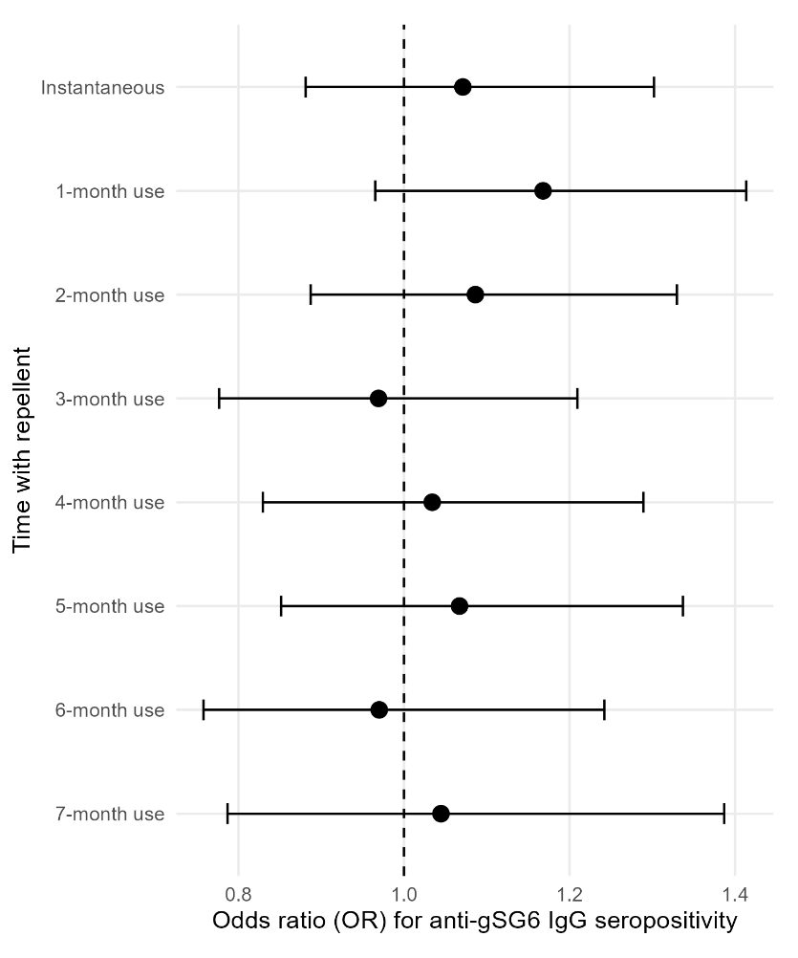
Fig. S2. Forest plots showing the instantaneous and cumulative effects of repellent distribution on odds of seropositivity in all participants. Figures show the estimated odds ratios (95%CI) of anti-gSG6-P1 IgG seropositivity for distributed repellent compared to the period of no exposure to repellent. Estimates were generated using mixed effects logistic modelling, adjusting for temporality, season and risk group, with crossed random-effects for village, month and village-specific heterogeneity in the effect of repellent. Separate models were fitted to estimate the instantaneous and cumulative effects of repellent distribution (1-7 months); model output found in Additional file 4 :Table 1. n=14,128 antibody measurements from 10,857 participants.
Table S3. Instantaneous and cumulative effects of repellent use on gSG6-P1 IgG antibody seropositivity (n=14,128 antibody measurements from N=10,857 participants).
Variable | Instantaneous |  |  |  |  | 1 month use |  |  |  |  | 2 months use |  |  |  |  | 3 months use
Variable | OR | 95%CI |  | p |  | OR | 95%CI |  | p |  | OR | 95%CI |  | p |  | OR | 95%CI |  | p
Intervention
No repellent | Ref. |  |  |  |  | Ref. |  |  |  |  | Ref. |  |  |  |  | Ref.
Repellent | 1.07 | 0.88 | 1.30 | 0.490 |  | 1.17 | 0.97 | 1.41 | 0.11 |  | 1.09 | 0.89 | 1.33 | 0.423 |  | 0.97 | 0.78 | 1.21 | 0.782
Risk group |  |  |  | *0.001 |  |  |  |  | *0.001 |  |  |  |  | *0.001 |  |  |  |  | *<0.001
Village Resident | Ref. |  |  |  |  | Ref. |  |  |  |  | Ref. |  |  |  |  | Ref.
Migrant | 0.85 | 0.72 | 1.01 | 0.063 |  | 0.86 | 0.73 | 1.02 | 0.091 |  | 0.85 | 0.72 | 1.01 | 0.064 |  | 0.84 | 0.71 | 1 | 0.048
Forest Dweller | 1.21 | 1.08 | 1.36 | 0.001 |  | 1.22 | 1.08 | 1.37 | 0.001 |  | 1.22 | 1.08 | 1.36 | 0.001 |  | 1.22 | 1.09 | 1.37 | 0.001
Month | 1.35 | 1.18 | 1.54 | 0.000 |  | 1.34 | 1.18 | 1.53 | 0 |  | 1.35 | 1.18 | 1.54 | 0 |  | 1.36 | 1.2 | 1.55 | 0
Season |  |  |  | *0.014 |  |  |  |  | *0.014 |  |  |  |  | *0.014 |  |  |  |  | *0.016
Cool | Ref. |  |  |  |  | Ref. |  |  |  |  | Ref. |  |  |  |  | Ref.
Hot | 0.45 | 0.09 | 2.30 | 0.338 |  | 0.46 | 0.09 | 2.32 | 0.345 |  | 0.46 | 0.09 | 2.32 | 0.348 |  | 0.48 | 0.1 | 2.39 | 0.369
Rainy | 0.14 | 0.04 | 0.54 | 0.004 |  | 0.14 | 0.04 | 0.55 | 0.005 |  | 0.14 | 0.04 | 0.55 | 0.004 |  | 0.15 | 0.04 | 0.57 | 0.005
Random effect variances | var |  |  |  |  | var |  |  |  |  | var |  |  |  |  | var
Intercept: Month | 1.17 |  |  |  |  | 1.17 |  |  |  |  | 1.15 |  |  |  |  | 1.15
Intercept: Village | 0.38 |  |  |  |  | 0.38 |  |  |  |  | 0.37 |  |  |  |  | 0.35
Slope: Intervention | 0.26 |  |  |  |  | 0.22 |  |  |  |  | 0.29 |  |  |  |  | 0.4
Table shows estimated odds ratio (OR), 95% confidence interval (95%CI), p-value (p), with random-effects variances (var). Mixed effects logistic modelling estimating the instantaneous and delayed effects of the distribution of repellent and anti-gSG6-P1 IgG seropositivity, adjusting for temporality, season and risk group, with random-effects for village, month and village-specific heterogeneity in the effect of repellent.
*Indicates p-value for Wald joint tests for variables with >2 categories (risk group and season)

Variable | 4 months use |  |  |  |  | 5 months use |  |  |  |  | 6 months use |  |  |  |  | 7 months use
Variable | OR | 95%CI |  | p |  | OR | 95%CI |  | p |  | OR | 95%CI |  | p |  | OR | 95%CI |  | p
Intervention
No repellent | Ref. |  |  |  |  | Ref. |  |  |  |  | Ref. |  |  |  |  | Ref.
Repellent | 1.03 | 0.83 | 1.29 | 0.765 |  | 1.07 | 0.85 | 1.34 | 0.572 |  | 0.97 | 0.76 | 1.24 | 0.81 |  | 1.04 | 0.79 | 1.39 | 0.762
Risk group |  |  |  | *0.001 |  |  |  |  | *0.001 |  |  |  |  | *0.001 |  |  |  |  | *0.001
Village Resident | Ref. |  |  |  |  | Ref. |  |  |  |  | Ref. |  |  |  |  | Ref.
Migrant | 0.84 | 0.71 | 0.99 | 0.042 |  | 0.86 | 0.73 | 1.02 | 0.081 |  | 0.86 | 0.73 | 1.02 | 0.083 |  | 0.85 | 0.71 | 1 | 0.052
Forest Dweller | 1.2 | 1.07 | 1.34 | 0.002 |  | 1.21 | 1.08 | 1.36 | 0.001 |  | 1.22 | 1.09 | 1.37 | 0.001 |  | 1.21 | 1.08 | 1.36 | 0.001
Month | 1.35 | 1.19 | 1.54 | 0 |  | 1.35 | 1.18 | 1.54 | 0 |  | 1.36 | 1.19 | 1.55 | 0 |  | 1.35 | 1.19 | 1.54 | 0
Season |  |  |  | *0.015 |  |  |  |  | *0.013 |  |  |  |  | *0.013 |  |  |  |  | *0.014
Cool | Ref. |  |  |  |  | Ref. |  |  |  |  | Ref. |  |  |  |  | Ref.
Hot | 0.46 | 0.09 | 2.32 | 0.35 |  | 0.45 | 0.09 | 2.27 | 0.334 |  | 0.46 | 0.09 | 2.29 | 0.342 |  | 0.46 | 0.09 | 2.3 | 0.343
Rainy | 0.15 | 0.04 | 0.56 | 0.005 |  | 0.14 | 0.04 | 0.54 | 0.004 |  | 0.14 | 0.04 | 0.54 | 0.004 |  | 0.14 | 0.04 | 0.55 | 0.004
Random effect variances | var |  |  |  |  | var |  |  |  |  | var |  |  |  |  | var
Intercept: Month | 1.14 |  |  |  |  | 1.15 |  |  |  |  | 1.15 |  |  |  |  | 1.15
Intercept: Village | 0.37 |  |  |  |  | 0.39 |  |  |  |  | 0.38 |  |  |  |  | 0.39
Slope: Intervention | 0.32 |  |  |  |  | 0.29 |  |  |  |  | 0.35 |  |  |  |  | 0.47
Table shows estimated odds ratio (OR), 95% confidence interval (95%CI), p-value (p), with random-effects variances (var). Mixed effects logistic modelling estimating the the instantaneous and delayed effects of the distribution of repellent and anti-gSG6-P1 IgG seropositivity, adjusting for temporality, season and risk group, with random-effects for village, month and village-specific heterogeneity in the effect of repellent.
*Indicates p-value for Wald joint tests for variables with >2 categories (risk group and season)

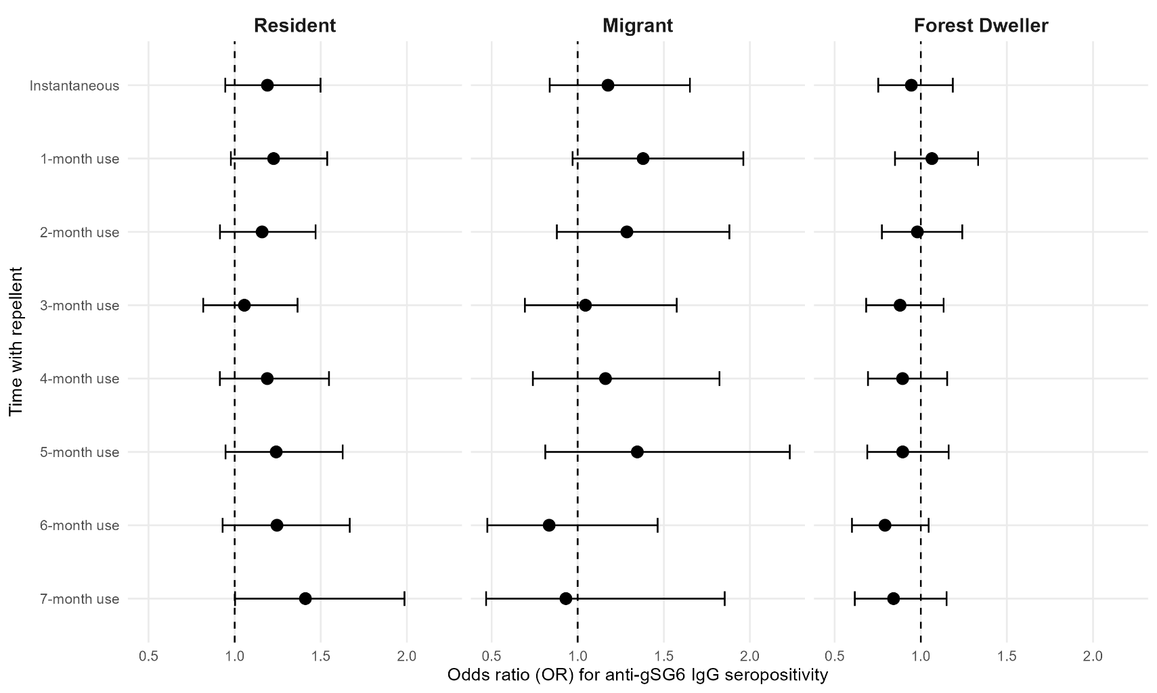
Fig. S3. Forest plots showing the instantaneous and cumulative effects of repellent use on the odds of anti-gSG6-P1 IgG seropositivity for each risk group. Figures show the estimated odds ratios (95% confidence interval) of anti-gSG6-P1 IgG seropositivity for repellent use compared to the period of no exposure to repellent separately for village residents, migrants and forest dwellers. Estimates were generated using mixed effects logistic modelling adjusting for temporality, season and the moderating effect of risk group, with crossed random-effects for village, month and village-specific heterogeneity in the effect of repellent. Separate models were fitted to estimate the instantaneous and cumulative effects of repellent use (1-7 months of use). n=14,128 antibody measurements from N=10,857 participants.

Table S4. Instantaneous and cumulative effects of repellent use on gSG6-P1 IgG antibody seropositivity, modified by risk group (n=14,128 antibody measurements from N=10,857 participants).
Variable | Instantaneous |  |  |  |  | 1 month use |  |  |  |  | 2 months use |  |  |  |  | 3 months use
Variable | OR | 95%CI |  | p |  | OR | 95%CI |  | p |  | OR | 95%CI |  | p |  | OR | 95%CI |  | p
Intervention
No repellent | Ref. |  |  |  |  | Ref. |  |  |  |  | Ref. |  |  |  |  | Ref.
Repellent | 1.19 | 0.95 | 1.50 | 0.138 |  | 1.23 | 0.98 | 1.54 | 0.077 |  | 1.16 | 0.91 | 1.47 | 0.222 |  | 1.06 | 0.82 | 1.37 | 0.675
Risk group |  |  |  | *<0.001 |  |  |  |  | *<0.002 |  |  |  |  | *<0.003 |  |  |  |  | *<0.004
Village Resident | Ref. |  |  |  |  | Ref. |  |  |  |  | Ref. |  |  |  |  | Ref.
Migrant | 0.86 | 0.69 | 1.08 | 0.186 |  | 0.83 | 0.68 | 1.03 | 0.088 |  | 0.83 | 0.68 | 1.02 | 0.071 |  | 0.85 | 0.7 | 1.03 | 0.096
Forest Dweller | 1.36 | 1.16 | 1.59 | <0.001 |  | 1.29 | 1.11 | 1.51 | 0.001 |  | 1.3 | 1.12 | 1.5 | <0.001 |  | 1.3 | 1.13 | 1.5 | <0.001
Intervention X Risk group |  |  |  | *0.110 |  |  |  |  | *0.263 |  |  |  |  | *0.218 |  |  |  |  | *0.298
Village Resident | Ref. |  |  |  |  | Ref. |  |  |  |  | Ref. |  |  |  |  | Ref.
Migrant | 0.99 | 0.71 | 1.38 | 0.944 |  | 1.13 | 0.79 | 1.6 | 0.512 |  | 1.11 | 0.76 | 1.61 | 0.589 |  | 0.99 | 0.66 | 1.48 | 0.957
Forest Dweller | 0.79 | 0.64 | 0.99 | 0.043 |  | 0.87 | 0.69 | 1.09 | 0.217 |  | 0.85 | 0.67 | 1.06 | 0.152 |  | 0.83 | 0.66 | 1.06 | 0.133
Month | 1.35 | 1.18 | 1.54 | <0.001 |  | 1.34 | 1.18 | 1.53 | <0.001 |  | 1.35 | 1.18 | 1.54 | <0.001 |  | 1.36 | 1.2 | 1.55 | <0.001
Season |  |  |  | *0.014 |  |  |  |  | *0.015 |  |  |  |  | *0.014 |  |  |  |  | *0.016
Cool | Ref. |  |  |  |  | Ref. |  |  |  |  | Ref. |  |  |  |  | Ref.
Hot | 0.45 | 0.09 | 2.31 | 0.340 |  | 0.46 | 0.09 | 2.33 | 0.347 |  | 0.46 | 0.09 | 2.32 | 0.349 |  | 0.48 | 0.1 | 2.4 | 0.371
Rainy | 0.14 | 0.04 | 0.55 | 0.005 |  | 0.14 | 0.04 | 0.55 | 0.005 |  | 0.15 | 0.04 | 0.55 | 0.005 |  | 0.15 | 0.04 | 0.57 | 0.005
Random effect variances | var |  |  |  |  | var |  |  |  |  | var |  |  |  |  | var
Intercept: Month | 1.18 |  |  |  |  | 1.17 |  |  |  |  | 1.15 |  |  |  |  | 1.15
Intercept: Village | 0.38 |  |  |  |  | 0.37 |  |  |  |  | 0.36 |  |  |  |  | 0.35
Slope: Intervention | 0.26 |  |  |  |  | 0.22 |  |  |  |  | 0.3 |  |  |  |  | 0.41
Table shows estimated odds ratio (OR), 95% confidence interval (95%CI), p-value (p), with random-effects variances. Mixed effects logistic modelling estimating the instantaneous and delayed effects of the distribution of repellent and anti-gSG6-P1 IgG seropositivity, adjusting for temporality, season and the modifying effect of risk group (fitted as an interaction between intervention and risk group), with random-effects for village, month and village-specific heterogeneity in the effect of repellent.
*Indicates p-value for Wald joint tests for variables with >2 categories (risk group and season)
Variable | 4 months use |  |  |  |  | 5 months use |  |  |  |  | 6 months use |  |  |  |  | 7 months use
Variable | OR | 95%CI |  | p |  | OR | 95%CI |  | p |  | OR | 95%CI |  | p |  | OR | 95%CI |  | p
Intervention
No repellent | Ref. |  |  |  |  | Ref. |  |  |  |  | Ref. |  |  |  |  | Ref.
Repellent | 1.19 | 0.91 | 1.55 | 0.197 |  | 1.24 | 0.95 | 1.63 | 0.118 |  | 1.25 | 0.93 | 1.67 | 0.141 |  | 1.41 | 1 | 1.99 | 0.048
Risk group |  |  |  | *<0.005 |  |  |  |  | *<0.006 |  |  |  |  | *<0.007 |  |  |  |  | *<0.008
Village Resident | Ref. |  |  |  |  | Ref. |  |  |  |  | Ref. |  |  |  |  | Ref.
Migrant | 0.85 | 0.71 | 1.02 | 0.085 |  | 0.86 | 0.72 | 1.03 | 0.104 |  | 0.91 | 0.76 | 1.08 | 0.27 |  | 0.88 | 0.74 | 1.05 | 0.145
Forest Dweller | 1.3 | 1.13 | 1.48 | <0.001 |  | 1.31 | 1.15 | 1.49 | <0.001 |  | 1.33 | 1.17 | 1.51 | <0.001 |  | 1.3 | 1.15 | 1.48 | <0.001
Intervention X Risk group |  |  |  | *0.074 |  |  |  |  | *0.034 |  |  |  |  | *0.007 |  |  |  |  | *0.007
Village Resident | Ref. |  |  |  |  | Ref. |  |  |  |  | Ref. |  |  |  |  | Ref.
Migrant | 0.98 | 0.62 | 1.53 | 0.917 |  | 1.08 | 0.65 | 1.81 | 0.756 |  | 0.67 | 0.38 | 1.18 | 0.166 |  | 0.66 | 0.33 | 1.32 | 0.24
Forest Dweller | 0.75 | 0.58 | 0.97 | 0.027 |  | 0.72 | 0.55 | 0.94 | 0.017 |  | 0.64 | 0.48 | 0.85 | 0.002 |  | 0.6 | 0.43 | 0.82 | 0.002
Month | 1.36 | 1.19 | 1.54 | <0.001 |  | 1.35 | 1.18 | 1.54 | <0.001 |  | 1.36 | 1.19 | 1.55 | <0.001 |  | 1.36 | 1.19 | 1.54 | <0.001
Season |  |  |  | *0.015 |  |  |  |  | *0.014 |  |  |  |  | *0.014 |  |  |  |  | *0.014
Cool | Ref. |  |  |  |  | Ref. |  |  |  |  | Ref. |  |  |  |  | Ref.
Hot | 0.46 | 0.09 | 2.33 | 0.351 |  | 0.45 | 0.09 | 2.28 | 0.335 |  | 0.46 | 0.09 | 2.3 | 0.344 |  | 0.46 | 0.09 | 2.31 | 0.344
Rainy | 0.15 | 0.04 | 0.56 | 0.005 |  | 0.14 | 0.04 | 0.54 | 0.004 |  | 0.14 | 0.04 | 0.54 | 0.004 |  | 0.14 | 0.04 | 0.55 | 0.005
Random effect variances | var |  |  |  |  | var |  |  |  |  | var |  |  |  |  | var
Intercept: Month | 1.14 |  |  |  |  | 1.15 |  |  |  |  | 1.15 |  |  |  |  | 1.15
Intercept: Village | 0.37 |  |  |  |  | 0.38 |  |  |  |  | 0.37 |  |  |  |  | 0.39
Slope: Intervention | 0.34 |  |  |  |  | 0.29 |  |  |  |  | 0.33 |  |  |  |  | 0.45
Table shows estimated odds ratio (OR), 95% confidence interval (95%CI), p-value (p), with random-effects variances. Mixed effects logistic modelling estimating the instantaneous and delayed effects of the distribution of repellent and anti-gSG6-P1 IgG seropositivity, adjusting for temporality, season and the modifying effect of risk group (fitted as an interaction between intervention and risk group), with random-effects for village, month and village-specific heterogeneity in the effect of repellent.
*Indicates p-value for Wald joint tests for variables with >2 categories (risk group and season)

Text S1. Instantaneous and cumulative effects of repellent use on anti-gSG6-P1 IgG antibody levels for each risk group, after adjusting for individual level antibody dynamics.
We estimated the instantaneous and cumulative effects of repellent distribution on anti-gSG6-P1 IgG, accounting for repeated measurements within participants (included as a nested random-effect) and the length of time between samples (fixed-effect). We observed a similar trend of reduced antibodies after allowing for 6 and 7 month lagged effect of repellent for high-risk groups (e.g. 6-month effect for migrants: -0.105, 95%CI: -0.222, 0.012, p=0.079; and forest-goers: -0.014, 95%CI: -0.078, 0.050, p=0.666); and increases for village residents (0.052; 95%CI: -0.014, 0.118; p=0.124). However, the statistical evidence for these effects was weak. Of note, a sensitivity analysis removing the individual with 10 visits, did not impact the direction, magnitude or p-values of these estimates.
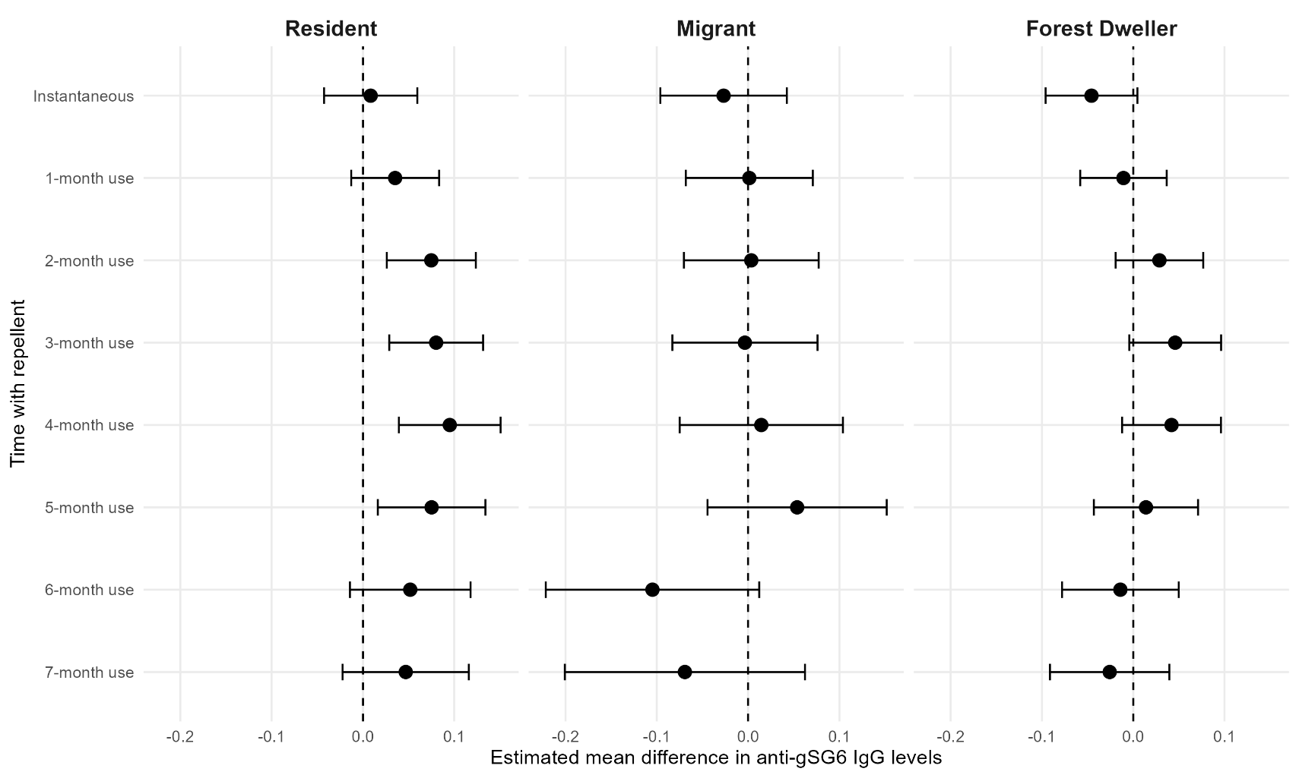
Fig. S4. Forest plots showing the instantaneous and cumulative effects of repellent use on anti-gSG6-P1 IgG antibody levels for each risk group, after adjusting for individual level antibody dynamics. Figures show the estimated mean difference (95% confidence interval) in anti-gSG6-P1 IgG antibody levels for repellent use compared to the period of no exposure to repellent separately for village residents, migrants and forest dwellers. Estimates were generated using mixed effects linear modelling adjusting for study- and individual-level temporality, season and the moderating effect of risk group, with nested random-effects to account for repeated measures (with samples nested in individuals nested in villages) and village-specific heterogeneity in the effect of repellent. Separate models were fitted to estimate the instantaneous and cumulative effects of repellent use (1-7 months of use). n=14,128 antibody measurements from N=10,857 participants.
Fig. S5. Caterpillar plot showing village random slope predictions for effect of repellent use (instantaneous and cumulative (3 and 6 months)) on anti-gSG6-P1 IgG levels and 95% confidence intervals for 111 villages sorted by estimated mean difference value.
Fig. S6. Caterpillar plots show village-level effect with 95% confidence intervals of 6-months of repellent use on gSG6-P1 IgG levels for each risk group. Estimates were derived by combining village-specific random effects (i.e. slope) with the fixed effects estimates of 6-months use the intervention on gSG6-P1 IgG levels for village residents, migrants and forest dwellers.

