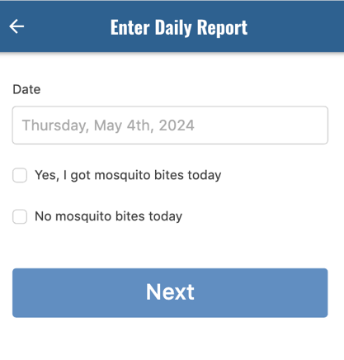
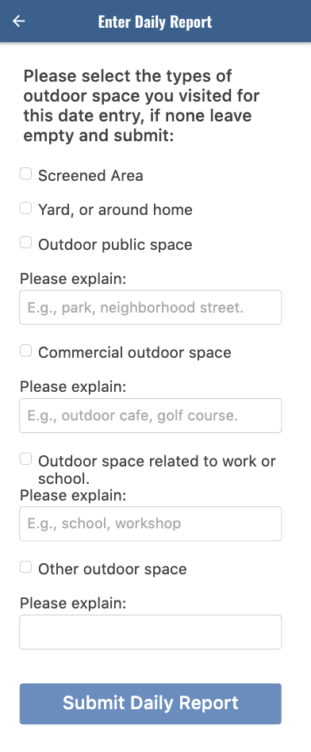
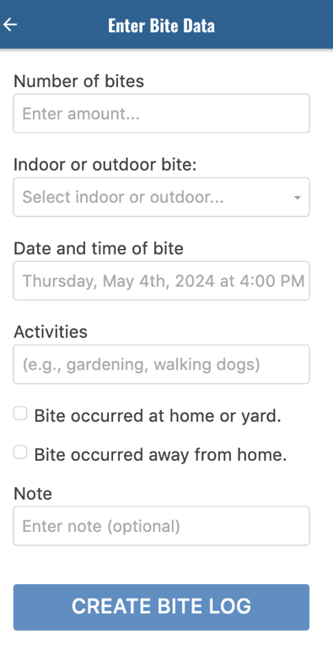
- b) d)

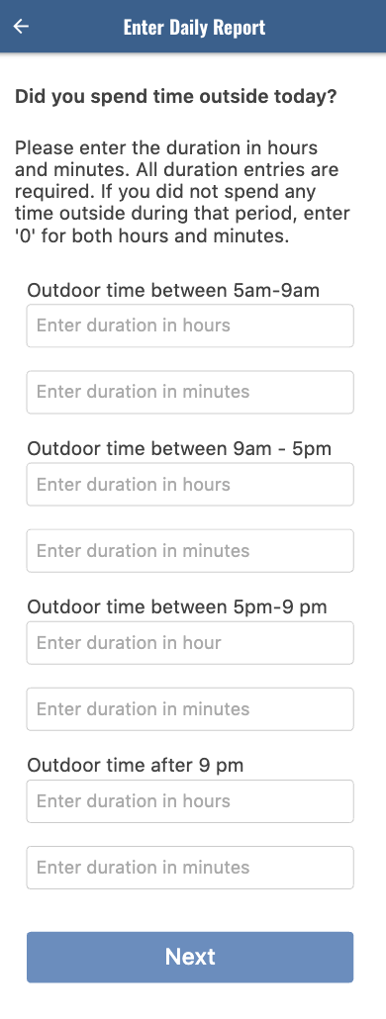
c)

S1 Figure. Screenshots of the Bite Diary app illustrating its two main survey components.
The first component (a) captures bite data reported when participants are bitten. The second component, completed daily during the participation period, records whether participants experienced any bites each day (b), the amount of time spent outdoors during different periods of the day (c), and the types of outdoor environments visited.

