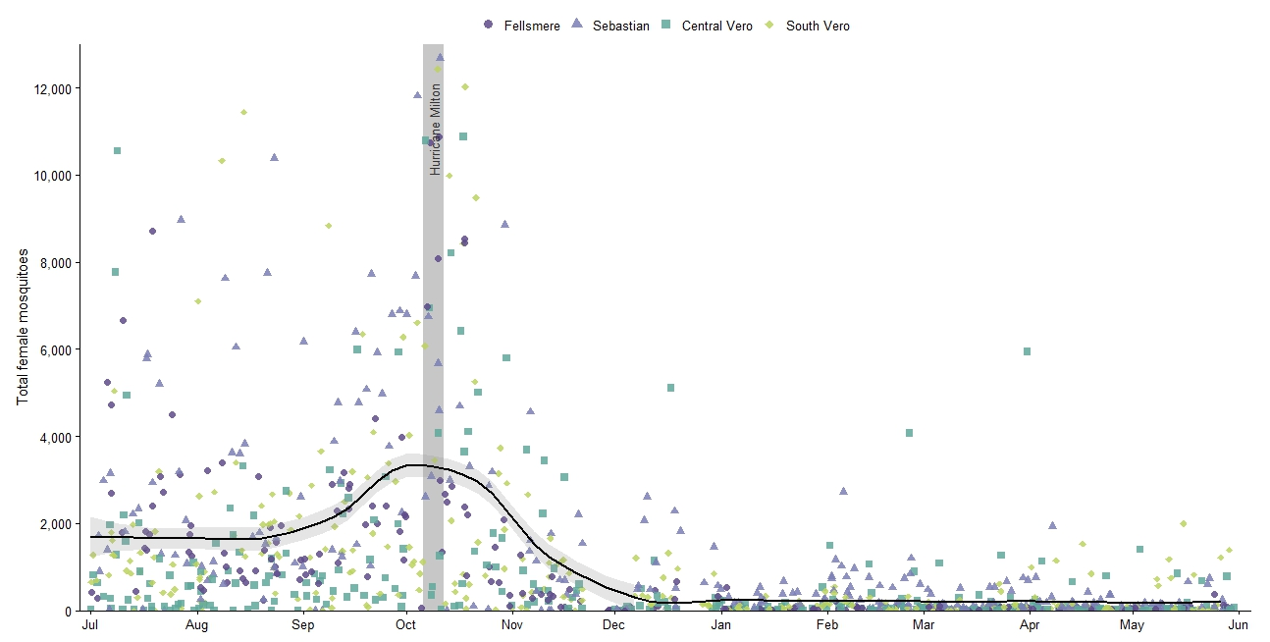

S2 Fig. Indian River Mosquito Control District Female Mosquito abundance, July 2024–May 2025.
Total female mosquitoes collected per trap-night at 30 CDC light trap sites operated by the Indian River Mosquito Control District, grouped into four geographic regions: Fellsmere (n = 5), Sebastian (n = 9), Central Vero (n = 9), and South Vero (n = 7). Each point represents a single trap-night, with a LOESS smoother (95% CI) fit across all sites. The vertical grey bar marks the landfall of Hurricane Milton (9 October 2024), which preceded a sharp region-wide spike in adult female abundance followed by a steep decline through the winter.

