Table S1. Distribution of COⅠ gene haplotypes among different geographical populations of Ae. albopictus.

Haplotype | Region
H01 | SDDY | JNA | GDFS | YNKM
H02 | SDDY | JNA | GDFS | YNKM | GDGZ | FJFZ | SDJN | HNCS
H03 | SDDY | YNKM
H04 | SDDY | JNA | YNKM | SDJN
H05 | SDDZ | YNKM
H06 | JNA
H07 | GDFS
H08 | GDFS
H09 | GDFS | GDGZ | FJFZ
H10 | HNSY | XSBN | HNHK
H11 | HNSY
H12 | HNSY
H13 | YNKM
H14 | HNHK
H15 | XSBN
H16 | XSBN
H17 | XSBN
H18 | XSBN
H19 | XSBN
H20 | XSBN
H21 | XSBN
H22 | XSBN
H23 | XSBN
H24 | XSBN
H25 | XSBN
H26 | XSBN
H27 | XSBN
H28 | XSBN
H29 | GDGZ
H30 | GDGZ
H31 | FJFZ
H32 | FJFZ
H33 | FJFZ
H34 | HNCS

Table S2. Genetic differentiation(left) and gene flow among(right) the geographic groups of Ae. albopictus based on COⅠ.

 | SDDY | SDDZ | JNA | SDJN | GDFS | YNKM | FJFZ | HNCS | GDGZ | HNSY | HNHK | XSBN
SDDY | 0 | 1.99800 | 6.08232 | 0.48269 | 0.83966 | 0.72477 | 0.18300 | 0.31170 | 0.68587 | 0.13051 | 0.06793 | 0.27856
SDDZ | 0.11121 | 0 | 0.69511 | 4.17791 | 2.87774 | 8.60269 | 0.17129 | 2.63184 | 3.26272 | 0.11971 | 0.07667 | 0.24856
JNA | 0.03948 | 0.26452 | 0 | 0.25290 | 0.41775 | 0.34011 | 0.14955 | 0.17235 | 0.34498 | 0.11318 | 0.06350 | 0.22930
SDJN | 0.34121 | 0.05646 | 0.49712 | 0 | 2.40873 | 83.92508 | 0.10338 | 23.37949 | 6.02510 | 0.08237 | 0.02193 | 0.24433
GDFS | 0.22943 | 0.07993 | 0.37439 | 0.09403 | 0 | 3.52701 | 0.26588 | 1.48901 | 41.00413 | 0.12891 | 0.05577 | 0.31958
YNKM | 0.25647 | 0.02824 | 0.42365 | 0.00297 | 0.06619 | 0 | 0.12814 | 14.57800 | 6.51956 | 0.09725 | 0.04576 | 0.24502
FJFZ | 0.57737 | 0.59341 | 0.62571 | 0.70746 | 0.48461 | 0.66113 | 0 | 0.06986 | 0.18358 | 0.08678 | 0.04716 | 0.19887
HNCS | 0.44508 | 0.08675 | 0.59192 | 0.01058 | 0.14376 | 0.01686 | 0.78159 | 0 | 4.20395 | 0.05848 | 0.01577 | 0.18628
GDGZ | 0.26713 | 0.07117 | 0.42018 | 0.03984 | 0.00606 | 0.03693 | 0.57659 | 0.05613 | 0 | 0.10597 | 0.05907 | 0.25171
HNSY | 0.65701 | 0.67621 | 0.68836 | 0.75218 | 0.65978 | 0.71994 | 0.74233 | 0.81042 | 0.70231 | 0 | 1.23694 | 2.04779
HNHK | 0.78633 | 0.76531 | 0.79745 | 0.91935 | 0.81762 | 0.84527 | 0.84097 | 0.94065 | 0.80889 | 0.16813 | 0 | 4.82717
XSBN | 0.47298 | 0.50144 | 0.52159 | 0.50573 | 0.43892 | 0.50503 | 0.55695 | 0.57302 | 0.4983 | 0.1088 | 0.04924 | 0

Table S3. Analysis of molecular variance (AMOVA) of Ae. albopictus populations based on COⅠ.
Source of variation | d. f. | Sum of squares | Variance components | Percentage of variation | Fixation indices
Among groups | 2 | 305.066 | 0.29234 Va | 49.42 | F_{CT}=0.49422*
Among populations within groups | 9 | 80.066 | 0.07279 Vb | 12.31 | F_{SC}=0.24330*
Within populations | 731 | 333.691 | 0.22638 Vc | 38.27 | F_{ST}=0.61728*
Total | 742 | 718.822 | 0.59151

*P < 0.05

Table S4. Geographic distances among 12 Ae. albopictus populations based on COⅠ.

 | SDDY | SDDZ | JNA | SDJN | GDFS | YNKM | FJFZ | HNCS | GDGZ | HNSY | HNHK | XSBN
SDDY | 0
SDDZ | 132.1 | 0
JNA | 205.5 | 196.6 | 0
SDJN | 247.9 | 228.7 | 42.7 | 0
GDFS | 1700.2 | 1666.5 | 1495.9 | 1454.5
YNKM | 2120.4 | 2021.5 | 1939.2 | 1899.9 | 1135.6 | 0
FJFZ | 1297.9 | 1319.5 | 1123.2 | 1091.6 | 722.6 | 1754.6 | 0
HNCS | 1191.5 | 1130.2 | 988.3 | 945.7 | 608.6 | 1065.9 | 794.1 | 0
GDGZ | 1687.7 | 1651.6 | 1483 | 1441.4 | 34.1 | 1105.4 | 736.8 | 583.2 | 0
HNSY | 2293.6 | 2246.7 | 2088.1 | 2045.8 | 621 | 1036.6 | 1310.3 | 1126.6 | 623.2 | 0
HNHK | 2103.4 | 2056.1 | 1897.9 | 1855.6 | 444 | 969.3 | 1153.1 | 936.9 | 441.9 | 190.6 | 0
XSBN | 2409.2 | 2312.9 | 2224.7 | 2184.7 | 1278.1 | 296.7 | 1949.8 | 1318.4 | 1252 | 1024.1 | 1011.6 | 0

Table S5. Environmental variables of 12 Ae. albopictus populations from three climatic zones in China.

Climate zone | Site code | Mean annual temperature(℃) | Annual precipitation(mm) | altitude(m)
Temperate | SDDY | 15.43 | 789.18 | 12.0
Temperate | SDDZ | 15.22 | 672.59 | 19.0
Temperate | JNA | 18.37 | 621.28 | 58.0
Temperate | SDJN | 16.51 | 735.58 | 53.0
Subtropical | GDFS | 24.04 | 2422.91 | 15.24
Subtropical | YNKM | 16.48 | 989.84 | 2103.0
Subtropical | FJFZ | 21.34 | 1388.36 | 85.0
Subtropical | HNCS | 18.8 | 1686.56 | 120.0
Subtropical | GDGZ | 24.04 | 2422.91 | 15.24
Tropical | HNSY | 23.51 | 2067.81 | 7.0
Tropical | HNHK | 25.67 | 2135.63 | 24.0
Tropical | XSBN | 24.81 | 1391.67 | 579.0

Table S6. Relative directed migration rates (M = m/μ) among three climatic regions .

Recipient ↓ / Source → | Temperate | Subtropical | Tropical
Temperate | 128.61 | 166.56 | 4.25
Subtropical | 19.37 | 69.24 | 3.42
Tropical | 0.01 | 1.28 | 126.55

Temperate: SDDY、SDDZ、SDJNA 、SDJN; Subtropical: GDFS、YNKM、FJFZ、HNCS、GDGZ； Tropical: HNSY、HNHK、XSBN

Table S7. Effective population size (Theta) data (including 95 per cent confidence intervals)
Population | Climate zone | Theta MLE | 95%CI(Lower) | 95%CI(Upper)
SDDY | Temperate | 0.003509 | 0.002737 | 0.004599
SDDZ | Temperate | 0.004439 | 0.003769 | 0.005423
JNA | Temperate | 0.003281 | 0.002666 | 0.004098
SDJN | Temperate | 0.002087 | 0.001707 | 0.002591
GDFS | Subtropical | 0.002052 | 0.001576 | 0.002738
YNKM | Subtropical | 0.00438 | 0.003745 | 0.005171
FJFZ | Subtropical | 0.003696 | 0.002995 | 0.004654
HNCS | Subtropical | 0.003803 | 0.003284 | 0.004422
GDGZ | Subtropical | 0.004929 | 0.004243 | 0.005753
HNSY | Tropical | 0.003684 | 0.0031 | 0.004427
HNHK | Tropical | 0.002304 | 0.001951 | 0.00275
XSBN | Tropical | 0.017361 | 0.014906 | 0.020374

Table S8. Pairwise directed migration rates (M = m/μ) with 95% confidence intervals among twelve populations.
To SDDY | MLE | 95%CI(Lower) | 95%CI(Upper) | Convergent state
SDDZ | 0.259827† | 0.000728 | 0.000439 | Artifact
JNA | 103.0837 | 103.273 | 103.0081 | Converged
GDFS | 0.028549† | 0.000718 | 0.000529 | Artifact
HNSY | 0.028540† | 0.000718 | 0.000529 | Artifact
YNKM | 1003.121† | 1005.973 | 1004.698 | Artifact
HNHK | 0.028555† | 0.000718 | 0.000529 | Artifact
XSBN | 0.041026† | 0.000722 | 0.000529 | Artifact
GDGZ | 0.259818† | 0.000728 | 0.000529 | Artifact
FJFZ | 0.028552† | 0.000718 | 0.000529 | Artifact
HNCS | 0.041747† | 0.000722 | 0.000529 | Artifact
SDJN | 103.1640 | 103.2733 | 103.008 | Converged

To SDDZ | MLE | 95%CI(Lower) | 95%CI(Upper) | Convergent state
SDDY | 0.013146† | 0.00057 | 0.000329 | Artifact
JNA | 0.011268† | 0.000566 | 0.000328 | Artifact
GDFS | 0.011352† | 0.000566 | 0.000328 | Artifact
HNSY | 0.013133† | 0.000569 | 0.000329 | Artifact
YNKM | 254.2073 | 261.2682 | 189.629 | Converged
HNHK | 0.016638† | 0.000574 | 0.000329 | Artifact
XSBN | 50.81310 | 52.10334 | 48.8967 | Converged
GDGZ | 0.029518† | 0.00058 | 0.00033 | Artifact
FJFZ | 0.013133† | 0.000569 | 0.000329 | Artifact
HNCS | 0.018943† | 0.000576 | 0.000329 | Artifact
SDJN | 308.5227† | 312.8848 | 325.8801 | Artifact

To JNA | MLE | 95%CI(Lower) | 95%CI(Upper) | Convergent state
SDDY | 0.020081† | 0.000815 | 0.000902 | Artifact
SDDZ | 75.58577 | 75.6839 | 75.5546 | Converged
GDFS | 0.020075† | 0.000814 | 0.000902 | Artifact
HNSY | 0.020081† | 0.000814 | 0.000902 | Artifact
YNKM | 0.028632† | 0.000823 | 0.000913 | Artifact
HNHK | 0.020075† | 0.000814 | 0.000902 | Artifact
XSBN | 0.020083† | 0.000814 | 0.000902 | Artifact
GDGZ | 914.6606 | 917.9112 | 912.6458 | Converged
FJFZ | 0.020081† | 0.000815 | 0.000902 | Artifact
HNCS | 0.019546† | 0.000814 | 0.000901 | Artifact
SDJN | 0.020075† | 0.000815 | 0.000902 | Artifact

To GDFS | MLE | 95%CI(Lower) | 95%CI(Upper) | Convergent state
SDDY | 0.059765† | 0.002164 | 0.00063 | Artifact
SDDZ | 0.042691† | 0.002124 | 0.000626 | Artifact
JNA | 0.042691† | 0.002124 | 0.000626 | Artifact
HNSY | 0.042691† | 0.002124 | 0.000626 | Artifact
YNKM | 0.042397† | 0.002124 | 0.000626 | Artifact
HNHK | 0.042198† | 0.002123 | 0.000626 | Artifact
XSBN | 0.042393† | 0.002124 | 0.000626 | Artifact
GDGZ | 1177.475† | 1179.491 | 1178.876 | Artifact
FJFZ | 0.042216† | 0.002124 | 0.000626 | Artifact
HNCS | 0.457103† | 0.002917 | 0.000753 | Artifact
SDJN | 0.059764† | 0.002165 | 0.00063 | Artifact

To HNSY | MLE | 95%CI(Lower) | 95%CI(Upper) | Convergent state
SDDY | 0.009378† | 0.000295 | 0.000128 | Artifact
SDDZ | 0.009374† | 0.000295 | 0.000128 | Artifact
JNA | 0.009374† | 0.000295 | 0.000128 | Artifact
GDFS | 0.009375† | 0.000295 | 0.000128 | Artifact
YNKM | 0.009377† | 0.000295 | 0.000128 | Artifact
HNHK | 0.009377† | 0.000295 | 0.000128 | Artifact
XSBN | 0.011433† | 0.000295 | 0.000128 | Artifact
GDGZ | 0.009375† | 0.000295 | 0.000128 | Artifact
FJFZ | 0.009377† | 0.000295 | 0.000128 | Artifact
HNCS | 0.009375† | 0.000295 | 0.000128 | Artifact
SDJN | 0.009376† | 0.000295 | 0.000128 | Artifact

To YNKM | MLE | 95%CI(Lower) | 95%CI(Upper) | Convergent state
SDDY | 0.011406† | 0.000502 | 0.000205 | Artifact
SDDZ | 0.014242† | 0.000509 | 0.000204 | Artifact
JNA | 0.106322† | 0.000514 | 0.000205 | Artifact
GDFS | 0.014080† | 0.000509 | 0.000204 | Artifact
HNSY | 0.014851† | 0.000508 | 0.000205 | Artifact
HNHK | 0.011406† | 0.000502 | 0.000205 | Artifact
XSBN | 0.011399† | 0.000502 | 0.000204 | Artifact
GDGZ | 79.76661 | 81.52072 | 76.71998 | Converged
FJFZ | 84.46592 | 84.51426 | 84.39195 | Converged
HNCS | 42.18981 | 42.25667 | 42.19557 | Converged
SDJN | 84.46069 | 84.50875 | 84.39197 | Converged

To HNHK | MLE | 95%CI(Lower) | 95%CI(Upper) | Convergent state
SDDY | 0.016755† | 0.00017 | 0.000603 | Artifact
SDDZ | 0.016968† | 0.00017 | 0.000603 | Artifact
JNA | 0.016967† | 0.00017 | 0.000603 | Artifact
GDFS | 0.016967† | 0.00017 | 0.000603 | Artifact
HNSY | 331.4720 | 332.7909 | 329.1025 | Converged
YNKM | 0.016966† | 0.00017 | 0.000603 | Artifact
XSBN | 0.016684† | 0.00017 | 0.000603 | Artifact
GDGZ | 0.016967† | 0.00017 | 0.000603 | Artifact
FJFZ | 0.016968† | 0.00017 | 0.000603 | Artifact
HNCS | 0.016968† | 0.00017 | 0.000603 | Artifact
SDJN | 0.016803† | 0.00017 | 0.000603 | Artifact

To XSBN | MLE | 95%CI(Lower) | 95%CI(Upper) | Convergent state
SDDY | 0.006056† | 0.000309 | 0.001548 | Artifact
SDDZ | 0.006056† | 0.000309 | 0.001548 | Artifact
JNA | 0.006056† | 0.000309 | 0.001548 | Artifact
GDFS | 0.006052† | 0.000309 | 0.001565 | Artifact
HNSY | 77.54703 | 77.21441 | 77.8637 | Converged
YNKM | 0.007284† | 0.000311 | 0.001613 | Artifact
HNHK | 350.2552 | 348.1206 | 352.6623 | Converged
GDGZ | 0.006057† | 0.000309 | 0.001548 | Artifact
FJFZ | 19.0483† | 19.07229 | 19.05704 | Artifact
HNCS | 0.007274† | 0.000311 | 0.001613 | Artifact
SDJN | 0.006082† | 0.000309 | 0.001551 | Artifact

To GDGZ | MLE | 95%CI(Lower) | 95%CI(Upper) | Convergent state
SDDY | 0.009240† | 0.000454 | 0.000377 | Artifact
SDDZ | 80.60353 | 63.03333 | 81.34351 | Converged
JNA | 0.009238† | 0.000454 | 0.000377 | Artifact
GDFS | 0.009239† | 0.000454 | 0.000377 | Artifact
HNSY | 0.009240† | 0.000454 | 0.000377 | Artifact
YNKM | 0.010948† | 0.000458 | 0.000379 | Artifact
HNHK | 0.009237† | 0.000454 | 0.000377 | Artifact
XSBN | 0.009207† | 0.000454 | 0.000377 | Artifact
FJFZ | 0.009131† | 0.000454 | 0.000377 | Artifact
HNCS | 0.009240† | 0.000454 | 0.000377 | Artifact
SDJN | 0.009239† | 0.000454 | 0.000377 | Artifact

To FJFZ | MLE | 95%CI(Lower) | 95%CI(Upper) | Convergent state
SDDY | 0.016681† | 0.000422 | 0.000743 | Artifact
SDDZ | 0.016679† | 0.000422 | 0.000743 | Artifact
JNA | 103.4765 | 102.7005 | 120.7526 | Converged
GDFS | 0.016679† | 0.000422 | 0.000743 | Artifact
HNSY | 51.14803 | 51.18126 | 50.63833 | Converged
YNKM | 0.016243† | 0.000422 | 0.000742 | Artifact
HNHK | 0.020971† | 0.000423 | 0.00075 | Artifact
XSBN | 0.016685† | 0.000422 | 0.000743 | Artifact
GDGZ | 0.016679† | 0.000422 | 0.000743 | Artifact
HNCS | 0.016679† | 0.000422 | 0.000743 | Artifact
SDJN | 0.016685† | 0.000422 | 0.000743 | Artifact

To HNCS | MLE | 95%CI(Lower) | 95%CI(Upper) | Convergent state
SDDY | 0.016834† | 0.002744 | 0.000634 | Artifact
SDDZ | 0.011406† | 0.002568 | 0.000628 | Artifact
JNA | 0.011433† | 0.00257 | 0.000629 | Artifact
GDFS | 0.149192† | 0.003102 | 0.000644 | Artifact
HNSY | 0.011408† | 0.002569 | 0.000628 | Artifact
YNKM | 0.011417† | 0.002569 | 0.000628 | Artifact
HNHK | 0.011410† | 0.002566 | 0.000628 | Artifact
XSBN | 0.011405† | 0.002568 | 0.000628 | Artifact
GDGZ | 0.011431† | 0.002569 | 0.00063 | Artifact
FJFZ | 0.016679† | 0.002744 | 0.000634 | Artifact
SDJN | 118.4663 | 121.749 | 117.808 | Converged

To SDJN | MLE | 95%CI(Lo er) | 95%CI(Upper) | Convergent state
SDDY | 317.3436 | 317.9509 | 316.5454 | Converged
SDDZ | 211.7663 | 211.9701 | 211.0267 | Converged
JNA | 423.5239 | 423.9365 | 422.0523 | Converged
GDFS | 0.025433† | 0.001083 | 0.001179 | Artifact
HNSY | 0.025337† | 0.001083 | 0.001179 | Artifact
YNKM | 317.6888† | 317.9531 | 316.5415 | Artifact
HNHK | 0.025295 | 0.001083 | 0.001179 | Converged
XSBN | 0.025334† | 0.001083 | 0.001179 | Artifact
GDGZ | 840.9465 | 843.3369 | 837.2837 | Converged
FJFZ | 0.025310† | 0.001083 | 0.001179 | Artifact
HNCS | 0.025434† | 0.001083 | 0.001179 | Artifact

Unmarked values are considered converged and reliable.
Asterisk (*) indicates the estimate carried a LAMARC convergence warning (Warning: Convergence to the maximum cannot be guaranteed) during profile likelihood calculation.
Dagger (†) indicates an artifact estimate: although no formal warning was issued, the MLE exceeds the 95% CI upper bound (or the likelihood surface was excessively flat), suggesting non-identifiability due to insufficient data. Such values should be interpreted as semi-quantitative indicators of relative connectivity rather than absolute biological rates.

Table S9. Genotype frequencies at codons 1532 and 1534 of the VGSC gene in 12 Ae. albopictus populations from China
Population | No. of samples | 1532 |  |  | 1534
 |  | I/I | T/T | I/T | F/F | S/S | C/C | F/C | F/S | F/L | C/S | L/S | C/L
SDDY | 35 | 30(85.71%) | 0 | 5(14.29%) | 35(100.00%) | 0 | 0 | 0 | 0 | 0 | 0 | 0 | 0
SDDZ | 61 | 51(83.61%) | 0 | 10(16.39%) | 4(6.56%) | 45(73.77%) | 0 | 0 | 11(18.03%) | 0 | 0 | 1(1.64%) | 0
JNA | 59 | 55(93.22%) | 1(1.69%) | 3(5.08%) | 31(52.54%) | 9(15.25%) | 2(3.39%) | 0 | 15(25.42%) | 2(3.39%) | 0 | 0 | 0
SDJN | 47 | 42(89.36%) | 1(2.13%) | 4(8.51%) | 16(34.04%) | 6(12.77%) | 3(6.38%) | 2(4.26%) | 17(36.17%) | 0 | 0 | 2(4.26%) | 1(2.13%)
Subtotal | 202 | 178(88.12%) | 2(0.99%) | 22(10.89%) | 86(42.57%) | 60(29.70%) | 5(2.48%) | 2(0.99%) | 43(21.29%) | 2(0.99%) | 0 | 3(1.49%) | 1(0.50%)
GDFS | 30 | 30(100.00%) | 0 | 0 | 3(10.00%) | 10(33.33%) | 2(6.67%) | 3(10.00%) | 8(26.67%) | 3(10.00%) | 0 | 0 | 1(3.33%)
YNKM | 35 | 35(100.00%) | 0 | 0 | 0 | 8(22.86%) | 10(28.57%) | 0 | 3(8.57%) | 0 | 14(40.00%) | 0 | 0
FJFZ | 35 | 35(100.00%) | 0 | 0 | 9(25.71%) | 6(17.14%) | 0 | 0 | 20(57.14%) | 0 | 0 | 0 | 0
HNCS | 35 | 33(94.29%) | 2(5.71%) | 0 | 17(48.57%) | 12(34.29%) | 0 | 0 | 6(17.14%) | 0 | 0 | 0 | 0
GDGZ | 37 | 37(100.00%) | 0 | 0 | 7(18.92%) | 5(13.51%) | 10(27.03%) | 2(5.41%) | 10(27.03%) | 3(8.11%) | 0 | 0 | 0
Subtotal | 172 | 170(98.84%) | 2(1.16%) | 0 | 36(20.93%) | 41(23.84%) | 22(12.79%) | 5(2.91%) | 47(27.33%) | 6(3.49%) | 14(8.14%) | 0 | 1(0.58%)
HNSY | 31 | 31(100.00%) | 0 | 0 | 14(45.16%) | 4(12.90%) | 0 | 1(3.23%) | 5(16.13%) | 7(22.58%) | 0 | 0 | 0
HNHK | 70 | 70(100.00%) | 0 | 0 | 0 | 0 | 40(57.14%) | 7(10.00%) | 2(2.86%) | 0 | 21(30.00%) | 0 | 0
XSBN | 71 | 71(100.00%) | 0 | 0 | 0 | 69(97.18%) | 0 | 0 | 0 | 0 | 0 | 2(2.82%) | 0
Subtotal | 172 | 172(100.00%) | 0 | 0 | 14(8.14%) | 73(42.44%) | 40(23.26%) | 8(4.65%) | 7(5.23%) | 7(4.07%) | 21(12.21%) | 2(2.82%) | 0
total | 546 | 520(95.24%) | 4(0.73%) | 22(4.03%) | 136(24.91%) | 174(31.87%) | 67(12.27%) | 15(2.75%) | 97(17.77%) | 15(2.75%) | 35(6.41%) | 5(0.92%) | 2(0.37%)

Table S10. Allele frequencies at codons 1532 and 1534 of the VGSC gene in 12 Ae. albopictus populations from China
Sample code | No. of Samples*2 | 1532 |  | 1534
 |  | ATC/I | ACC/T | TTC/F | TCC/S | TGC/C | TTG/L | TTA/L | CTC/L
SDDY | 70 | 65(92.86%) | 5(7.14%) | 70(100%) | 0 | 0 | 0 | 0 | 0
SDDZ | 122 | 112(91.80%) | 10(8.20%) | 19(15.57%) | 102(83.61%) | 0 | 0 | 0 | 1(0.82%)
JNA | 118 | 113(95.76%) | 5(4.24%) | 79(66.95%) | 33(27.97%) | 4(3.39%) | 0 | 0 | 2(1.69%)
SDJN | 94 | 88(93.62%) | 6(6.38%) | 51(54.26%) | 31(32.98%) | 9(9.57%) | 1(1.06%) | 1(1.06%) | 1(1.06%)
Subtotal | 404 | 378(93.56%) | 26(6.44%) | 219(54.21%) | 166(41.09%) | 13(3.22%) | 1(0.25%) | 1(0.25%) | 4(0.99%)
GDFS | 60 | 60(100%) | 0 | 20(33.33%) | 29(48.33%) | 8(13.33%) | 3(5.00%) | 0 | 0
YNKM | 70 | 70(100%) | 0 | 3(4.29%) | 33(47.14%) | 34(48.57%) | 0 | 0 | 0
FJFZ | 70 | 70(100%) | 0 | 38(54.29%) | 32(45.71%) | 0 | 0 | 0 | 0
HNCS | 70 | 66(94.29%) | 4(5.71%) | 40(57.14%) | 30(42.86%) | 0 | 0 | 0 | 0
GDGZ | 74 | 74(100%) | 0 | 29(39.19%) | 20(27.03%) | 22(29.73%) | 2(2.70%) | 0 | 1(1.35%)
Subtotal | 344 | 340(98.84%) | 4(1.16%) | 130(37.79%) | 144(41.86%) | 64(18.60%) | 5(1.45%) | 0 | 1(0.29%)
HNSY | 62 | 62(100%) | 0 | 41(66.13%) | 13(20.97%) | 1(1.61%) | 7(11.29%) | 0 | 0
HNHK | 140 | 140(100%) | 0 | 9(6.43%) | 23(16.43%) | 108(77.14%) | 0 | 0 | 0
XSBN | 142 | 142(100%) | 0 | 0 | 140(98.59%) | 0 | 2(1.41%) | 0 | 0
Subtotal | 344 | 344(100%) | 0 | 50(14.53%) | 176(51.16%) | 109(31.69%) | 9(2.62%) | 0 | 0
Total | 1092 | 1062(97.25%) | 30(2.75%) | 399(36.54%) | 486(44.51%) | 186(17.03%) | 15(1.37%) | 1(0.09%) | 5(0.46%)

Table S11. Distribution and Frequeney of Combined Mutations at Positions 1532 and 1534 in the VGSC Gene of Ae. albopictus
Type | Genotypes | SDDY | SDDZ | JNA | SDJN | GDFS | YNKM | FJFZ | HNCS | GDGZ | HNSY | HNHK | XSBN
1 | I/I+F/F | 30(85.71%) |  | 28(47.45%) | 13(27.66%) | 3(10%) |  | 9(25.71%) | 15(42.86%) | 7(18.92%) | 14(45.16%)
2 | I/I+F/L |  |  | 1(1.70%) |  | 3(10%) |  |  |  | 3(8.11%) | 7(22.58%)
3 | I/I+F/S |  | 5(8.20%) | 15(25.42%) | 16(34.04%) | 8(26.67%) | 3(8.57%) | 20(57.14%) | 6(17.14%) | 10(27.03%) | 5(16.13%) | 2(2.86%)
4 | I/I+F/C |  |  |  | 2(4.26%) | 3(10%) |  |  |  | 2(5.40%) | 1(3.23%) | 7(10.00%)
5 | I/I+S/S |  | 45(73.77%) | 9(15.25%) | 6(12.77%) | 10(33.33%) | 8(22.86%) | 6(17.14%) | 12(34.29%) | 5(13.51%) | 4(12.9%) |  | 69(97.18%)
6 | I/I+C/C |  |  | 2(3.39%) | 3(6.38%) | 2(6.67%) | 10(28.57%) |  |  | 10(27.03%) |  | 40(57.14%)
7 | I/I+S/C |  |  |  |  |  | 14(40%) |  |  |  |  | 21(30.00%)
8 | I/I+S/L |  | 1(1.64%) |  | 1(2.13%) |  |  |  |  |  |  |  | 2(2.82%)
9 | I/I+C/L |  |  |  | 1(2.13%)
10 | T/T+F/F |  |  | 1(1.70%) | 1(2.13%) |  |  |  | 2(5.71%)
11 | I/T+S/L |  |  |  | 1(2.13%)
12 | I/T+F/F | 5(14.29%) | 4(6.56%) | 2(3.39%) | 2(4.26%)
13 | I/T+F/S |  | 6(9.83%) |  | 1(2.13%)
14 | I/T+F/L |  |  | 1(1.70%)

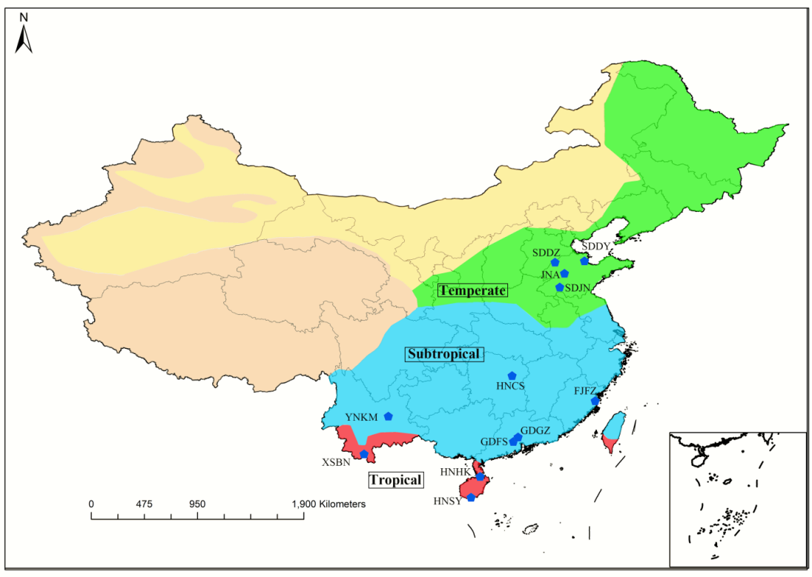

Figure S1. Sampling site distribution and climatic zone delineation of 12 Ae. albopictus populations in China
Sampling sites are color-coded by climatic zone: red for tropical, blue for subtropical, and green for temperate. The background shading indicates the approximate ranges of the three major temperature zones of China, based on the national climatic regionalization standard (accumulated temperature ≥10°C and its duration in days). The core classification criterion of this study is the geographic location of each sampling site and its corresponding actual climatic characteristics. The link of the base map: https://cloudcenter.tianditu.gov.cn/administrativeDivision, Basemap Approval Number: GS(2024)0650.

Figure S2. Multiple Factor Analysis (MFA) showing the association between population genetic structure and environmental variables. Points represent populations from temperate (blue), subtropical (green), and tropical (red) regions. Environmental predictors include mean annual temperature (W1), annual precipitation (W2), and altitude (G1). Ellipses represent 68% confidence ellipses for the temperate and subtropical populations; the tropical populations (comprising only three sampling sites) were not plotted in the figure.

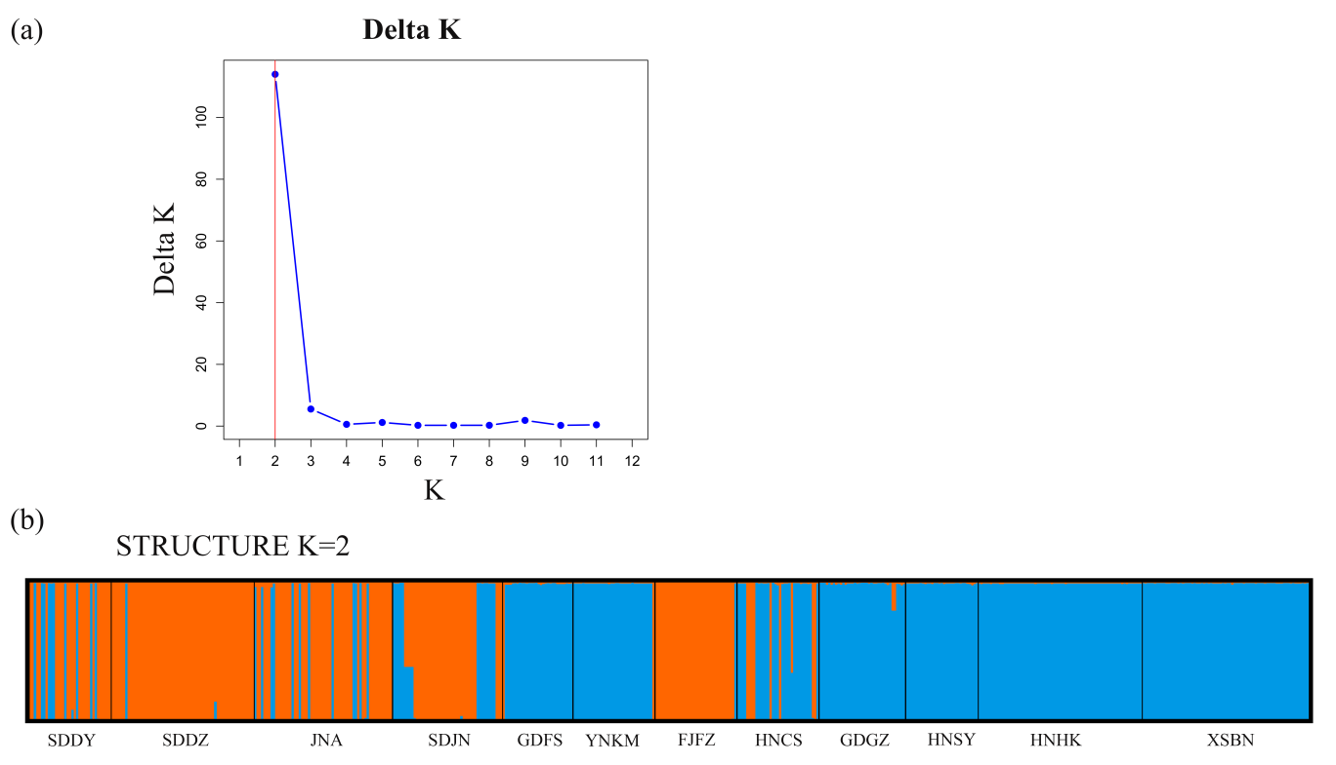
Figure S3. Population genetic structure of Ae. Albopictus based on the VGSC gene.
(a) Determination of the optimal number of genetic clusters (K) using the ΔK method. (b) STRUCTURE bar plot for K = 2, with each individual represented by a vertical bar partitioned by inferred ancestry proportions. Populations are separated by black lines.

