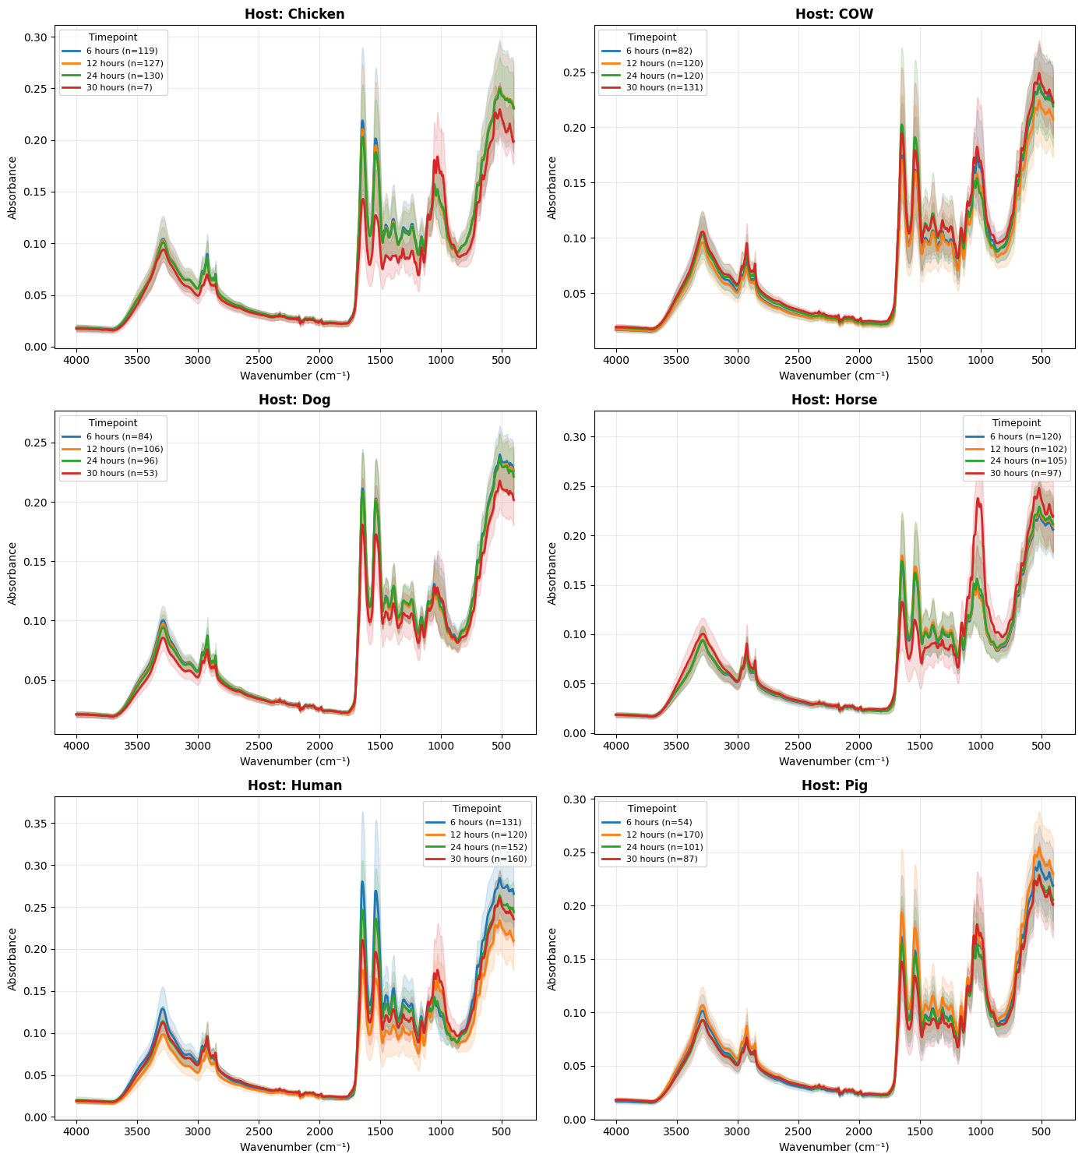
Supplementary Material
Figure S1: Spectra from mid-infrared spectroscopy obtained from laboratory-reared Cx. quinquefasciatus dried bloodspots, averaged across the six host species and each of the four timepoints.

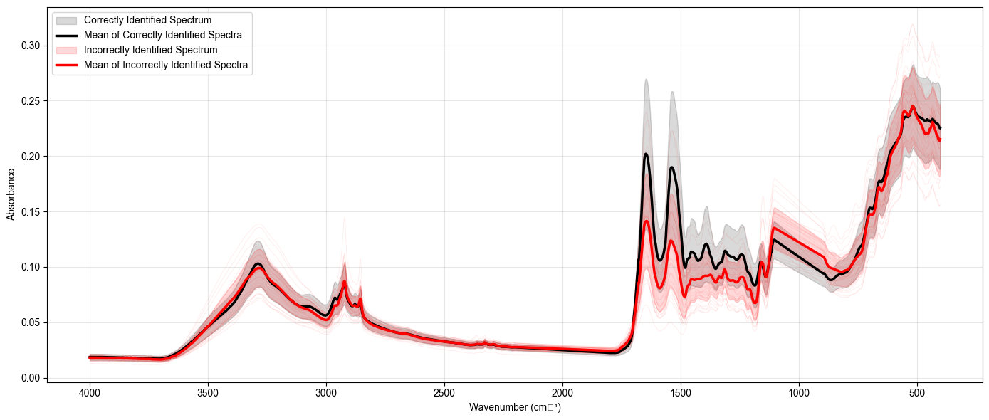
Figure S2: Mean and individual spectra of incorrect and correctly labelled host species from each dried bloodspot from laboratory-reared Cx. quinquefasciatus.

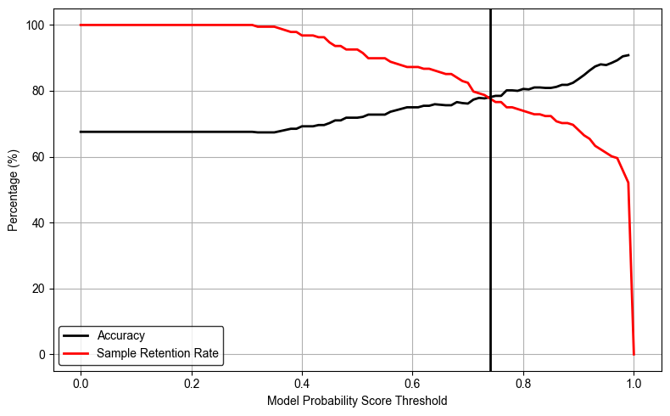
Figure S3: Overall multi-layer perceptron model accuracy and sample retention rate after applying model probability score thresholds for dried blood spots collected from field-collected mosquitoes in the Philippines (n = 187). The vertical line indicates the optimal threshold (0.73).

