Table S1. Microsatellites used in the study.
Locus | Primer sequence (5′–3′) |  | References | Location
ANS014 | F | FAM-GGTTGGGTTAAAACGCG | Jung et al.,  [36] | X
ANS014 | R | CTGCTGAATGCTCCTC | Jung et al.,  [36] | X
ANS040 | F | FAM-TTCCGTCCCGTTATCCTCG | Jung et al.,  [36] | X
ANS040 | R | CCGGAAAAGTCACAGGG | Jung et al.,  [36] | X
ANS101 | F | FAM-TCCAGATTCCCTACGTACGTG | Jung et al.,  [36] | X
ANS101 | R | ATGGGGCGCTCACACCTCCAA | Jung et al.,  [36] | X
ANS121 | F | HEX-TCAATTCCGCCACTCAACGTT | Jung et al.,  [36] | 2L
ANS121 | R | ACGCGTCCACCTTTACCAGGT | Jung et al.,  [36] | 2L
ANS122 | F | NED-TATGGAAATTGTGTGCAGCTCGC | Jung et al.,  [36] | 3R
ANS122 | R | CGCTTCACGCCACAAATCCAA | Jung et al.,  [36] | 3R
ANS1 | F | HEX-GACAAGCTGAGCTGCCAACAG | Ma and Fan [37] | 3R
ANS1 | R | GGCAAGGGTGGTACAGAATGAC | Ma and Fan [37] | 3R
ANS5 | F | CAAGAAGTTCAACAGCGGCA | Ma and Fan [37] | 3R
ANS5 | R | NED-GCTGGAGCACTGACGGACTT | Ma and Fan [37] | 3R
ANS11 | F | NED-CATCTCGTTCCCTCGAAGGAC | Ma and Fan [37] | 2L
ANS11 | R | GCCTACAACAAGCCAACCGA | Ma and Fan [37] | 2L
ANS13 | F | FAM-GGATGATGGCTAGGATTTCG | Ma and Fan [37] | 3L
ANS13 | R | TGGCGCTGTTGATGTTATTG | Ma and Fan [37] | 3L
ANS18 | F | GATTGCTAGCATTATTAAACCTGCTGC | Ma and Fan [37] | 2R
ANS18 | R | HEX-TAAATAATGGCAATCCGGTCGT | Ma and Fan [37] | 2R

Table S2. Genetic diversity estimates per microsatellite locus.
 |  | An. sinensis |  |  | An. kleini
 |  | In/near  the DMZ | Humphreys USAG | Daegu | In/near  the DMZ
ANS014 | Ar | 26.5 | 27.5 | 31.4 | 4.1
ANS014 | H_{e} | 0.901 | 0.945 | 0.935 | 0.274
ANS014 | F_{Is} | 0.101 | 0.140 | 0.112 | 0.169
ANS014 | HWE | ns | p < 0.05 | p < 0.05 | ns
ANS040 | Ar | 8.9 | 7 | 7.7 | 7.5
ANS040 | H_{e} | 0.697 | 0.605 | 0.619 | 0.595
ANS040 | F_{Is} | 0.037 | 0.118 | 0.207 | 0.017
ANS040 | HWE | ns | ns | p < 0.05 | p < 0.05
ANS1 | Ar | 11.2 | 10.9 | 10.7 | 17.6
ANS1 | H_{e} | 0.866 | 0.868 | 0.838 | 0.887
ANS1 | F_{Is} | 0.364 | 0.388 | 0.368 | 0.193
ANS1 | HWE | p < 0.05 | p < 0.05 | p < 0.05 | p < 0.05
ANS101 | Ar | 5.3 | 4.9 | 5.8 | 6.3
ANS101 | H_{e} | 0.591 | 0.613 | 0.656 | 0.734
ANS101 | F_{Is} | 0.142 | 0.116 | −0.064 | −0.04
ANS101 | HWE | ns | ns | ns | ns
ANS11 | Ar | 10.8 | 10.9 | 11.7 | 9.9
ANS11 | H_{e} | 0.794 | 0.828 | 0.835 | 0.764
ANS11 | F_{Is} | 0.060 | 0.044 | 0.119 | 0.638
ANS11 | HWE | ns | ns | ns | p < 0.05
ANS121 | Ar | 10.5 | 11.9 | 9.8 | 11.6
ANS121 | H_{e} | 0.745 | 0.660 | 0.712 | 0.838
ANS121 | F_{Is} | 0.447 | 0.308 | 0.216 | 0.02
ANS121 | HWE | p < 0.05 | p < 0.05 | p < 0.05 | ns
ANS122 | Ar | 11.1 | 11.8 | 13.2 | 7.7
ANS122 | H_{e} | 0.809 | 0.862 | 0.795 | 0.774
ANS122 | F_{Is} | 0.064 | 0.081 | −0.044 | 0.279
ANS122 | HWE | ns | p < 0.05 | ns | p < 0.05
ANS13 | Ar | 3.9 | 3.0 | 2.8 | 1.9
ANS13 | H_{e} | 0.480 | 0.242 | 0.325 | 0.04
ANS13 | F_{Is} | 0.531 | 0.225 | 0.304 | −0.016
ANS13 | HWE | p < 0.05 | ns | p < 0.05 | ns
ANS18 | Ar | 2.0 | 2.0 | 2.8 | 4.4
ANS18 | H_{e} | 0.500 | 0.479 | 0.515 | 0.547
ANS18 | F_{Is} | 0.144 | −0.001 | 0.120 | −0.723
ANS18 | HWE | ns | ns | ns | p < 0.05
ANS5 | Ar | 3.6 | 3.0 | 4.0 | 3.4
ANS5 | H_{e} | 0.184 | 0.261 | 0.213 | 0.434
ANS5 | F_{Is} | 0.007 | 0.122 | 0.097 | 0.094
ANS5 | HWE | ns | ns | p < 0.05 | ns

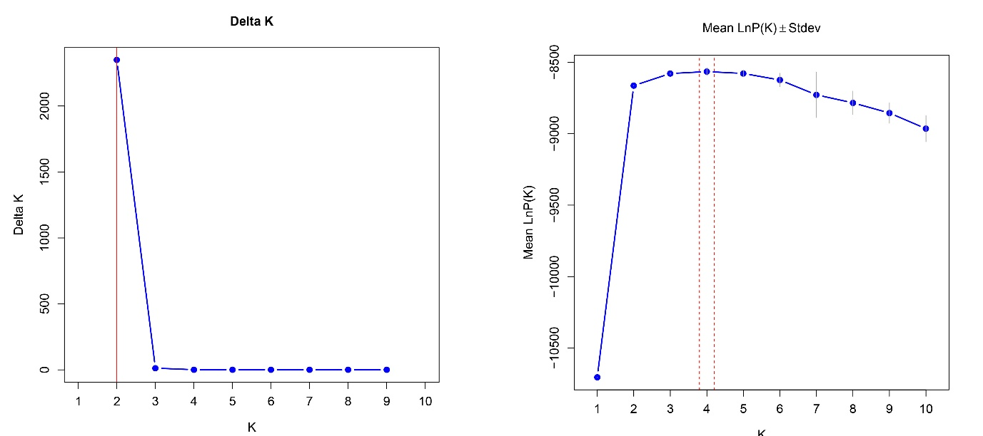Fig. S1. Inference of the number of clusters from microsatellite data [left, ΔK; right, mean LnP(K)].

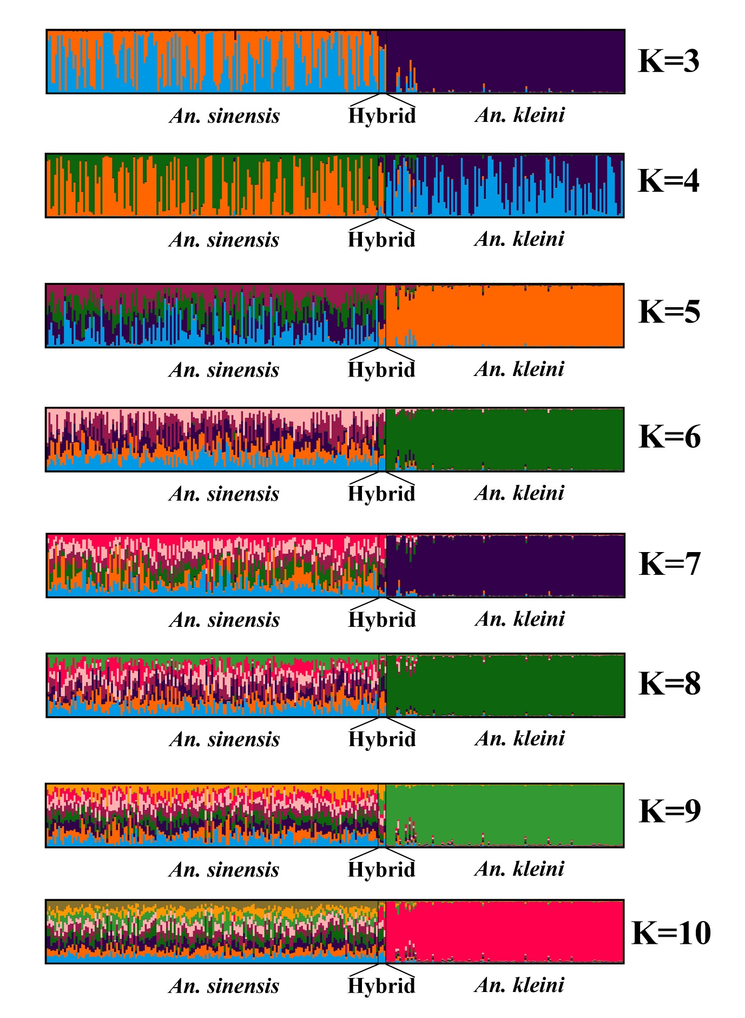Fig. S2. STRUCTURE analysis results for Anopheles species across K=3-10.

Table S3. Genetic differentiation at each locus between An. sinensis and An. kleini.
Locus | F_{st}
ANS13 | 0.5818 | 3L
ANS18 | 0.3028 | 2R
ANS014 | 0.2477 | X
ANS040 | 0.2197 | X
ANS122 | 0.1044 | 3R
ANS101 | 0.0926 | X
ANS5 | 0.0816 | 3R
ANS11 | 0.0689 | 2L
ANS121 | 0.0383 | 2L
ANS1 | 0.0118 | 3R

