Supplementary material

The protein expression system impacts the efficacy of Phlebotomus papatasi SP32 as a marker of exposure in humans, dogs, and mice

Barbora Dvořáková^{1,#}, Eva Pyrihová², Tereza Kolarčíková², Suha K. Arserim³, Metin Pekagirbas⁴, Kardelen Yetismis⁵, Fabiano Oliveira^{f}, Jesus G. Valenzuela^{f}, Yusuf Özbel⁵, Seray Töz⁵, Miroslava Alblová², Petr Volf¹, Iva Kolářová^{1,*,#}

¹ Department of Parasitology, Faculty of Science, Charles University, Prague, Czech Republic
² Institute of Biotechnology, Czech Academy of Sciences, Vestec, Czech Republic
³ Vocational School of Health Sciences, Celal Bayar University, Manisa, Türkiye
⁴ Veterinary School, Department of Parasitology, Aydin Adnan Menderes University, Aydin, Türkiye
⁵ Department of Parasitology, Faculty of Medicine, Ege University, Izmir, Türkiye
⁶ Laboratory of Malaria and Vector Research, National Institutes of Health, Rockville, United States

# BD and IK share the first authorship
* Correspondence: iva.kolarova@natur.cuni.cz

GLOSSARY
Youden's index (also known as Youden's J statistic) is a single number used to determine the optimal cut off point for a diagnostic test. Its equation is J = sensitivity + specificity - 1 and its value ranges from 0 to 1. Jmax is the maximal value of Youden's index corresponding to the point on the ROC curve that sits the furthest above the diagonal line, providing equal weight to true positives (sensitivity) and true negatives (specificity).

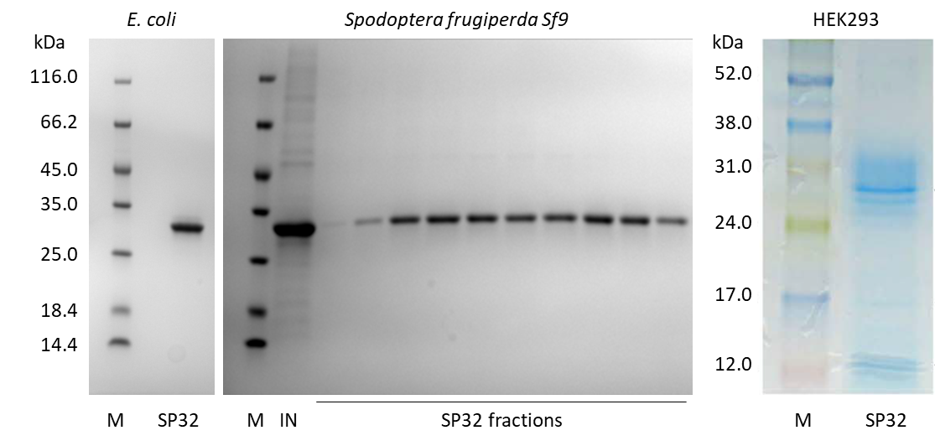
Figure S1: Purity level of the recombinant Phlebotomus papatasi SP32 proteins.
Left side (E. coli and Sf9): After purification, the samples in reducing buffer were loaded onto an 8-16 % SDS-PAGE gradient gel and then visualised using a house-made Coomassie staining solution. M = protein marker (peqGOLD Marker I, VWR, #27-1010), IN = input sample used for size exclusion chromatography.
Right side (HEK293): Recombinant SP32 was run on a 15 % SDS-PAGE gel and stained with Coomassie blue. The RPN800E molecular weight marker (Amersham) was used. Mass spectrometry confirmed that all visible bands belonged to P. papatasi SP32 (GenBank accession no. AF335490, Marzouki et al. 2012).
The Escherichia coli SP32 image was adapted from Kolarova et al. (2026) and the HEK293 SP32 image was adapted from Marzouki et al. (2012).

References:
Kolarova et al. 2026. Parasite & Vectors. doi: 10.1186/s13071-026-07286-4.
Marzouki et al. 2012. PLoS Neglected Tropical Diseases. doi: 10.1371/journal.pntd.0001911. Erratum in: PLoS Negl Trop Dis. 2024, doi: 10.1371/journal.pntd.0012303.

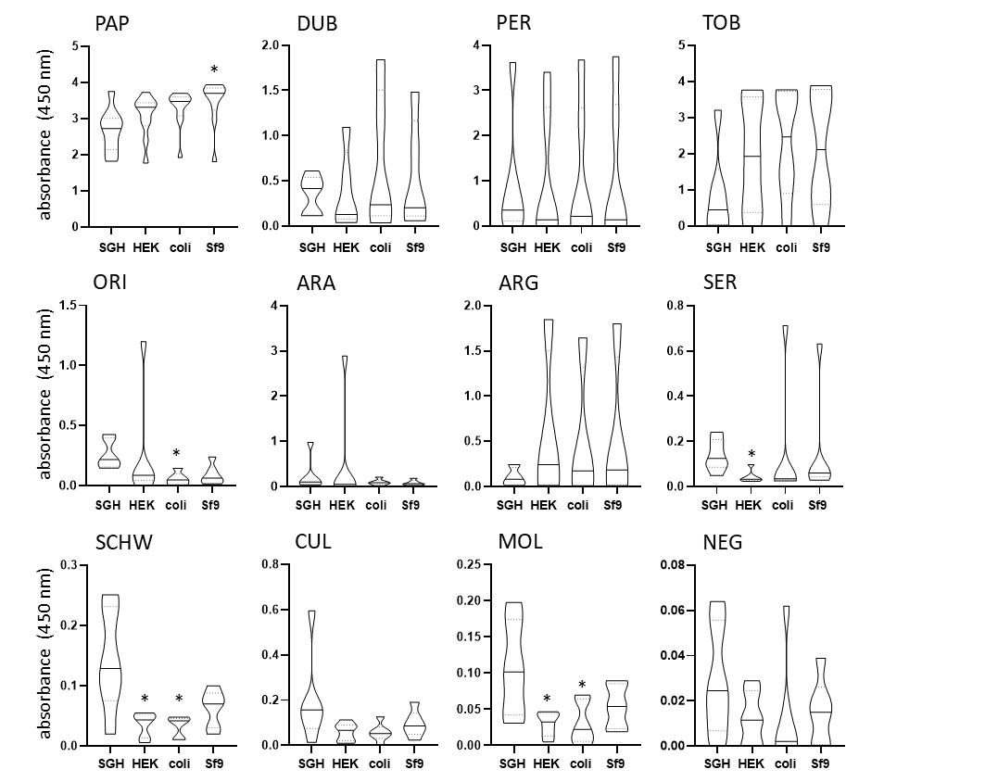
Figure S2. The reactivity of P. papatasi SP32 recombinant proteins with sera from mice experimentally bitten by a single insect species.
Phlebotomus papatasi salivary gland homogenate (SGH) and recombinant proteins expressed in human kidney cells (HEK), Escherichia coli (coli), and Spodoptera frugiperda (Sf9) were tested in ELISA to detect IgG antibodies in the sera of mice repeatedly bitten by one of the following insect species: P. papatasi (PAP), P. duboscqi (DUB), P. perniciosus (PER), P. tobbi (TOB), P. orientalis (ORI), P. arabicus (ARA), P. argentipes (ARG), P. sergenti (SER), Sergentomyia schwetzi (SCHW), Culex quinquefasciatus (CUL), or C. pipiens molestus (MOL). Non-bitten mice were used as controls (NEG). The data are presented as violin plots with a solid line marking the median value and dotted lines representing Q1 and Q3 quartiles. The same dataset was used as for Figure 2. The data were pooled from two independent experiments. Asterisks (*) indicate significant differences compared to SGH (p < 0.05).

