Additional file 1:

Table 1: Mapping results RRBS following Bismark alignments and MethylKit analysis
 |  | Mapping Efficiency | %C in CpG | %C in CHG | %C in CHH | bisulfite conversion efficiency* | Mapped regions | Mapped CpG 10r
Sample_844 | Control1 | 60.2 | 77.9 | 1.0 | 0.7 | 99.26 | 120145 | 542585
Sample_845 | Control2 | 59.3 | 77.9 | 1.0 | 0.7 | 99.26 | 150754 | 482559
Sample_846 | Control3 | 59.8 | 77.3 | 1.0 | 0.7 | 99.26 | 152279 | 486403
Sample_847 | Control4 | 58.3 | 76.7 | 1.0 | 0.7 | 99.20 | 157704 | 495952
Sample_848 | Control5 | 59.5 | 77.7 | 1.0 | 0.7 | 99.27 | 143643 | 467583
Sample_849 | MEHP1 | 59.2 | 77.3 | 1.0 | 0.7 | 99.27 | 113306 | 368262
Sample_850 | MEHP2 | 59.5 | 77.9 | 1.0 | 0.7 | 99.27 | 126368 | 417905
Sample_851 | MEHP3 | 59.9 | 77.9 | 1.0 | 0.7 | 99.28 | 139910 | 454898
Sample_852 | MEHP4 | 59.0 | 77.0 | 1.1 | 0.7 | 99.20 | 139808 | 453697
Sample_853 | MEHP5 | 59.3 | 77.3 | 1.0 | 0.7 | 99.19 | 144503 | 466496
Sample_854 | 5AC1 | 59.6 | 77.7 | 1.0 | 0.7 | 99.27 | 143028 | 466040
Sample_855 | 5AC2 | 59.2 | 77.0 | 1.0 | 0.7 | 99.28 | 101961 | 312047
Sample_856 | 5AC3 | 58.4 | 76.7 | 1.0 | 0.7 | 99.21 | 121503 | 403161
Sample_857 | 5AC4 | 58.8 | 76.9 | 1.0 | 0.7 | 99.20 | 133817 | 445084
Sample_858 | 5AC5 | 59.8 | 77.8 | 1.0 | 0.7 | 99.28 | 126292 | 410153
Average |  | 59.3 | 77.4 | 1.0 | 0.7 | 99.25 | 134335 | 444855
*Assessed by MethylKit

Table 2: Overview of the total amount of tiles at different features versus the amount of differentially methylated tiles (DMRs). (A) MEHP specific tiles and DMRs. (B) 5AC specific tiles and DMRs. * indicates enrichment outside the analyzed feature
- MEHP | Total tiles | DMRs | p hyper
 | 66896 | 410
Promoters | 2547 | 12 | 8.22E-01
Gene bodies | 38906 | 290 | 7.54E-04*
CGis | 42147 | 185 | 7.58E-01
CNEs | 2514 | 80 | 1.25E-31

- 5AC | Total tiles | DMRs | p hyper
 | 61455 | 580
Promoters | 2357 | 19 | 2.12E-01
Gene bodies | 35624 | 290 | 5.06E-05*
CGis | 39288 | 185 | 3.20E-54*
CNEs | 2296 | 80 | 5.20E-23

Table 3: Primer sequences used for RT QPCR
DNMTs | Forward | Reverse | Accession number
ef1a | TTGAGAAGAAAATCGGTGGTGCTG | GGAACGGTGTGATTGAGGGAAATTC | NM_131263.1
bactin | CGAGCAGGAGATGGGAAC | CAACGGAAACGCTCATTGC | NM_131031.1
rps18 | CATCCCAGAGAAGTTTCAGCACATC | CGCCTTCCAACACCCTTAATAGC | NM_173234.1
hmbs | GTGTGTGGAATTGGACAACAAAGTG | CGAGGGCTGATGATGAGATATTGC | NM_201154.1
hprt1 | CAGCGATGAGGAGCAAGGTTATG | GTCCATGATGAGCCCGTGAGG | NM_212986.1
dnmt1* | GAGCCTGTGAAGCAGGAGAA | CATGAATGGCACTGCACAGA | NM_131189.2
dnmt3bb.2* | AAACAACGCGCTTCCACG | TTCCATAACCACCACCGTCC | AF135438.1
dnmt3bb.1* | GCGTCAGAAGTATGCGAGGA | GACCTTTCCTAGCAGGGTTGA | AB196915.1
dnmt3bb.3* | GCTCCATCACATCTCAGCCC | CAAATCCGACACCGGCAAAG | XM_009296722.1
dnmt3ab* | AGAAAACCCATTCGCGTCCT | GTGCCCTCGTAGAGACCTTTT | AB196917.1
dnmt3ba* | ATCCGACATCTCTTTGCACC | GTGAAGTGAATTTGCAGAAAGC | AB196918.1
dnmt3aa* | GGACGTATTGTGTCCTGCT | ATCACCAAACCACATGACCC | AB196919.1
*sequences taken from Santangeli et al. 2016

Table 4: Primer sequences used for BisPCR2 analysis
 |  | associated gene | Location from TSS | Meth diff (%) | Region for validation | no. CpG | Strand | Ta | Ratio  PCR#2
CvsMEHP DMC
Chr2:43611806-43611806 |  | nrp1b | 8023 upstream | 25 | Chr2:43611512-43611846 | 6 | -1 | 52 | 2
Primer F | nrp1b_F | ACACTCTTTCCCTACACGACGCTCTTCCGATCTGAGAGTTAGTTTGTTTAGATATT
Primer R | nrp1b_R | GTGACTGGAGTTCAGACGTGTGCTCTTCCGATCTCTTCCATAACCCTTTATATT
Chr4:53831128-53831128 |  | CT583728.4 | 399 upstream | 24 | Chr4:53831094-53831415 | 16 | 1 | 54 | 2
Primer F | CT583728.4_F | ACACTCTTTCCCTACACGACGCTCTTCCGATCTTTAAAAAGTATGGAAGGTAAGTG
Primer R | CT583728.4_R | GTGACTGGAGTTCAGACGTGTGCTCTTCCGATCTCCCATTCTACTTCAACATAATA
Chr9:39356710-39356710 |  | cps1 | 399 upstream | -24 | Chr9:39356640-39356899 | 11 | 1 | 52 | 2
Primer F | cps1_F | ACACTCTTTCCCTACACGACGCTCTTCCGATCTTTGTTAAGTGTTTGTGATTGT
Primer R | cps1_R | GTGACTGGAGTTCAGACGTGTGCTCTTCCGATCTAACTAACCTATCTAATTATTCCC
Chr12:29105853-29105853 |  | Gabrz | 165848 downstream | 25 | Chr12:29105587-29105921 | 13 | -1 | 50 | 2
Primer F | gabrz_F | ACACTCTTTCCCTACACGACGCTCTTCCGATCTTTTTTATTTTTATGAAGGTTTTG
Primer R | gabrz_R | GTGACTGGAGTTCAGACGTGTGCTCTTCCGATCTAAACCTAACCTATTTAAATC
Chr20:43514811-43514811 |  | si:dkey-14a7.6 | 1531 upstream | -26 | Chr20:43514527-43514862 | 13 | -1 | 50 | 2
Primer F | si:dkey-14a7.6_F | ACACTCTTTCCCTACACGACGCTCTTCCGATCTATTAAGTTTAGAGTGTGGAA
Primer R | si:dkey-14a7.6_R | GTGACTGGAGTTCAGACGTGTGCTCTTCCGATCTAACCCTACTAAAATAAATTATAT
Chr21:20158965-20158965 |  | si:dkey-247m21.3 | 34401 upstream | 30 | Chr21:20158921-20159221 | 7 | 1 | 52 | 2
Primer F | si:dkey-247m21.3_F | ACACTCTTTCCCTACACGACGCTCTTCCGATCTTGATGTGAGATTGGTTATTT  GTGACTGGAGTTCAGACGTGTGCTCTTCCGATCTCAAACATAACTTCAATACTC
Primer R | si:dkey-247m21.3_R
Cvs5AC DMC
Chr2:32025720-32025720 |  | mycb | 7318 upstream | 34 | Chr2:32025720-32025720 | 7 | 1 | 54 | 7
Primer F | mycb_F | ACACTCTTTCCCTACACGACGCTCTTCCGATCTGAAATAAGATATTTTAAAGTGTT
Primer R | mycb_R | GTGACTGGAGTTCAGACGTGTGCTCTTCCGATCTACAATAACACTAACACCAAA
Chr3:48276633-48276633 |  | si:ch211-245b21.1 | 1957 upstream | -30 | Chr3:48276549-48276951 | 12 | -1 | 56 | 2
Primer F | si:ch211-245b21.1_F | ACACTCTTTCCCTACACGACGCTCTTCCGATCTTAGGATAGAAGATAGTTAGAAGT
Primer R | si:ch211-245b21.1_R | GTGACTGGAGTTCAGACGTGTGCTCTTCCGATCTTTTTATCCAAAAATACCAATACT
Chr6:57641668-57641668 |  | cbfa2t2 | 84319 gene body | 32 | Chr6:57641533-57641785 | 14 | 1 | 56 | 7
Primer F | cbfa2t2_F | ACACTCTTTCCCTACACGACGCTCTTCCGATCTTAGGTTTTTTAGGGTGTATT
Primer R | cbfa2t2_R | GTGACTGGAGTTCAGACGTGTGCTCTTCCGATCTTATATTTATATTCATCTTCAATC
Chr25:36706591-36706591 |  | si:dkey-234i14.6 | 8250 gene body | -36 | Chr25:36706556-36706894 | 15 | -1 | 54 | 7
Primer F | si:dkey-234i14.6_F | ACACTCTTTCCCTACACGACGCTCTTCCGATCTTAATTAAAAATTGGATGTTATT
Primer R | si:dkey-234i14.6_R | GTGACTGGAGTTCAGACGTGTGCTCTTCCGATCTAAATCTCTAAAAATATTCATCT

Figure 1: Average standard deviation of all CpGs analyzed with BisPCR2 within technical replicates. 5AC5 and 5AC6 represent the two different samples that were analyzed for technical variation. Error bars represent SEM.
Figure 2: Calibration curves from BisPCR2 analysis. Calibration curves represent average methylation off all CpG sites on a specific locus.
Figure 3: Correlation plot of mutual analyzed CpG sites between RRBS and BisPCR2 analysis. (Spearman correlation = 0.8885, P <0.0001)
Figure 4: Phenotypic effects on swim bladder and gastrointestinal tract in 5-azacytidine (5AC) exposed larvae. Pictures represent individual larvae at 15 dpf.
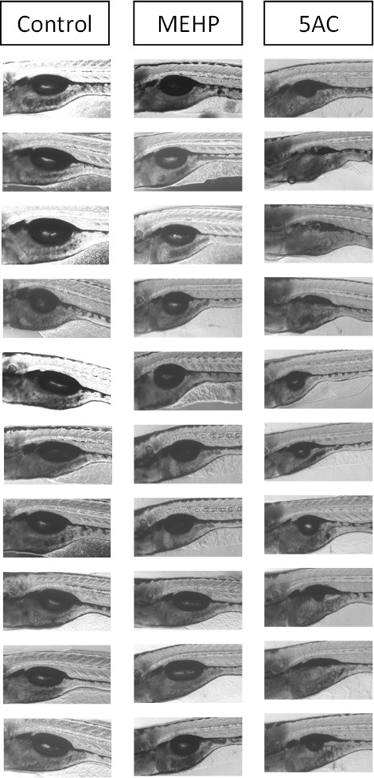

Figure 5: Global methylation analysis of zebrafish larvae exposed to 5-azacytidine (5AC) from 0 to 6 dpf (n=6, Error bars represent 95% CI, ANOVA with Dunnets multiple comparisons P < 0.05).

Figure 6: Cluster analysis (Ward) of DNA methylation after exposure of zebrafish larvae exposed to 10 and 25 µM 5-azacytidine (5AC) from 0 to 6 dpf. Highlighted are clusters that represent dose response relations.
Figure 7: Hierarchical clustering of methylation measured in 10 specific loci in F0 larvae 6 dpf and 15 dpf, and adult (sperm) samples, as well as F1 and F2 larvae (6dpf) (Ward clustering).

