The Histone chaperone Nrp1 is required for chromatin stability and nuclear division in Tetrahymena thermophila

Yingjie Lian ¹, Huijuan Hao¹, Jing Xu^{1, 2}, Tao Bo ¹, Aihua Liang ¹, Wei Wang ¹*

Supplemental Information
Supplemental Figure Legends
Supplemental Figures S1-S8
Supplemental Tables S1-S2

Supplemental Figure S1
Multiple sequence alignment of Nrp1 proteins from different model organisms.
(A) Multiple sequence alignment of Nrp1s from (T.t (Tetrahymena thermophila), P.t (Paramecium tetraurelia), A.t (Arabidopsis thaliana), C.e (Caenorhabditis elegans), D.m (Drosophila melanogaster), H.s (Homo sapiens), S.p (Schizosaccharomyces pombe), S.c (Saccharomyces cerevisiae), X.l (Xenopus lqevis)). Residues are colored according to conservative.
(B) Multiple sequence alignment of Nrp1 proteins from 7 different Tetrahymena species. TPR domains are indicated. Residues are colored according to Clustalx multiple sequence alignment.

Supplemental Figure S2
（A）Expression profile of the NRP1. The expression profile microarray data are obtained from the Tetrahymena Functional Genomics Database (http://tfgd.ihb.ac.cn/). The y-axis indicates microarray expression values. The x-axis indicates developmental stages.
(B) Heat map of transcript abundance of NRP1 and histones in Tetrahymena. The data are obtained from the Tetrahymena Functional Genomics Database (http://tfgd.ihb.ac.cn/). L1-L3: vegetative growth stage (~1×10⁵cells/ml, ~3.5 ×10⁵cells/ml and ~1×10⁶ cells/ml), S0-24: starvation stage (at 0, 3, 6, 9, 12, 15 and 24 h), and C: conjugation stage (at 0, 2, 4, 6, 8, 10, 12, 14, 16 and 18 h after mixing).
Supplemental Figure S3
(A) HA antibody specific detection. Indirect immunofluorescence of untagged cells during vegetative growth stage and pair formation stage using HA antibody. Scale bar, 10 µm.
(B) Western blot analysis of Nrp1-HA. Whole cell extracts made from WT and Nrp1-HA cells from vegetative growth stage using anti-HA antibody. α-Tubulin is a loading control on Western blot analysis.
Supplemental Figure S4
NRP1 is essential for proliferation of T. thermophila. (A) Schematic of the NRP1 knockout. NRP1 was replaced by Neo4 cassette by homologous recombination. (B) Identification of NRP1 knockout mutants. Total DNA was isolated from wild-type CU428 and somatic NRP1 knockout cells. KO-NRP1-B and KO-NRP1-C are different mating type mutants from B2086 and CU428 respectively. Different lanes represent different clones, M：molecular weight markers；lane1-3, KO-NRP1-B cells; lane4, wild type cells; lane5-9, KO-NRP1-C cells. The target gene was amplified by PCR. The arrow indicates recombination band and wild-type band. (C) NRP1 knockout mutants recover into WT cells. Identification of NRP1 knockout mutants under paromomycin-free medium culture. M：molecular weight markers；lane1-4, KO-NRP1-B cells; lane5, wild type cells; lane6-8, KO-NRP1-C cells.

Supplemental Figure S5
NRP1 knockdown inhibits cellular survival and proliferation. The single cell was aspirated into the drops of SPP and incubated for 4 days at 30 °C. The drops were then transferred into individual wells of 96-well plates and cultured. The proliferation of cells was observed through a stereo microscope. n =200.

Supplemental Figure S6
Localization of γ-H2A.X during early meiotic stage. Immunofluorescence staining of γ-H2A.X in WT cells and nrp1i cells. γ-H2A.X was used as an indicator of DNA double-strand breaks (DSBs). DNA was stained with DAPI. Scale bar, 10 µm.

Supplemental Figure S7
Western blotting analysis of Nrp1-HA. The whole cell extracts (WCE) of WT and Nrp1 mutant were prepared. Top panel was probed with anti-HA antibody, the bottom panel was probed with anti-tubulin antibody as a loading control.

Supplemental Figure S8
Localization of HA-Nrp1 during late conjugation stage. (A) Schematic diagram of OE-HA-NRP1 construction. (B) OE-NRP1-B and OE-NRP1-C mutants were confirmed by PCR. Arrows indicate mutants (2200 bp) and WT (750 bp). M：molecular weight markers；lane1, lane3, wild type cells; lane2, lane4, OE-NRP1-B cells; lane5-8, OE-NRP1-C cells. (C) Immunofluorescence staining of overexpressing HA-Nrp1 mutants. HA-Nrp1 was overexpressed under MTT1 promoter with Cd²⁺ induction. DNA was stained with DAPI. Arrowheads indicate old MACs, stars indicate anlagen. Scale bar, 10 µm.

Supplementary Figure 1
A

B

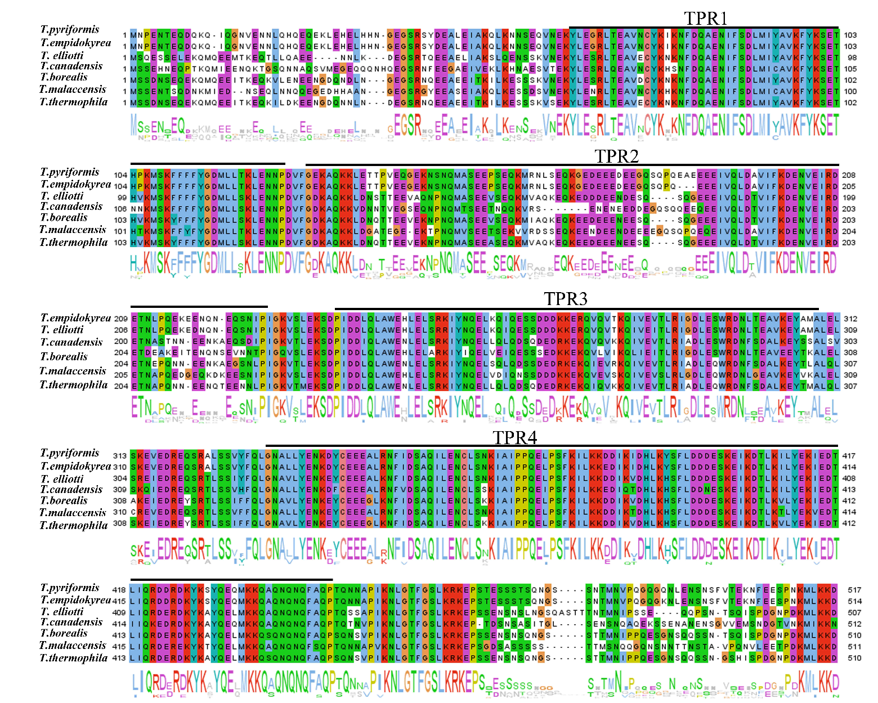

Supplementary Figure 2

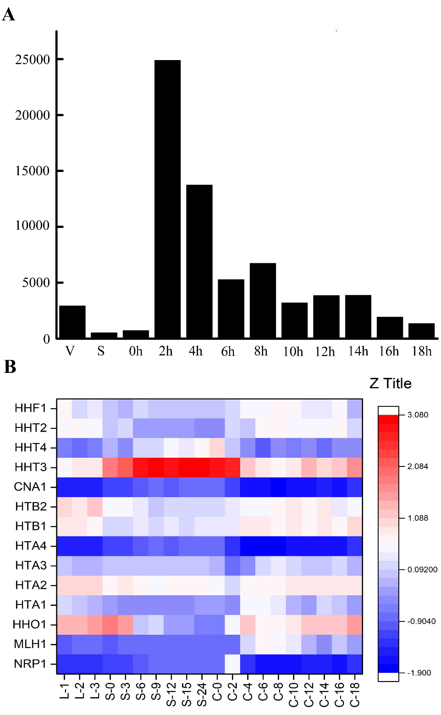

Supplementary Figure 3

Supplementary Figure 4

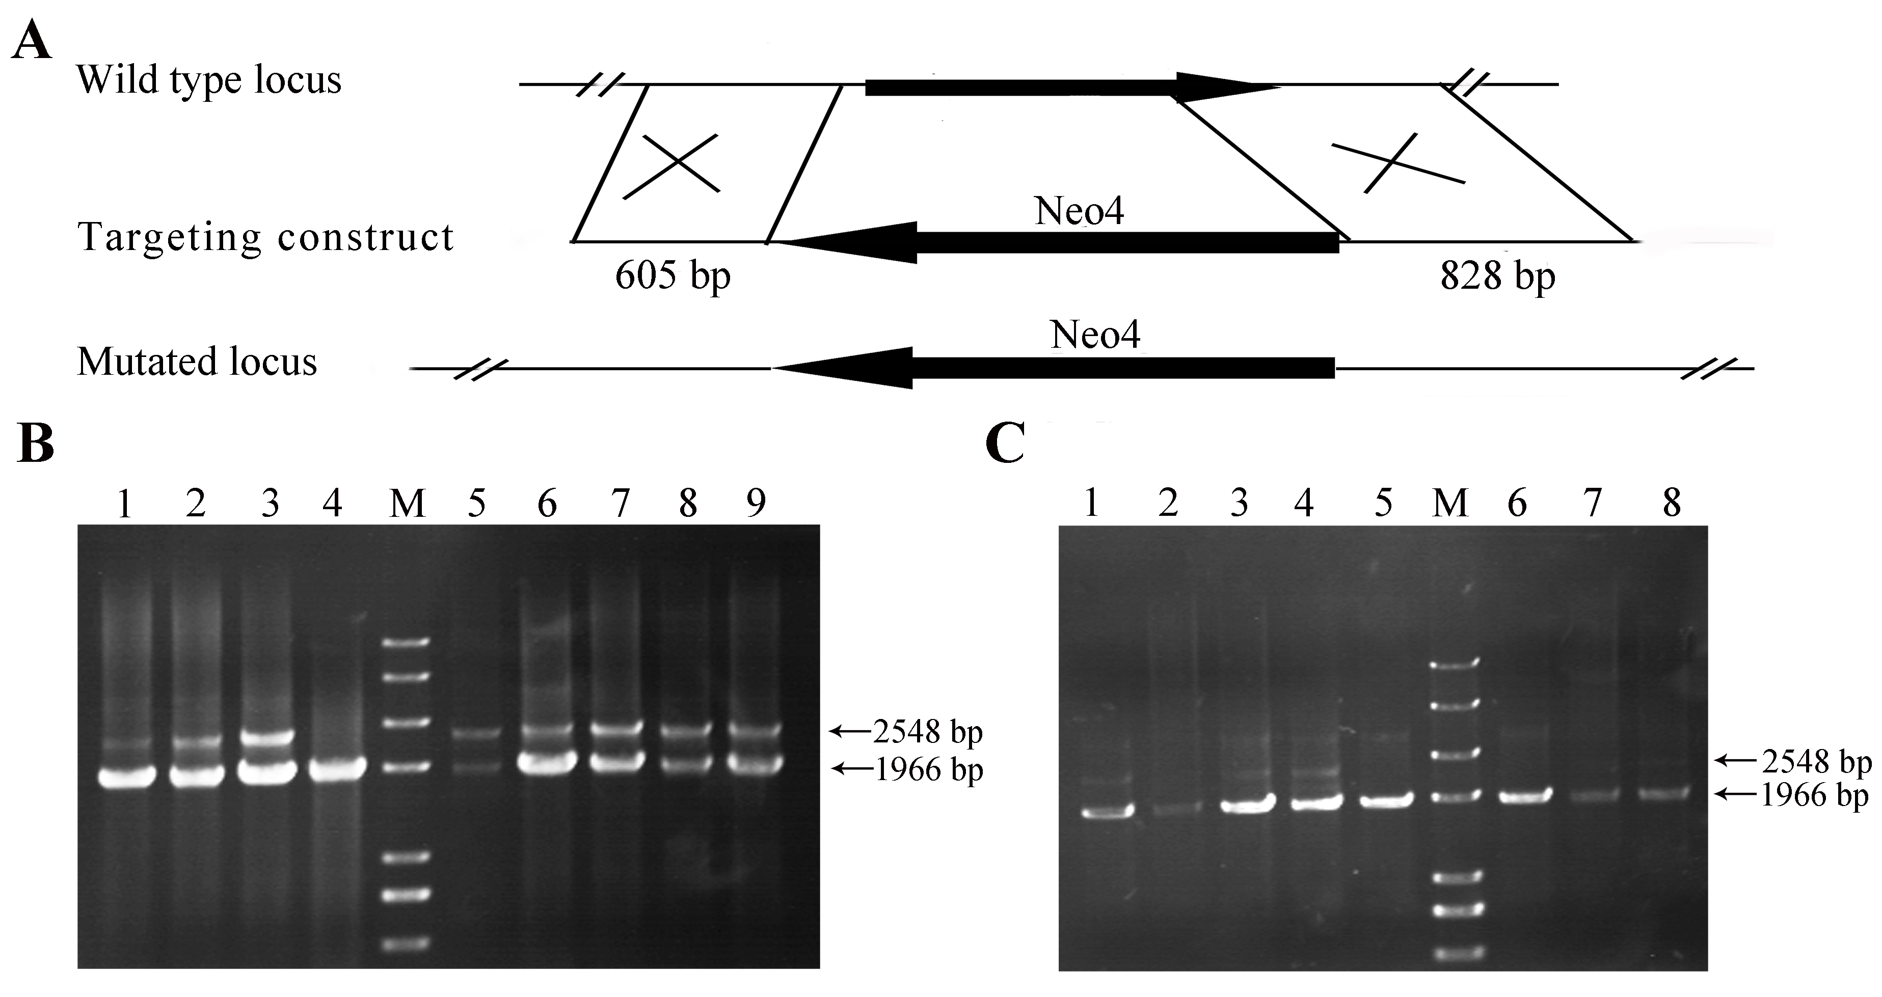

Supplementary Figure 5

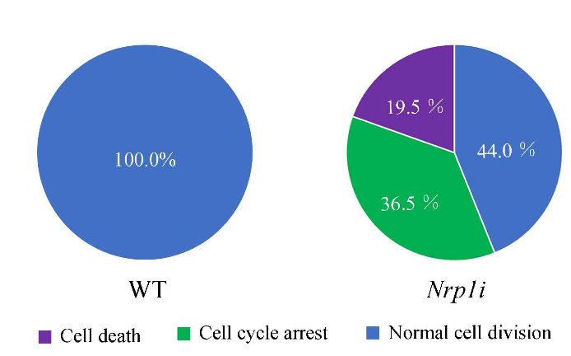

Supplementary Figure 6
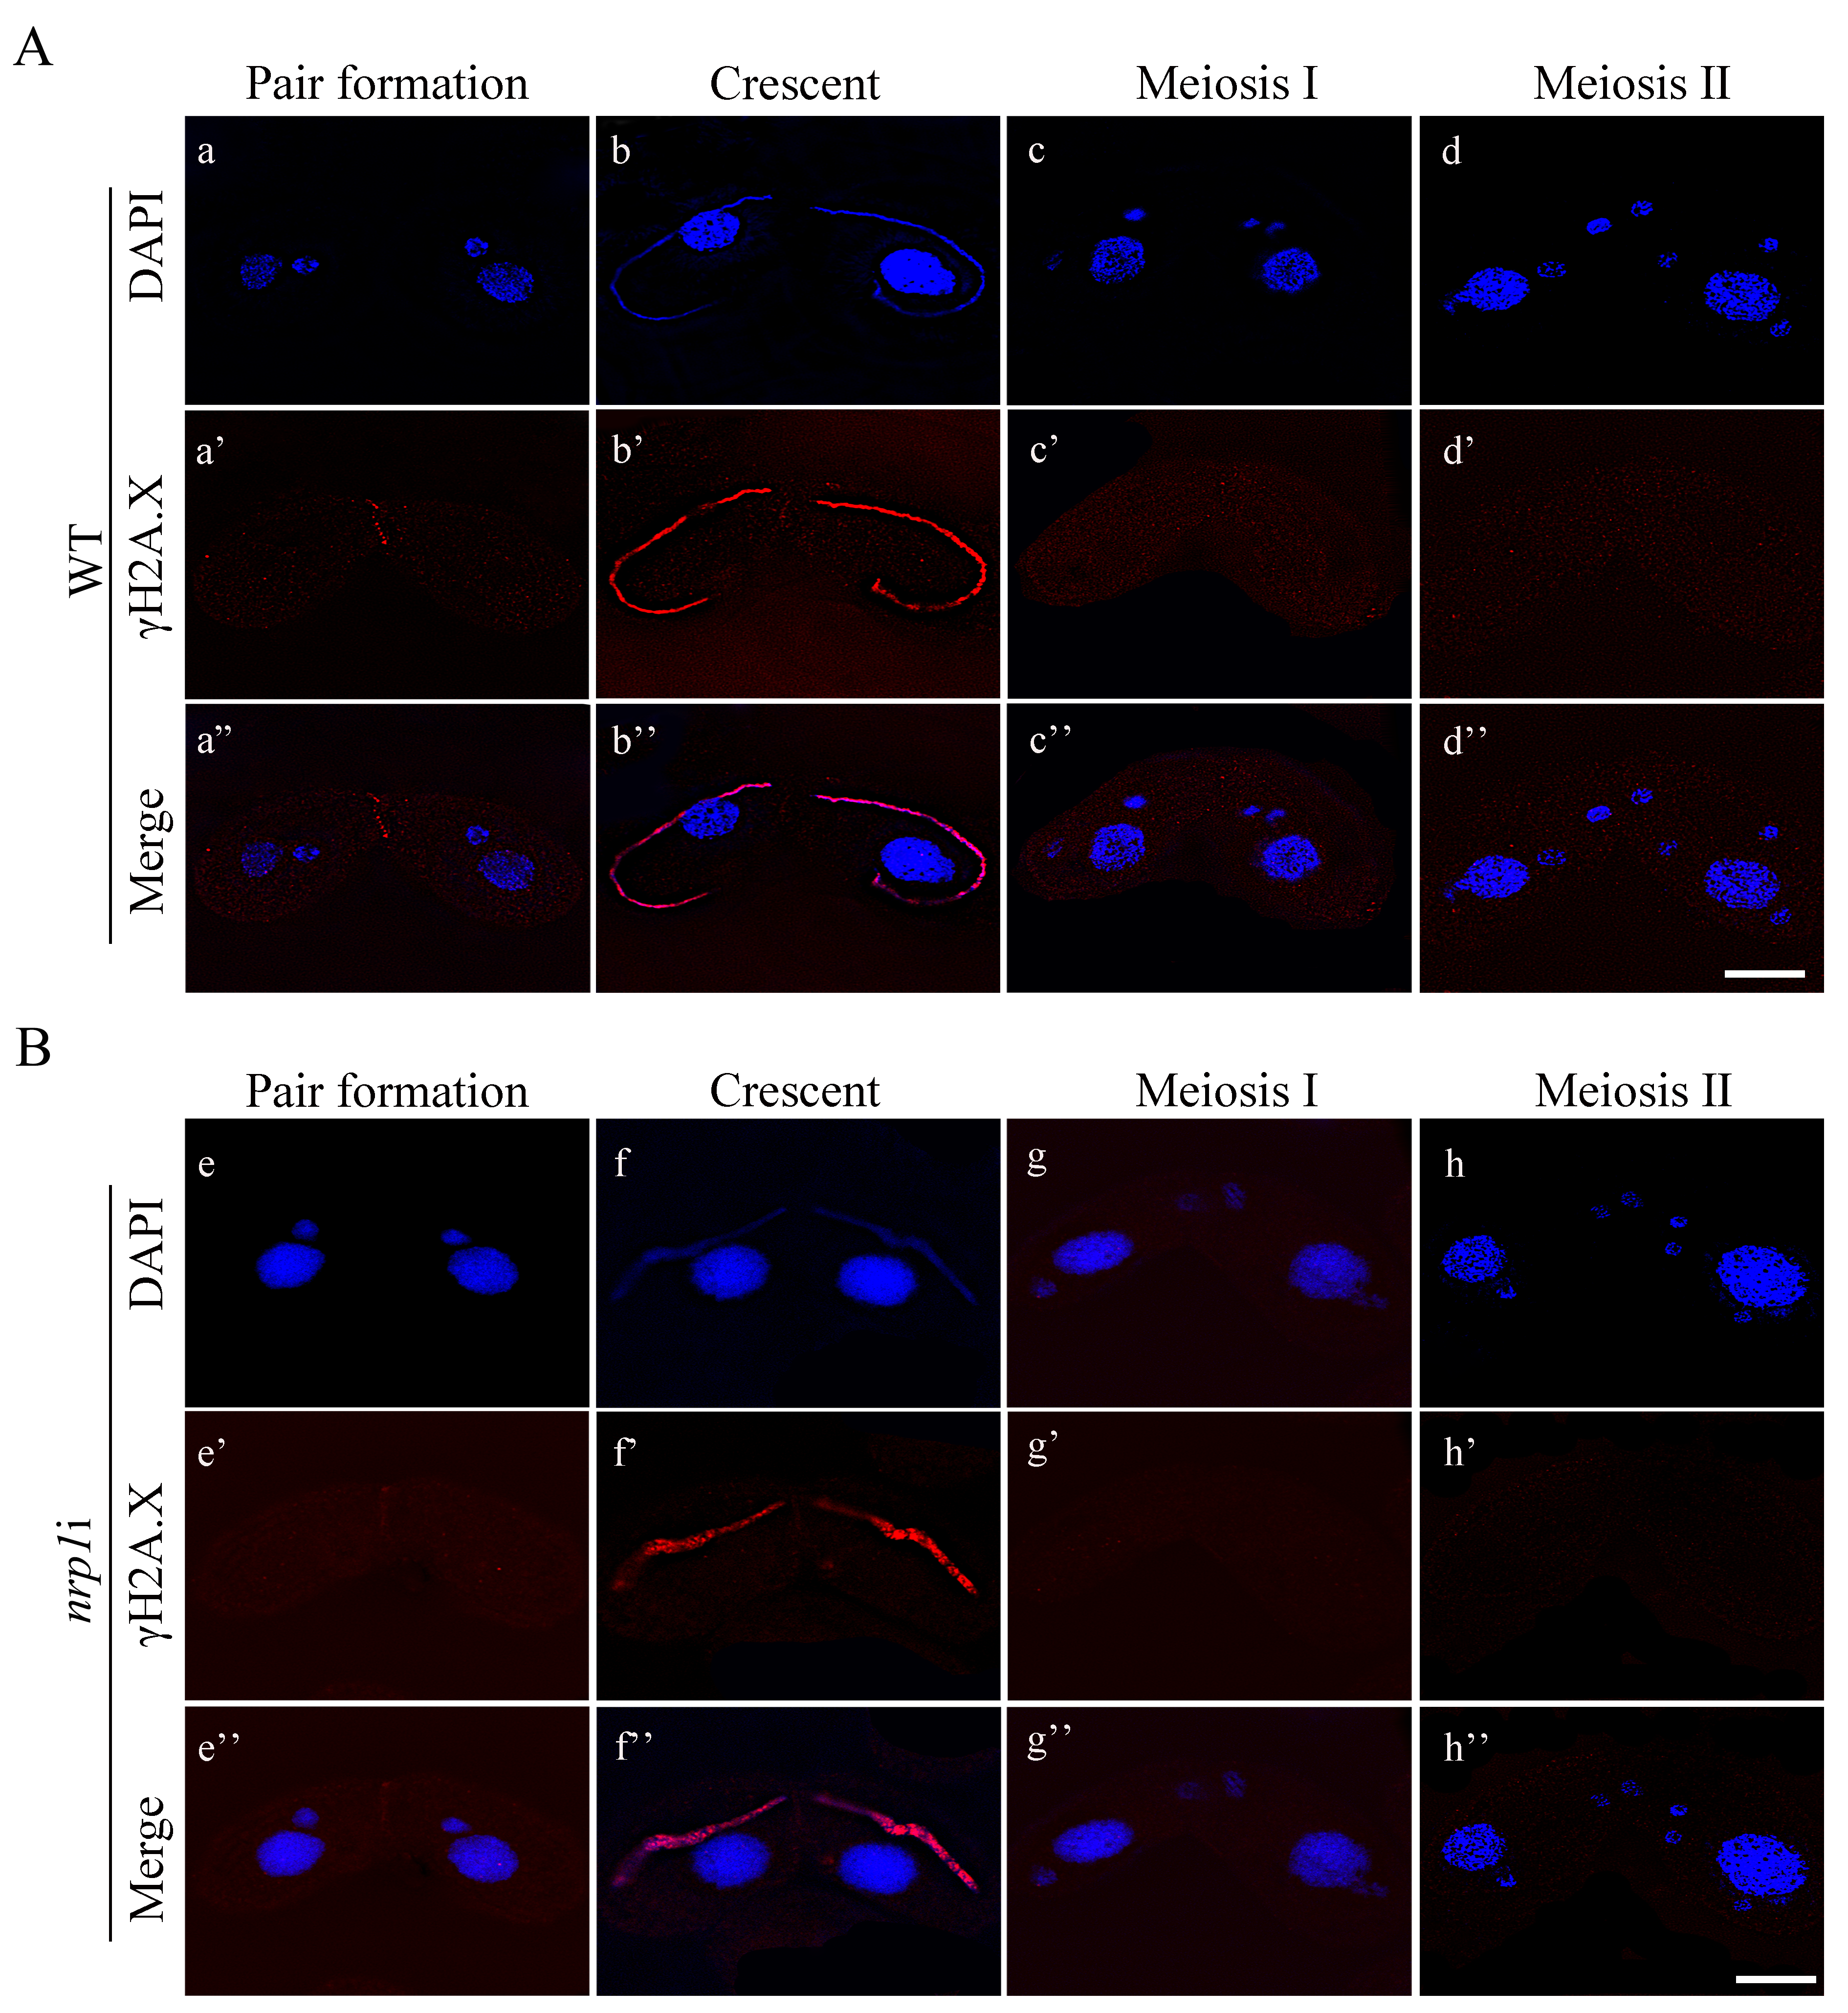

Supplementary Figure 7

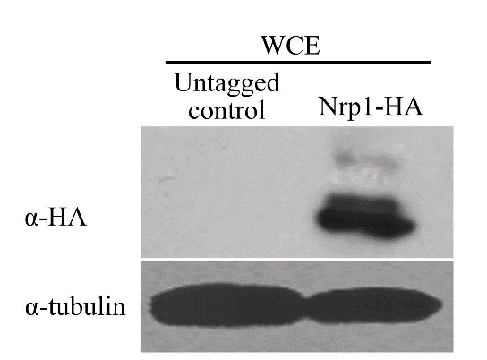

Supplementary Figure 8

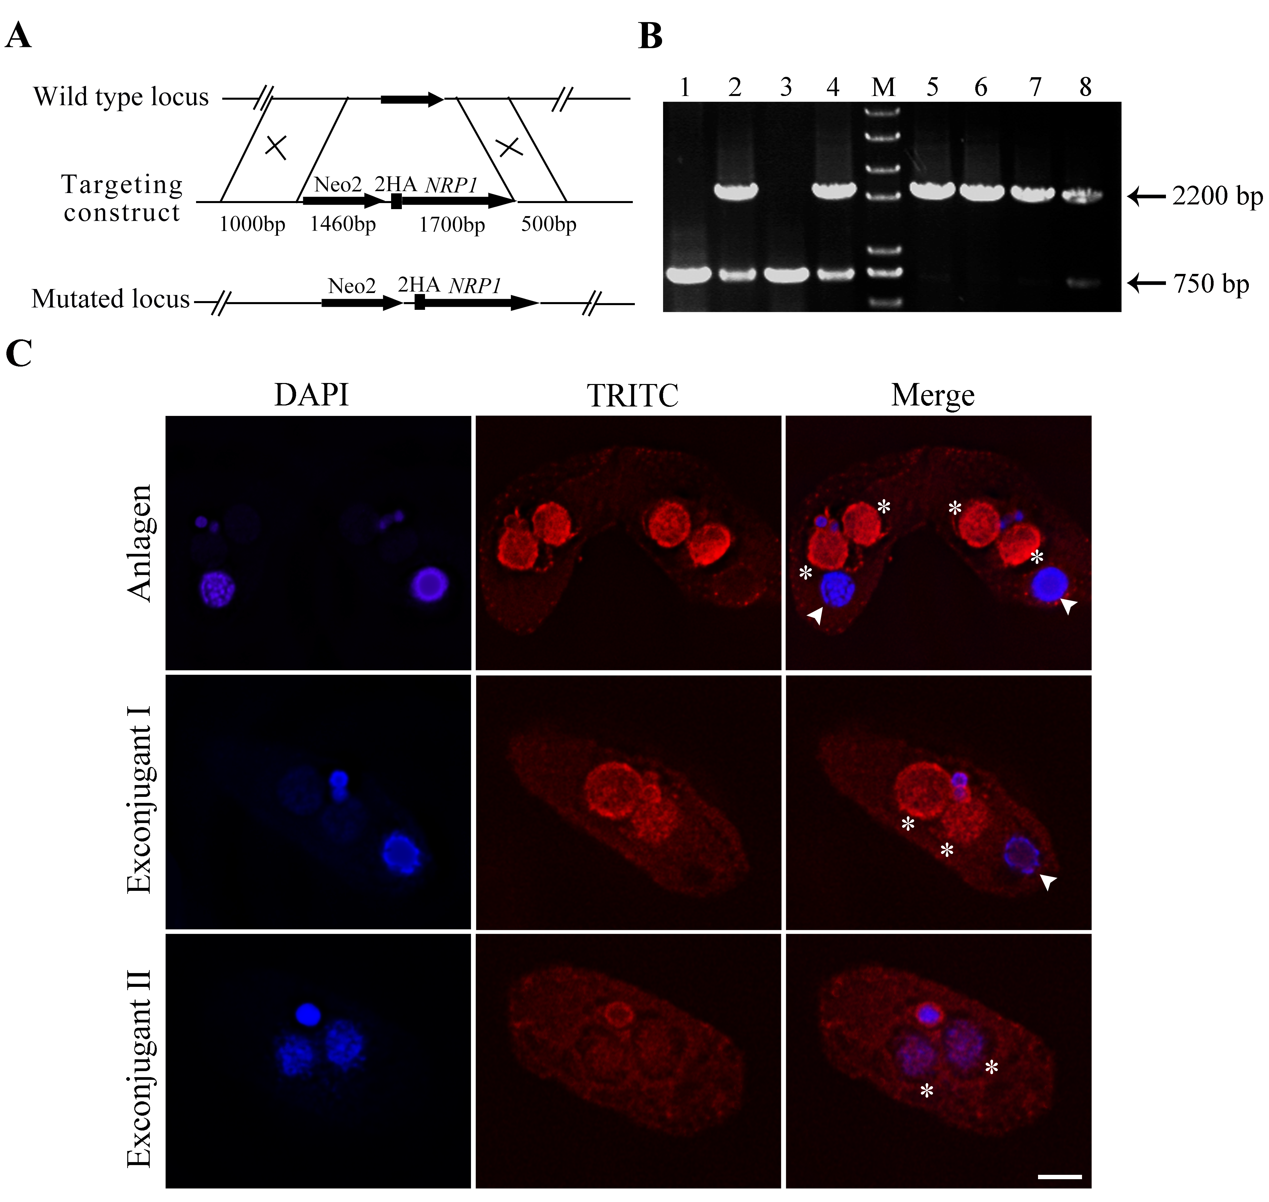

Supplementary Table S1: Primers used in this work
PCR primers | Sequence
NRP1-HA-F1 | GAGCTCATAAGATAGCTAAGATGAGGATAG
NRP1-HA-R1 | GCGGCCGCATCCTTTTTGAGCATTTTATCTGG
NRP1-HA-F2 | CTCGAGGTAATAGCTTGCAACATCACTTTC
NRP1-HA-R2 | GGTACCTCACCATTTAAGCCTCCAGTAAC
HA-NRP1-F | GTCGAAGTAACTTTAAGAATTGCTG
HA-NRP1-R | ACTCTATGGTAGTTAGTCAACTATG
J-NRP1-HA-F | CCAGATAAAATGCTCAAAAAGGATT
J-NRP1-HA-R | GAAAGTGATGTTGCAAGCTATTAC
RNAi- NRP11F | GTTTAAAC AGAATATTGTGAAGAAGAGGGTCTT
RNAi- NRP11R | GGATCCCCTGATTCTTAAGGTGGGATATTC
RNAi- NRP1 2F | CCCGGGAGAATATTGTGAAGAAGAGGGTCTT
RNAi- NRP12R | CTGCAGCCTGATTCTTAAGGTGGGATATTC
KO-NRP1-5’-F | GAGCTCAGCTCTTAGATAGATTTTATTTTT
KO-NRP1-5’-R | GCGGCCGCTTCAATAAATAAGATAAACTATAAC
KO-NRP1-3’-F | CTCGAGCAATTCCTCCTTAAGAACTTCCTAG
KO-NRP1-3’-R | GGTACCAAGATATCAAAATTAATCACTGAAGATC
J-KO-NRP1-F | ATTCTAATAGTTTCTGTGTAGCGG
J-KO-NRP1-R | TTAGGTAAGTTAATTAATCCTCAATATG
RT-NRP1-F | ACAAAGCTTACTAAGAACTTATGA
RT-NRP1-R | CATTAGATGATTGTTGACTATTACC
OE-NRP1-F | GGATCCATGAGTTCTGACAATAGTGAATAAG
OE-NRP1-R | GGCGCGCCTCAATCCTTTTTGAGCATTTTATCTG
OE-J-NRP1-F | GCTACGTGATTCACGATTTATGCAATG
OE-J-NRP1-R | CGAAACTGATTTTATGCAATTATGAATTAC

Underline indicates recognition sites of the restriction enzymes.

Supplementary Table S2: Identification of the interactive proteins of Nrp1-HA by affinity purification combined with mass spectrometry analysis

Gene ID | Prey | UniquePepCout
TTHERM_00196370 | chaperonin CPN60_1 (Hsp60) | 7
TTHERM_00444670 | heat shock protein HSP90 | 7
TTHERM_000570549 | histone H3.1 | 3
TTHERM_00189180 | Histone H3.2 | 3
TTHERM_00016200 | histone H3.4 | 2
TTHERM_00016170 | histone H3.3 | 2
TTHERM_00442300 | histone chaperone asf1 | 2
TTHERM_00786930 | nucleosome assembly protein | 4
TTHERM_00283330 | metallopeptidase family M24 containing protein (CET1 SPT16) | 1
TTHERM_00688660 | Histone binding protein RBBP4 or subunit C of Caf1 complex protein | 1
TTHERM_00046920 | TBP interacting DNA helicase (RVB2) | 3
TTHERM_00448570 | DNA replication licensing factor MCM6 | 1
TTHERM_01207610 | MCM2 3 5 family protein | 1
TTHERM_00865240 | DNA ligase I, ATP dependent protein (Lig1) | 1
TTHERM_00142330 | DNA repair RAD51_like protein | 1
TTHERM_00825440 | DNA topoisomerase IV (Top2) | 1
TTHERM_00149190 | Ubiquitin activating enzyme E1 UAB14 | 3
TTHERM_01341620 | Ubiquitin conjugating enzyme E2 (UBC4) | 1
TTHERM_01123950 | Ubiquitin conjugating enzyme E2 (UCN2) | 1
TTHERM_00647540 | acyltransferase family protein | 1
TTHERM_00637650 | ELP3 family histone acetyltransferase | 1
TTHERM_00388200 | spindle assembly abnormal like protein, putative (SAS6A) | 2

