Title: Prenatal vitamin intake in first month of pregnancy and DNA methylation in cord blood and placenta

Additional Material
This supplementary material contains 7 supplementary figures and 8 supplementary tables. An additional 10 large supplementary tables are provided as comma separated value tables.

Supplemental Figure 1. Sample exclusion/inclusion.
MARBLES Cord Blood
N=247
MARBLES Placenta
N=92
N=239
N=236
N=223
N=92
N=92
N=90
N=213
N=86
EARLI
Cord Blood
N=175
EARLI Placenta
N=134
Multiple Birth
N=2
N=173
N=170
N=170
N=128
N=127
N=127
N=164
N=121
Missing Variables of Interest
N=33
Missing Variables of Interest
N=12
Missing Variables of Interest
N=16
N=70
N=201
N=88
N=113
Missing Variables of Interest
N=51
Multiple Birth
N=8
Multiple Birth
N=6
Multiple Birth
N=0
Smoking During Pregnancy
N=6
Smoking During Pregnancy
N=6
Smoking During Pregnancy
N=4
Smoking During Pregnancy
N=10
Drop All But One Siblings
N=1
Drop All But One Siblings
N=0
Drop All But One Siblings
N=2
Drop All But One Siblings
N=13
Sex Mismatch
N=1
Sex Mismatch
N=3
Sex Mismatch
N=0
Sex Mismatch
N=3
Supplemental Figure 2. CpG probe exclusion/inclusion.
Fail Detection-P in >10% of Samples
N=661
Fail Detection-P in >5% of Samples
N=4,630
Fail Detection-P in >5% of Samples
N=1,699
Cross Reactive Probes
N=42,967
Cross Reactive Probes
N=43,068
Cross Reactive Probes
N=29,153
MARBLES Cord Blood
N=865,859
MARBLES Placenta
N=865,859
N=861,229
N=818,262
Remaining Y Chromosome Probes
N=379
N=817,883
N=864,160
N=821,092
N=821,008
Remaining Y Chromosome Probes
N=84
EARLI Placenta and Cord
N= 485,512
N= 484,851
N= 455,698
N= 455,650
Remaining Y Chromosome Probes
N=48
Supplemental Figure 3. Heatmap of DNA methylation principal components associations with covariates. T-test or ANOVA used for categorical covariates, Pearson’s product moment correlation used for continuous covariates. Cells in heatmap colored based on p-value of principal component and covariate association. Dark red – p < 0.001, red – 0.001 < p < 0.05, orange – 0.05 < p < 0.10, yellow – 0.10 < 0.5, white – p > 0.5. 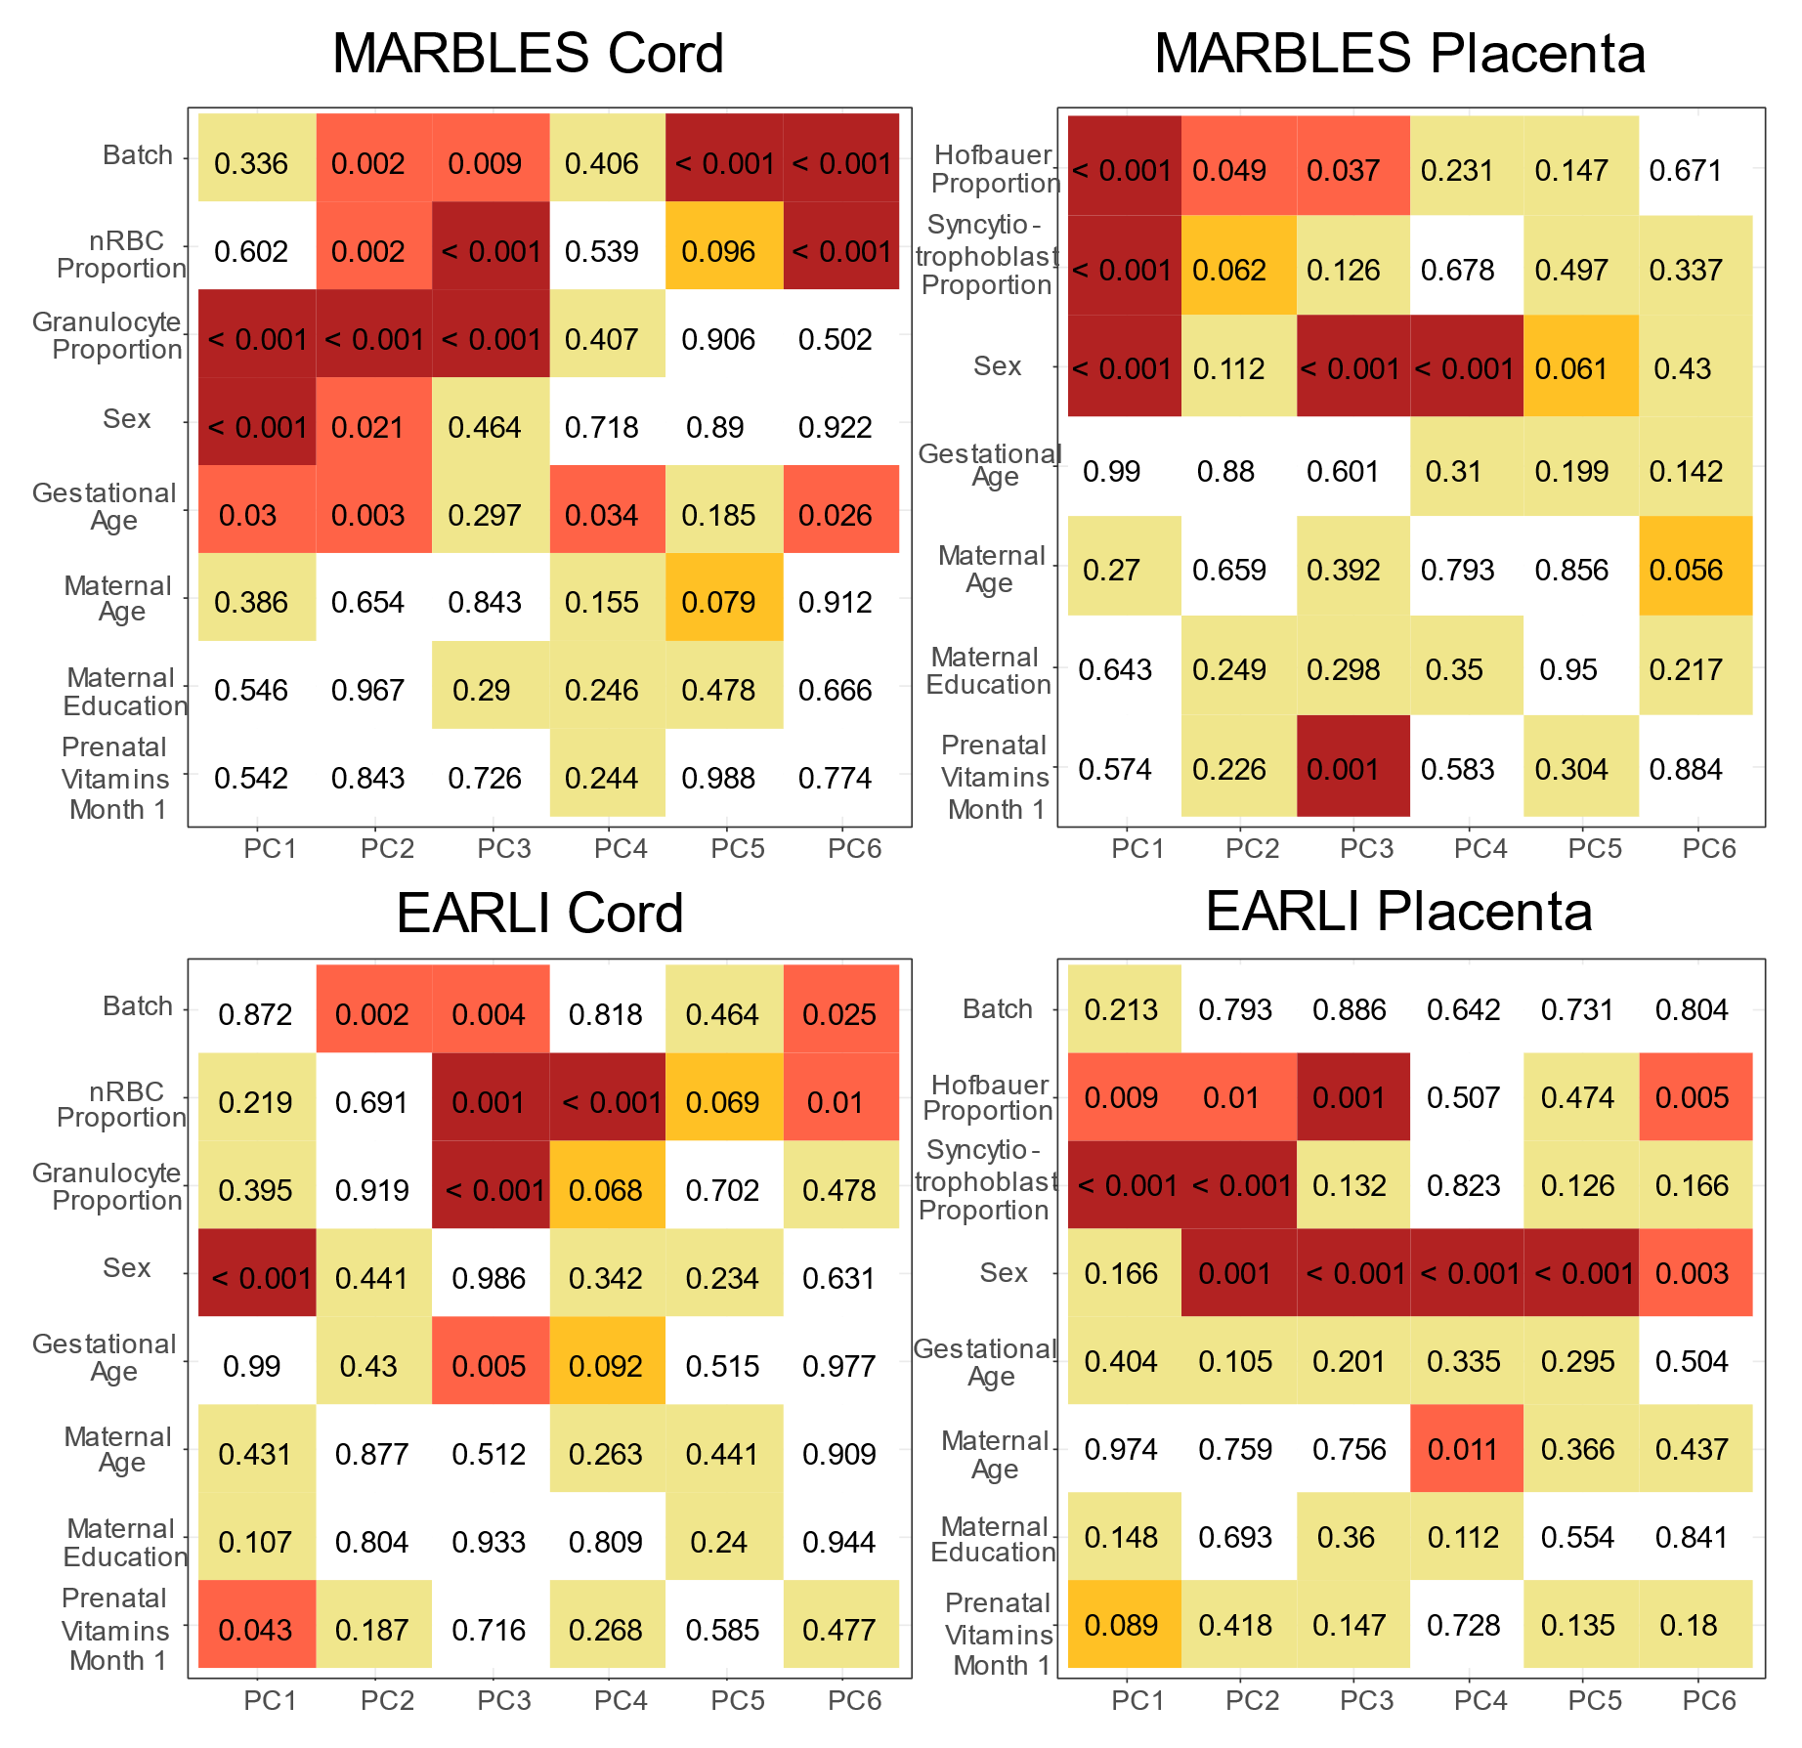

Supplemental Figure 4. Differences in array wide mean DNA methylation, split by regions in relation to CpG islands, comparing prenatal vitamin intake in month one of pregnancy versus no prenatal vitamin intake in month one of pregnancy. Regression models were adjusted for sex, maternal age, gestational age, maternal education, ancestry PCs, and estimated cell proportions.
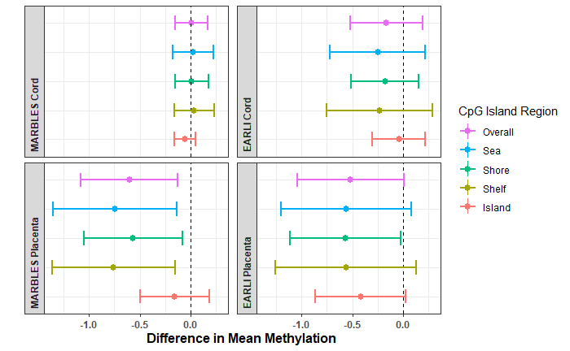
Supplemental Figure 5. Scatter plots of effect estimates for CpGs with P<0.01 in both tissues in A) MARBLES (n_{CpGs} =20) and B) EARLI (n_{CpGs} =66).
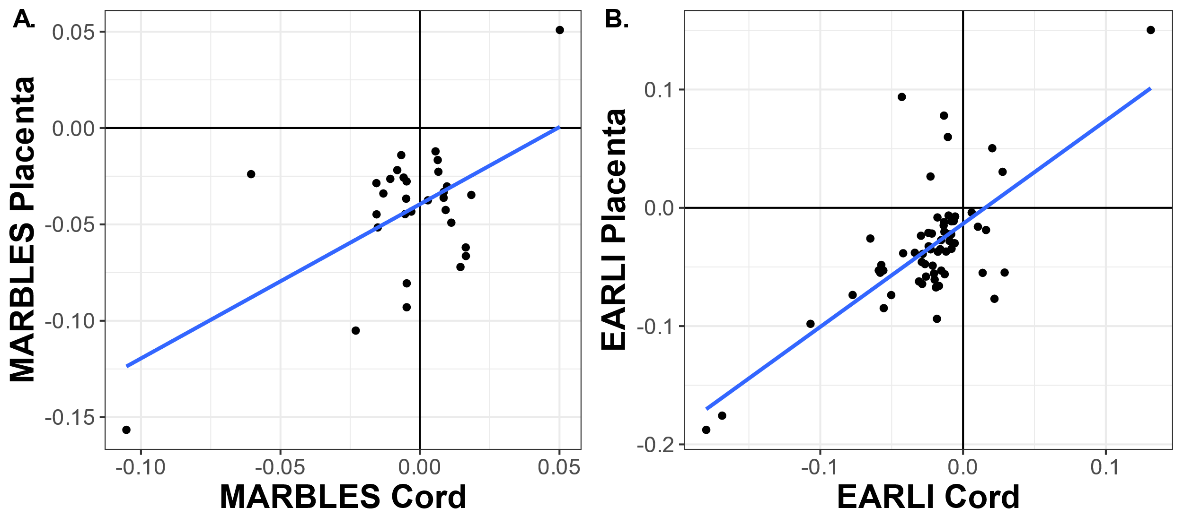

Supplemental Figure 6. Number of gene ontology pathways with p-value<0.01 unique to and in common with cohorts/tissues.
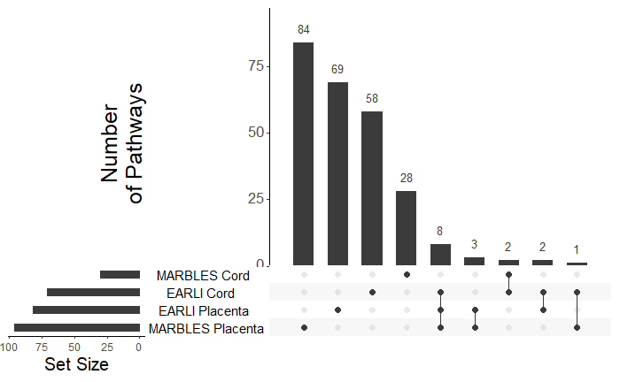
Supplemental Figure 7. eFORGE analysis for enrichment of chromatin state marker signatures. Dark points have adjusted-P value < 0.01, light points have adjusted-P > 0.01. (Abbreviations: ZNF/Rpts, zinc finger genes & repeats; TxWk, Weak transcription; TxFlnk, transcription at gene 5' and 3'; Tx, Strong transcription; TssBiv, Bivalent/Poised transcription start site; TssAFlnk, Flanking Active transcription start site; TssA, Active transcription start site; ReprPCWk, Weak Repressed PolyComb; ReprPC, Repressed PolyComb; Quies, Quiescent/Low; Het, Heterochromatin; EnhG, Generic Enhancers; EnhBiv, Flanking Bivalent TSS/Enhancer; Enh, Enhancers; BivFlnk, Flanking Bivalent TSS/Enh).
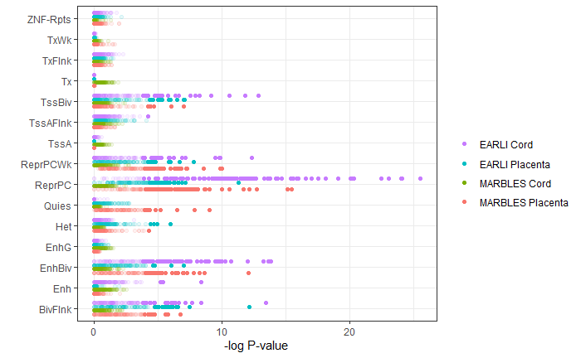

Supplementary Table 1. Prenatal vitamin intake by month of pregnancy, from three months prior to conception through ninth month of pregnancy.

 |  | Month -3 | Month -2 | Month -1 | Month 1 | Month 2 | Month 3 | Month 4 | Month 5 | Month 6 | Month 7 | Month 8 | Month 9
MARBLES cord | Yes | 50 | 57 | 66 | 102 | 155 | 170 | 170 | 167 | 163 | 168 | 168 | 168
MARBLES cord | No | 151 | 144 | 135 | 99 | 46 | 31 | 30 | 33 | 36 | 31 | 31 | 24
MARBLES cord | Missing |  |  |  |  |  |  | 1 | 1 | 2 | 2 | 2 | 9
MARBLES placenta | Yes | 15 | 18 | 22 | 33 | 52 | 59 | 58 | 55 | 52 | 56 | 55 | 57
MARBLES placenta | No | 55 | 52 | 48 | 37 | 18 | 11 | 12 | 15 | 18 | 14 | 15 | 12
MARBLES placenta | Missing |  |  |  |  |  |  |  |  |  |  |  | 1
EARLI  cord | Yes | 34 | 26 | 29 | 71 | 99 | 101 | 105 | 106 | 108 | 109 | 109 | 109
EARLI  cord | No | 69 | 77 | 74 | 42 | 14 | 12 | 8 | 7 | 5 | 4 | 4 | 4
EARLI  cord | Missing | 10 | 10 | 10
EARLI placenta | Yes | 15 | 16 | 18 | 53 | 73 | 78 | 81 | 82 | 84 | 85 | 85 | 85
EARLI placenta | No | 68 | 67 | 65 | 35 | 15 | 10 | 7 | 6 | 4 | 3 | 3 | 3
EARLI placenta | Missing | 5 | 5 | 5

Supplemental Table 12. Whole-genome bisulfite sequencing (WGBS) differentially methylated region (DMR) analysis compared with methylation array results
 | MARBLES Placenta WGBS (n=39 with PV, 52 no PV) | MARBLES Cord Batch 1 WGBS (n=17 with PV, 28 no PV) | MARBLES Cord Batch 2 WGBS (n=17 with PV, 25 o PV) | EARLI Cord WGBS (33 with PV, 30 no PV)
N DMRs in WGBS | 165 | 301 | 469 | 36
Lower Methylation DMRs in WGBS | 132 (80.0%) | 150 (49.8%) | 319 (68.0%) | 23 (63.9%)
Array CpGs within DMRs in WGBS | 61 | 65 | 120 | 4
Array CpGs within DMRs in same direction of effect as WGBS DMR | 48 (78.7%) | 36 (55.4%) | 58 (48.3%) | 3 (75.0%)
Array CpGs within 5kb of DMRs in WGBS | 803 | 1243 | 2176 | 155
Array CpGs within 5kb of DMRs in same direction of effect as WGBS DMR | 535 (66.6%) | 631 (50.8%) | 1061 (48.8%) | 91 (58.7%)

Other Supplemental Files:
Single site results spreadsheets for all CpGs
Supplemental Table 2. Single site DNA methylation array regression results for use of prenatal vitamins in the first month of pregnancy in placenta of EARLI cohort at all CpGs.
Supplemental Table 3. Single site DNA methylation array regression results for sites use of prenatal vitamins in the first month of pregnancy in placenta of MARBLES cohort at all CpGs.
Supplemental Table 4. Single site DNA methylation array regression results for use of prenatal vitamins in the first month of pregnancy in cord blood of EARLI cohort at all CpGs.
Supplemental Table 5. Single site DNA methylation array regression results for use of prenatal vitamins in the first month of pregnancy in cord blood of MARBLES cohort at all CpGs.

Supplemental Table 6. Gene ontology ranking by p-value for EARLI placenta, EARLI cord blood, MARBLES placenta, and MARBLES cord blood, ordered by rank sum across the four cohort/tissue groups.
Supplemental Table 7. Gene ontology enrichment results for MARBLES cord blood.
Supplemental Table 8. Gene ontology enrichment results for EARLI cord blood.
Supplemental Table 9. Gene ontology enrichment results for MARBLES placenta.
Supplemental Table 10. Gene ontology enrichment results for EARLI placenta.

Supplemental Table 11. Differentially methylation region analysis for whole genome bisulfite sequencing data

