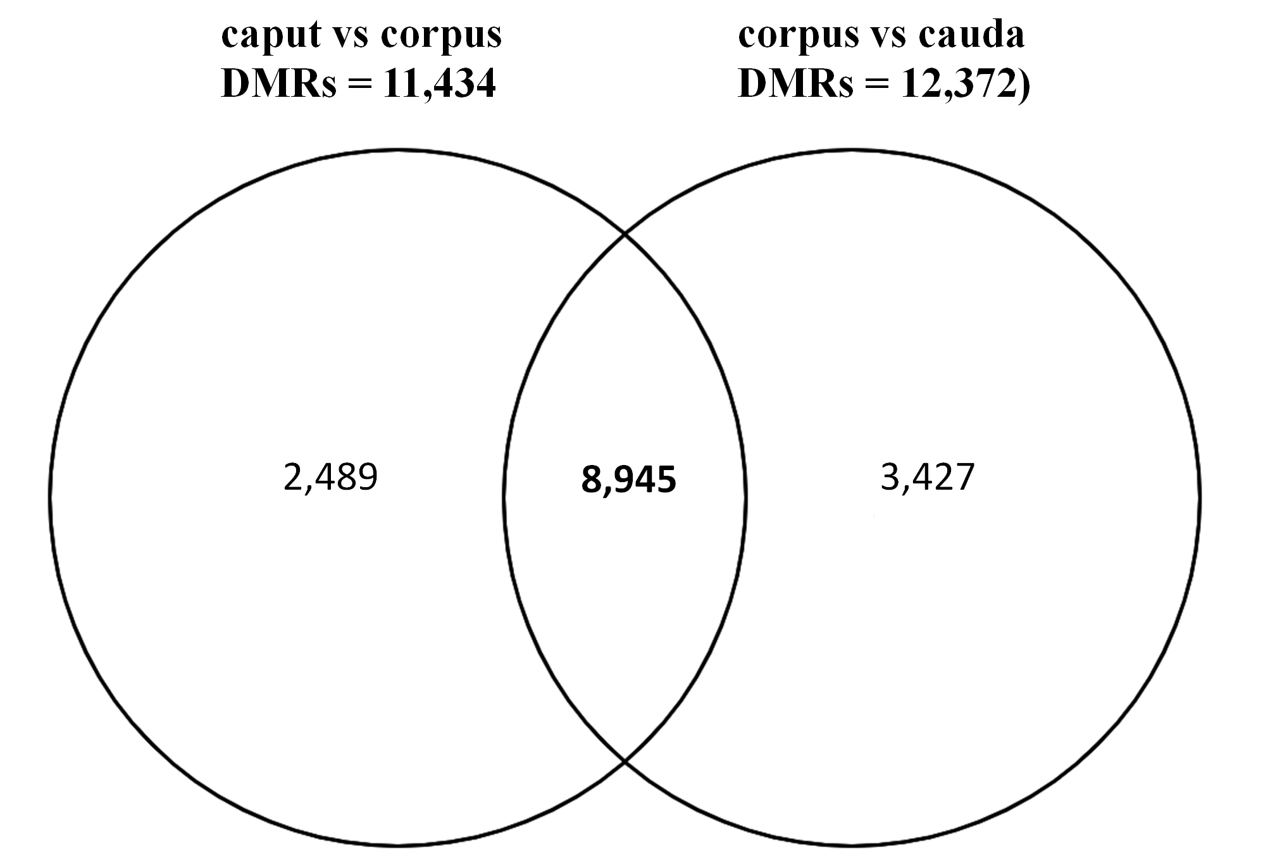
Additional File 5. Venny Diagram of 8,945 DMRs shared between caput vs corpus (DMRs = 11,434), corpus vs cauda (DMRs = 12,372).

