Supplementary Figure 1. Histogram showing the age distribution for samples in each GTEx tissue type.

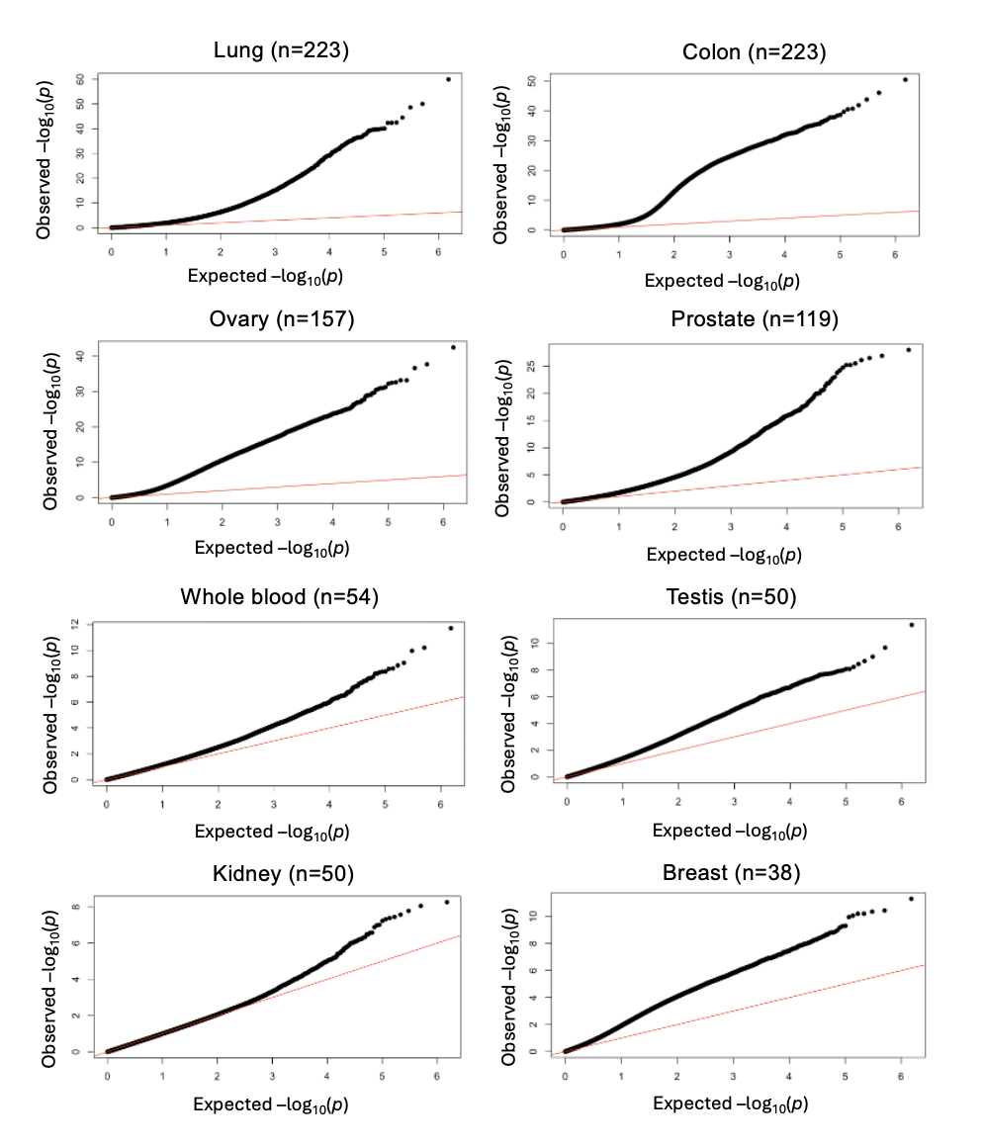
Supplementary Figure 2. Quantile-quantile plots of P values showing the association between chronological age and DNAm by tissue type.

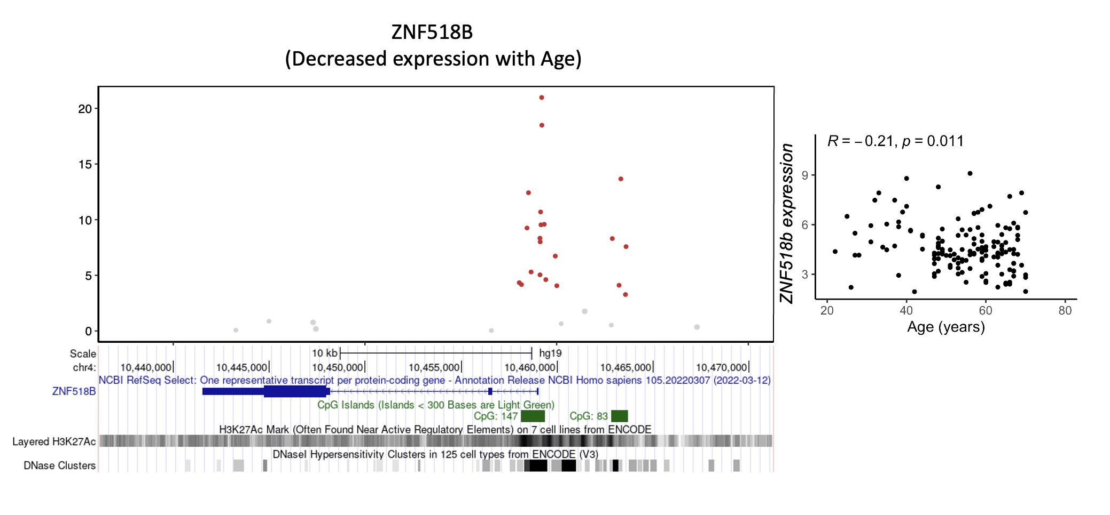
-log10 P

Supplementary Figure 3. Association of age with DNA methylation and expression of ZNF518B region in lung tissue. Pearson’s correlation coefficient (R) and Pearson’s correlation P value reported for expression scatterplots. Red dot indicates hypermethylation at CpG site with increasing age.

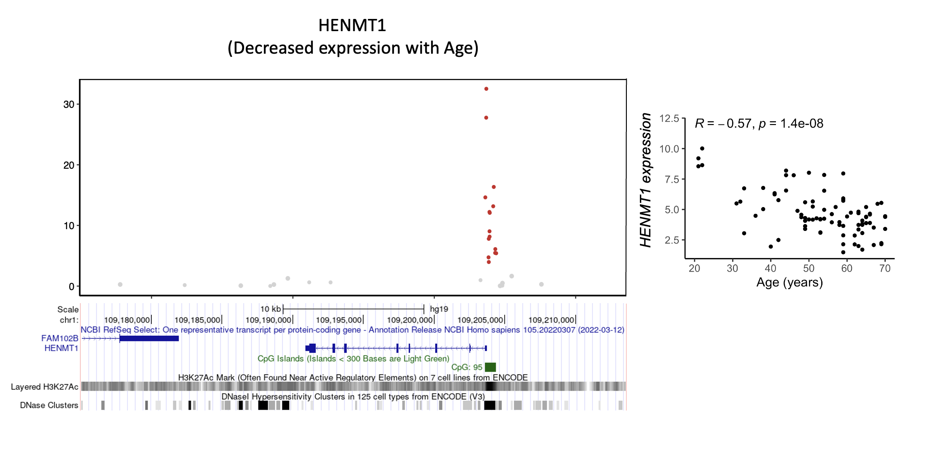
-log10 P
Supplementary Figure 4. Association of age with DNA methylation and expression of HENMT1 region in in colon tissue. Pearson’s correlation coefficient (R) and Pearson’s correlation P value reported for expression scatterplots. Red dot indicates hypermethylation at CpG site with increasing age.

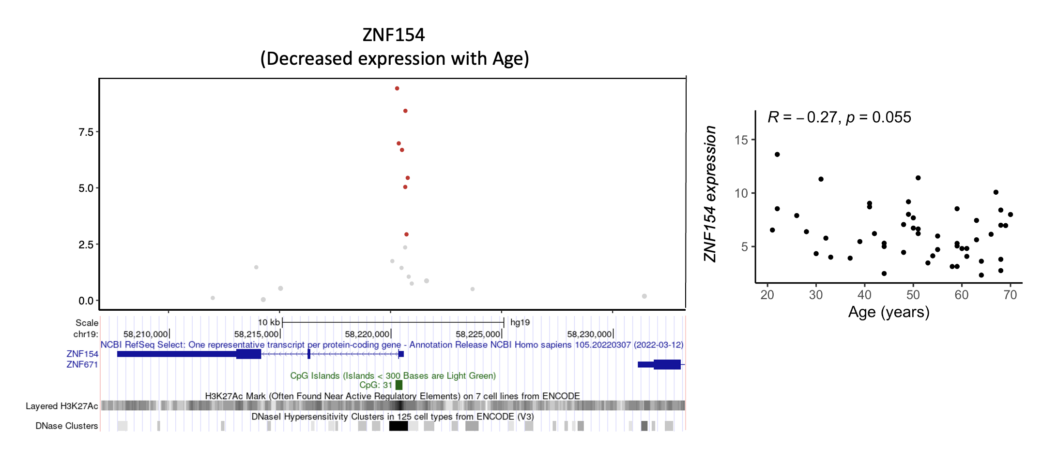
-log10 P
Supplementary Figure 5. Association of age with DNA methylation and expression of ZNF154 region in prostate tissue. Pearson’s correlation coefficient (R) and Pearson’s correlation P value reported for expression scatterplots. Red dot indicates hypermethylation at CpG site with increasing age.

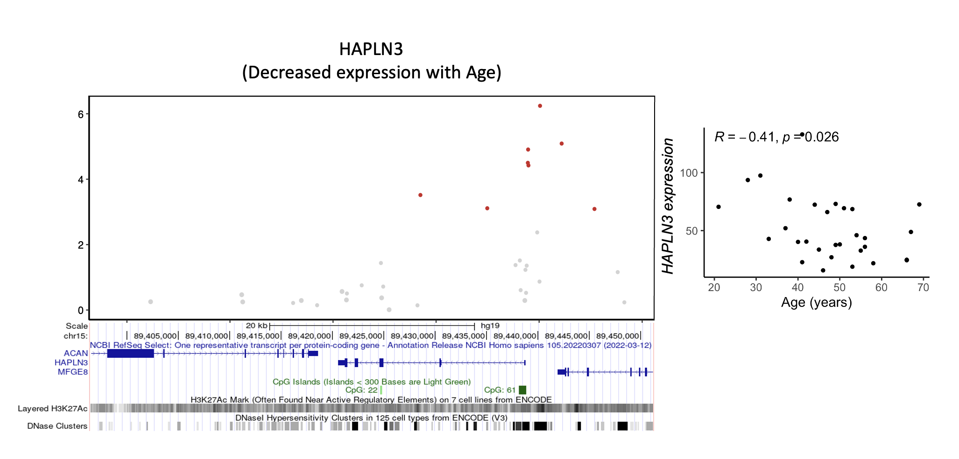
-log10 P
Supplementary Figure 6. Association of age with DNA methylation and expression of HAPLN3 region in breast tissue. Pearson’s correlation coefficient (R) and Pearson’s correlation P value reported for expression scatterplots. Red dot indicates hypermethylation at CpG site with increasing age.

