Supplemental Materials for

H3.3K122A results in a neomorphic phenotype in mouse embryonic stem cells

Benjamin J. Patty¹, Cailin Jordan^{1,2}, Santana M. Lardo¹, Kris Troy^{1,3}, Sarah J. Hainer^{1,4*}
¹Department of Biological Sciences, University of Pittsburgh, Pittsburgh, PA USA
²Current address: Basic Sciences Division, Fred Hutchinson Cancer Center, Seattle, WA USA
³Current address: Molecular, Cellular, and Developmental Biology Department, University of California Santa Barbara, Santa Barbara, CA USA
⁴UPMC Hillman Cancer Center, University of Pittsburgh, Pittsburgh, PA USA
*correspondence: sarah.hainer@pitt.edu

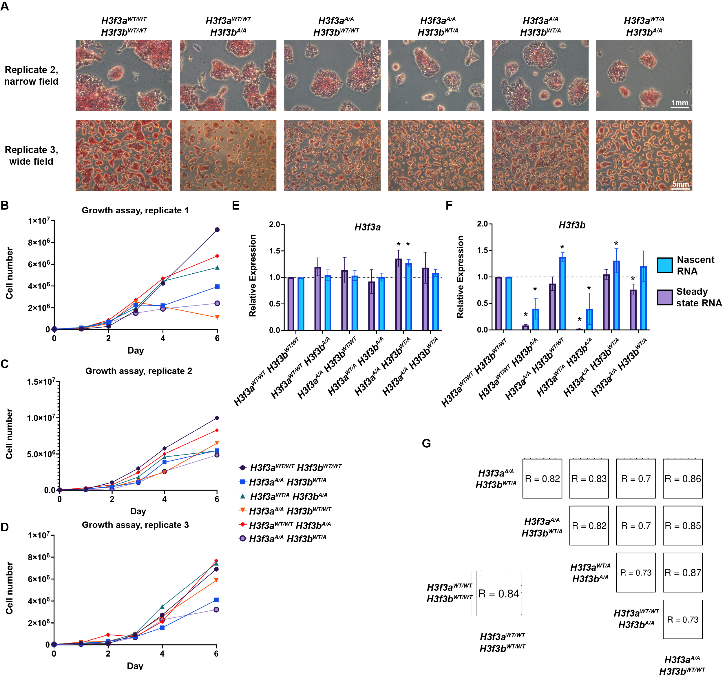
Supplemental Figure 1. H3.3K122A cell lines have several phenotypic distinctions from wildtype ES cells.
- Two biological replicates of Alkaline Phosphatase (AP) staining for wildtype and H3.3K122A targeted cell lines.
- Biological replicate 1 of 6-day growth assays for wildtype and H3.3K122A cell lines.
- As in B, replicate 2.
- As in B, replicate 3.
- Nascent (blue) and total RT-qPCR (purple) for H3f3a expression in wildtype and H3.3K122A cell lines. Representative of average and standard deviation of three biological replicates.
- As in A, for H3f3b expression.
- Spearman’s Rho of log₁₀(normalized counts) of H3.3 CUT&RUN for wildtype, single and dual targeted cell lines over H3.3 consensus peaks.
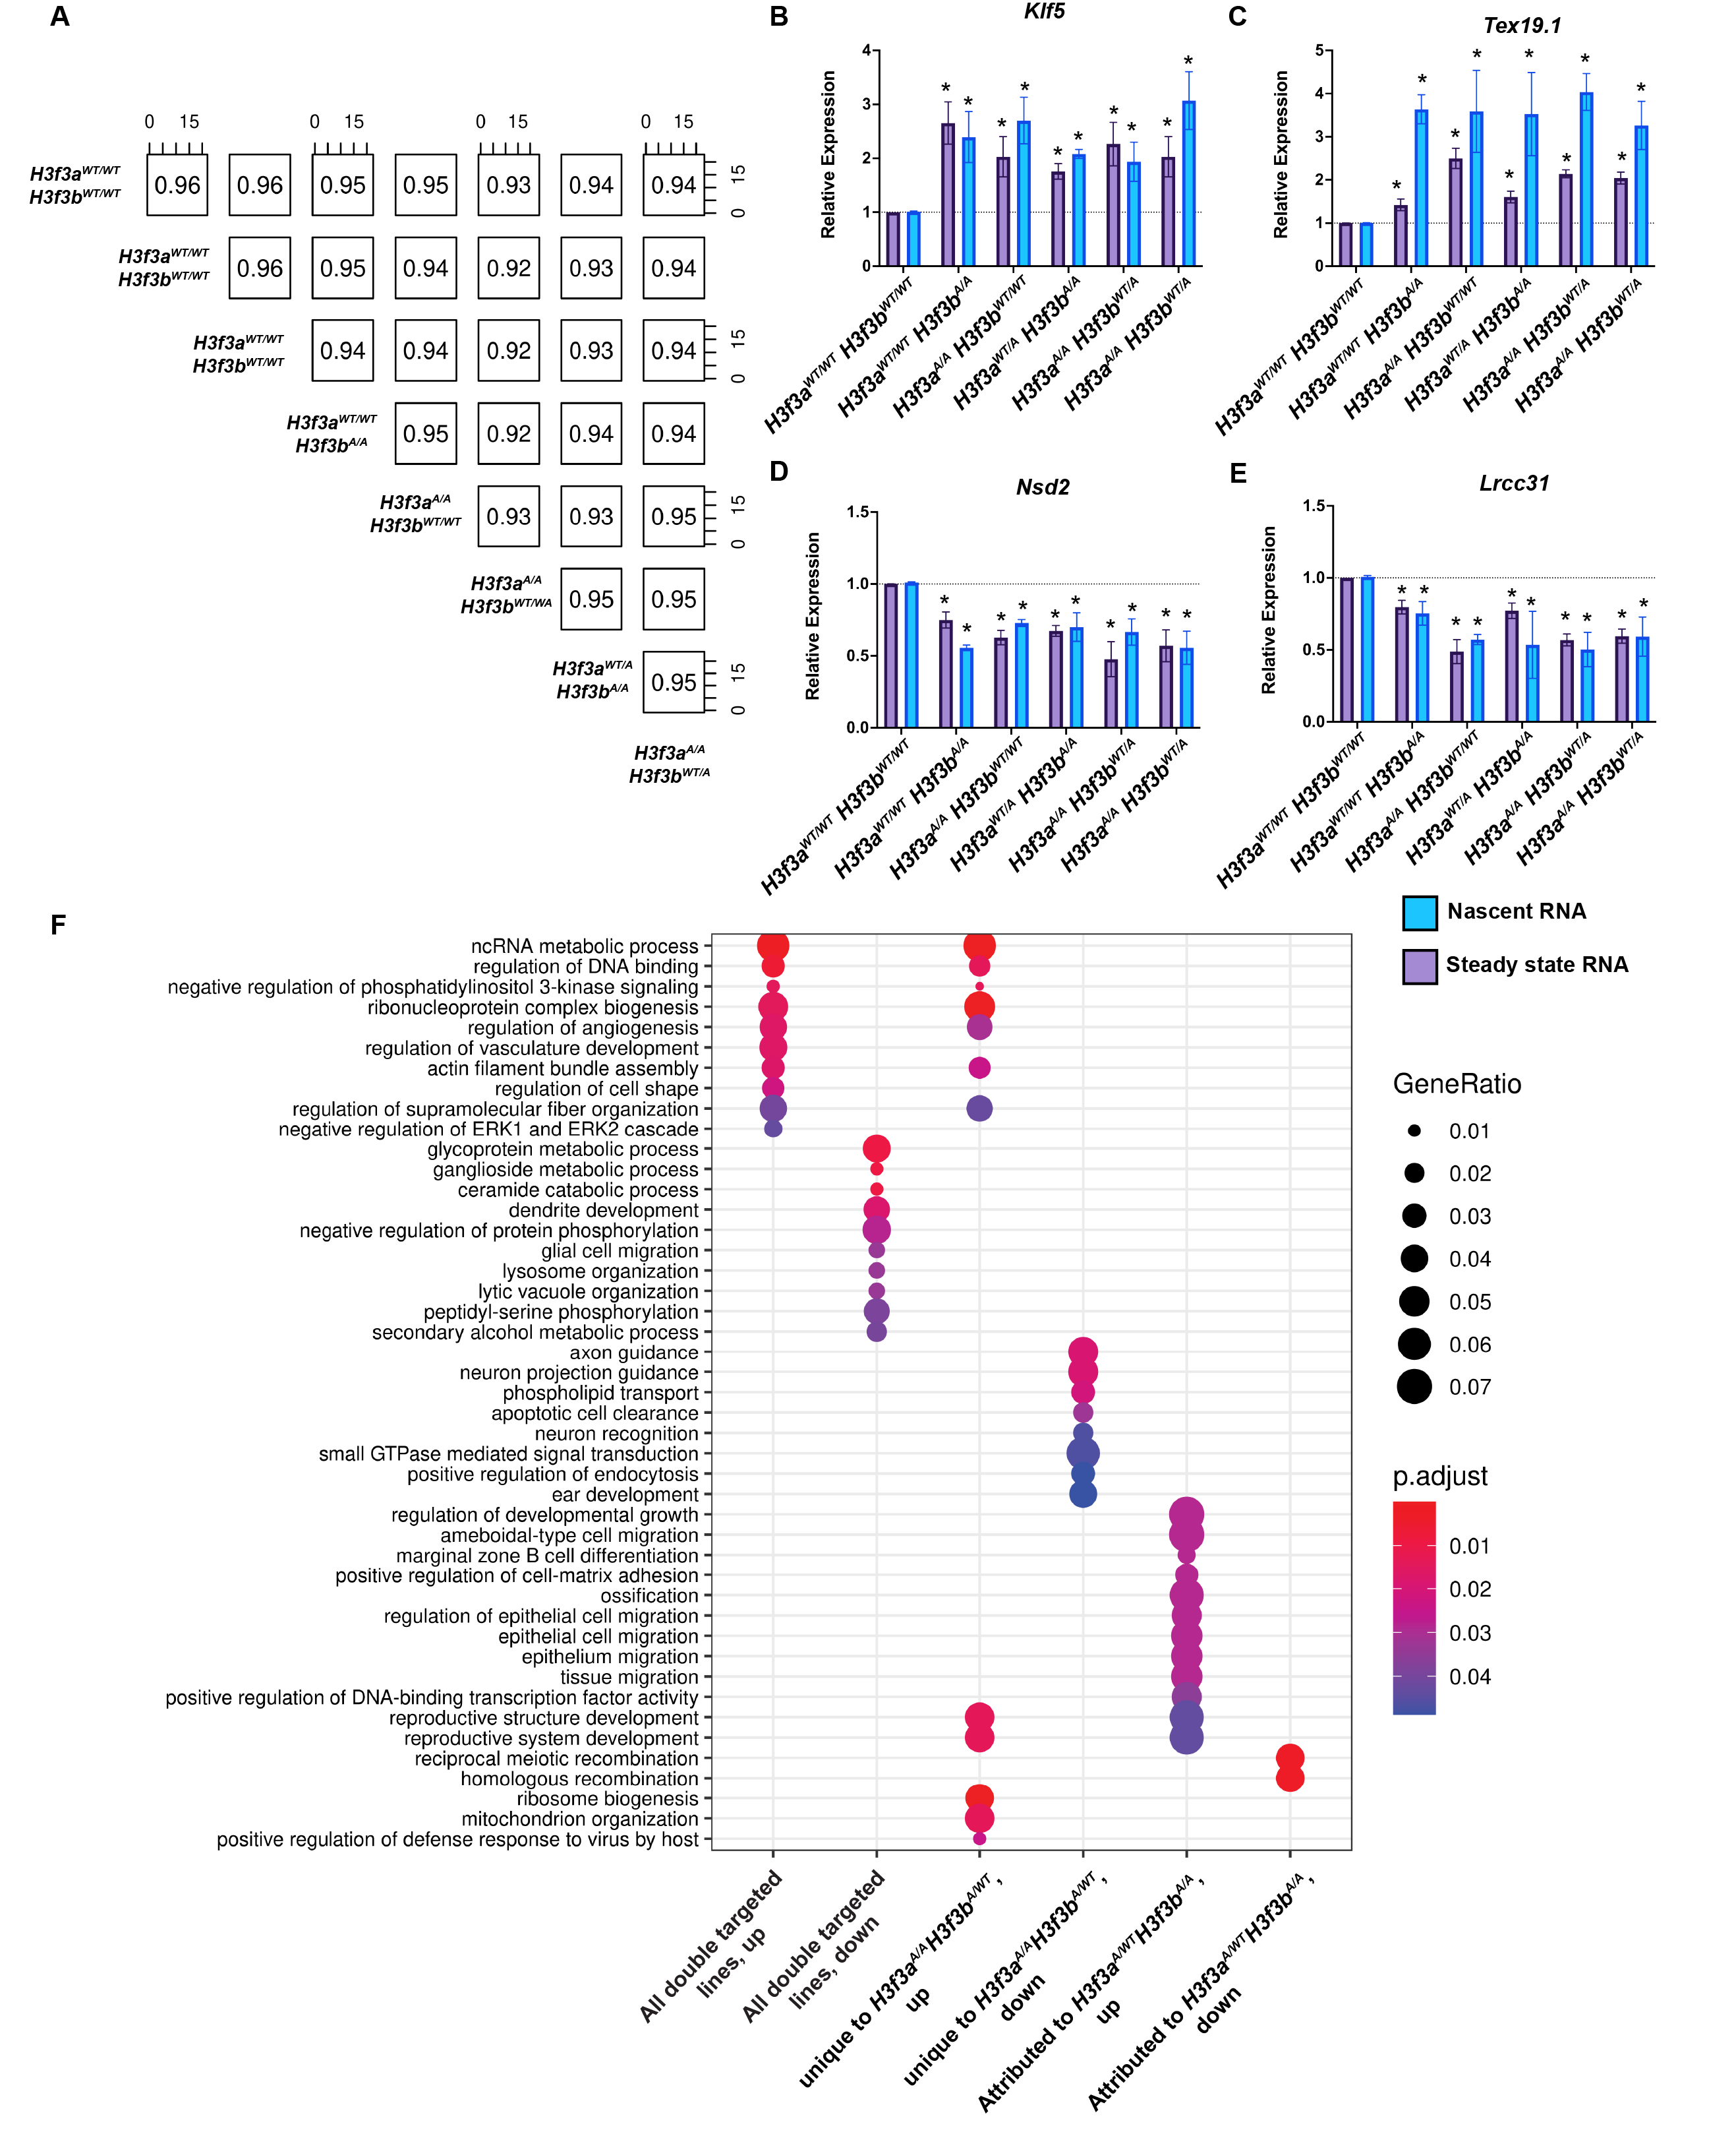
Supplemental Figure 2. Transcriptomic differences between targeted and wildtype mES cells.
- Spearman’s Rho of log₁₀(normalized counts) for all Gencode features for TT-seq datasets for wildtype, single targeted, and dual targeted cell lines. Each colored square indicates the cell line.
- Nascent (blue) and total RT-qPCR (purple) for Klf5 expression in wildtype and H3K122A cell lines. Representative of average and standard deviation of three biological replicates.
- As in B, for Tex19.1.
- As in B, for Nsd2.
- As in B, for Lrrc31.
- GO terms enriched within differentially expressed genes unique to each indicated gene sets, as detailed in Figure 4G.

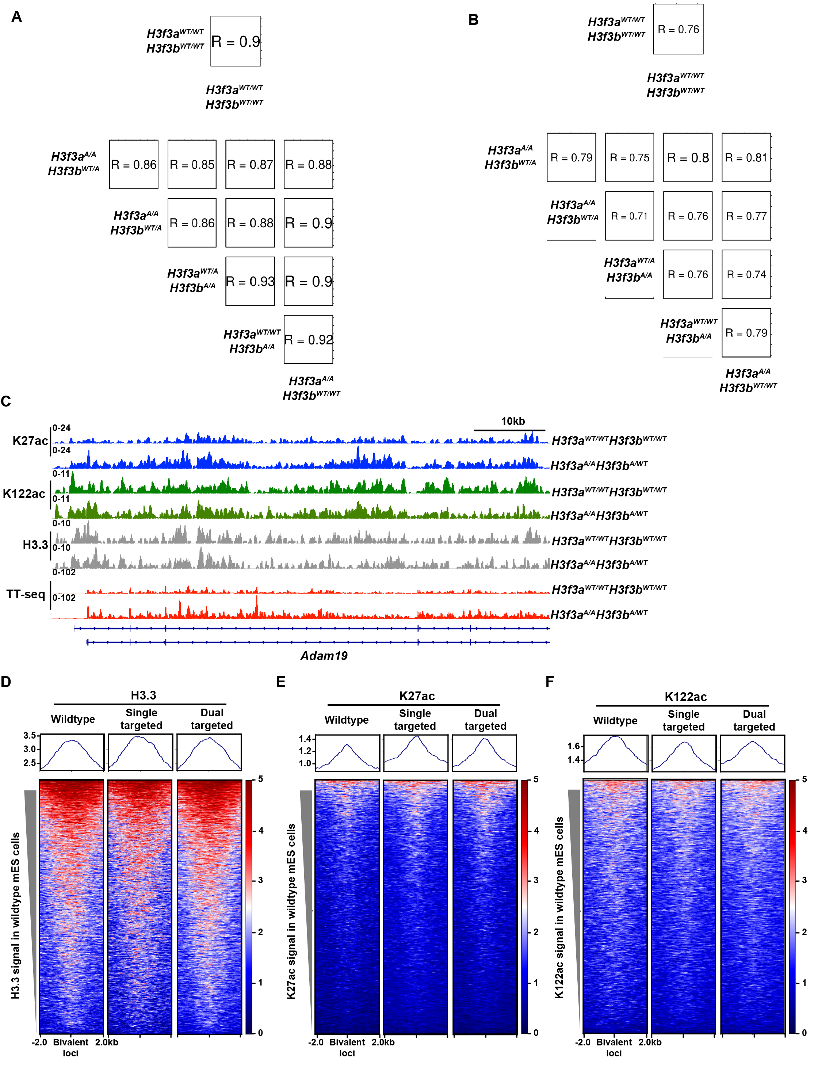
Supplemental Figure 3. Comparison of K27ac and K122ac enrichment over peaks in H3.3K122A and wildtype ES cells.
- Spearman’s Rho of log₁₀(normalized counts) of K27ac CUT&RUN for wildtype, single and dual targeted cell lines over K27ac consensus peaks (from this study). Each colored square indicates the cell line.
- As in A, for K122ac CUT&RUN over K122ac consensus peaks called using previously published K122ac ChIP-seq data²⁶.
- Browser track showing replicate averaged enrichment of K27ac (blue), K122ac (green), H3.3 (grey), and sense nascent transcription (red) over the 5’ end of the Adam19 locus in H3f3a^{A/A}H3f3b^{A/WT} and wildtype mES cells.
- Enrichment of H3.3 CUT&RUN signal in averaged wildtype (n=2), single targeted (n=2), and dual targeted cell lines (n=3) over bivalent loci⁵⁷.
- Enrichment of K27ac CUT&RUN signal in averaged wildtype (n=2), single targeted (n=2), and dual targeted cell lines (n=3) over bivalent loci⁵⁷.
- Enrichment of K122ac CUT&RUN signal over averaged wildtype (n=2), single targeted (n=2), and dual targeted cell lines (n=3) over bivalent loci⁵⁷.

Supplemental Table 1. H3.3K122A targeting results
Cell Line | Clones screened | WT | hetereozygote | homozygote
Targeting 1: H3f3a K122A H3f3b untargeted | 100 | 44 | 44 | 12
Targeting 1:  H3f3a untargeted H3f3b K122A | 264 | 53 | 151 | 60
Targeting 2:  H3f3a^{A/A}  Target H3f3b K122A | 263 | 216 | 47 | 0
Targeting 2:  Target H3f3a K122A  H3f3b^{A/A} | 234 | 142 | 92 | 0
Targeting 3 (in 2i):  H3f3a^{A/A}  Target H3f3b K122A | 256 | 166 | 90 | 0

Supplemental Table 2. Oligos used in this study.

Name | Sequence
H3f3a K122A guide + | 5’ CACCGCGCGTATGCGGCGTGCTAGC
H3f3a K122A guide - | 5’ AAACGCTAGCACGCCGCATACGCG
H3f3b K122A guide + | 5’ CACCGAAGCTCTCTCCCCCCGTATC
H3f3b K122A guide - | 5’ AAACGATACGGGGGGAGAGAGCTT
H3f3a PCR check targeting F | 5’ TCTTGATGTTTTGTGAGGCTGT
H3f3a PCR check targeting R | 5’ ACGTGGAGAAACGCCAATAC
H3f3b PCR check targeting F | 5’ GCGGCTTGATTGCTCCAGTA
H3f3b PCR check targeting R | 5’ CTTGTCACTCCTGAGCCACA
H3f3b esiRNA F | 5’ GGGCGGGTCATGGGAGTAAGAACACAGCTTC
H3f3b esiRNA R | 5’ GGGCGGGTTTGTAAGGCCTATTAGAAAGATCCA
H3f3a CRISPRi guide | 5’ GCGAGTTTGCCTTCCGCGGGC
H3f3a total qPCR primer F | 5' ACAAAAGCCGCTCGCAAGAG
H3f3a total qPCR primer R | 5' ATTTCTCGCACCAGACGCTG
H3f3a nascent qPCR primer F | 5' TTGCTCAGGACTTCAAAACAGA
H3f3a nascent qPCR primer R | 5' GGCTTTTAATGACAGCTACACG
H3f3b total qPCR primer F | 5' TGGCTCTGAGAGAGATCCGTCGTT
H3f3b total qPCR primer R | 5' GGATGTCTTTGGGCATGATGGTGAC
H3f3b nascent qPCR primer F | 5' CTTGATTGCTCCAGTAGGAGTG
H3f3b nascent qPCR primer R | 5' GCCATAAAAACCGCTTCAAC
Klf4 total qPCR primer F | 5' CCCGTCCTTCTCCACGTTC
Klf4 total qPCR primer R | 5' GTTCCTCACGCCAACGGTTA
Klf4 nascent qPCR primer F | 5' TTTGTGCTGAAGGCGGCTT
Klf4 nascent qPCR primer R | 5' TGGGCTTCCTTTGCTAACT
Klf5 total qPCR primer F | 5' GAGGACTCATACGGGCGAGA
Klf5 total qPCR primer R | 5' CTTCCTGTAGTGGCGGGTC
Klf5 nascent qPCR primer F | 5' ACGTACACCATGCCAAAGTCA
Klf5 nascent qPCR primer R | 5' TATCGGGACTTCCAGGCTTCT
Tex19.1 total qPCR primer F | 5' TGTCTGCAGCTAAGCGGAC
Tex19.1 total qPCR primer R | 5' ATATTGGAGCAAGTGTGAAGCTGA
Tex19.1 nascent qPCR primer F | 5' GGGGATTGGGGGTCCCTTTATG
Tex19.1 nascent qPCR primer R | 5' AGAGCTCAGTGGGCAAAA
Nsd2 total qPCR primer F | 5' TGAAGAAGCGAAATCGGGCT
Nsd2 total qPCR primer R | 5' GCTGTCTGAGACCTCATGCT
Nsd2 nascent qPCR primer F | 5' GCCCCAGAAAGAGCTTTGGAT
Nsd2 nascent qPCR primer R | 5' CTGCTTGGCACTTTCTTGGC
Nsd3 total qPCR primer F | 5' CGGTGTCTCTCCTGTGATCG
Nsd3 total qPCR primer R | 5' TCTCTCATCGAGCCTTCAGT
Nsd3 nascent qPCR primer F | 5' GCCACCTCCTGTTAAAATCGC
Nsd3 nascent qPCR primer R | 5' TAGGCTCCCTTTGTGCATTGTT
Lrcc31 total qPCR primer F | 5' TAAGTCTGTCGTGGAACAGCC
Lrcc31 total qPCR primer R | 5' GCACTTCTTAATCCTTGCGCT
Lrcc31 nascent qPCR primer F | 5' GTCTAGACCCGTGTCAGCAG
Lrcc31 nascent qPCR primer R | 5' TGACTTAGAAATGCACCTGAAATCC
Chd9 total qPCR primer F | 5' GGTGGGACTTTGATGCTGAT
Chd9 total qPCR primer R | 5' CCCACTCTTTCCAAGAAGCA
Chd9 nascent qPCR primer F | 5' TCACAGGCTACTGGAGACCCA
Chd9 nascent qPCR primer R | 5' GGGTTTGGAGTTAGGGGCTC
Gapdh qPCR primer F | 5’ TTGATGGCAACAATCTCCAC
Gapdh qPCR primer R | 5’ CGTCCCGTAGACAAAATGGT

Supplemental Table 3. Homology construct sequences for K122A cell line generation. The codon change and PAM mutation are indicated in bolded red.
Homology construct | Sequence
H3f3a K122A | 5’ AAATTACACGCTAAGGATCTGGAAGAAAGCACTTTGGAGCTGGTAATAAGCCAATT  GGGACAAGGTCCTGAGTTCAATCCTCAGCATTCCAGAGTGGAAGCAGAAGGTAAACG  TGAGGCCCATTGCGGGATCCTGGGCTGCCTTAGTGATGAGTTCCAATACACTTCCTCT  GGTAAGGATGAGGACGTTAGGATTTGTTGGTTTCTTTGAGGCCATTTGTTTACTAGGGA  GCGTGTTAACATTTGGAGTATTGAAGTGTCTTGATGTTTTGTGAGGCTGTAGAAAACTTT  GTGAACTTAGGCATCTTGACAGGTTTCTATGTGAGCGTTTGATAAATTCTTTAAAGGGTT  TTACTGTGTAAGTGTATTTTAACTGTTGGAAACAATACCACTAAGTCATTTCTCTTTTATT  GTTGCAGGAGGCAAGTGAGGCCTATCTGGTTGGCCTTTTTGAAGATACCAATCTGTGTG  CTATCCATGCCAAACGTGTAACAATTATGCCAGCCGATATTCAGCTAGCACGCCGCATA  CGCGGAGAACGTGCTTAAGAGTCCACTATGAGGGGAAACATTTCATTCTCAAAAAAATTT  TTTTTCCTCTTCTTCCTGTTATCAGTAGTTCTGAATGTTAGATATTTTTTCCATGGGGTCAA  AGGTACCTAAGTATATGATTGCGAGTGGAAACATAGGGGACAGAATCAGGTATTGGCGTT  TCTCCACGTTCATTTGTGTGTGAATTTTTAATATAAATGCAAGATGGAAAGCATTAATGCAA  GCAAAATGTTTCAGTGAACACATTTCAACAGTTCAACTTTATAACAATTATAAATAAACCTGT  TAAAATTTTCTGGACAATGCCAGCATTTGGATTTTTTTAAAATAAGTAAATTTCTTATTGACG  GCAACTAAATGGTGTTTGTAGCATTTTTATCACACAGTAGATTCCATCCATTCACTATACTTT  TCTAACTGAGTTGTCCTACATACAAGTACATGTTTT
H3f3b K122A | 5’ AACAGCTGGCCACCAAGGCGGCTCGGAAAAGCGCGCCCTCTACCGGCGGGGTGAAGA  AGCCTCACCGCTACAGGTAGGCAGAGGGCTGGGAACAATGACTTGGCCGCCGGCTTGCG  GGCGGGCGCTCTCTCCCTTCTCCCTGACCGTTGACGCCTTCCTTCTTCTGGTGACTGCAG  GCCAGGGACCGTGGCTCTGAGAGAGATCCGTCGTTACCAGAAATCGACTGAGCTGCTCAT  CCGGAAGCTGCCATTCCAGAGATTGGTGAGGGAGATCGCCCAGGATTTCAAAACCGACTT  GAGGTTTCAAAGTGCAGCCATCGGTGCCCTTCAGGTAAAGGGACAAAAGGCTTGGTGGCA  CTCGGGGCGGCGGCTTGATTGCTCCAGTAGGAGTGTTAATGCTGTTGCTCTTGTCCTCAAC  AGGAGGCTAGCGAAGCATACCTGGTGGGGTTGTTTGAAGATACCAATCTGTGTGCCATCCA  CGCCAAGAGAGTCACCATCATGCCCGCCGACATCCAGTTGGCTCGGCGGATACGGGGGGA  GAGAGCTTAAGTTGAAGCGGTTTTTATGGCATTTTGTAGTAAATTCTGTAAAATACTTTGGTT  TAATTTGTGACTTTTTTTGTAAGAAATTGTTTATAATATGTTGCATTTGTACTTAAGTCATTC  CATCTTTCACTCAGGATGAATGGGAAGAGTGACTGACTGTTCACAGACCTCAGTGATGTGA  GCACTGTGGCTCAGGAGTGACAAGTTGCTAATACGCAGAAGGGATGGGTGATACTTCTTGC  TTTTCATGATGCATGTTTCTGTATGTTAATGACTTGTTGGGTAGCTATTAAGGTACTAGAATT  GATAAATGTGTACAGGGTCCTTTTGCAATAAAACTGGTTATGACTTGATCCAAGTGTTTAACC  ATACATCACTGTGATAGAATGTGGGCTTTTTCAAAGGTTGAAGATACAAGTTTTAGCCACAG  TGTAACAGTTTCCTTTAAAAAAAA

