Table of Contents

Fig_S1: The mean empirical cumulative distribution function (ECDF) of CpG reads per NGS method prior to down-sampling to 29x coverage.
Fig_S2: The ECDF of CpG reads per NGS method calculated on each sample separately after down-sampling to 29× coverage.
Fig_S3: Overlapping CpG sites targeted by the different methods.
Fig_S4: Violin plots representing the coverage of genomic structural elements per sample and method.
Fig_S5: Methylation KDE per method calculated on each sample separately.
Fig_S6: Coverage and methylation distribution paired comparisons among NGS methods for the three samples.
Fig_S7: Methylation distribution paired comparisons between EPIC and NGS methods for the three samples.
Fig_S8: Joint distributions of coverage versus methylation, per sample and NGS method.
Fig_S9: The detection of hyper- and hypomethylated regions by the methods of the overlapping CpGs at 29× coverage for the three samples.
Fig_S10: The average percentage of methylation observed for UCSC genes per sample and NGS method, from 10kb upstream of the TSS to 10kb downstream the TTS.

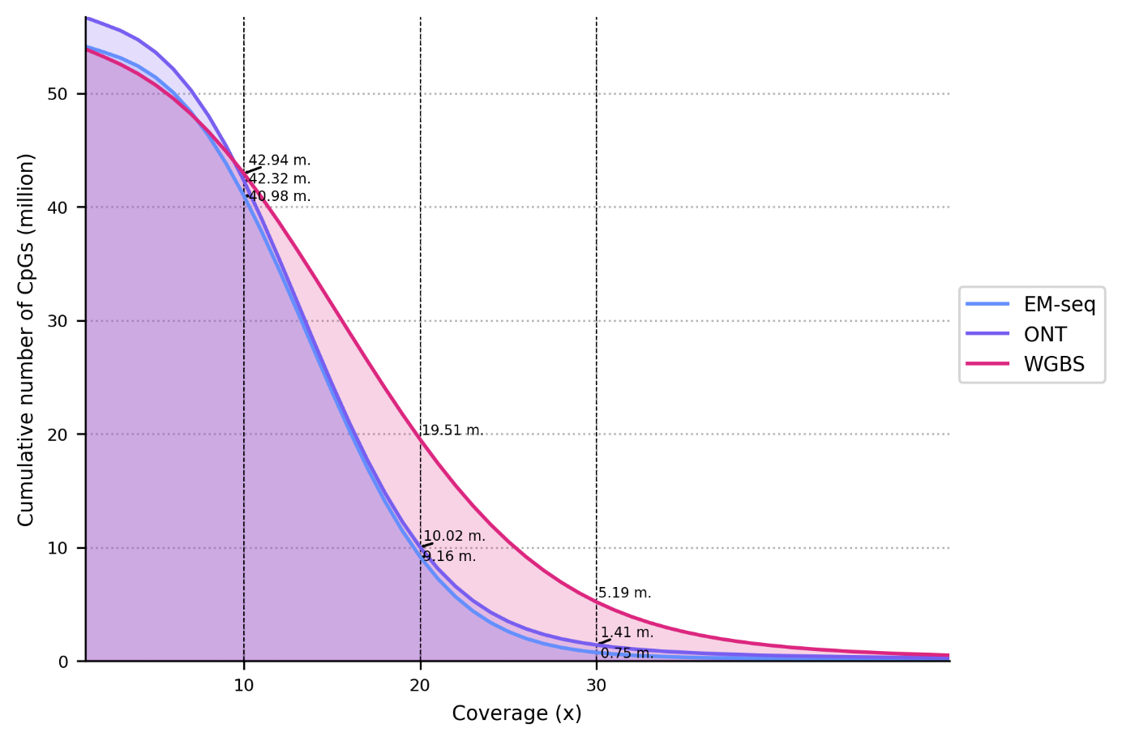
Figure S1: The mean empirical cumulative distribution function (ECDF) of CpG reads per NGS method prior to down-sampling to 29x coverage.

Figure S2: The ECDF of CpG reads per NGS method calculated on each sample separately after down-sampling to 29× coverage.

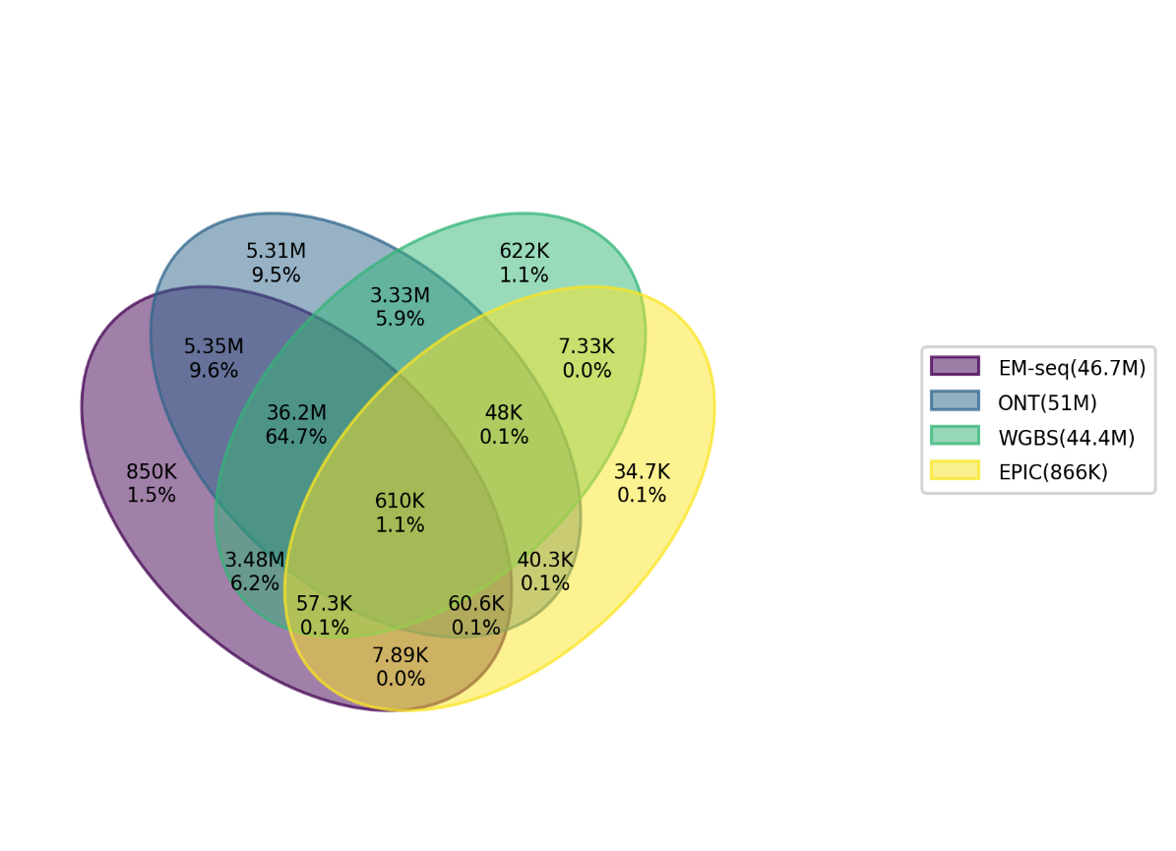
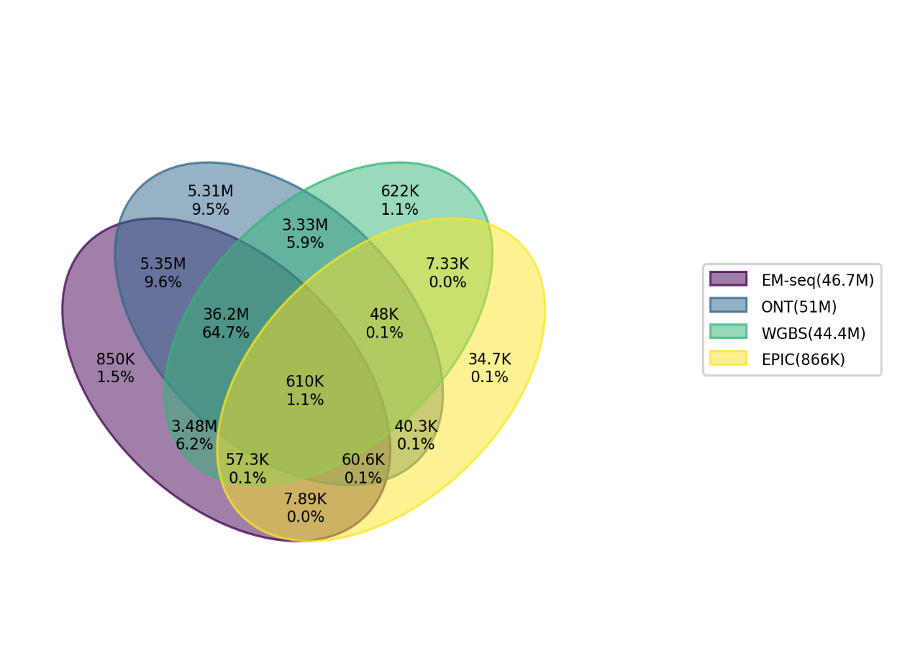
Figure S3: Overlapping CpG sites targeted by the different methods. Venn diagram showing the number of CpG sites having a coverage greater than 10×, identified in the pairwise comparisons.

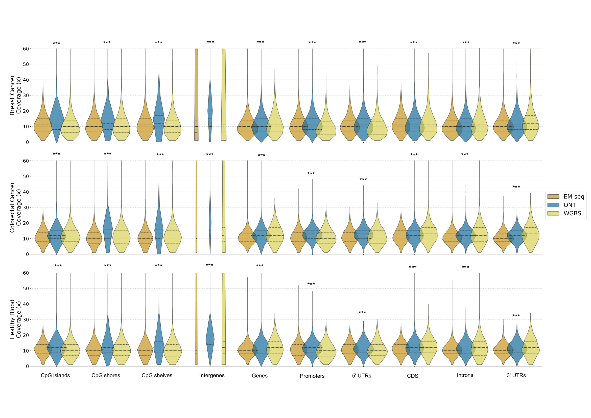
Figure S4: Violin plots representing the coverage of genomic structural elements per sample and method. ANOVA statistical significance is reported per structural group, indicated with ‘*’ for p = 0.01 – 0.05; ‘**’ for p = 0.001 – 0.01; and ‘***’ for p = 0 – 0.001.- above the corresponding plot.

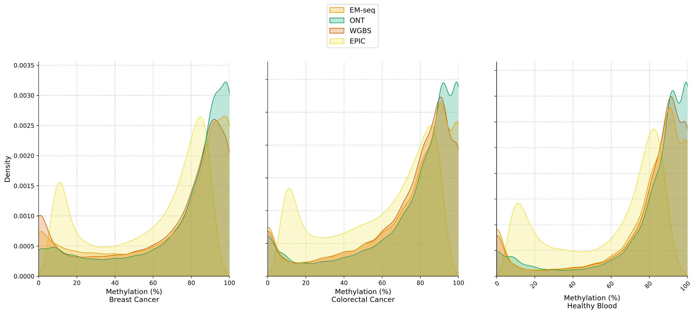
Figure S5: Methylation kernel density estimation (KDE) per method calculated on each sample separately. KDE was estimated using the seaborn kdeplot function.

Breast Cancer
Cell Line
A

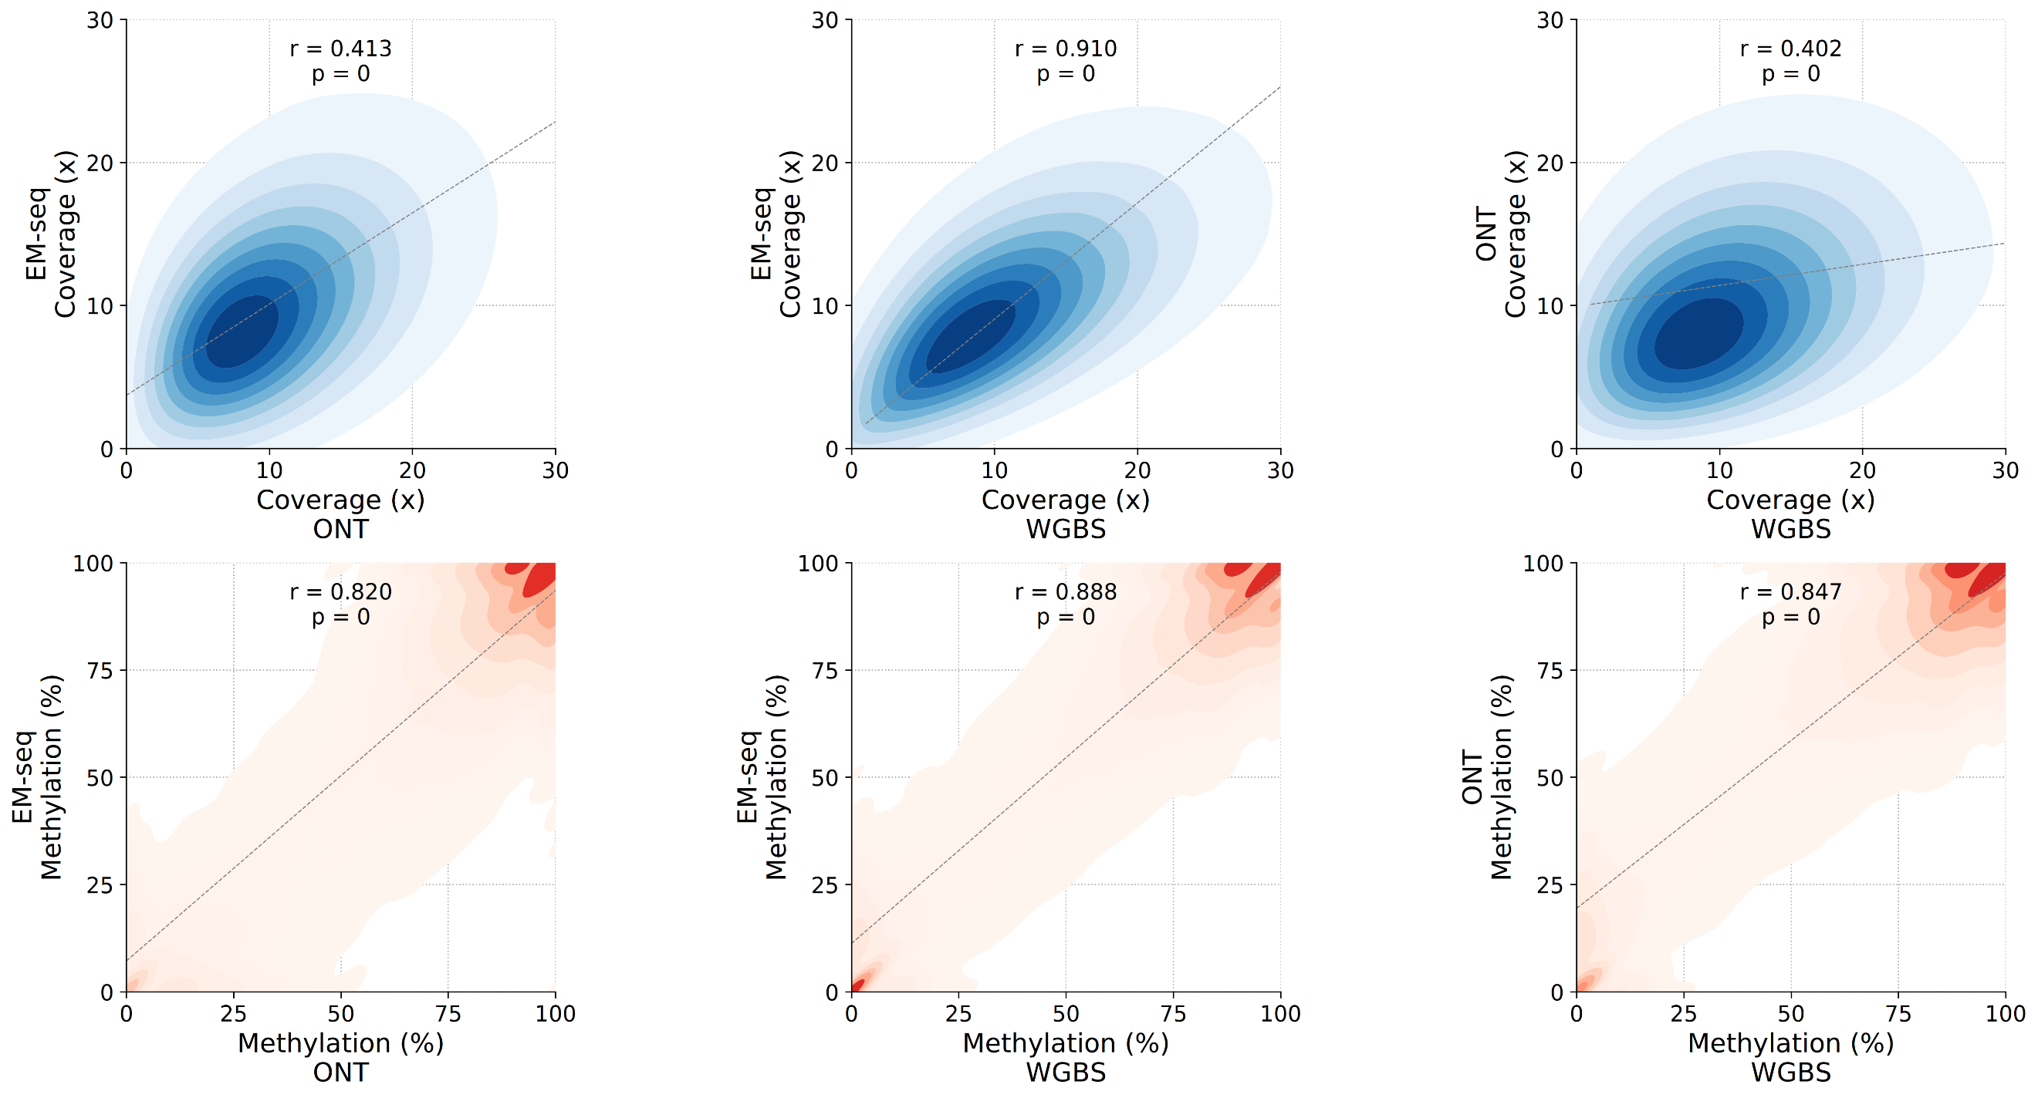

Colorectal Cancer Tissue
B

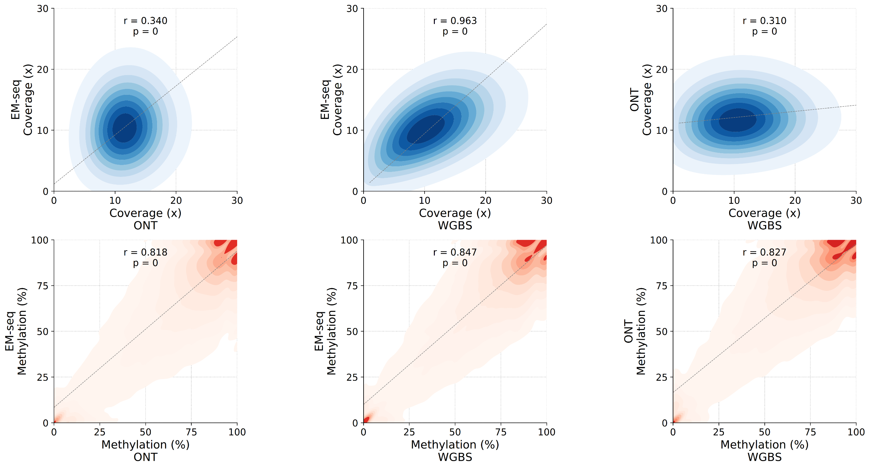

Healthy Blood

C

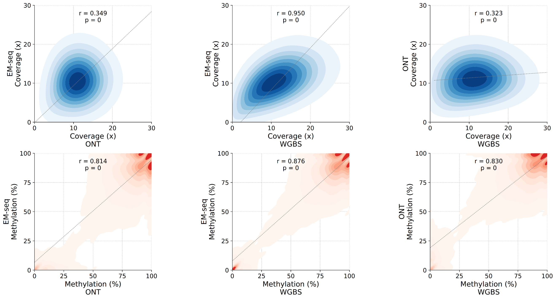

Figure S6: Coverage and methylation distribution paired comparisons among NGS methods for the three samples (A: Breast Cancer cell line; B: Colorectal Cancer Tissue; C: Healthy blood). In each comparison, only the sites that were jointly identified by both methods in the pair were included. Pearson correlation coefficient and p-values are reported in each comparison, computed using Pearson’s method from scipy stats module, measuring the linear relationship within the pair. The distributions were computed using seaborn kdeplot, and the regression line with seaborn regplot.

Breast Cancer | 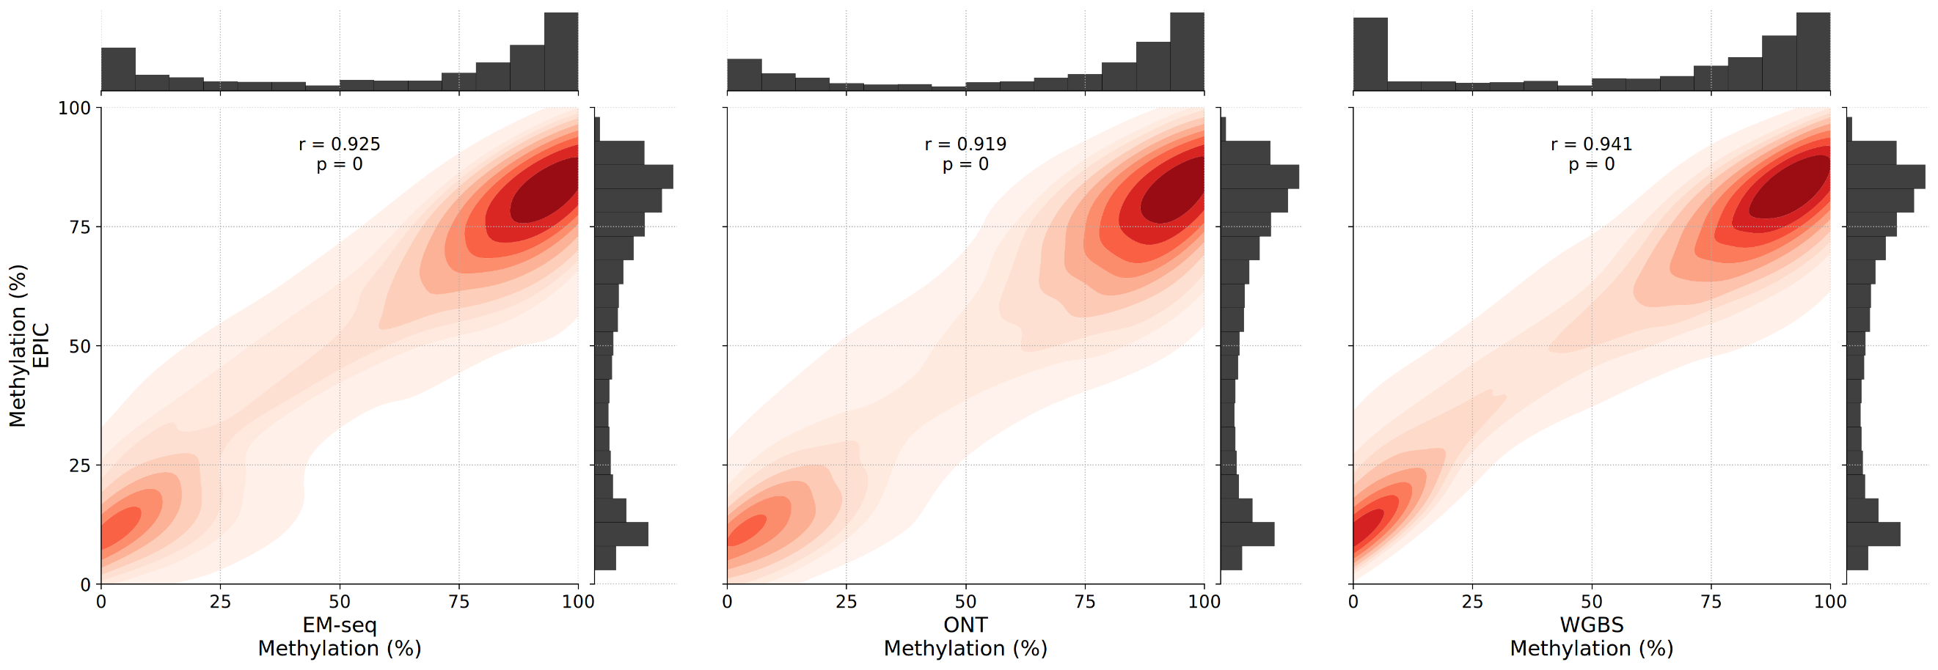
Colorectal Cancer | 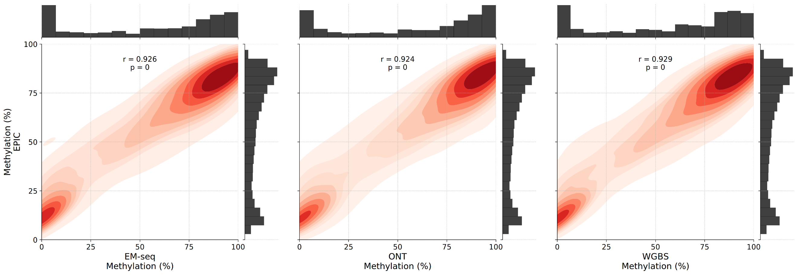
Healthy Blood | 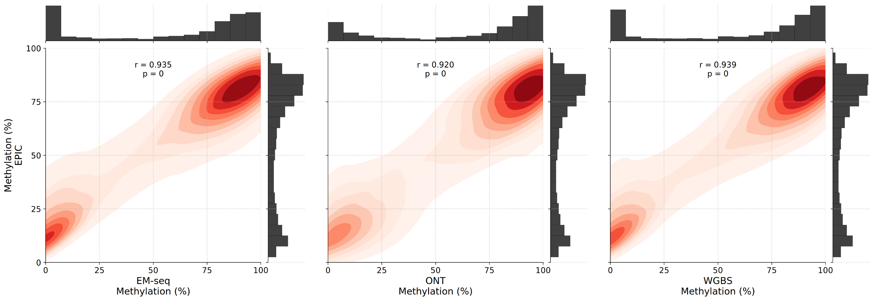

Figure S7: Methylation distribution paired comparisons between EPIC and NGS methods for the three samples. In each comparison, only the sites that were jointly identified by both methods in the pair were included. Pearson correlation coefficient and p-values are reported in each comparison, computed using Pearson’s method from scipy stats module, measuring the linear relationship within the pair. The distributions were computed using seaborn kdeplot, and the regression line with seaborn regplot.

 | EM-seq | ONT | WGBS
Breast Cancer | 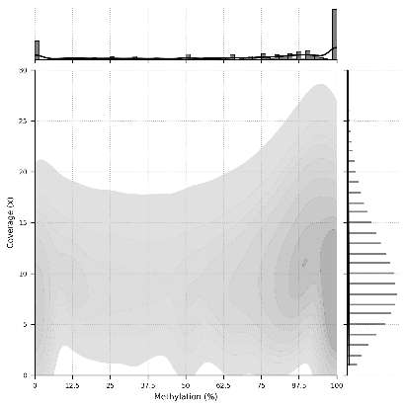 | 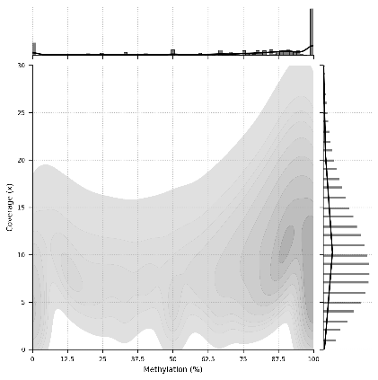 | 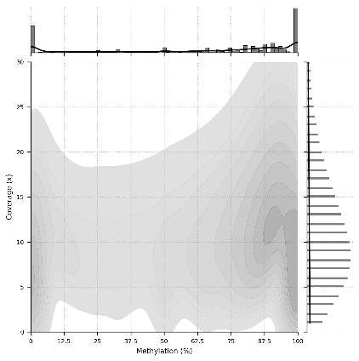
Colorectal Cancer | 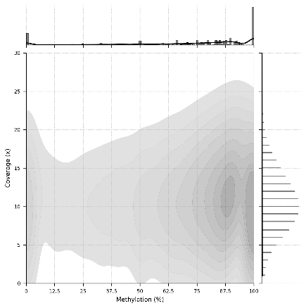 | 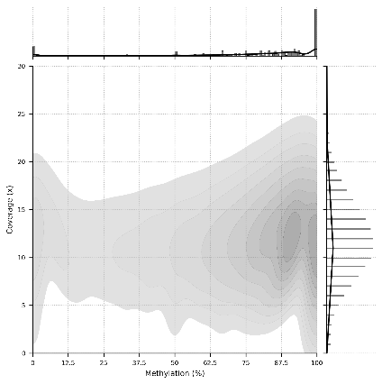 | 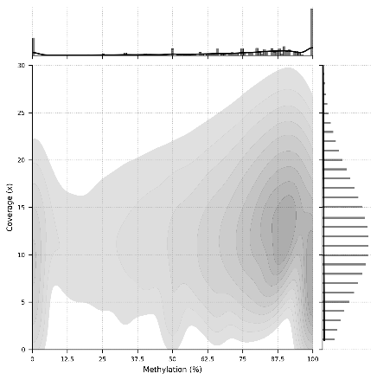
Healthy Blood | 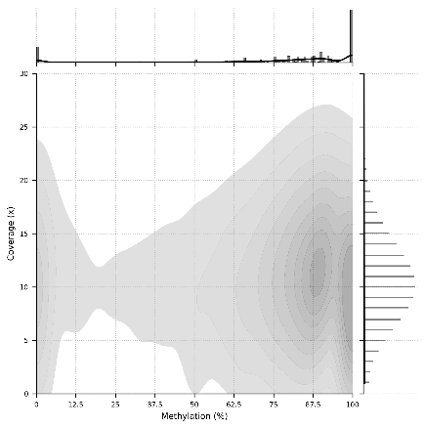 | 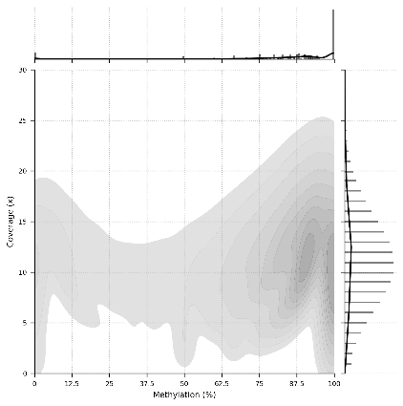 | 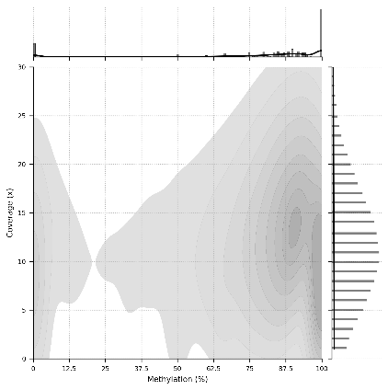

Figure S8: Joint distributions of coverage versus methylation, per sample and NGS method. The distributions were computed using seaborn kdeplot, with a minimum value to show threshold of 0.05. Marginal histograms with respective kernel densities are also shown, using seaborn histplot.

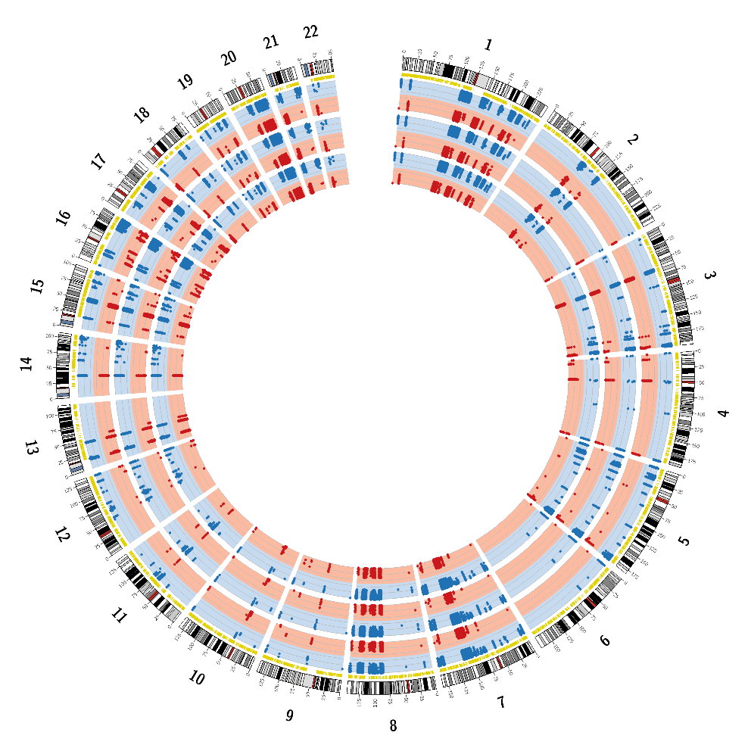
A

Breast Cancer
Cell Line

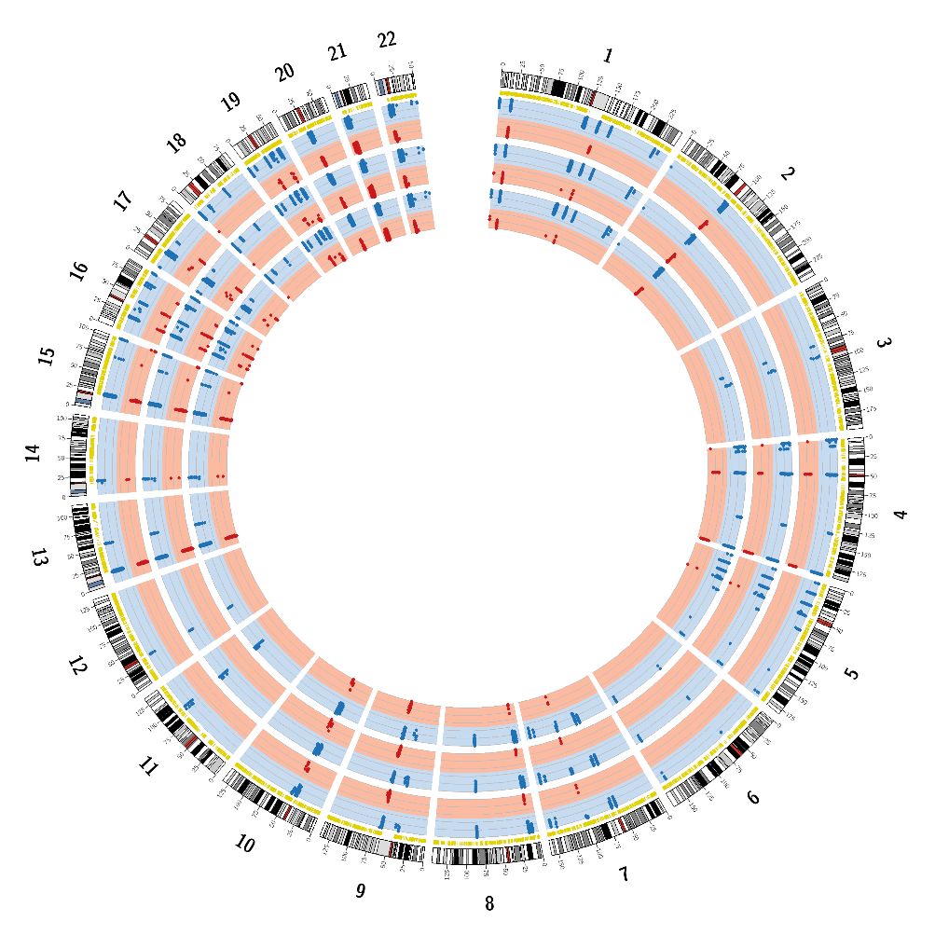
Colorectal Cancer Tissue
B
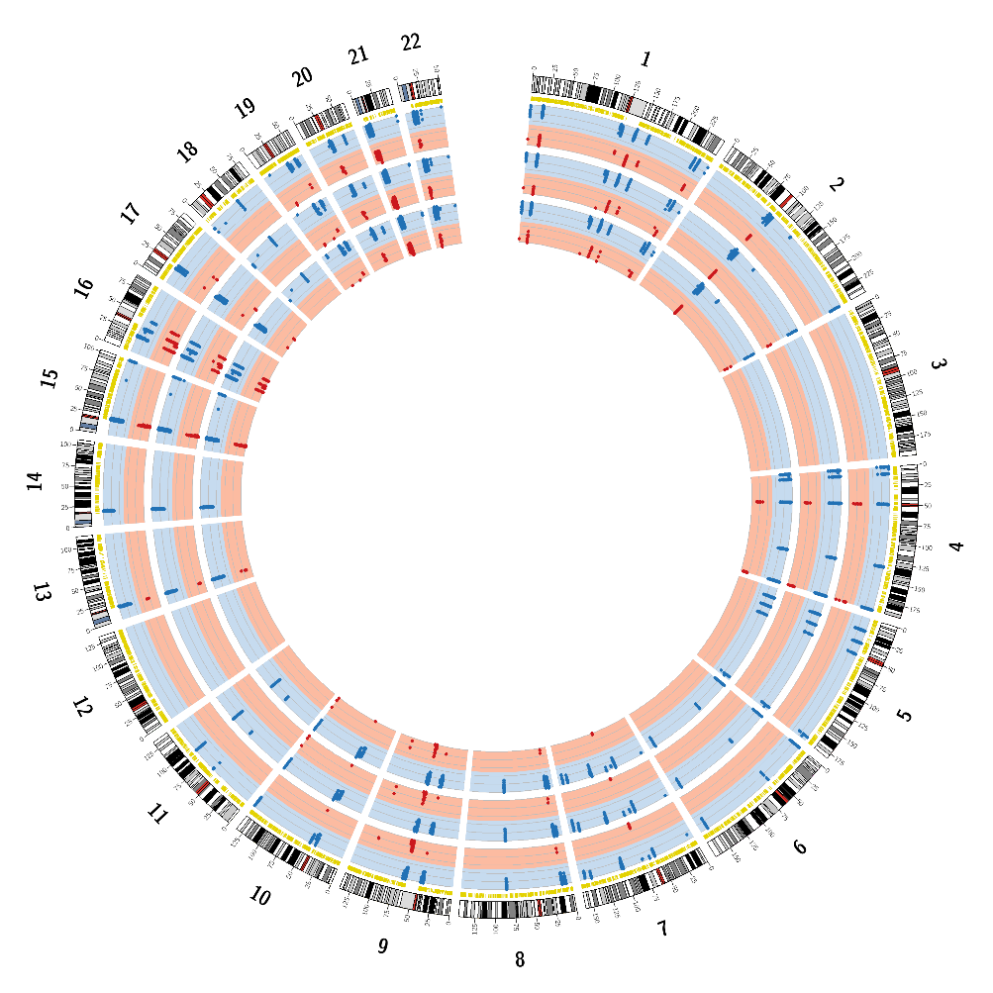
Healthy Blood
C

Figure S9: The detection of hyper- and hypomethylated regions by the methods of the overlapping CpGs at 29× coverage for the three samples (A: Breast Cancer cell line; B: Colorectal Cancer Tissue; C: Healthy blood). From outer to inner circle: chromosomes, CpGs (yellow), methylation profiles from ONT, WGBS and EM-seq data. Methylation frequency >0.7 (hypermethylation, blue) and <0.3 (hypomethylation, red). Breast Cancer cell line, Colorectal Cancer tissue and healthy blood evaluated 304k, 24k and 19k overlapping CpGs, respectively.

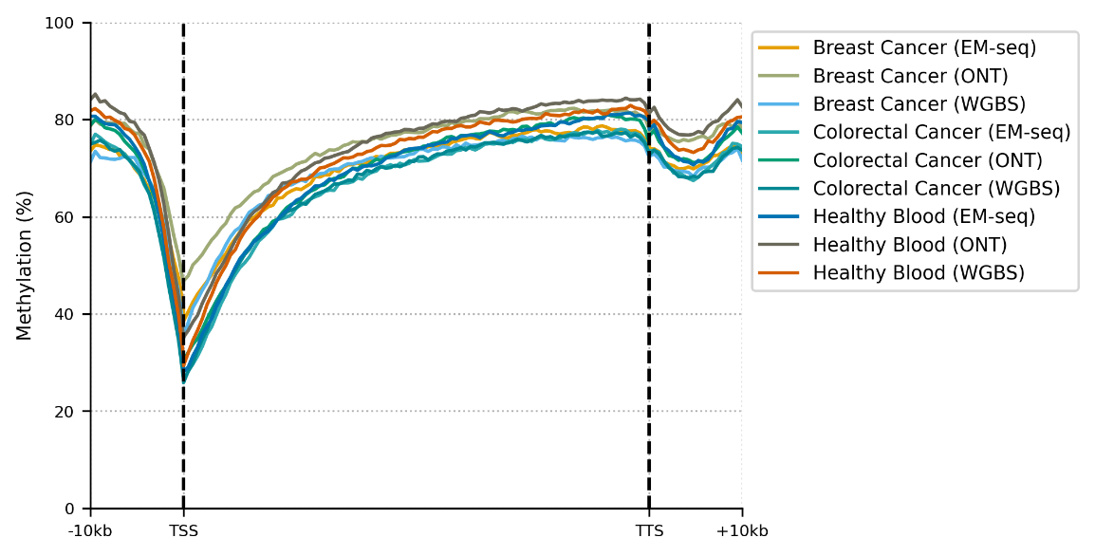
Figure S10: The average percentage of methylation observed for UCSC genes per sample and NGS method, from 10kb upstream of the transcription start site (TSS) to 10kb downstream the transcription termination site (TTS).

