Supplementary data: Mechanistic insights revealed by lipid profiling in monogenic insulin resistance syndromes.

Michael Eiden¹, Albert Koulman¹, Mensud Hatunic², James A. West^{1,3}, Steven Murfitt³, Michael Osei¹, Claire Adams², Xinzhu Wang^{1,3}, Yajing Chu³, Luke Marney¹, Lee D. Roberts^{1,3}, Stephen O’Rahilly², Robert K. Semple², David B. Savage², and Julian L. Griffin^{1,3}

¹Medical Research Council Human Nutrition Research, Fulbourn Road, Cambridge;²Metabolic Research Laboratories, Institute of Metabolic Science, University of Cambridge, UK; ³Department of Biochemistry and the Cambridge Systems Biology Centre, University of Cambridge, Tennis Court Road, Cambridge.

Supplementary Table 1: Triglyceride (TAG) species in blood plasma from individuals with lipodystrophy (LD) or the control group. Each TAG species is identified by the number of carbons (first) and double bonds (second). Fold-change indicates a relative increase in the LD group. P-value calculated for a Student’s T-test comparing the two groups. Bonferoni corrected p_{i} = 0.0018

TAG species | m/z | Rt | HRMS² fragmentation | MSI identification level ^{[25]} | Fold-change | p-value
46:0 (M+NH₄⁺) | 796.739 | 42.1 | 523.473(100); 525.477(2); 551.504(47); 579.53(5) | 2 | 3.13 | 0.0000001
46:1 (M+NH₄⁺) | 794.723 | 40.4 | 493.426 (24); 495.440(12); 519.441(24); 521.456(100); 533.456(6); 535.472(21); 549.488(38) | 2 | 2.55 | 0.00001
46:2 (M+NH₄⁺) | 792.707 | 38.6 | 493.426 (24); 495.440(12); 519.441(24); 521.456(100); 533.456(6); 535.472(21); 549.488(38) | 2 | 2.04 | 0.0019
48:0 (M+NH₄⁺) | 824.771 | 43.6 | 523.471(9); 537.489(5); 551.502(100), 565.519(5); 579.535(7) | 2 | 2.89 | 0.0000008
48:1 (M+NH₄⁺) | 822.758 | 42.1 | 523.471(42), 549.487(100), 551,502(29), 577.519(27) | 2 | 1.96 | 0.000002
48:2 (M+NH₄⁺) | 820.739 | 40.4 | 521.456(20); 547.472(62); 549.487(100); 575.503(5); 577.516(7) | 2 | 1.47 | 0.002
48:3 (M+NH₄⁺) | 818.724 | 38.7 | 519.441(43); 521.457(100); 523.473(21); 545.457(43); 547.473(61); 549.488(8); 573.488(54); 575.504(28); 577.519(5); 601.52(40); 603.531(2) | 2 | 1.42 | 0.036
50:0 (M+NH₄⁺) | 852.802 | 45.0 | 495.443(1); 523.473(3); 537.488(2); 551.503(61); 565.519(15); 579.535(100) | 2 | 0.8 | 0.002
50:1 (M+NH₄⁺) | 850.786 | 43.6 | 549.486(4); 551.501(66); 552.504(11); 577.517(100); 579.532(2); 605.548(2) | 2 | 1.57 | 0.00003
50:2 (M+NH₄⁺) | 848.769 | 42.0 | 547.471(1); 549.485(100); 551.501(8); 563.501(0); 575.501(65); 577.516(42); 579.53(0); 603.532(25) | 2 | 1.19 | 0.009
50:3 (M+NH₄⁺) | 846.754 | 40.4 | 547.47(77); 549.485(100); 549.56(0); 549.578(0); 561.486(0); 563.504(0); 573.485(60); 575.501(81); 577.516(2); 601.516(62); 603.532(4) | 2 | 1.014 | 0.85
50:4 (M+NH₄⁺) | 844.739 | 39.1 | 545.455(15); 546.034(0); 547.47(100); 549.485(18); 571.47(7); 573.486(34); 575.502(3); 597.271(0); 599.501(75); 601.517(6) | 2 | 1 | 0.97
52:2 (M+NH₄⁺) | 876.801 | 43.6 | 575.502(9); 577.517(100); 579.532(10); 603.532(64); 605.548(2) | 2 | 1.013 | 0.786
52:3 (M+NH₄⁺) | 874.785 | 42.3 | 549.485(1); 573.486(1); 575.502(100); 577.517(72); 601.518(88); 603.533(20) | 2 | 0.85 | 0.000281
52:4 (M+NH₄⁺) | 872.769 | 40.9 | 573.486(35); 575.502(100); 577.517(6); 599.502(53); 601.518(34); 603.533(1) | 2 | 0.81 | 0.00989
52:5 (M+NH₄⁺) | 870.754 | 39.5 | 547.472(2); 549.489(20); 551.503(6); 571.473(28); 573.488(100); 575.504(86); 577.52(9); 597.489(65); 599.504(58); 601.52(7); 603.535(3) | 2 | 0.83 | 0.15
52:6 (M+NH₄⁺) | 868.739 | 38.4 | 523.473(49); 547.471(22); 549.489(31); 571.473(54); 573.489(100); 575.505(19); 595.472(30); 597.489(60); 599.503(13); 603.534(10);625.516(7); 627.529(5) | 2 | 1.04 | 0.76
54:5 (M+NH₄⁺) | 898.785 | 40.9 | 549.488(2); 551.506(4); 553.511(1); 573.489(1); 575.505(12); 577.52(39); 579.53(1); 597.49(4); 599.505(100); 601.52(100); 603.535(30); 625.52(20); 627.536(3) | 2 | 1.56 | 0.03
54:6 (M+NH₄⁺) | 896.770 | 39.5 | 549.49(9); 551.504(33); 573.489(4); 575.504(65); 577.52(23); 595.473(1); 597.488(48); 599.504(100); 601.52(47); 603.536(5); 623.504(29); 625.519(8) | 2 | 0.88 | 0.11
54:7 (M+NH₄⁺) | 894.754 | 38.0 | 549.489(100);573.489(36); 575.504(48); 595.474(13); 597.489(60); 599.504(49); 601.518(8); 621.489(17); 623.504(15); 651.528(2); 653.604(8) | 2 | 0.76 | 0.0013
54:8 (M+NH₄⁺) |  |  |  | 3 | 0.78 | 0.03
56:8 (M+NH₄⁺) | 920.770 | 39.6 | 575.504(100); 577.52(1); 599.504(14); 601.519(11); 621.489(5); 623.504(18); 625.518(3); 647.504(14); 649.519(3) | 2 | 0.88 | 0.11
56:9 (M+NH₄⁺) | 918.754 | 33.7 | 573.487(96); 597.487(100); 599.503(83) | 2 | 0.76 | 0.0013
56:10 (M+NH₄⁺) | 916.739 |  |  | 3 | 0.78 | 0.03
58:8 (M+NH₄⁺) | 948.801 | 41.0 | 575.503(6); 601.519(15); 602.522(5); 603.536(100); 627.534(8); 649.52(25); 651.536(3) | 2 | 1.36 | 0.097
58:9 (M+NH₄⁺) | 946.786 | 38.1 | 601.52(100); 625.518(8); 647.504(3); 649.52(9) | 2 | 1.05 | 0.79
58:10 (M+NH₄⁺) | 944.770 |  |  | 3 | 1.01 | 0.98

Supplementary Figure 1
OPLS-DA analysis of the lipid profile of blood plasma from individuals with insulin receptoropathies (INSR) and lipodystrophy (LD). Using this model to predict class membership where 1 signifies a perfect classification as LD and 0 as a perfect classification of INSR, the two groups were readily discriminated with INSR = 0.81 ± 0.22 and LD = 0.09 ± 0.22 (p = 1.2 * 10⁻⁶ according to a Student’s t-test).

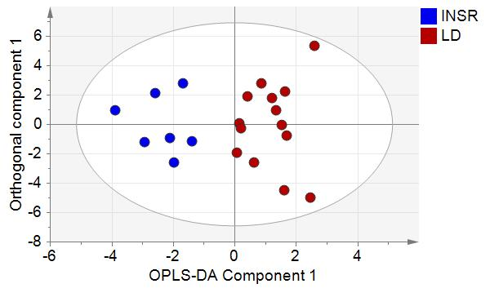

Supplementary Figure 2
OPLS-DA analysis of the triglyceride (TAG) profiles of female lipodystrophic patients compared with female controls. A. Scores Plot R²X=50.8%; R²Y=61.7%, Q²=30.5%. B. S-plot showing the most important TAGs for discriminating the two groups.
A
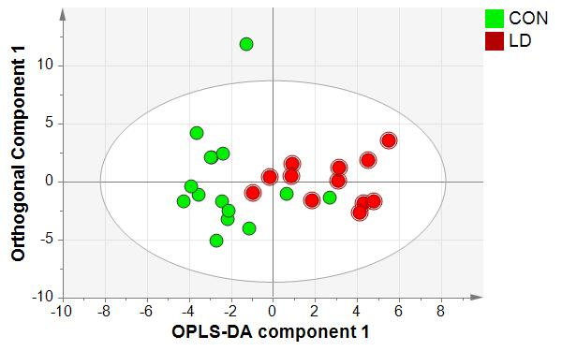
B 