Additional file 2: Supporting information
Metabolic characterisation of the natural progression of chronic hepatitis B.
Johannes C. Schoeman^{1,2}, Jun Hou³, Amy C. Harms^{1,2}, Rob J. Vreeken^{1,2,#}, Ruud Berger^{1,2}, Thomas Hankemeier^{1,2,*}, and Andre Boonstra^{3,*,ᶴ}
¹ Department of Analytical Biosciences, Leiden Academic Center for Drug Research, Leiden University, Einsteinweg 55, 2333 CC, Leiden, The Netherlands.
² Netherlands Metabolomics Centre, Leiden University, Einsteinweg 55, 2333 CC, Leiden, The Netherlands.
³ Department of Gastroenterology and Hepatology, Erasmus University Medical Center, Rotterdam, Wytemaweg 80, 3015 CE, The Netherlands.

* Both authors contributed equally

Current Address
#Discovery Sciences, Janssen R&D, Turnhoutseweg 30, 2340 Beerse, Belgium

ᶴCorresponding author:
Andre Boonstra,
Department of Gastroenterology and Hepatology
Erasmus MC – University Medical Center Rotterdam
Wytemaweg 80, Room Na-1011
3015 CE Rotterdam, the Netherlands
Phone: +31 10 7035944, Fax: +31 10 7032793
E-mail: p.a.boonstra@erasmusmc.nl

Figures
PCA scores plot
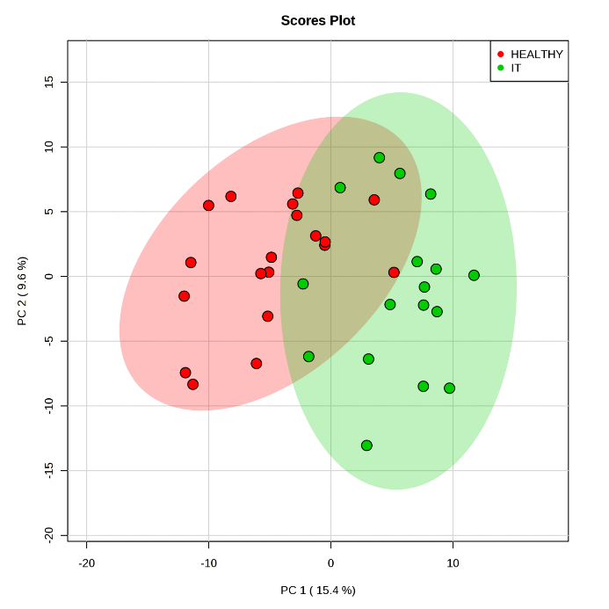
Figure S1. HCs vs IT phase PCA analyses. PCA analyses plotting PC1 vs. PC2 for the HCs (Red) versus the IT phase (Green), using the fused data set comprising of 37 cases and all 314 detected metabolites. Natural group clustering lead to partial differentiation between the two groups, indicating metabolic differences between them.

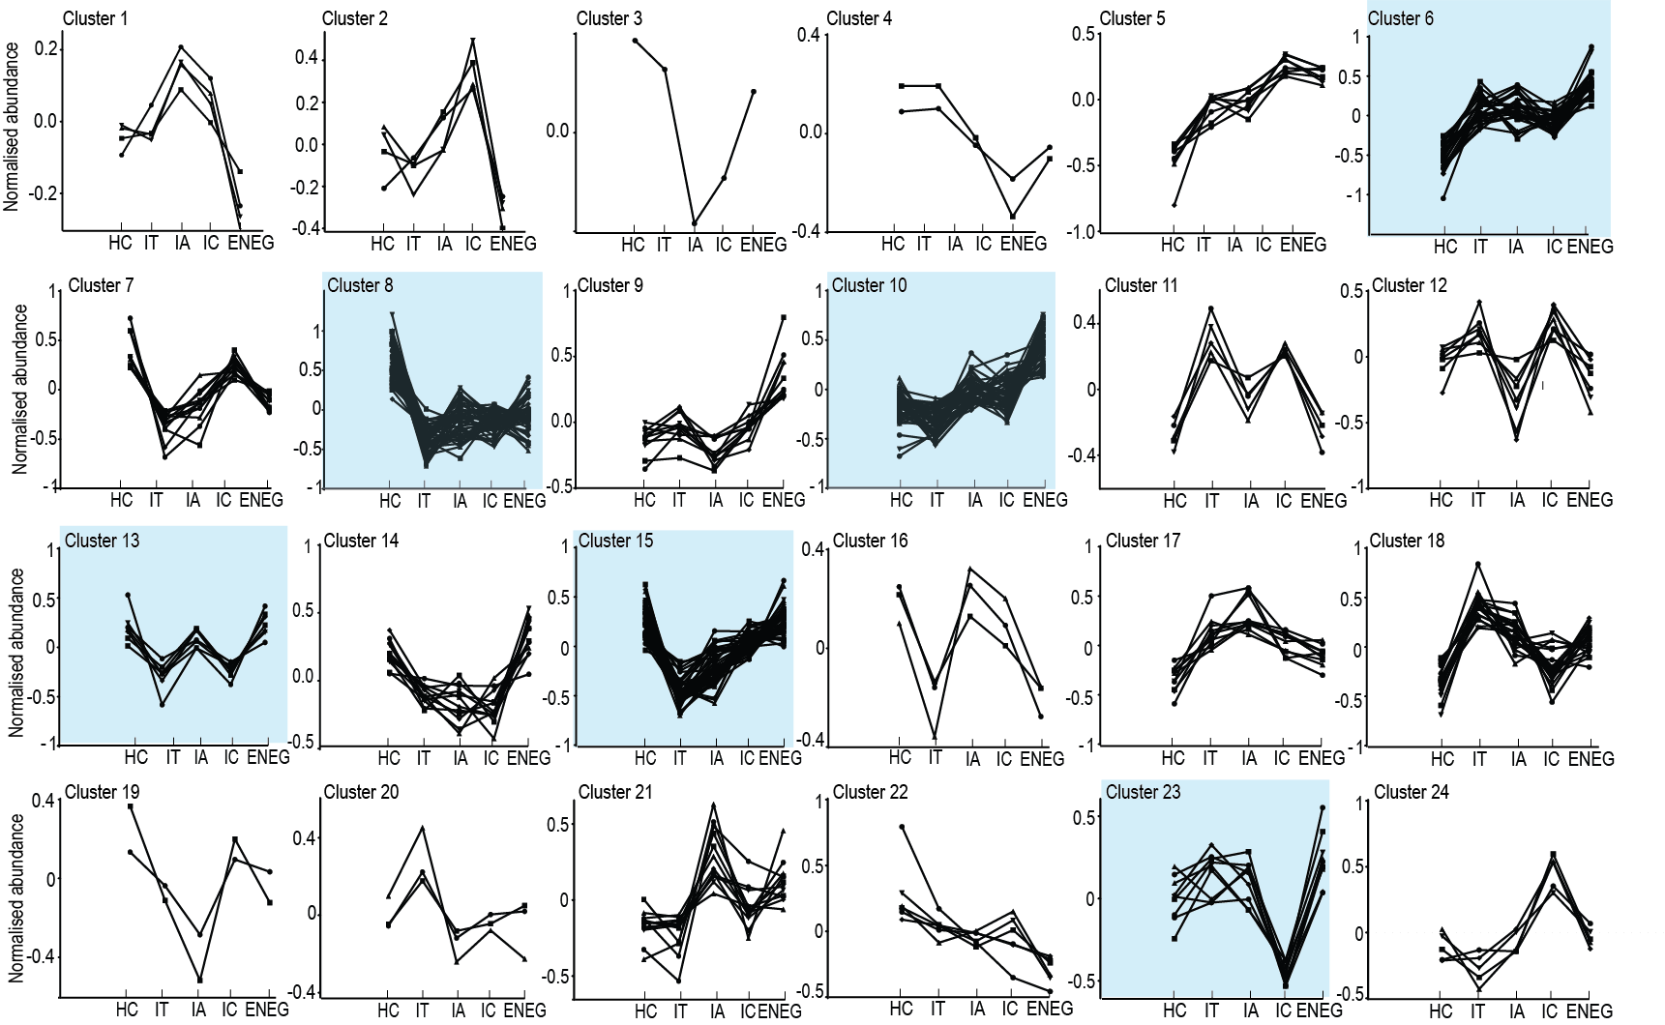
Figure. S2. K-means clustering. Metabolites are grouped into different classes by K-means clustering based on the changes of their abundance during the progression of chronic HBV. Expression pattern-based analysis was performed with all 314 metabolites and 88 patients. A K-means clustering was performed in MATLAB using kmeans on these metabolites in order to examine alterations in their measurement during the course of chronic HBV. Within each cluster metabolites present similar expression patterns, while different from metabolites in other clusters. The 24 clusters present the best partition of all 314 metabolites and are shown in the figure, with the blue highlighted clusters being discussed in the main text. The x-axis shows the healthy controls (HC) and the four clinical phases (IT, IA, IC, and ENEG). The y-axis is the abundance of metabolites normalized to the overall mean of the metabolite across all samples.

Tables.
TABLE S1. Descriptive statistics of significant serum metabolites between HCs and the IT phase. The table contains their corresponding statistical scores and descriptive statistics using normalised area ratios, ordered by metabolic class.
Targeted Metabolomics Platform |  | Metabolite | T-Test | False discovery rate | Fold change | Healthy Controls | IT Phase
 |  | Metabolite | p-value | q-value | (FC) | Mean ± SD | Mean ± SD
 | Phospholipids
Positive Lipids |  | PC C32:1 | 0.0012 | 0.006 | 0.51 | 0.68 ± 0.44 | 0.35 ± 0.22
 |  | PC C32:2 | < 0.0001 | < 0.001 | 0.52 | 0.19 ± 0.06 | 0.1 ± 0.04
 |  | PC C34:1 | 0.0029 | 0.010 | 0.76 | 7.74 ± 1.9 | 5.91 ± 1.52
 |  | PC C34:3 | 0.0001 | 0.001 | 0.64 | 0.67 ± 0.22 | 0.43 ± 0.14
 |  | PC C34:4 | < 0.0001 | < 0.001 | 0.45 | 0.06 ± 0.02 | 0.03 ± 0.01
 |  | PC C36:3 | < 0.0001 | 0.001 | 0.72 | 6.36 ± 1.65 | 4.62 ± 0.86
 |  | PC C36:4 | 0.0006 | 0.003 | 0.75 | 7.2 ± 1.64 | 5.47 ± 1.1
 |  | PC C36:6 | 0.0134 | 0.035 | 0.72 | 0.03 ± 0.01 | 0.02 ± 0.01
 |  | PC C38:3 | 0.0063 | 0.018 | 0.7 | 1.37 ± 0.49 | 0.96 ± 0.37
 |  | PE C38:4 | < 0.0001 | < 0.001 | 0.6 | 0.33 ± 0.1 | 0.2 ± 0.07
 | Plasmalogens
Positive Lipids |  | pPC C34:2 | 0.0003 | 0.002 | 1.37 | 0.29 ± 0.08 | 0.4 ± 0.1
 |  | pPC C36:2 | 0.0005 | 0.003 | 1.25 | 0.09 ± 0.02 | 0.12 ± 0.02
 |  | pPC C36:3 | 0.0005 | 0.003 | 1.3 | 0.07 ± 0.02 | 0.1 ± 0.02
 |  | pPC C38:6 | 0.0025 | 0.009 | 1.6 | 0.16 ± 0.03 | 0.22 ± 0.08
 |  | pPE C38:5 | 0.002 | 0.008 | 1.42 | 0.19 ± 0.06 | 0.28 ± 0.09
 |  | pPE C38:7* | 0.0229 | 0.052 | 1.4 | 0.07 ± 0.02 | 0.1 ± 0.03
 | Lysophospholipids
Negative Lipids |  | LPE C18:0 | 0.0002 | 0.002 | 0.65 | 0.13 ± 0.03 | 0.08 ± 0.03
 |  | LPE C18:1 | 0.0027 | 0.008 | 0.66 | 0.07 ± 0.03 | 0.05 ± 0.02
 |  | LPE C18:2* | 0.025 | 0.052 | 0.71 | 0.14 ± 0.07 | 0.10 ± 0.05
 |  | LPE C20:3 (w3w6) | 0.0002 | 0.001 | 0.54 | 0.008 ± 0.003 | 0.005 ± 0.002
 |  | LPE C20:4 | 0.0008 | 0.003 | 0.72 | 0.079 ± 0.023 | 0.058 ± 0.015
 |  | LPE C22:5 (w3)* | 0.0249 | 0.052 | 0.75 | 0.008 ± 0.003 | 0.006 ± 0.002
 |  | sn1 LPC C14:0 | < 0.0001 | < 0.001 | 0.47 | 0.19 ± 0.06 | 0.09 ± 0.03
 |  | sn1 LPC C15:0 | < 0.0001 | < 0.001 | 0.63 | 0.1 ± 0.02 | 0.06 ± 0.02
 |  | sn1 LPC C16:1 | 0.0002 | 0.001 | 0.71 | 0.35 ± 0.09 | 0.25 ± 0.07
 |  | sn1 LPC C18:1 | < 0.0001 | < 0.001 | 0.73 | 4.04 ± 0.67 | 2.99 ± 0.68
 |  | sn1 LPC C18:2 | 0.0081 | 0.02 | 0.79 | 8.0 ± 2.1 | 6.4 ± 1.6
 |  | sn1 LPC C18:3 (w3w6) | < 0.0001 | < 0.001 | 0.55 | 0.118 ± 0.041 | 0.065 ± 0.031
 |  | sn1 LPC C20:3 (w3w6) | < 0.0001 | < 0.001 | 0.53 | 0.82 ± 0.33 | 0.44 ± 0.15
 |  | sn1 LPC C20:3 (w9) | < 0.0001 | < 0.001 | 0.46 | 0.034 ± 0.017 | 0.015 ± 0.008
 |  | sn1 LPC C20:4 | 0.0003 | 0.001 | 0.69 | 1.84 ± 0.52 | 1.28 ± 0.35
 |  | sn1 LPC C22:4 | 0.008 | 0.02 | 0.67 | 0.053 ± 0.02 | 0.035 ± 0.01
 |  | sn1 LPC C22:5 (w6) | 0.0015 | 0.004 | 0.59 | 0.042 ± 0.019 | 0.025 ± 0.01
 |  | sn2 LPC C14:0 | < 0.0001 | < 0.001 | 0.46 | 0.04 ± 0.013 | 0.018 ± 0.007
 |  | sn2 LPC C16:1 | 0.0001 | < 0.001 | 0.69 | 0.068 ± 0.018 | 0.047 ± 0.013
 |  | sn2 LPC C18:1 | < 0.0001 | < 0.001 | 0.74 | 0.7 ± 0.11 | 0.52 ± 0.12
 |  | sn2 LPC C18:2 | 0.0058 | 0.015 | 0.77 | 1.59 ± 0.42 | 1.24 ± 0.32
 |  | sn2 LPC C18:3 (w3w6) | < 0.0001 | < 0.001 | 0.54 | 0.02 ± 0.01 | 0.01 ± 0.01
 |  | sn2 LPC C20:3 (w3w6) | < 0.0001 | < 0.001 | 0.54 | 0.16 ± 0.06 | 0.09 ± 0.03
 |  | sn2 LPC C20:4 | 0.0049 | 0.013 | 0.73 | 0.35 ± 0.11 | 0.26 ± 0.07
 | Lyso-Plasmalogens
Negative Lipids |  | pLPC C16:0 | 0.0006 | 0.002 | 1.32 | 0.1 ± 0.03 | 0.13 ± 0.02
 |  | pLPC C16:1 | 0.0035 | 0.011 | 1.21 | 0.03 ± 0.005 | 0.04 ± 0.006
 |  | pLPC C18:1 | 0.0001 | 0.003 | 1.44 | 0.068 ± 0.018 | 0.088 ± 0.017
 |  | pLPC C18:2 | 0.0017 | 0.005 | 1.32 | 0.014 ± 0.004 | 0.019 ± 0.004
 | Triglycerides
Positive Lipids |  | TG C42:1 | 0.0055 | 0.017 | 0.42 | 0.07 ± 0.05 | 0.03 ± 0.02
 |  | TG C44:2 | 0.0016 | 0.007 | 0.49 | 0.11 ± 0.07 | 0.05 ± 0.02
 |  | TG C46:1 | < 0.0001 | 0.001 | 0.44 | 0.73 ± 0.43 | 0.32 ± 0.11
 |  | TG C46:2 | < 0.0001 | 0.001 | 0.4 | 0.37 ± 0.22 | 0.15 ± 0.06
 |  | TG C46:3 | 0.0015 | 0.007 | 0.3 | 0.09 ± 0.06 | 0.03 ± 0.02
 |  | TG C48:1 | 0.0002 | 0.002 | 0.4 | 1.93 ± 1.29 | 0.79 ± 0.57
 |  | TG C48:2 | < 0.0001 | 0.001 | 0.4 | 1.44 ± 0.87 | 0.58 ± 0.33
 |  | TG C48:3 | 0.0005 | 0.003 | 0.43 | 0.49 ± 0.3 | 0.21 ± 0.09
 |  | TG C48:4* | 0.0233 | 0.052 | 0.52 | 0.1 ± 0.07 | 0.05 ± 0.03
 |  | TG C50:0 | 0.0209 | 0.049 | 0.66 | 0.70 ± 0.43 | 0.46 ± 0.42
 |  | TG C50:1 | 0.0017 | 0.007 | 0.51 | 4.05 ± 2.47 | 2.09 ± 1.67
 |  | TG C50:2 | 0.0009 | 0.005 | 0.55 | 4.62 ± 2.27 | 2.55 ± 1.56
 |  | TG C50:3 | 0.0019 | 0.008 | 0.58 | 2.23 ± 1.06 | 1.31 ± 0.62
 |  | TG C50:4 | 0.009 | 0.024 | 0.59 | 0.65 ± 0.34 | 0.39 ± 0.18
 |  | TG C50:5 | 0.0184 | 0.044 | 0.57 | 0.14 ± 0.08 | 0.08 ± 0.04
 |  | TG C51:1 | 0.0005 | 0.003 | 0.6 | 0.34 ± 0.15 | 0.2 ± 0.07
 |  | TG C51:2 | 0.0005 | 0.003 | 0.61 | 0.48 ± 0.19 | 0.29 ± 0.11
 |  | TG C51:3 | 0.0034 | 0.011 | 0.66 | 0.28 ± 0.12 | 0.19 ± 0.07
 |  | TG C52:1 | 0.0021 | 0.008 | 0.56 | 1.67 ± 0.98 | 0.94 ± 0.89
 |  | TG C52:2 | 0.0028 | 0.01 | 0.68 | 9.1 ± 2.9 | 6.2 ± 2.6
 |  | TG C54:1 | 0.0051 | 0.016 | 0.65 | 0.19 ± 0.09 | 0.12 ± 0.05
 |  | TG C54:2 | 0.0034 | 0.011 | 0.67 | 1.31 ± 0.44 | 0.88 ± 0.37
 |  | TG C55:2 | 0.0001 | 0.001 | 0.68 | 0.08 ± 0.02 | 0.05 ± 0.02
 |  | TG C56:5 | 0.0113 | 0.03 | 0.75 | 0.47 ± 0.15 | 0.36 ± 0.16
 |  | TG C58:5 | 0.0177 | 0.043 | 0.79 | 0.04 ± 0.01 | 0.03 ± 0.01
 | Amines
Amines |  | Kynurenine | 0.0008 | 0.007 | 0.69 | 0.008 ± 0.002 | 0.005 ± 0.001
 |  | Saccharopine | < 0.0001 | < 0.001 | 0.55 | 0.006 ± 0.002 | 0.003 ± 0.001
 |  | 4-Hydroxyproline | 0.0039 | 0.025 | 1.68 | 0.13 ± 0.05 | 0.23 ± 0.12
 |  | Glutathione | 0.0009 | 0.007 | 0.72 | 0.003 ± 0.001 | 0.002 ± 0.001
 |  | Pipecolic_acid | 0.0007 | 0.007 | 1.46 | 1.01 ± 0.23 | 1.48 ± 0.54
 |  | s_Methylcysteine | 0.0074 | 0.04 | 1.70 | 0.2 ± 0.08 | 0.34 ± 0.19
 |  | Sarcosine* | 0.0306 | 0.129 | 1.30 | 0.011 ± 0.004 | 0.014 ± 0.005
 |  | Tryptophan* | 0.013 | 0.061 | 0.77 | 3.65 ± 0.91 | 2.83 ± 0.59
 |  | γ-Glutamylglutamine | 0.0004 | 0.007 | 0.65 | 0.012 ± 0.004 | 0.007 ± 0.003
Acyl Carnitines |  | Betaine* | 0.0288 | 0.235 | 1.33 | 2.35 ± 0.98 | 3.13 ± 0.95
 | Cholesterol esters
 |  | CE C18:3 | 0.017 | 0.043 | 0.77 | 0.04 ± 0.01 | 0.03 ± 0.01
 | Sphingomyelins
Positive Lipids |  | SM C18:1/14:0 | < 0.0001 | < 0.001 | 0.70 | 0.45 ± 0.1 | 0.32 ± 0.07
 |  | SM C18:1/21:0 | < 0.0001 | < 0.001 | 0.70 | 0.27 ± 0.05 | 0.19 ± 0.03
 |  | SM C18:1/23:0 | 0.0001 | 0.001 | 0.78 | 0.67 ± 0.12 | 0.53 ± 0.08
 |  | SM C18:1/25:0 | 0.0142 | 0.036 | 0.64 | 0.06 ± 0.02 | 0.04 ± 0.02
 |  | SM C18:1/25:1 | 0.001 | 0.005 | 0.64 | 0.1 ± 0.03 | 0.07 ± 0.03
 | Free fatty acid and Acyl-carnitines
Acyl Carnitines |  | Nonanoylcarnitine | < 0.0001 | < 0.001 | 0.29 | 0.34 ± 0.14 | 0.1 ± 0.05
 |  | Oleylcarnitine* | 0.0361 | 0.235 | 1.38 | 1.35 ± 0.44 | 1.87 ± 0.74
 |  | Linoleylcarnitine | 0.001 | 0.013 | 1.79 | 0.65 ± 0.28 | 1.16 ± 0.57
Negative Lipids |  | FA C20:2 | 0.0103 | 0.023 | 2.21 | 0.24 ± 0.13 | 0.53 ± 0.38
 |  | FA C18:2 | 0.0102 | 0.023 | 2.19 | 13.07 ± 8.16 | 28.57 ± 21.57
 | Oxylipins
Oxylipins |  | 5-HETrE | 0.0001 | 0.003 | 0.39 | 0.03 ± 0.02 | 0.01 ± 0.01
 |  | 11-HDoHE* | 0.0037 | 0.065 | 2.68 | 0.02 ± 0.01 | 0.05 ± 0.04
 |  | 14-HDoHE* | 0.0194 | 0.227 | 2.38 | 0.29 ± 0.31 | 0.68 ± 0.72
 |  | 8,9-DiHETrE* | 0.0347 | 0.262 | 0.70 | 0.01 ± 0.003 | 0.004 ± 0.002
 |  | 10-HDoHE* | 0.0442 | 0.262 | 1.76 | 0.04 ± 0.03 | 0.06 ± 0.05
 |  | 12,13-DiHOME* | 0.045 | 0.262 | 0.53 | 3.65 ± 2.93 | 1.94 ± 1.50
* q-value > 0.05

Table S2. Pattern analyses K-means serum metabolite scores and assigned clusters
(Additional File 3: Excel format)

Table S3. Descriptive statistics of significant serum metabolites between clinical phases. The table contains their corresponding anova p value, pattern analyses cluster and phase descriptive statistics using normalised area ratios, ordered by metabolic class.
Targeted  Metabolomics Platform | Metabolite | p-value | Pattern analyse cluster | Healthy Controls  Mean ± SD | IT Phase  Mean ± SD | IA Phase  Mean ± SD | IC Phase  Mean ± SD | ENEG Phase  Mean ± SD
Phospholipids
Positive Lipids | PC C38:4 | 0.0432 | 15 | 3.94 ± 0.94 | 3.3 ± 0.59 | 3.15 ± 0.75 | 3.78 ± 0.95 | 3.95 ± 0.99
Positive Lipids | PC C40:4 | 0.0478 | 14 | 0.08 ± 0.03 | 0.07 ± 0.03 | 0.06 ± 0.03 | 0.06 ± 0.03 | 0.09 ± 0.04
Lysophospholipids
Negative Lipids | sn1 LPC C20:3 (w3w6) | 0.0284 | 8 | 0.82 ± 0.33 | 0.44 ± 0.15 | 0.49 ± 0.16 | 0.47 ± 0.16 | 0.65 ± 0.25
Negative Lipids | sn2 LPC C20:3 (w3w6) | 0.0263 | 8 | 0.16 ± 0.06 | 0.09 ± 0.03 | 0.1 ± 0.03 | 0.09 ± 0.03 | 0.13 ± 0.05
Negative Lipids | LPE C18:1 | 0.0490 | 15 | 0.07 ± 0.03 | 0.05 ± 0.02 | 0.06 ± 0.03 | 0.07 ± 0.03 | 0.07 ± 0.05
Negative Lipids | LPE C20:3 (w3w6) | 0.0292 | 15 | 0.008 ± 0.003 | 0.005 ± 0.002 | 0.006 ± 0.003 | 0.007 ± 0.003 | 0.007 ± 0.003
Negative Lipids | LPE C20:4 | 0.0226 | 15 | 0.079 ± 0.023 | 0.058 ± 0.015 | 0.057 ± 0.019 | 0.074 ± 0.021 | 0.073 ± 0.03
Negative Lipids | sn1 LPC C20:1 | 0.0323 | 21 | 0.047 ± 0.009 | 0.045 ± 0.008 | 0.061 ± 0.016 | 0.056 ± 0.017 | 0.054 ± 0.015
Triglycerides
Positive Lipids | TG C54:2 | 0.0268 | 10 | 1.31 ± 0.44 | 0.88 ± 0.37 | 1.29 ± 0.78 | 1.23 ± 0.68 | 2.13 ± 2.14
Positive Lipids | TG C54:3 | 0.0158 | 10 | 3.18 ± 0.83 | 2.64 ± 1.18 | 3.68 ± 1.84 | 3.28 ± 1.63 | 5.26 ± 3.8
Positive Lipids | TG C54:4 | 0.0398 | 10 | 3.28 ± 1.33 | 3.35 ± 1.57 | 4.69 ± 2.09 | 3.59 ± 1.66 | 5.27 ± 3.41
Positive Lipids | TG C55:3 | 0.0249 | 10 | 0.09 ± 0.02 | 0.08 ± 0.02 | 0.09 ± 0.03 | 0.09 ± 0.02 | 0.11 ± 0.03
Positive Lipids | TG C56:3 | 0.0282 | 10 | 0.14 ± 0.04 | 0.12 ± 0.06 | 0.14 ± 0.07 | 0.14 ± 0.08 | 0.26 ± 0.29
Positive Lipids | TG C56:4 | 0.0013 | 10 | 0.23 ± 0.06 | 0.19 ± 0.08 | 0.25 ± 0.09 | 0.22 ± 0.11 | 0.36 ± 0.25
Positive Lipids | TG C56:5 | 0.0025 | 10 | 0.47 ± 0.15 | 0.36 ± 0.16 | 0.45 ± 0.23 | 0.41 ± 0.23 | 0.61 ± 0.26
Positive Lipids | TG C56:6 | 0.0415 | 10 | 0.72 ± 0.28 | 0.6 ± 0.31 | 0.71 ± 0.34 | 0.65 ± 0.27 | 0.86 ± 0.34
Positive Lipids | TG C58:5 | 0.0098 | 10 | 0.04 ± 0.01 | 0.03 ± 0.01 | 0.04 ± 0.01 | 0.04 ± 0.01 | 0.05 ± 0.03
Positive Lipids | TG C42:1 | 0.0428 | 15 | 0.07 ± 0.05 | 0.03 ± 0.02 | 0.03 ± 0.01 | 0.06 ± 0.06 | 0.07 ± 0.09
Positive Lipids | TG C52:2 | 0.0286 | 15 | 9.1 ± 2.87 | 6.24 ± 2.65 | 7.12 ± 2.89 | 7.55 ± 3.14 | 10.79 ± 5.36
Positive Lipids | TG C55:2 | 0.0157 | 15 | 0.08 ± 0.02 | 0.05 ± 0.02 | 0.06 ± 0.03 | 0.06 ± 0.02 | 0.08 ± 0.03
Amines
Amines | Ornithine | 0.0065 | 6 | 1.15 ± 0.27 | 1.37 ± 0.43 | 1.41 ± 0.29 | 1.47 ± 0.45 | 1.84 ± 0.45
Amines | Phenylalanine | 0.0126 | 10 | 0.84 ± 0.16 | 0.83 ± 0.14 | 0.98 ± 0.1 | 0.97 ± 0.16 | 1 ± 0.2
Amines | Glutamic acid | 0.0135 | 10 | 1.07 ± 0.38 | 1.14 ± 0.31 | 1.43 ± 0.42 | 1.37 ± 0.49 | 1.73 ± 0.66
Amines | Methionine | 0.0392 | 10 | 0.015 ± 0.008 | 0.014 ± 0.014 | 0.013 ± 0.005 | 0.015 ± 0.005 | 0.015 ± 0.006
Amines | Kynurenine | 0.0059 | 13 | 0.008 ± 0.002 | 0.005 ± 0.001 | 0.006 ± 0.002 | 0.006 ± 0.001 | 0.007 ± 0.002
Amines | Citrulline | 0.0061 | 9 | 0.32 ± 0.06 | 0.31 ± 0.07 | 0.3 ± 0.08 | 0.33 ± 0.09 | 0.4 ± 0.08
Acyl Carnitines | Carnitine | 0.0008 | 6 | 2.95 ± 0.87 | 3.26 ± 0.69 | 3.53 ± 0.73 | 3.19 ± 0.64 | 4.01 ± 0.64
Acyl Carnitines | Choline | 0.0113 | 10 | 1.22 ± 0.26 | 1.37 ± 0.36 | 1.89 ± 0.54 | 1.56 ± 0.4 | 1.78 ± 0.43
Sphingomyelins
Positive Lipids | SM C18:1/18:1 | 0.0112 | 12 | 0.35 ± 0.07 | 0.4 ± 0.05 | 0.33 ± 0.05 | 0.4 ± 0.06 | 0.37 ± 0.07
Positive Lipids | SM C18:1/25:0 | 0.0346 | 15 | 0.06 ± 0.02 | 0.04 ± 0.02 | 0.04 ± 0.02 | 0.05 ± 0.02 | 0.05 ± 0.03
Positive Lipids | SM C18:1/23:1 | 0.0023 | 7 | 0.52 ± 0.1 | 0.43 ± 0.05 | 0.4 ± 0.06 | 0.51 ± 0.08 | 0.45 ± 0.12
Positive Lipids | SM C18:1/21:0 | 0.0231 | 7 | 0.27 ± 0.05 | 0.19 ± 0.03 | 0.2 ± 0.04 | 0.24 ± 0.05 | 0.23 ± 0.08
Free fatty acid and Acyl-carnitines
Acyl Carnitines | Nonaylcarnitine | 0.0168 | 8 | 0.34 ± 0.14 | 0.1 ± 0.05 | 0.19 ± 0.12 | 0.16 ± 0.14 | 0.24 ± 0.18
Acyl Carnitines | Isovalerylcarnitine | 0.0097 | 10 | 0.83 ± 0.49 | 0.68 ± 0.29 | 0.94 ± 0.41 | 0.78 ± 0.22 | 1.07 ± 0.47
Acyl Carnitines | Stearoylcarnitine | 0.0295 | 10 | 0.47 ± 0.15 | 0.43 ± 0.13 | 0.5 ± 0.17 | 0.46 ± 0.13 | 0.58 ± 0.18
Acyl Carnitines | 2-Methylbutyroylcarnitine | 0.0390 | 10 | 0.59 ± 0.21 | 0.49 ± 0.18 | 0.55 ± 0.18 | 0.53 ± 0.22 | 0.71 ± 0.29
Acyl Carnitines | Decenoylcarnitine | 0.0226 | 18 | 1.25 ± 0.64 | 1.75 ± 1.19 | 1.74 ± 0.83 | 1.03 ± 0.58 | 1.41 ± 0.38
Acyl Carnitines | Decanoylcarnitine | 0.0468 | 23 | 0.95 ± 0.81 | 1.02 ± 0.9 | 0.93 ± 0.5 | 0.6 ± 0.4 | 0.89 ± 0.42
Negative Lipids | FA C20:4 (w6) | 0.0143 | 10 | 6.36 ± 4.91 | 6.31 ± 2.78 | 7.08 ± 2.82 | 5.93 ± 2.94 | 8.63 ± 3.09
Negative Lipids | FA C20:3 (w3w6) | 0.0293 | 23 | 0.85 ± 0.31 | 0.9 ± 0.39 | 0.86 ± 0.33 | 0.75 ± 0.34 | 1.09 ± 0.36
Negative Lipids | FA C22:4 | 0.0365 | 23 | 0.4 ± 0.16 | 0.49 ± 0.29 | 0.41 ± 0.19 | 0.38 ± 0.23 | 0.53 ± 0.17
Oxylipins
Oxylipins | 12-HETE | 0.0472 | 14 | 8.63 ± 15.99 | 5.71 ± 7.43 | 6.4 ± 5.77 | 4.59 ± 2.96 | 11.19 ± 8.67
Oxylipins | 5,6-DiHETrE | 0.0486 | 21 | 0.017 ± 0.009 | 0.019 ± 0.014 | 0.037 ± 0.034 | 0.019 ± 0.014 | 0.033 ± 0.025
Diacylglycerol
Positive Lipids | DG C36:2 | 0.0354 | 10 | 0.26 ± 0.07 | 0.22 ± 0.08 | 0.25 ± 0.09 | 0.24 ± 0.08 | 0.35 ± 0.17

