Additional File 9: Principal component loadings of clinical response
variables in discovery cohorts.
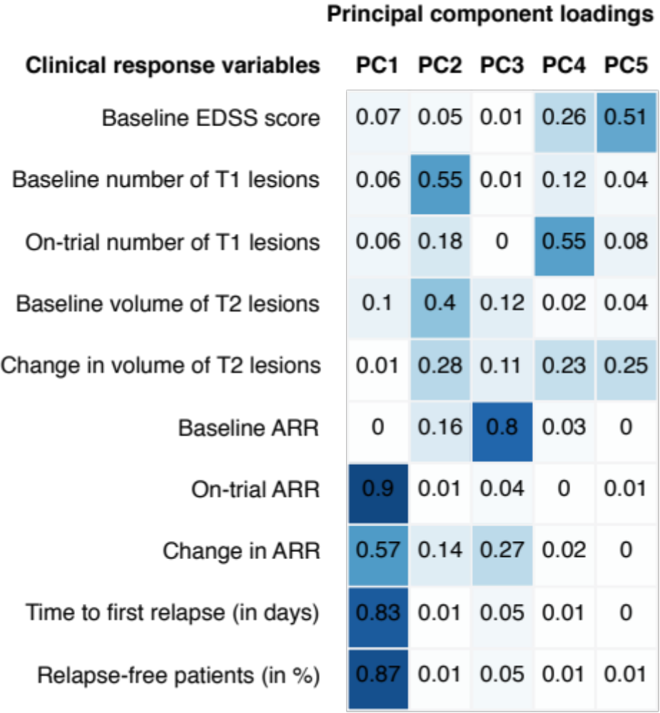

The top-five principal component loadings that cumulatively explained
~90% of the variance are shown. The pattern of the loadings indicated
that the clinical response variables that were not used in building the
model were orthogonal to the ones that were used to train the 4-SNP
model. Time-to-relapse, the binary relapse-free response variable,
on-trial ARR as well as the change in ARR had the largest loadings
on the first principal component while MRI variables and EDSS variables
loaded on the other principal components.

