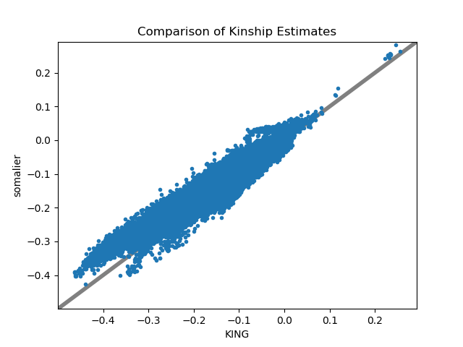
Additional File 1: Fig. S1. Comparison of KING estimate of kinship to that of somalier.

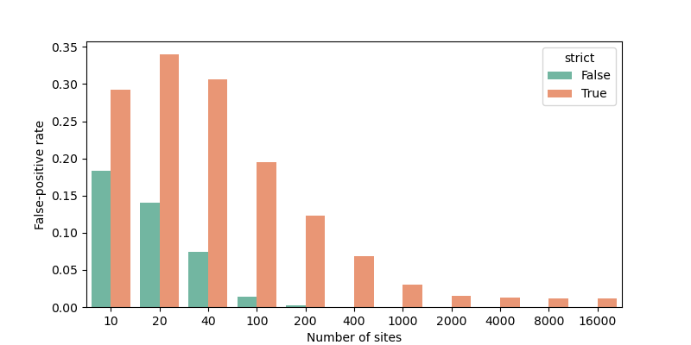
Additional File 2: Fig. S2. Evaluation of false-positive rate of somalier as number of assayed sites is varied. “Strict” mode requires that related samples have a relatedness > 0.8 and unrelated samples have a relatedness < 0.2. The non-strict mode requires that related samples have a relatedness value >= 0.5 and unrelated samples have a relatedness < 0.5. These are GTEx samples that are unrelated, but different tissues from the same individual are expected to have a relatedness value of 1.

