Fig S1-S6: Overview of SARS-CoV-2 genome coverage drop-out regions (Ns) of each sample that had a known Ct. Black indicates a region where there is missing data, or where the coverage dropped below 20X for CoronaHiT and ARTIC ONT and 10X for Illumina.

Fig. S1 - ARTIC LoCost for routine samples 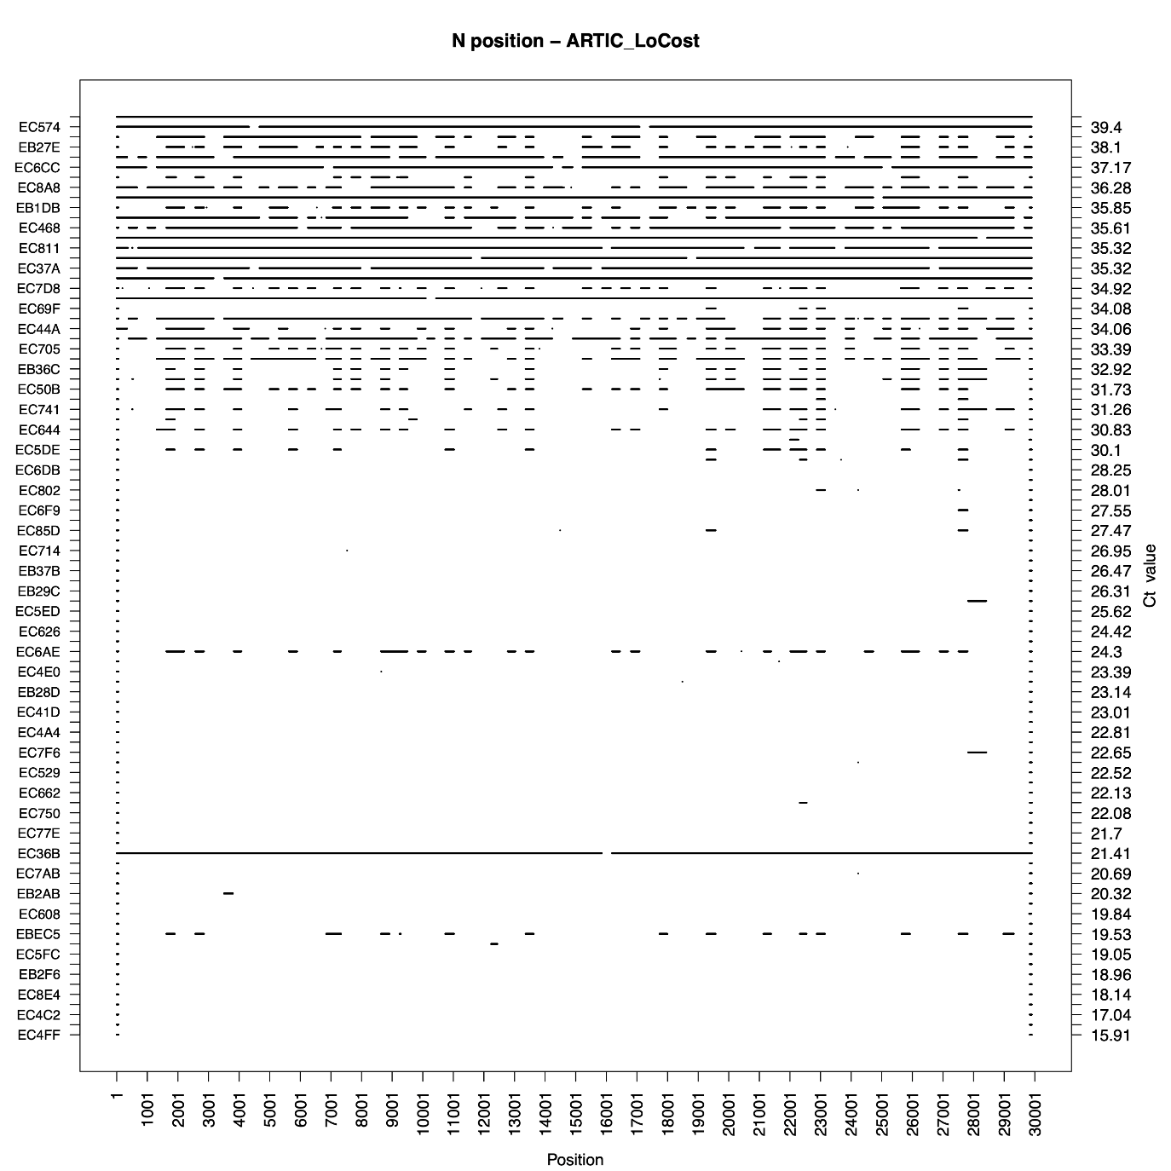

Fig. S2 - CoronaHiT-ONT for routine samples 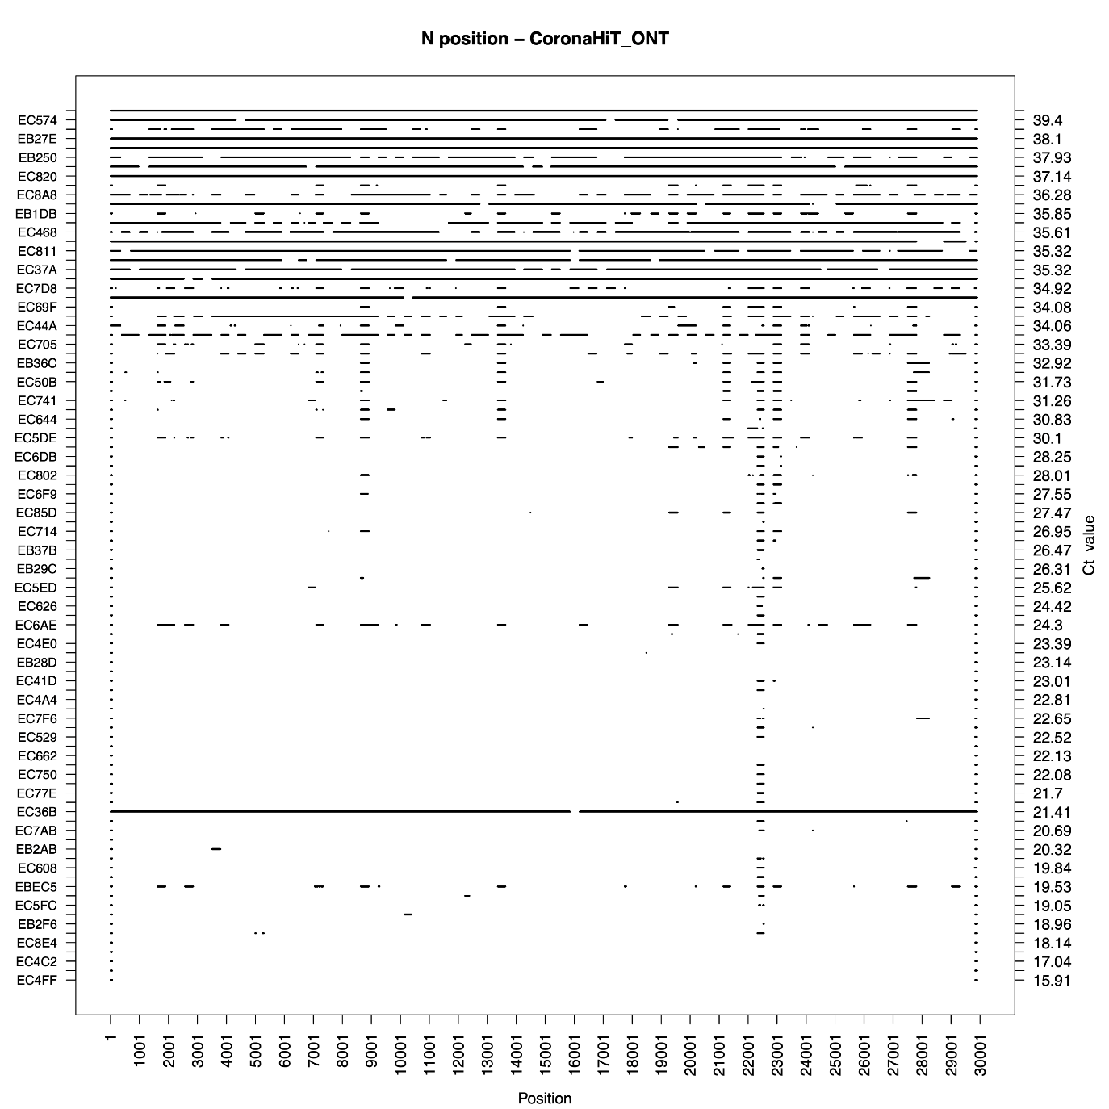

Fig. S3 - CoronaHiT-Illumina for routine samples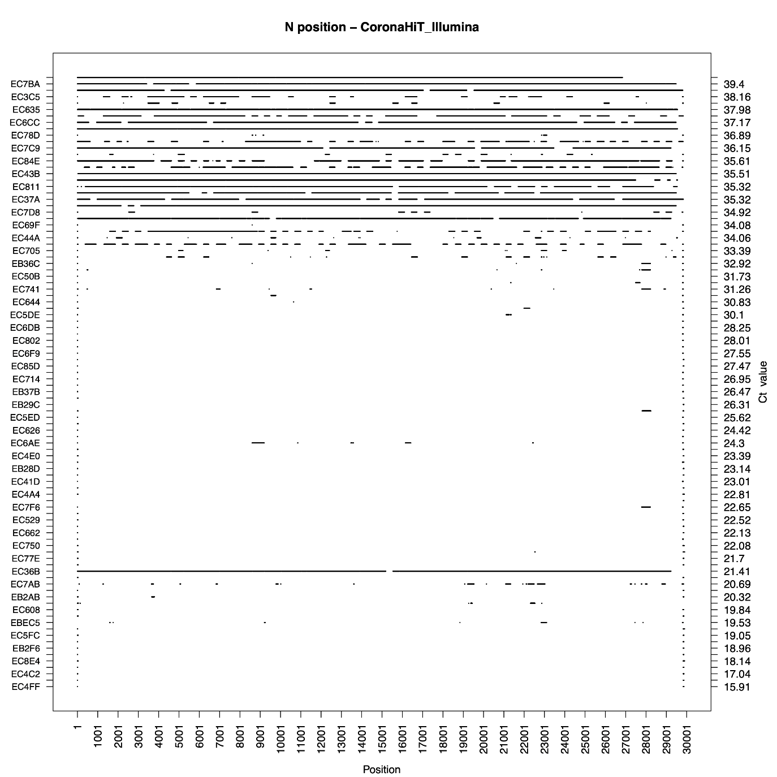

Fig. S4 - ARTIC LoCost for rapid response samples 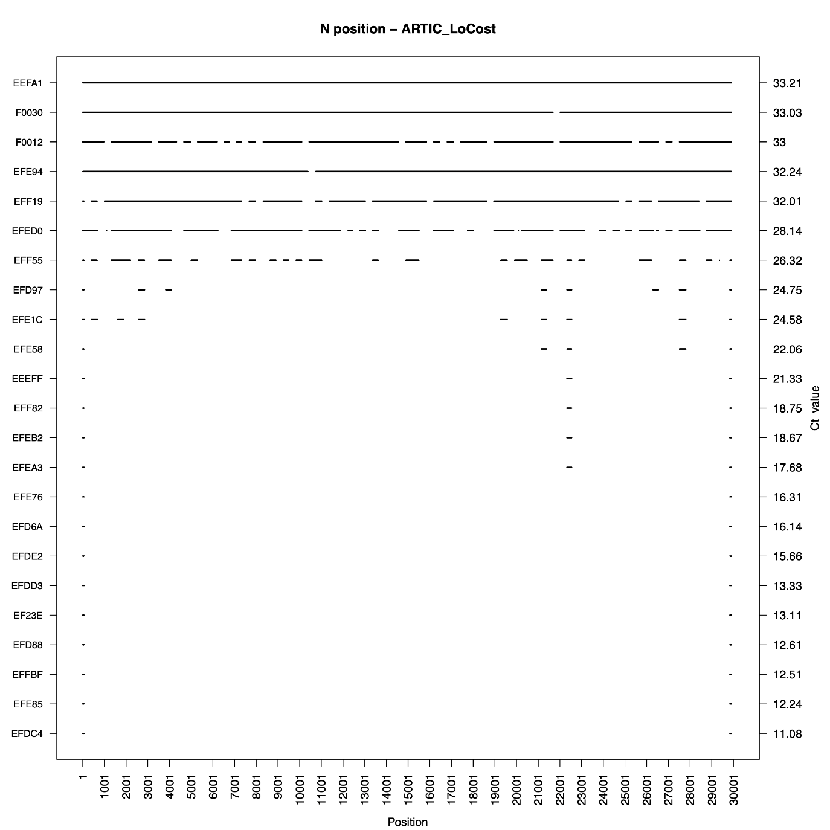

Fig. S5 - CoronaHiT-ONT for rapid response samples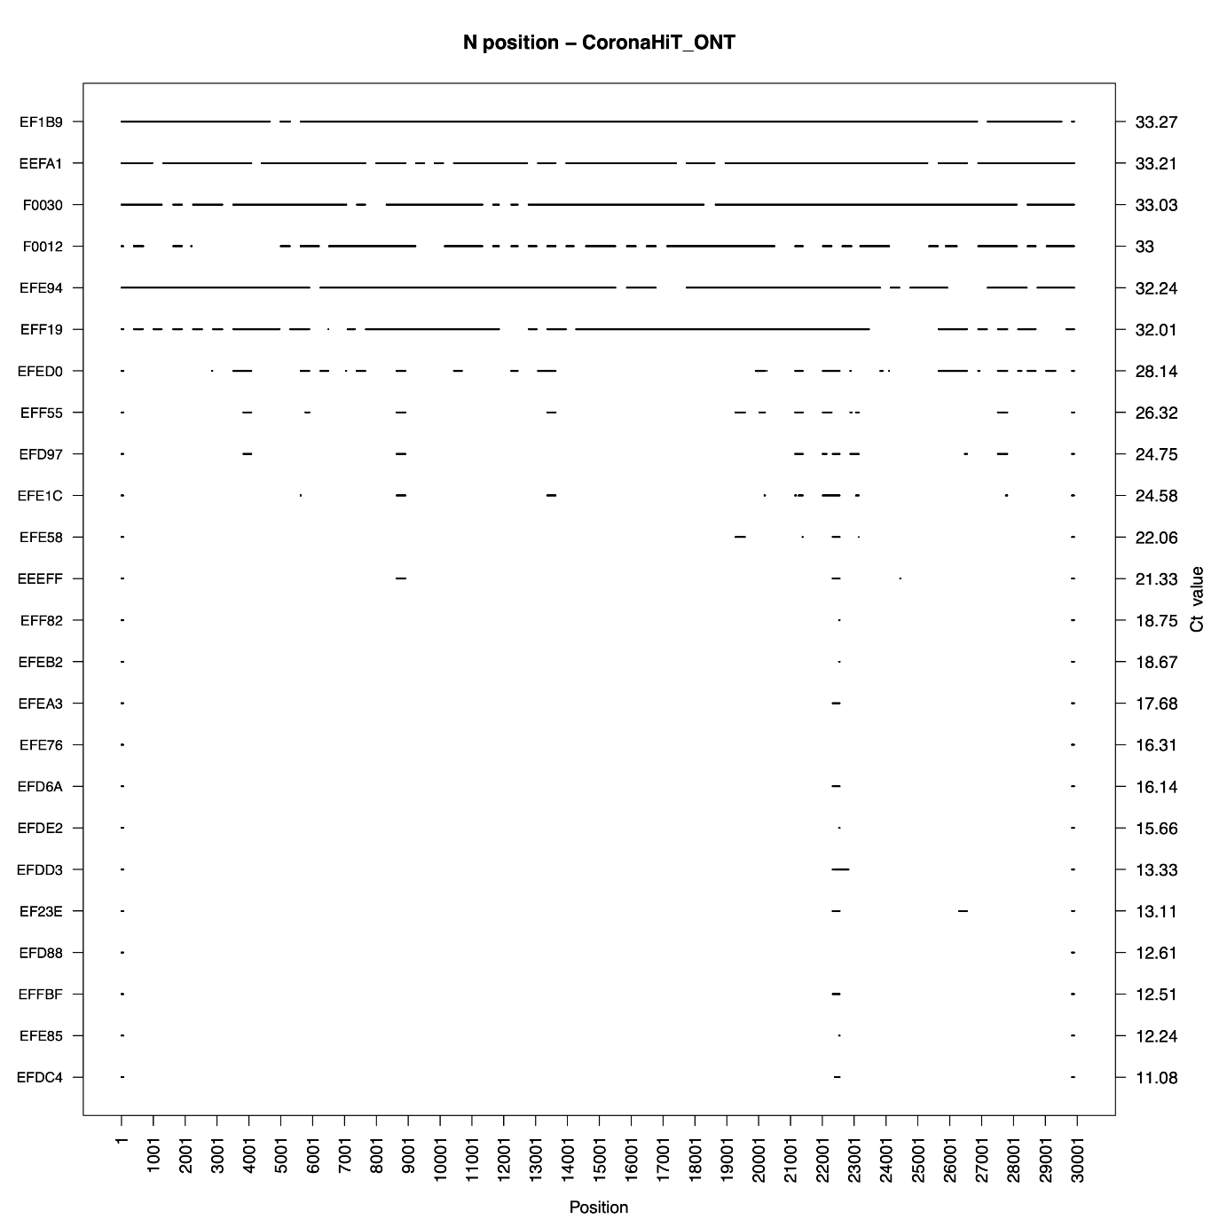

Fig. S6 - CoronaHiT-Illumina for rapid response samples