Additional information for:
Genotype–phenotype correlations, and novel molecular insights into the DHX30-associated neurodevelopmental disorders

Mannucci et al.

Additional file 7

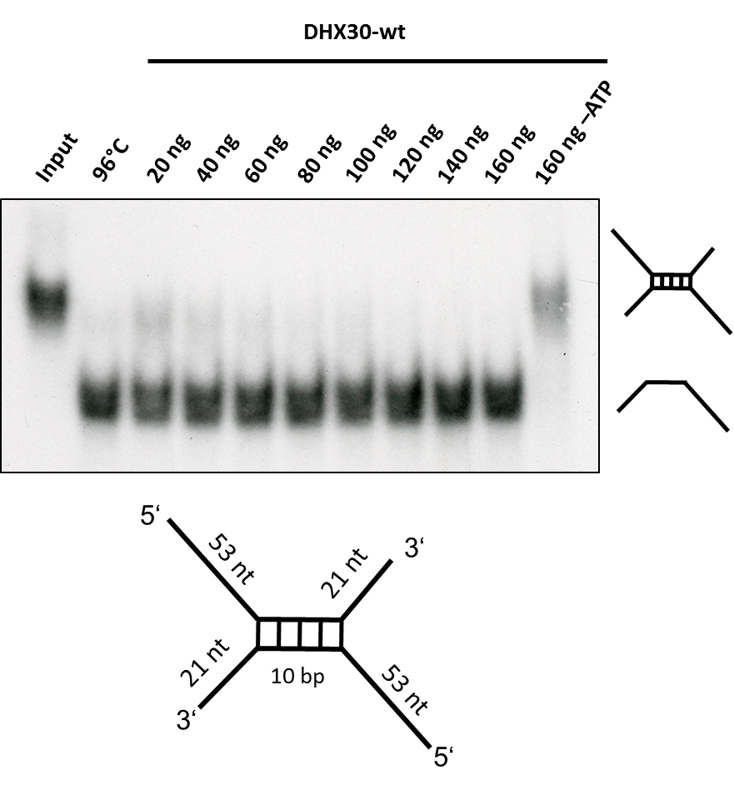

Fig. S4. DHX30 WT acts as an ATP-dependent RNA helicase. Top: Increasing amounts of His6-SUMO-tagged DHX30 WT protein were incubated with a 32P-labelled RNA substrate in the presence (lane 3-7) or absence (lane 8) of ATP and analyzed by native PAGE. The position of the RNA duplex and the single-stranded RNA are indicated in the first and second lane, respectively. Their schematic representation is shown at the right side. Bottom: RNA duplex containing a central GC sequence flanked by single-stranded regions of 53 nucleotides at the 5’ end and 21 nucleotides at the 3’ end.

