Additional File 1
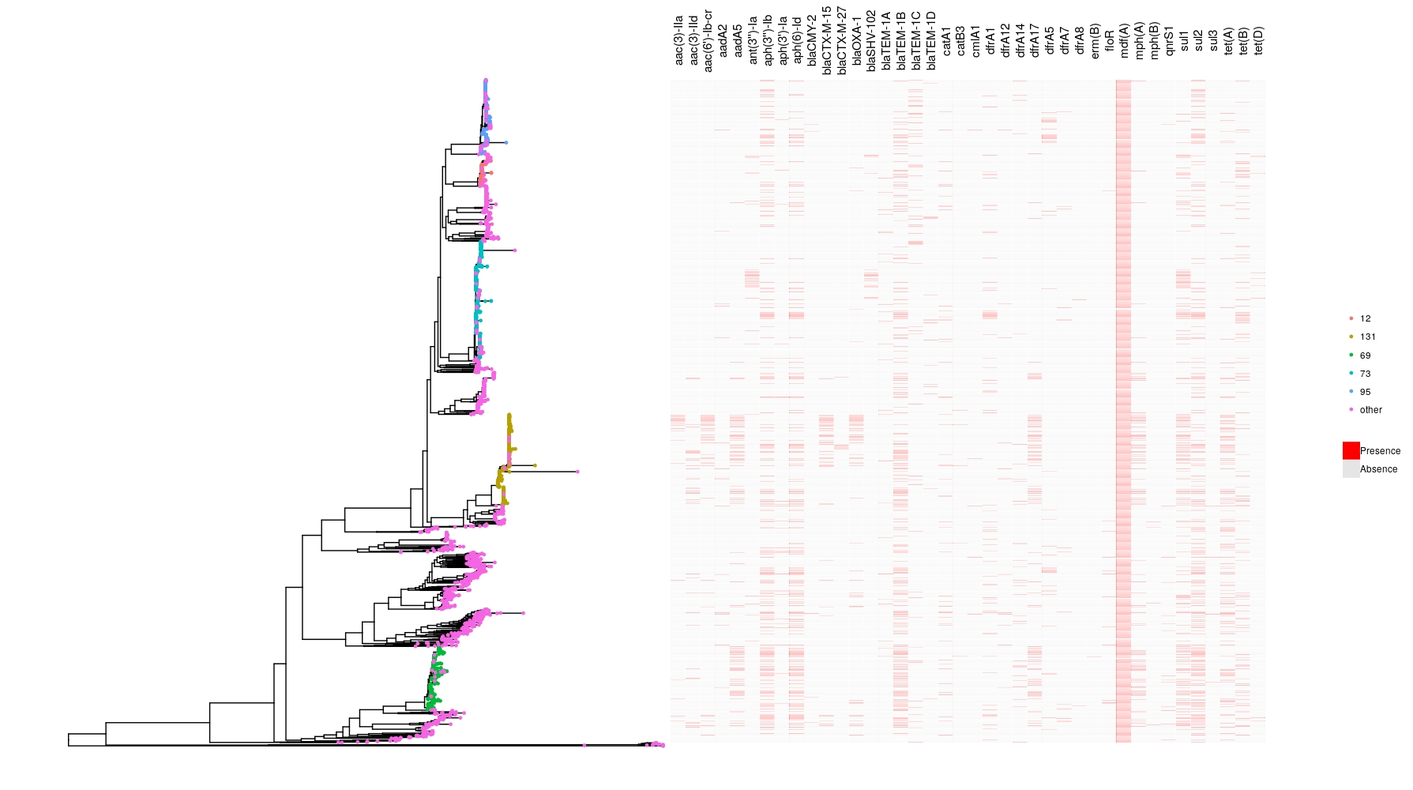
Fig S1: Gene presence/absence heatmap showing AMR gene presence/absence against the core genome phylogeny for E. coli. Tip colours show the location of the more common STs in the phylogeny. Only genes occurring >10 times in the dataset are shown. The tree is midpoint rooted. This figure is also available in higher resolution at https://doi.org/10.6084/m9.figshare.14459139.v2
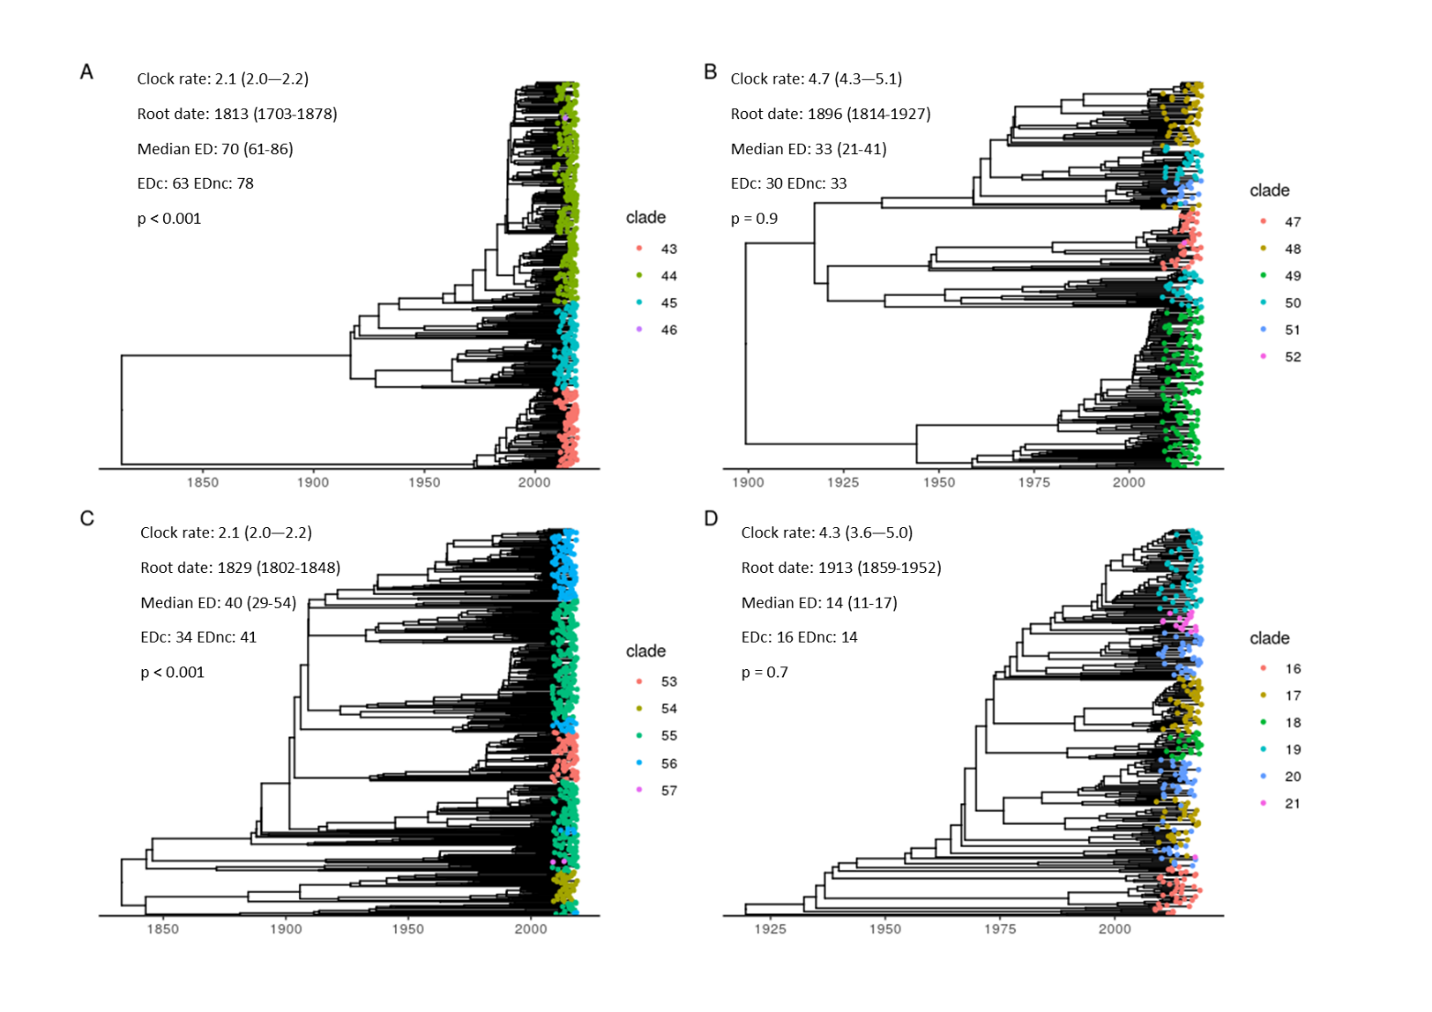
Fig S2: Time-scaled phylogenies for A) ST131 B) ST95 C) ST73 and D) ST69. Tip colours represent fastbaps clusters, which were computed from a multiple sequence alignment using the maximum likelihood tree to reduce search space. The text inset shows estimates for the molecular clock (mean, 95% highest posterior density interval), SNPs/site/year), root date (mean, 95% highest posterior density interval), evolutionary distinctiveness (ED, median and interquartile range) and median evolutionary distinctiveness for isolates with (EDc) and without (EDnc) a gene conferring ceftriaxone resistance. The p-value represents a Kruskal-Wallis test of the ED scores between the EDc and EDnc groups.

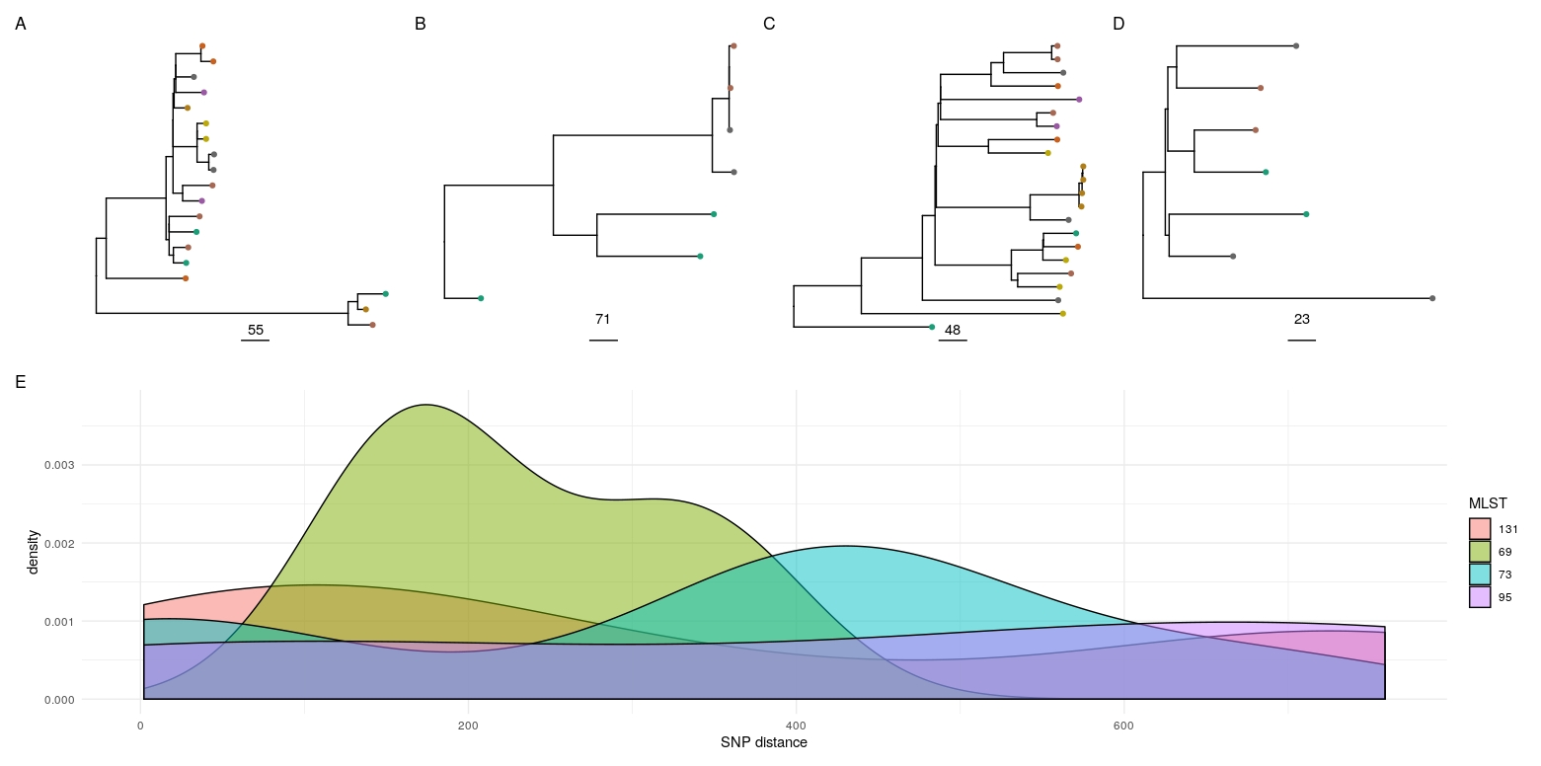
Fig S3: Possible transmission within nursing homes: A-D - Phylogenies for the major STs containing isolates orginating from nursing home residents where there was more than one patient from the same GP practice in the study (the assumption being that they may therefore reside in the same nursing home); panel A - ST131, B - ST95, C - ST73, D - ST69. Tip colours represent GP practices. E - density plot for cophenetic SNP distances for the major ST plots shown in A-D for patients presumed to be in the same nursing home. Out of 54 total pairwise comparisons of isolates in the same ST and presumed same nursing home, 4 were <= 10 SNPs, 5 11-20 SNPs, 2 21-50 SNPs, 3 51-100 SNPs and 40 >100 SNPs.
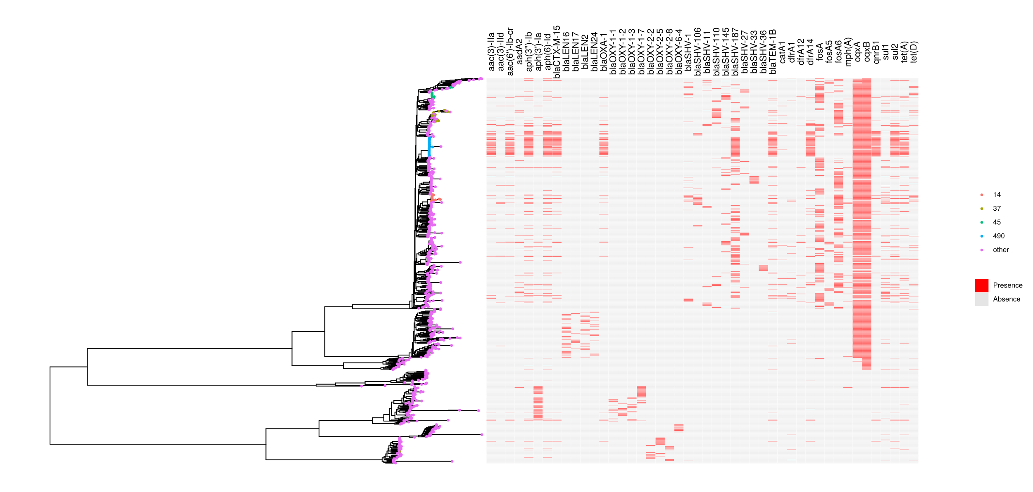
Fig S4: Gene presence/absence heatmap showing AMR gene presence/absence against the core genome phylogeny for Klebsiella spp. Only genes occurring >10 times in the dataset are shown. Tip colours show the location of the more common STs in the phylogeny. This figure is also available in higher resolution at https://doi.org/10.6084/m9.figshare.14459139.v2
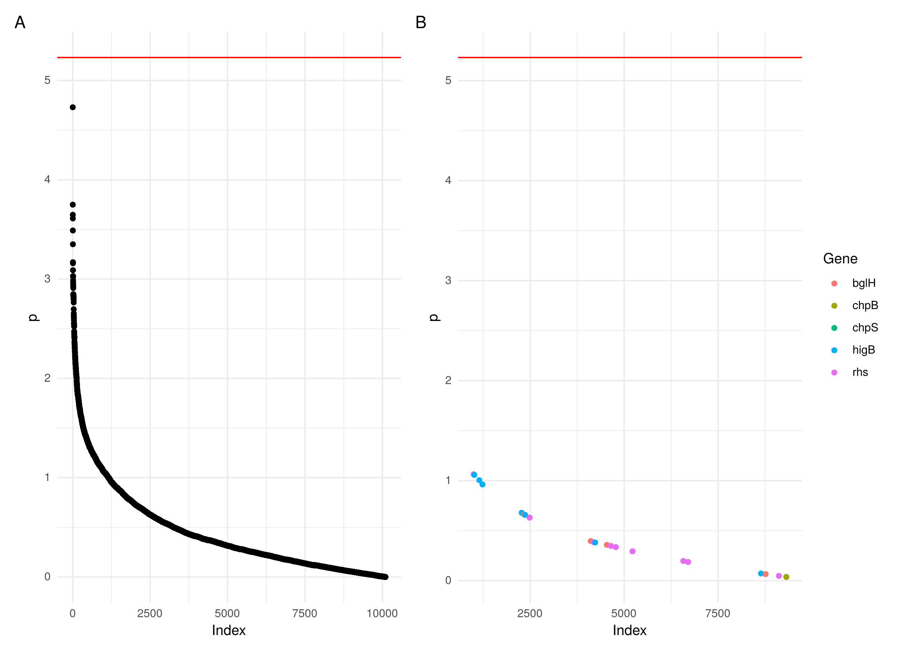
Fig S5: Manhattan plots of a pangenome wide association study of the association of genes with community/healthcare associated onset. A) all genes shown in descending order of -log10(p value). B) genes previously shown to be signficantly associated with either healthcare/community onset cases¹. Red horizontal bar represents the Bonferroni adjusted significance threshold.
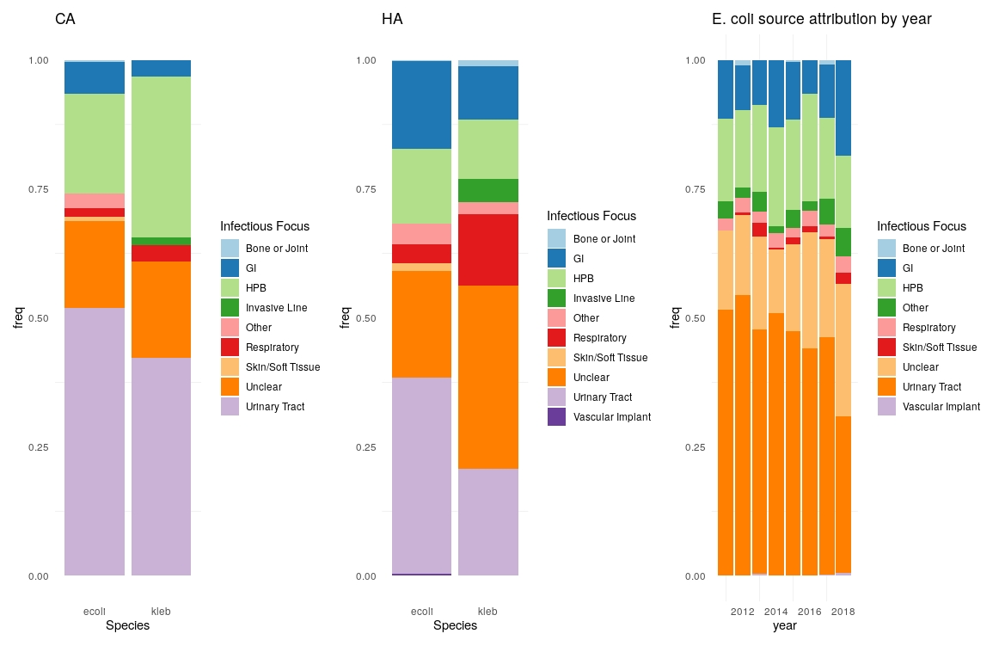
Fig S6: Proportions of presumed infectious foci for CA (left panel) and HA (central panel) BSI. Source attribution by year for E. coli (right panel).

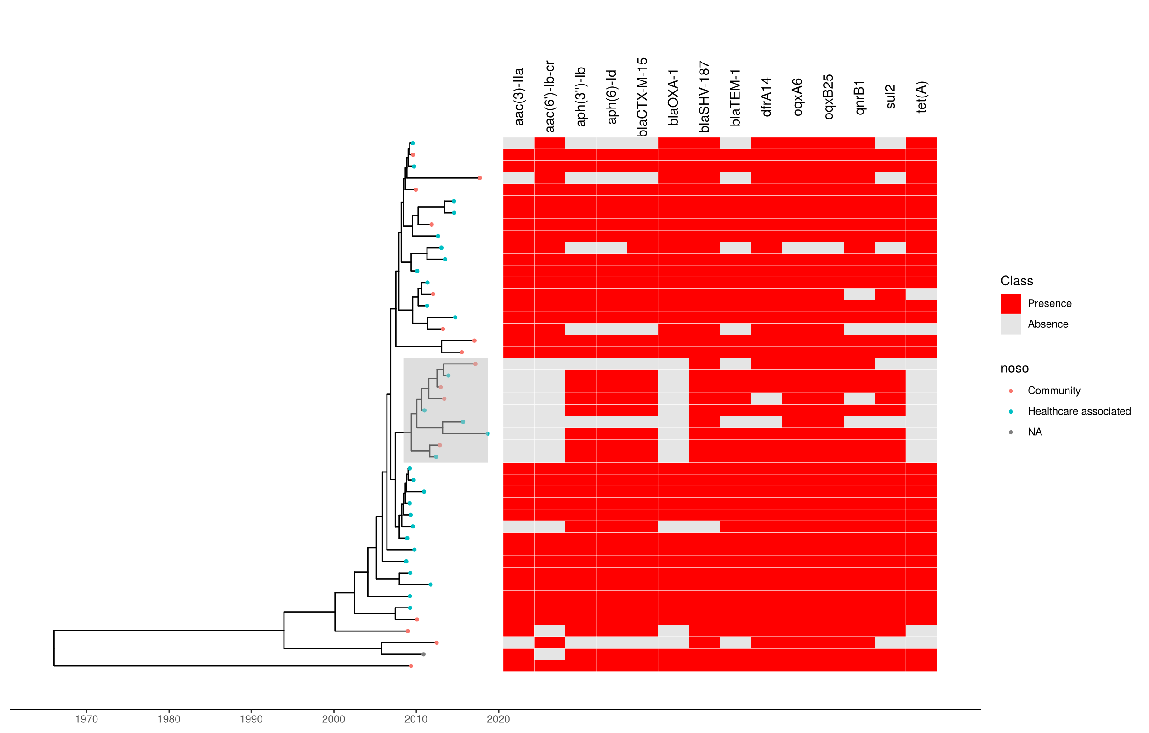
Fig S7: Timescaled phylogeny of Klebsiella pneumoniae ST490 with a heatmap of AMR genes. Tree tip colours indicate whether the isolate is community/healthcare associated. Only genes occurring >10 times are shown. The subclade which emerged without aac(3)-IIa, aac(6’)-Ib-cr, blaOXA-1 and tet(A) is shown with a grey highlighted box. The x axis shows time in years.
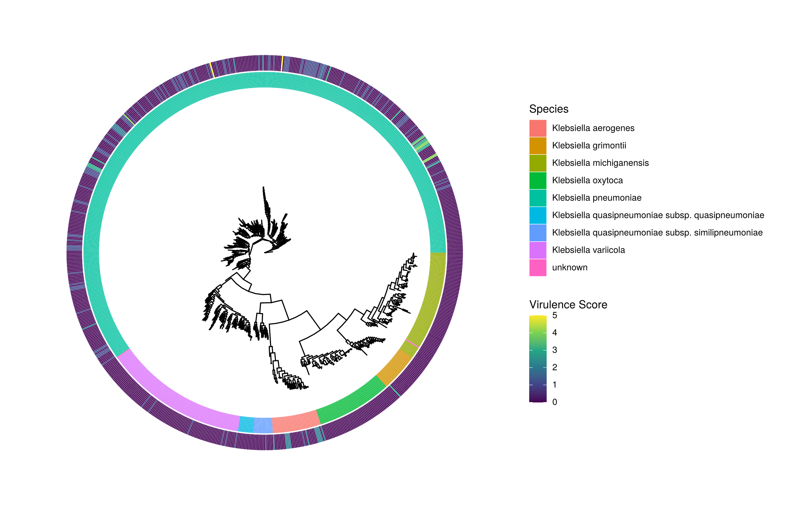
Fig S8: Phylogenetic tree of Klebsiella spp annotated with species (inner ring) and virulence score (outer ring). Virulence score is defined by Kleborate³ as follows: 0 – no acquired virulence loci, 1 – yersiniabactin only, 2 – yersiniabactin and colibactin (or colibactin only), 3 – aerobactin only, 4 – aerobactin and yersiniabactin (no colibactin), 5 – yersiniabactin, colibactin and aerobactin. This figure is also available in higher resolution at https://doi.org/10.6084/m9.figshare.14459139.v2

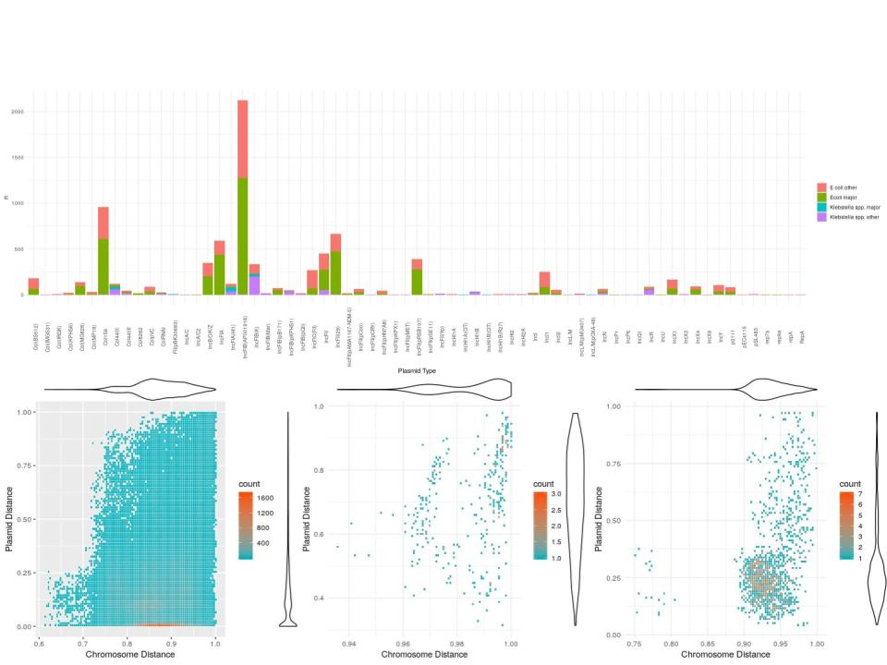
Fig S9: top panel - plasmid types in the PlasmidFinder database identified in the major/other E. coli/Klebsiella spp., bottom left - plot showing kmer based plasmidome similarity (y-axis) against chromosome similarity (x-axis) for isolates of the same MLST. Violin plots show the distribution of values for each axis. Origin of contigs was predicted as being plasmid/chromosome associated by ML Plasmids and distances calculated by Dashing. The bottom middle and right plots show the same thing for isolates of K. pneumoniae ST490 (middle) and E. coli ST131 (right) carrying a bla_{CTX-M-15} gene. This figure is also available in higher resolution at https://doi.org/10.6084/m9.figshare.14459139.v2
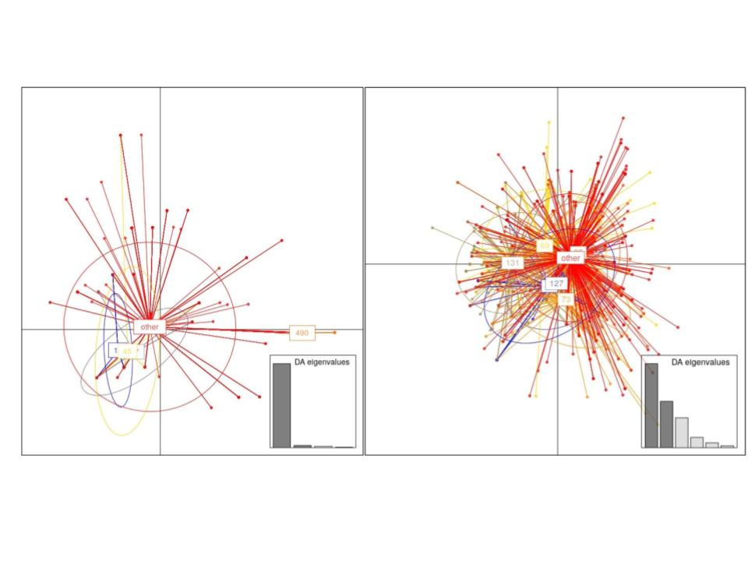
Fig S10: DAPC plots for Klebsiella spp. (left) and E. coli (right) showing discriminant factors which best discriminate isolates into STs based on plasmid types in the PlasmidFinder database.

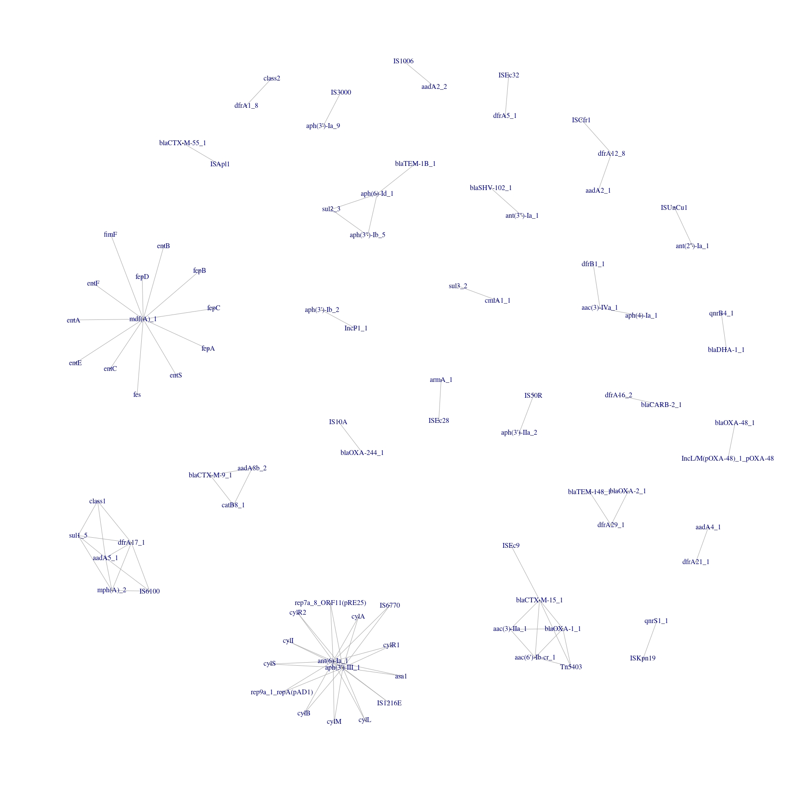
Fig S11: Networks of genes/plasmids/insertion sequences commonly co-occurring in E. coli. Edge lists were created from elements with a Pearson correlation coefficient >0.5. This figure is also available in higher resolution at https://doi.org/10.6084/m9.figshare.14459139.v2
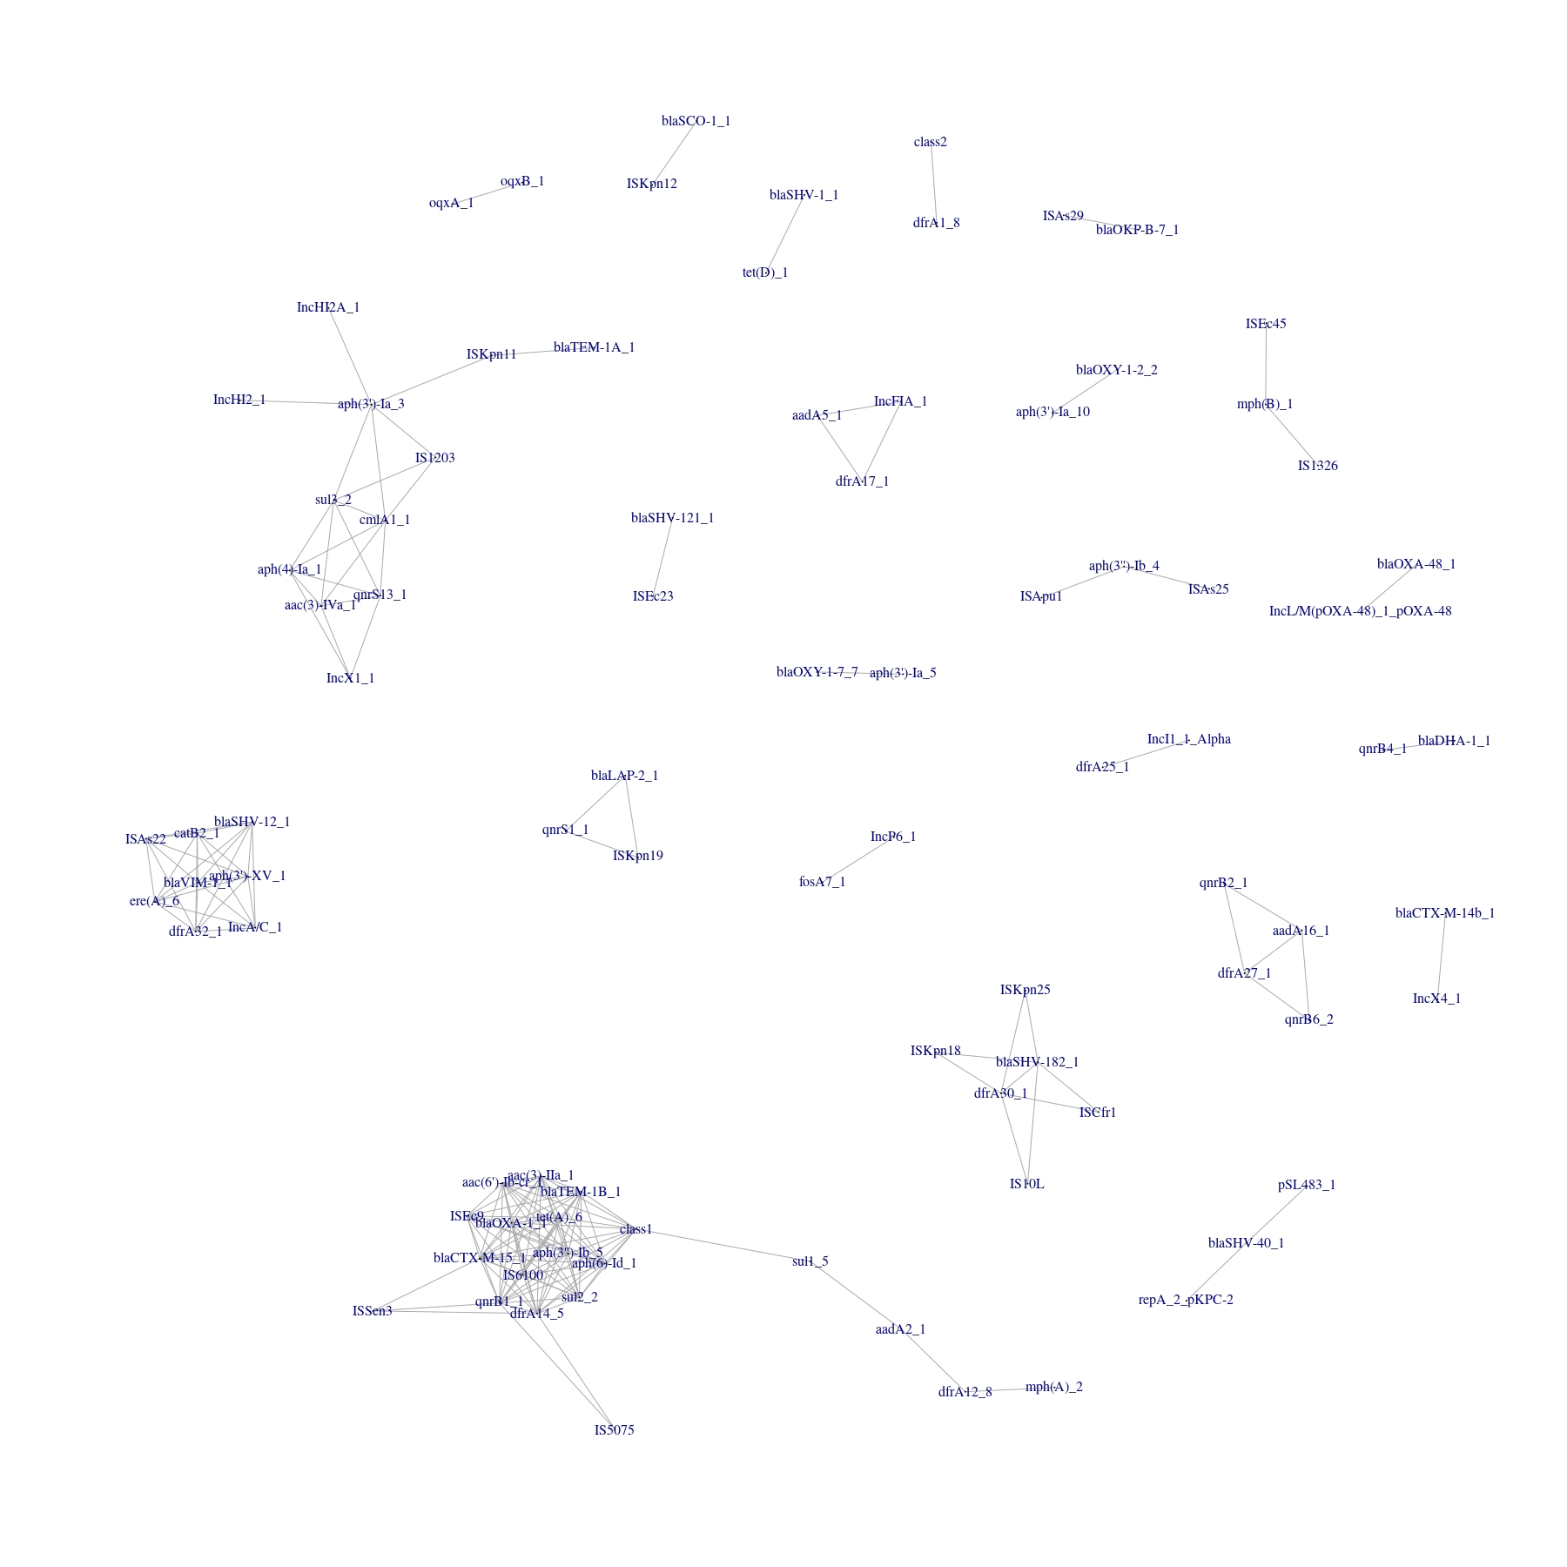
Fig S12: Networks of genes commonly co-occuring in Klebsiella spp. Edge lists were created from elements with a Pearson correlation coefficient >0.5. This figure is also available in higher resolution at https://doi.org/10.6084/m9.figshare.14459139.v2
Table S1: Incidence rate ratios for sub-lineage of major STs identified by fastbaps. Stacked negative binomial regression models were used to estimate incidence rate rations per year (IRRy). The p-value represents a Wald test for heterogeneity between the incidence rate for isolates of a sub-lineage compared to the incidence rate for all other isolates in a given ST (Bonferroni corrections to account for the number of tests performed per ST are shown to the right of this).
MLST | fastbaps cluster | IRRy | 95% CI | p_{heterogeneity} | Bonferroni corrected
131 | 43 | 1.18 | 1.09-1.27 | 0.96 | 1
131 | 44 | 1.20 | 1.10-1.32 | 0.08 | 0.25
131 | 45 | 1.12 | 1.01-1.25 | 0.03 | 0.1
95 | 47 | 1.21 | 1.00-1.46 | 0.19 | 0.93
95 | 48 | 1.18 | 1.11-1.25 | 0.01 | 0.05
95 | 49 | 1.05 | 1.00-1.10 | 0.01 | 0.03
95 | 50 | 1.06 | 0.96-1.16 | 0.32 | 1
95 | 51 | 1.00 | 0.89-1.10 | 0.07 | 0.35
73 | 53 | 1.17 | 1.10-1.26 | 0.13 | 0.52
73 | 54 | 1.02 | 0.92-1.14 | 0.13 | 0.52
73 | 55 | 1.11 | 1.04-1.18 | 0.47 | 1
73 | 56 | 1.07 | 0.98-1.16 | 0.29 | 1
69 | 16 | 0.95 | 0.87-1.05 | <0.001 | <0.001
69 | 17 | 1.18 | 1.11-1.24 | 0.14 | 0.86
69 | 18 | 1.29 | 1.16-1.44 | 0.04 | 0.25
69 | 19 | 1.31 | 1.19-1.43 | 0.002 | 0.01
69 | 20 | 1.05 | 0.95-1.17 | 0.04 | 0.24
69 | 21 | 1.15 | 0.93-1.42 | 0.87 | 1

Table S2: SNP ratios (median within/between region) and (median HA/all) were calculated for each ST. Permuted distributions were created by randomising tip labels 1000 times and recalculating ratios. P-values represent the number of permuted values at least as extreme as the observed value/1000. Values closer to 0 imply greater geographical/nosocomial clustering of isolates. In all cases the observed values were compatible with the null hypothesis.

 | Geographic distribution |  |  | Healthcare setting
ST | Observed ratio | Expected ratio | p-value | Observed ratio | Expected ratio | p-value
95 | 1.00 | 0.99 - 1.01 | 0.9 | 1 | 0.99 - 1.01 | 0.2
73 | 1.00 | 0..98 - 1.02 | 0.6 | 0.99 | 0.98 - 1.02 | 0.07
69 | 1.01 | 0.90 - 1.10 | 0.64 | 1.14 | 0.92 - 1.12 | 1
131 | 1.12 | 0.93 - 1.07 | 1 | 1 | 0.95 - 1.04 | 0.5

Table S3: Evolutionary distinctiveness (ED) scores for community-associated (CA) and healthcare-associated (HA) isolates amongst major E. coli STs. P-values represent Wilcoxon Rank Sum tests between the groups.
ST | Median ED CA (IQR) | Median ED HA (IQR) | p-value
95 | 40 (31 - 49) | 41 (33 - 47) | 0.7
73 | 49 (36 - 63) | 45 ( 35 - 57) | 0.09
69 | 18 (15 - 22) | 17 (14 - 21) | 0.06
131 | 74.7 (67.4 - 91.3) | 75.5 (67.9 - 91.3) | 0.8
Table S4: Top hits from a pangenome-wide association study (PGWAS) performed using Pyseer² of the assocation of gene presence/absence with pysician identified BSI source. Shown are the first 8 hits in order of likelihood ratio test p value. The Bonferroni corrected significance threshold was 1.10x10⁻⁶.
Gene | Allele frequency | Likelihood ratio test p-value (adjusted for population structure) | Beta | Standard Error | Gene H² | Associated source
papG | 0.39 | 3.43x10⁻²⁹ | 0.28 | 0.02 | 0.23 | Urinary tract
papC | 0.50 | 3.61x10⁻²⁰ | 0.23 | 0.02 | 0.19 | Urinary tract
papH | 0.50 | 4.97x10⁻²⁰ | 0.23 | 0.02 | 0.19 | Urinary tract
papD | 0.50 | 6.19x10⁻²⁰ | 0.23 | 0.02 | 0.19 | Urinary tract
papK | 0.43 | 3.83x10⁻¹⁹ | 0.21 | 0.02 | 0.19 | Urinary tract
papF | 0.47 | 3.11x10⁻¹⁶ | 0.20 | 0.02 | 0.17 | Urinary tract
papJ | 0.40 | 2.91x10⁻¹¹ | 0.17 | 0.03 | 0.14 | Urinary tract
papE | 0.32 | 1.86x10⁻⁹ | 0.15 | 0.03 | 0.13 | Urinary tract

Accession numbers of reference sequences used
ST131 - HG941718.1
ST95 - NZ_CP012625
ST73 - AE014075.1
ST69 - ERR3986909
ST490 - Custom de novo assembly available at 10.6084/m9.figshare.14498205
Integrase reference sequences used (taken from Fresia et al⁴):
Class 1 - AAQ16665.1
Class 2 - AAT72891.1
Class 3 - AAO32355.1
Class 4 - AAC 38424
Class 5 - AAD 55407.2

References
1. Goswami, C. et al. Genetic analysis of invasive Escherichia coli in Scotland reveals determinants of healthcare-associated versus community-acquired infections. Microb Genom 4, (2018).
2. Holt, K. Kleborate. https://github.com/katholt/Kleborate.
3. Lees, J. A., Galardini, M., Bentley, S. D., Weiser, J. N. & Corander, J. pyseer: a comprehensive tool for microbial pangenome-wide association studies. Bioinformatics 34, 4310–4312 (2018).
4. Fresia, P. et al. Urban metagenomics uncover antibiotic resistance reservoirs in coastal beach and sewage waters. Microbiome 7, 35 (2019).

