Additional file 1 of

Microbiota of the prostate tumor environment investigated by whole-transcriptome profiling

Paul Vinu Salachan^{1,2}, Martin Rasmussen^{1,2}, Jacob Fredsøe^{1,2}, Benedicte Ulhøi³, Michael Borre^{2,4}, Karina Dalsgaard Sørensen^{1,2}

¹Department of Molecular Medicine, Aarhus University Hospital, 8200 Aarhus N, Denmark
²Department of Clinical Medicine, Aarhus University, 8200 Aarhus N, Denmark
³Department of Pathology, Aarhus University Hospital, 8200 Aarhus N, Denmark
⁴Department of Urology, Aarhus University Hospital, 8200 Aarhus N, Denmark

Tables
Table S1. Wilcoxon test results comparing alpha diversity estimates for various comparisons.
Comparisons | Observed |  | Chao1 |  | ACE |  | Shannon |  | Simpson |  | Inverse Simpson
Comparisons | W | P | W | P | W | P | W | P | W | P | W | P
Discovery cohort
Malignant vs. Benign | 1909 | 1.5e-12 | 1909 | 1.5e-12 | 1909 | 1.5e-12 | 1730 | 1.7e-08 | 1539 | 4.5e-05 | 1539 | 4.5e-05
High vs. Low Gleason | 0 | 1.2e-10 | 0 | 1.2e-10 | 0 | 1.2e-10 | 46 | 3.1e-09 | 194 | 2.1e-05 | 194 | 2.1e-05
High vs. Low PSA | 148 | 5.7e-09 | 84 | 9.1e-14 | 44 | 1.9e-16 | 650 | 1.6e+00 | 703 | 3.4e+00 | 703 | 3.4e+00
pT3 vs. pT2 | 0 | 2.5e-13 | 0 | 2.5e-13 | 0 | 2.5e-13 | 287 | 9.0e-06 | 453 | 7.6e-03 | 453 | 7.6e-03
BCR vs. BCR-free | 16 | 3.4e-12 | 156 | 3.6e-08 | 85 | 4.2e-10 | 545 | 3.0e-01 | 601 | 9.7e-01 | 601 | 9.7e-01
Validation cohort
Malignant vs. Benign | 128 | 1.6e-05 | 128 | 1.6e-05 | 128 | 1.6e-05 | 42 | 1.1e+00 | 28 | 1.6e-01 | 28 | 1.6e-01
W, Wilcoxon test statistic. P, p value corrected for family wise error rate using the Bonferroni method.

Table S2. Validation of PCR amplicons by Sanger sequencing.
SampleID | Scientific Name | Max Score | Total Score | Query Cover | E Value | Percent Identity | Accession Length | Accession
M2 | Bacteroides fragilis | 706 | 706 | 98% | 0 | 91.15 | 1436 | NR_119164.1
M5* | Bacteroides fragilis | 577 | 577 | 90% | 2.00E-164 | 88.83 | 1436 | NR_119164.1
M11 | Bacteroides fragilis | 521 | 521 | 85% | 1.00E-147 | 89.33 | 1436 | NR_119164.1
B10 | Bacteroides fragilis | 544 | 544 | 98% | 2.00E-154 | 90.35 | 1436 | NR_119164.1
B13 | Bacteroides fragilis | 601 | 601 | 93% | 1.00E-171 | 88.94 | 1436 | NR_119164.1
B22 | Bacteroides fragilis | 521 | 521 | 82% | 1.00E-147 | 89.57 | 1436 | NR_119164.1
Shown are the identity of B. fragilis to assembled contigs, except in one case (asterisk) where identity to the reverse read is shown.

Table S5. Results from Kyoto Encyclopedia of Genes and Genomes (KEGG) pathway analysis. Up- and down-regulated host genes identified from the comparison between low vs. high Vibrio parahaemolyticus count group were used for KEGG pathway analysis.
Significant KEGG pathways in up-regulated genes
Pathway | Fold enrichment | p value | p-adj
Olfactory transduction | 5.577841663 | 7.01E-11 | 6.94E-09
Drug metabolism - cytochrome P450 | 8.926038062 | 4.89E-04 | 0.020410426
Metabolism of xenobiotics by cytochrome P450 | 8.202305246 | 7.22E-04 | 0.020410426
Drug metabolism - other enzymes | 10.99584399 | 9.86E-04 | 0.020410426
Chemical carcinogenesis | 7.587132353 | 0.00103083 | 0.020410426
Ascorbate and aldarate metabolism | 14.9869281 | 0.002185536 | 0.033229337
Steroid hormone biosynthesis | 8.720841785 | 0.002349549 | 0.033229337
Retinol metabolism | 7.903262868 | 0.003368396 | 0.041683901
Pentose and glucuronate interconversions | 12.26203209 | 0.003910476 | 0.04301524
Significant KEGG pathways in down-regulated genes
Pathway | Fold enrichment | p value | p-adj
Dilated cardiomyopathy | 4.939569161 | 2.79E-08 | 5.88E-06
cGMP-PKG signaling pathway | 3.455394816 | 1.60E-07 | 1.69E-05
Vascular smooth muscle contraction | 3.91965812 | 2.53E-07 | 1.78E-05
Calcium signaling pathway | 3.172013833 | 4.60E-07 | 2.43E-05
Hypertrophic cardiomyopathy (HCM) | 4.47960928 | 1.78E-06 | 7.53E-05
Focal adhesion | 2.756264448 | 6.35E-06 | 2.23E-04
cAMP signaling pathway | 2.647041847 | 3.08E-05 | 9.27E-04
Arrhythmogenic right ventricular cardiomyopathy (ARVC) | 4.23724236 | 4.14E-05 | 0.00109091
Adrenergic signaling in cardiomyocytes | 3.006694272 | 4.98E-05 | 0.001167746
Mineral absorption | 4.963203463 | 1.32E-04 | 0.002787404
Protein digestion and absorption | 3.474242424 | 1.58E-04 | 0.003036343
Neuroactive ligand-receptor interaction | 2.128623002 | 3.44E-04 | 0.006050787
Proteoglycans in cancer | 2.293 | 7.54E-04 | 0.012245937
Regulation of actin cytoskeleton | 2.183809524 | 0.00138483 | 0.020871363
ECM-receptor interaction | 3.012151067 | 0.001886739 | 0.026525358
Cardiac muscle contraction | 3.202920635 | 0.002011402 | 0.026525358
p-adj, p value corrected for false discovery rate.

Figures

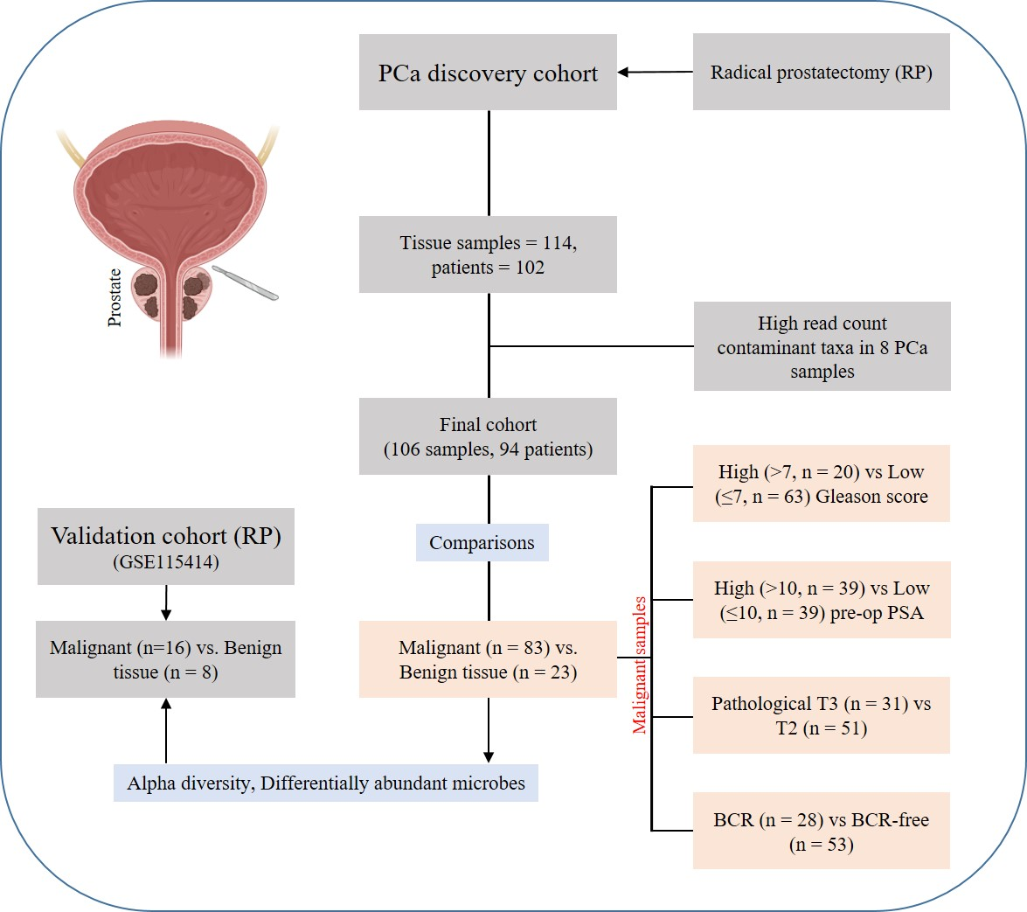
Figure S1. Overview of the patient cohort and the samples used in various comparisons. Exclusion of samples were performed due to the presence of very high read counts with very high contributions from taxa that are known to be tissue/reagent contaminants from previous studies. PCa, prostate cancer. Pre-op PSA, pre-operative prostate specific antigen. BCR, biochemical recurrence. Image partly made using Biorender.com
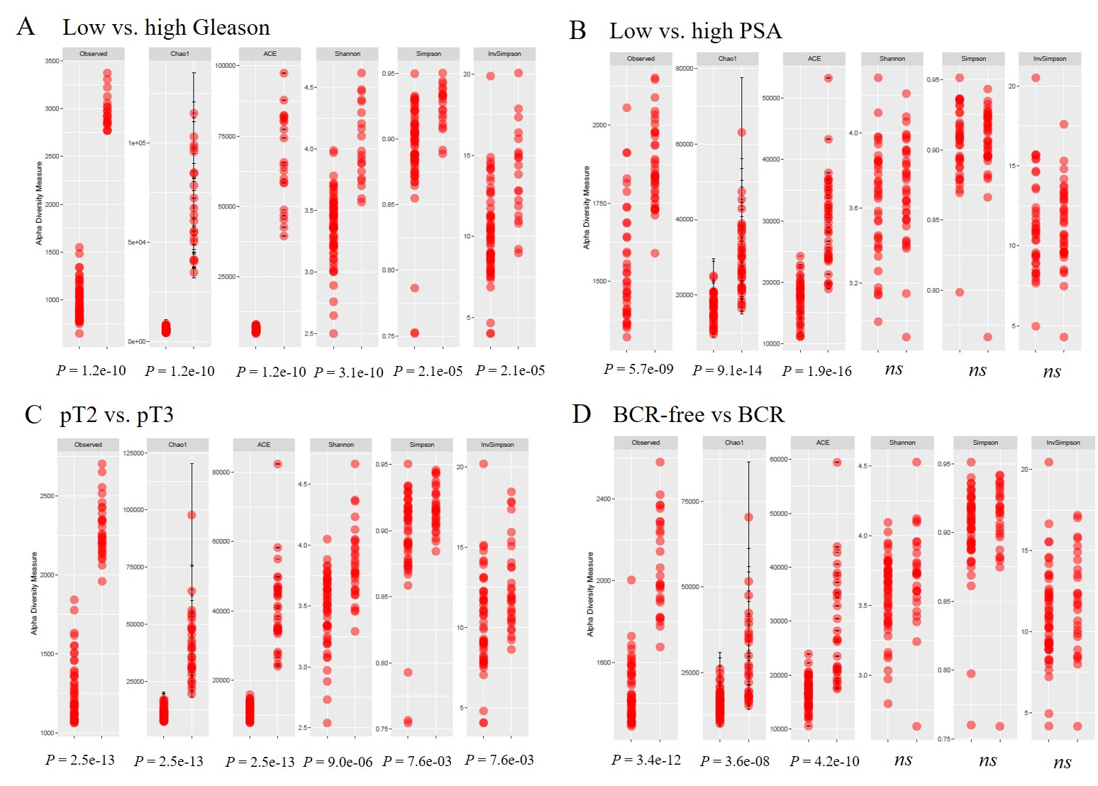
Figure S2. Differences in alpha diversity between less vs. more aggressive PCa based on A) pathological T-stage (pT2 vs.pT3), B) Gleason score (low vs. high), C) prostate specific antigen (low vs. high PSA) and D) biochemical recurrence (BCR-free vs. BCR). For each of the diversity measure, diversity within the less aggressive samples are shown first. A Wilcoxon rank sum test was used to compare the diversity estimates between the two groups and statistical significance was considered at a p value cut-off of 0.05. The more aggressive tissue samples had higher species diversity compared to the less aggressive tissue samples, although significance varied depending on the metric used. ns, not significant.
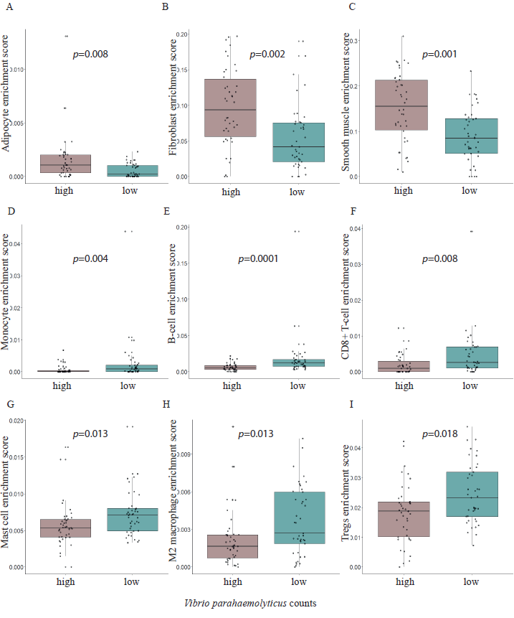
Figure S3. Boxplots showing differences in the enrichment scores between high vs. low Vibrio parahaemolyticus counts group for A) Adipocytes, B) Fibroblasts, C) Smooth muscle, D) Monocytes, E) B-cells, F) CD8+ T-cells, G) Mast cells, H) M2 macrophages, and I) T regulatory cells.

