Additional file 4: Figure S2

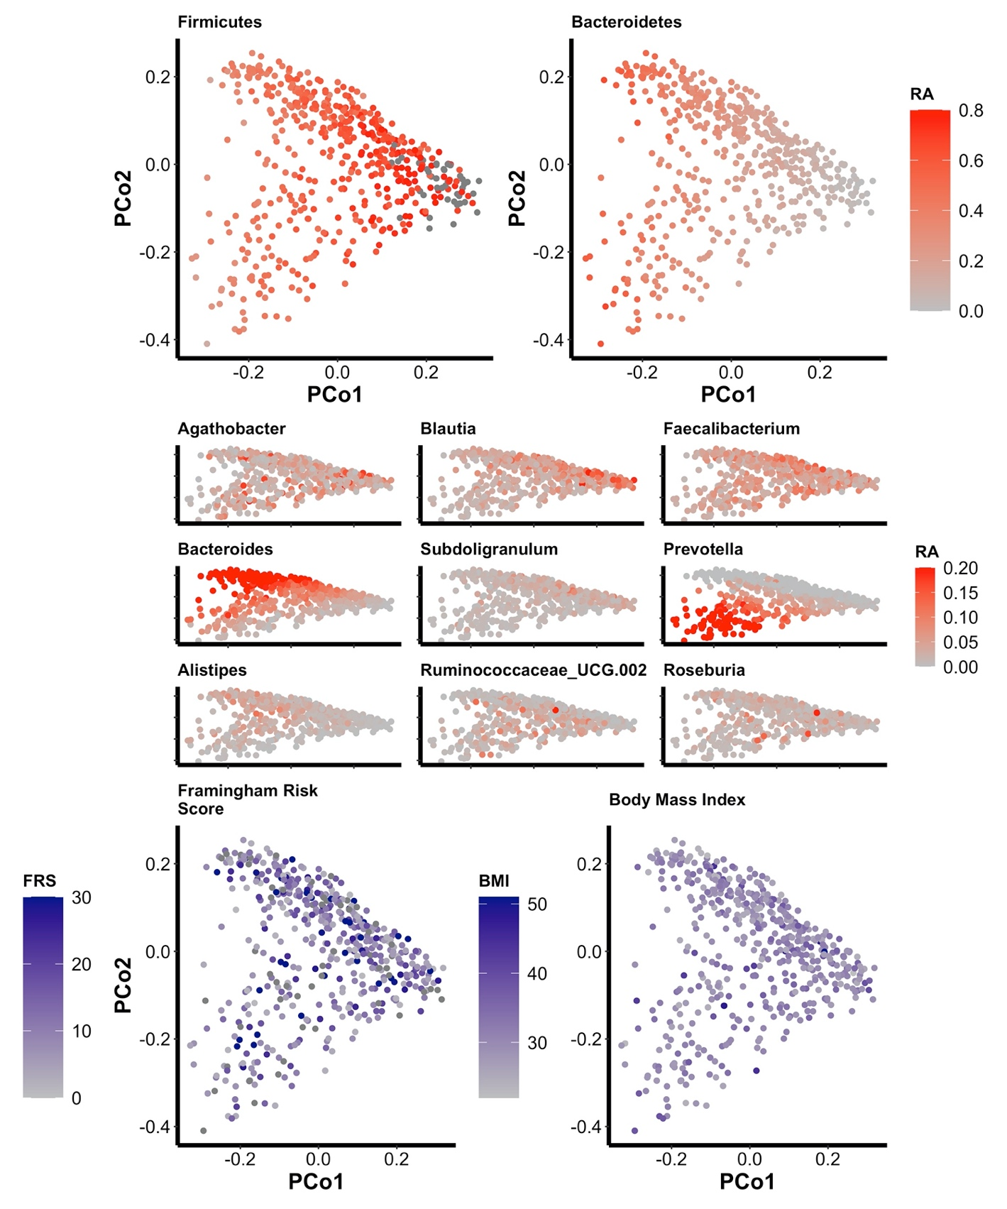Figure S2. Principal coordinate analysis of Weighted UniFrac dissimilarity colored in correspondence to the relative abundance of the 2 most abundant Phylum, 9 most abundant Genus, Framingham risk score and Body Mass Index.

Additional file 4: Figure S3

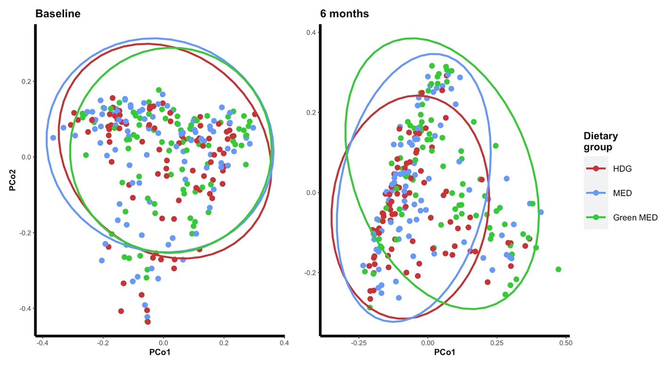
Figure S3. Principal coordinate analysis of Weighted UniFrac dissimilarity at baseline (left) and 6 months colored by lifestyle intervention group

