Additional File 1

Fig. S1. Analysis of human dura immune cells and comparison to murine dura immune cells. (A) Heatmap visualization of expression of the top 20 DEGs of each cell type characterized by Van Hove et al (10). (B) UMAP visualization of dura myeloid cells excluding mast cells. Monocyte/macrophages include C1, C2, C4. MHCII^{lo} MDSC-like cells include C6. DC-like cells include C0, C5, C7, and C8. migDC-like cells include C3. (C) UMAP visualization of dura myeloid cells excluding mast cells for select monocyte, macrophage, and DC marker genes. (D) Heatmap visualization of expression of the top 30 DEGs of each cell type characterized by Van Hove et al (10).

Fig. S2. Leptomeningeal fibroblast markers. Dot plot visualization of top DEGs of leptomeningeal fibroblast-like cell (FLC) clusters based upon the Saunders et al. (49) data set. Clustering of FLCs was performed and DEGs were reported by DeSisto et al. (39).

Fig. S3. Imaging mass cytometry of CD11b+ GZMB+ immune cells in DURA02 and DURA05. (A, B) Imaging mass cytometry of human dura sample DURA02 and DURA05, respectively, labeled with markers specified. Relative position of each image is denoted by bolded number in top left corner in reference to marked positions in Fig. 4A and Fig. 4E.

Fig. S4. Gene markers for PTPRC+ cells in dura and tumor samples. (A) Dot plot visualization of gene markers used for cell identification of CD45+ cells in dura and tumor samples (TCM: central memory T cell; TEM: effector memory T cell; CTL: cytotoxic T cell; TRM: resident memory T cell). (B) Dot plot visualization of gene markers used for cell identification of myeloid cells in dura and tumor samples.

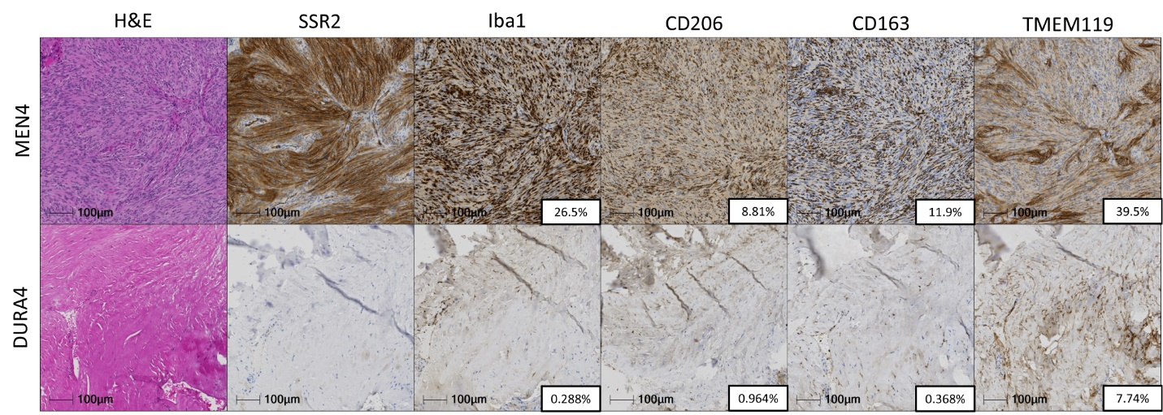
Fig. S5. Immunohistochemistry of a matched pair of non-tumor associated dura and tumor. Immunohistochemical staining of somatostatin receptor 2 (SSR2), Iba1, CD206, CD163, and TMEM119 in a matched pair of non-tumor associated dura and meningioma tumor (SAMPLE104). Insets contain %-positive area for selected marker.
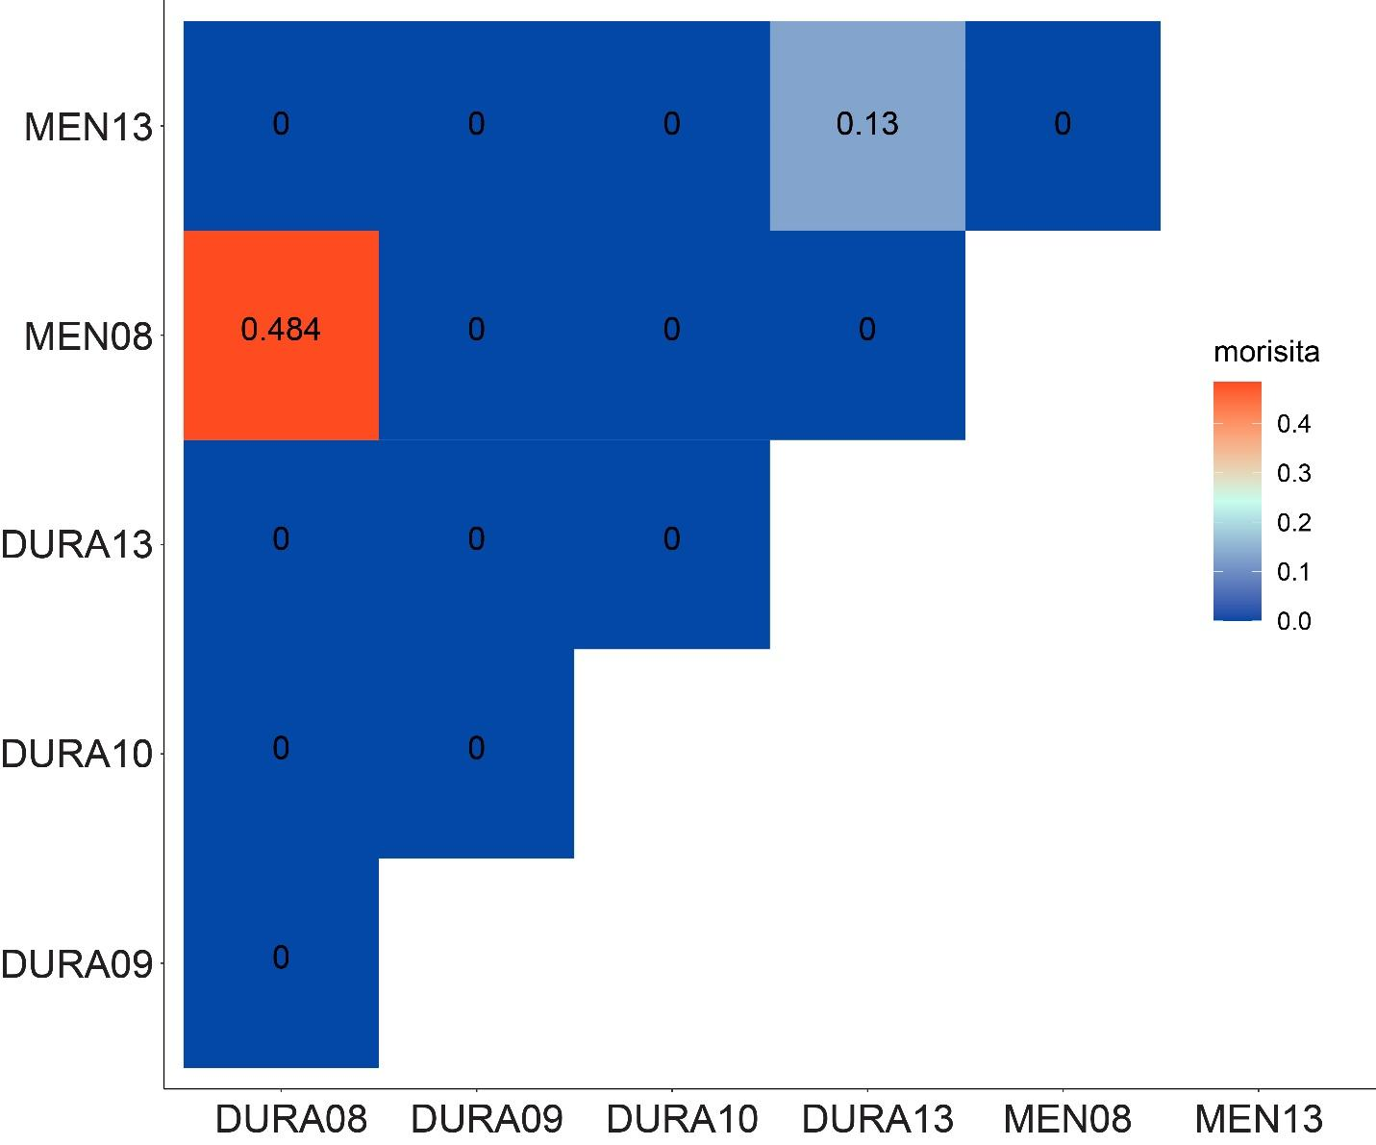
Fig. S6. Quantification of TCR overlap. The Morisita overlap index was calculated comparing the overall TCR repertoires from respective dura and tumor samples. Values range from 0 (no similarity) to 1 (completely identical TCR repertoires).

Fig. S7. Analysis of DURA09, MEN09, MEN104, and MEN108 samples differentiated by general cell types. (A) UMAP visualization of general cell types in DURA09, MEN09, MEN104, AND MEN108. (B) General markers used to differentiate specific cell types in Fig. S7A.
Fig. S8. CONICSmat analysis of putative patient specific tumor cells. (A-C) CONICSmat output of CNV analysis of patient specific tumor cells. Putative tumor cells were compared to patient matched non-tumor cells (PTPRC+ cells) to estimate CNVs. A: MEN104; B: MEN105; C: MEN09.

Table S1. Patient demographics and sample characteristics. Basic demographic information and sample characteristics.
Sample Names | Patient Gender | Tumor Location | Pathology | Tissue Type | Analyses performed
SAMPLE02 | F | L sphenoid wing | WHO grade II, atypical | Non-tumor associated dura (DURA02) | IMC
SAMPLE05 | M | R sphenoid wing | WHO grade II, atypical | Non-tumor associated dura (DURA05) | 3’ scRNAseq, IMC
SAMPLE06* | F | R frontotemporal | WHO grade II, atypical | Non-tumor associated dura (DURA06) | 3’ scRNAseq
SAMPLE08 | M | L frontal | WHO grade I, angiomatous | Non-tumor associated dura (DURA08) | 5’ scRNAseq, VDJ enrichment
 |  |  |  | Meningioma (MEN08) | 5’ scRNAseq, VDJ enrichment
SAMPLE09 | F | L frontal | WHO grade III, anaplastic | Non-tumor associated dura (DURA09) | 5’ scRNAseq, VDJ enrichment
 |  |  |  | Meningioma (MEN09) | 5’ scRNAseq
SAMPLE10 | M | L frontal | WHO grade I | Non-tumor associated dura (DURA10) | 5’ scRNAseq, VDJ enrichment
 |  |  |  | Meningioma (MEN10) | 5’ scRNAseq
SAMPLE11 | M | Parafalcine | WHO grade II, atypical with patchy angiomatous | Non-tumor associated dura (DURA11) | 5’ scRNAseq
SAMPLE13 | F | Parafalcine | WHO grade II, atypical | Non-tumor associated dura (DURA13) | 5’ scRNAseq, VDJ enrichment
 |  |  |  | Meningioma (MEN13) | 5’ scRNAseq, VDJ enrichment
SAMPLE104 | F | R temperoparietal | WHO grade I | Meningioma  (MEN104.1- CD45pos fraction, MEN104.2-CD45neg fraction) | 5’ scRNAseq, IHC
SAMPLE108 | M | R parasagittal | WHO grade II, atypical | Meningioma  (MEN108.1- CD45pos fraction, MEN108.2-CD45neg fraction) | 5’ scRNAseq
*Collected from a patient undergoing surgical resection for a recurrent meningioma. All other samples are collected from patients undergoing surgical resection for a primary meningioma.
Table S2. Gene markers for cell type identification. Markers used to characterize cell identity of obtained clusters based upon current literature.

Cell type | Markers | Ref.
Endothelial cell | PECAM1, CDH5, KDR, SELE, VWF | 40, 41
Fenestrated endothelium | PLVAP, PLPP1, PLPP3, NRP1, ESM1, RGCC | 51
Blood-brain barrier endothelium | FZD1-10, ADGRA2, CTNNB1, CDH5, SLC2A1, TNFRSF21, TNFRSF19, CLDN1, CLDN3, CLDN5, CLDN12, LSR, OCLN, TJP1, TJP2, TJP3, SLC5A1, SLCO1A2, SLC22A8, SLC16A1, PGP, ABCG2, ABCC4 | 50
Mesenchymal cell | COL1A1, COL1A2, LUM, DCN, ACTA2, RGS5
Immune cell | PTPRC, CD3E, SPI1, CD14
Naïve/central memory T cell (TCM) | SELL, CCR7, LEF1, TCF7, KLF2 | 29
CD4+ effector memory T cell (TEM) | SELL-, CCR7-, IL7R | 30
CD8+ TEM | SELL-, CCR7-, IL7R, CD8A, CD8B | 30
Resident memory T cell (TRM) | CD69, NR4A2, IL7R | 30
CD8+ cytotoxic T cell (CTL) | PRF1, NKG7, ZNF683, GZMB, CD8A, CD8B | 29
Natural killer cell | PRF1, NKG7, GZMB, KLRD1, KLRF1, CD3- | 31
B cell | CD79A, MS4A1, MHC class II | 32
Plasma-like B cells | IGHG3, IGHA1, DERL1, FKBP11 | 32
Monocyte/macrophage | CD14, VCAN, S100A8, S100A9, RNASE1, C1QA, C1QC, FCAR, GPNMB, MHC class II | 33-36
Microglia | AIF1, GPR34, CD14, C1QA, C1QB, C1QC | 26
Border associated macrophage (BAM) | MRC1, STAB1, CD163, APOE, MS4A7 | 10
MHCII^{lo} MDSC-like | Monocyte/macrophage genes, MHC class II- | 38
DC-like | CD14-, ITGAX, THBD, MHC class II | 33, 35
migDC-like | CD14-, IL3RA, CCR7, IDO1, LAD1, CCL22, RAMP1, MHC class II | 33, 35, 36
Mast cell | GATA2, KIT, HPGDS | 37
Fibroblast | LUM, DCN, COL1A1, COL1A2, COL3A1 | 40, 41
Mural cell | ACTA2, MYH11, CNN1, RGS5, PDGFRB, NOTCH3, MCAM, CSPG4 | 41-43

Table S3. Antibody Information. Antibody targets with respective conjugated heavy metals (if used for IMC), dilution factor, antibody clone, clone number, and manufacturer information. All conjugated antibodies were at a concentration of 0.5 mg/mL except for Iba1 (0.336 mg/mL). Otherwise, antibodies were at stock concentration.

Target | Label | Dilution factor | Clone | Manufacturer | Catalog #
a-SMA | 089Y | 1:50 | 1A4 | eBiosciences | 14-9760-82
CD14 | 144Nd | 1:400 | 3144025D | Fluidigm | EPR3653
CD163 | 147Sm | 1:200 | EDHu-1 | Fluidigm | 3147021D
CD11b | 149Sm | 1:100 | EPR1344 | Fluidigm | 3149028D
CD31 | 151Eu | 1:75 | EPR3094 | Fluidigm | 3151025D
CD4 | 156Gd | 1:450 | EPR6855 | Fluidigm | 3156033D
Iba1 | 158Gd | 1:500 | Poly | Novusbio | NBP2-19019
CD8a | 162Dy | 1:375 | C8/144B | Fluidigm | 3162034D
CD45RA | 166Er | 1:1000 | PTPRC/818 | Novusbio | NBP2-47957
GZMB | 167Er | 1:500 | EPR20129-217 | Fluidigm | 3167021D
Collagen I | 169Tm | 1:2500 | Polyclonal | Fluidigm | 3169023D
CD3 | 170Er | 1:100 | polyclonal C-Terminal | Fluidigm | 3170019D
CD45RO | 173Yb | 1:300 | UCHL1 | Fluidigm | 3173016D
HLA-DR | 174Yb | 1:350 | LN3 | Fluidigm | 3174025D
Histone H3 | 176Yb | 1:2000 | D1H2 | Fluidigm | 3176023D
DNA-Ir1 | 191Ir | 1:400 | 125uM | Fluidigm | 201192A
DNA-Ir2 | 193Ir | 1:400 | 125uM | Fluidigm | 201192A
CD206 | IHC | 1:2000 |  | abcam | ab64693
CD163 | IHC | 1:200 |  | Leica | NCL-L-CD163
Iba1 | IHC | 1:200 | EPR16588 | abcam | ab178846
TMEM119 | IHC | 1:250 | C-terminal | abcam | ab185333
Somatostatin receptor 2 | IHC | 1:1000 | UMB1-C-terminal | abcam | ab134152

Table S4. Gene markers for macrophage polarization states. Markers associated with macrophage polarization states.

Polarization state | Markers | Ref.
M1 macrophage polarization | CD86, CD80, IL1R1, TLR2, TLR4, NOS2, SOCS3, IL1B, TNF, IL6, FCGR2A, MARCO, NOS2, NFKB1, STAT1, IRF5, JUN, FCGR1A, IDO1, SOCS1, CXCL10 | 25
M2a macrophage polarization | CD163, MRC1, TGFB1, SLAMF1, SPHK1, THBS1, HMOX1, STATE3, TLR1, TLR8, TGM2, FCER2, CCL22 | 25
M2b macrophage polarization | MRC1, TREM2, IGF1, IL1RN, STAT6, KLF2, IRF4, PPARG, PPARD, CD163, TGM2, IL1R2, FCER2, CCL22 | 25
M2c macrophage polarization | IL6, VEGFA, IGF1, CD86, TNF, FCGR1A, MRC1, TGM2, FCER2, CCL22 | 25

