Assante et al., Acetyl-CoA metabolism drives epigenome change and contributes to carcinogenesis risk in fatty liver disease. Supplementary Figures.
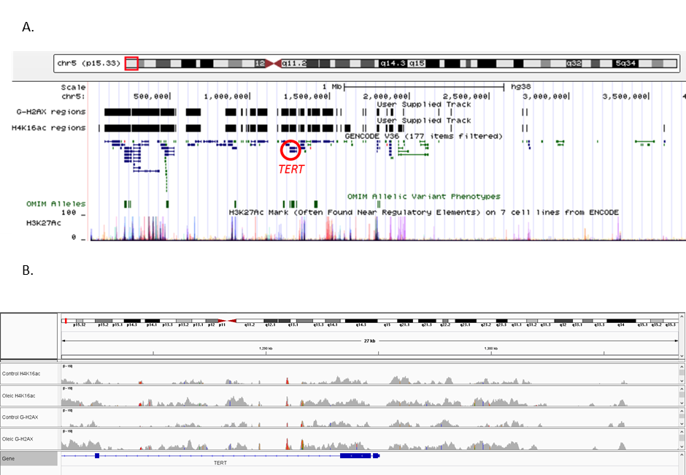
Supplementary Figure S1. A. UCSC Genome Browser of the chromosome 5 telomere-proximal gene cluster showing location of genes and ENCODE H3K27ac regions relative to ɣH2AX and H4K16ac ChIP-seq peak regions. B. IGV Genome Browser snapshot of the TERT promoter regions displaying aligned sequence reads from ChIP-seq files of the 4 samples top to bottom, control media cells H4K16ac, oleic acid treated cells H4K16ac, control media cells ɣH2AX, oleic acid treated cells ɣH2AX.

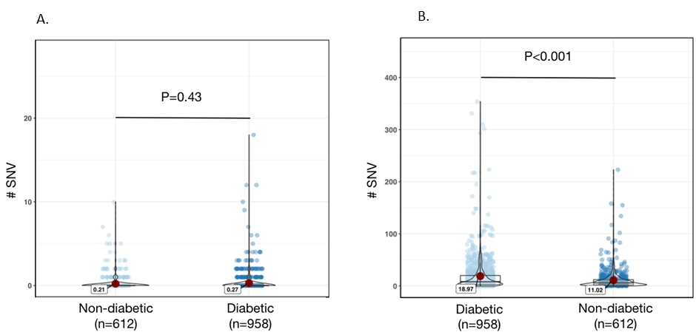

Supplementary Figure S2. Violin plots showing a comparison of the number of single nucleotide variants (SNVs) in individual genetic clones from donors with versus without diabetes, at A. control, and B. oleic acid peak regions. The median number of SNVs are annotated on the plots. Genetic clones from 20 non-diabetic patients, and 14 diabetics.

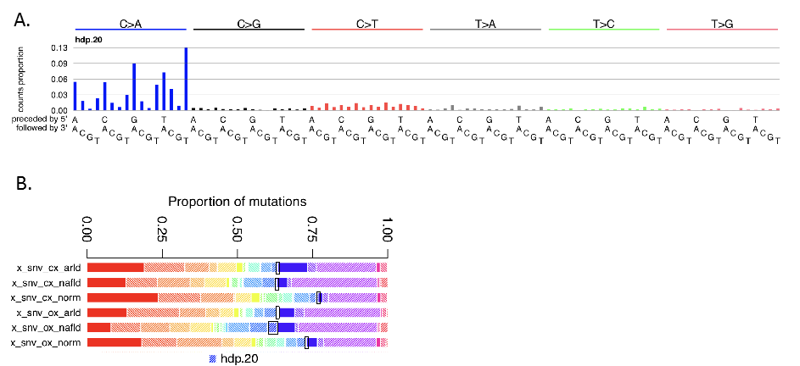

Supplementary Figure S3 A. A mutational signature (hdp.20) was detected with 97% cosine similarity to SBS18, indicating that a proportion of SNVs is attributable to a ROS associated mutational process and was most pronounced in NALFD clones at oleic acid peak regions. B. Bold black outlines highlight the relevant regions on the stacked bar plots corresponding to the ROS associated mutational signature. CX indicates control media cells ɣH2AX ChIP-seq peak regions, OX indicates oleic acid treated cells ɣH2AX ChIP-seq peak regions.

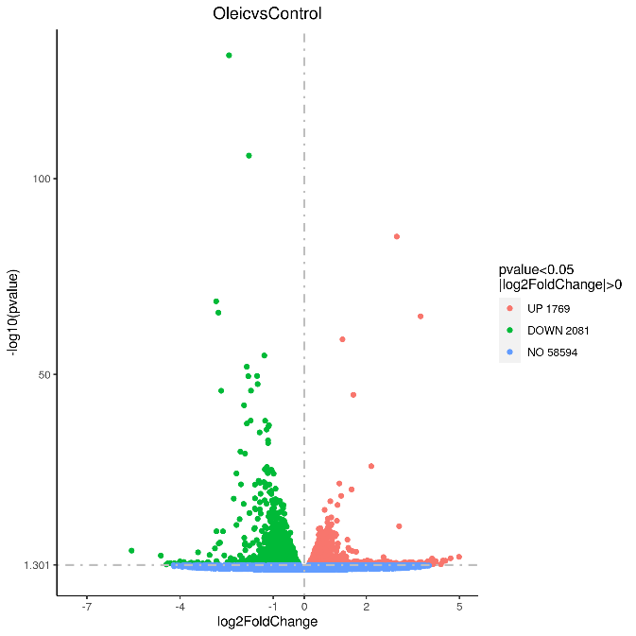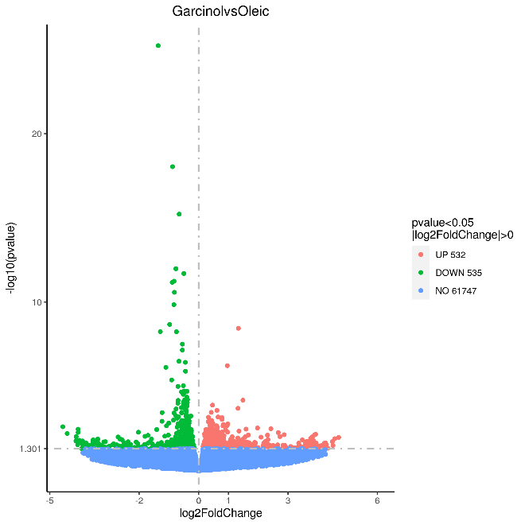
D.
C.
B.
A.

RHOB
TFRC
IFIT2
FOS
TXNIP
CYR61
JUN
LIPG
DHCR7
TXNIP
PLIN2
PDK4
ANGPTL4
SCDHCR7D
THBS1

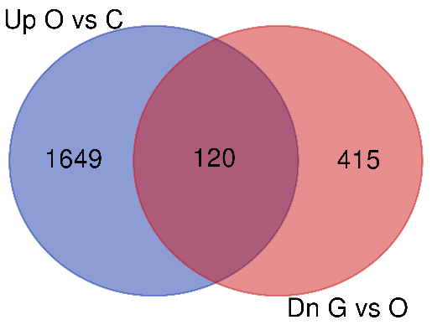
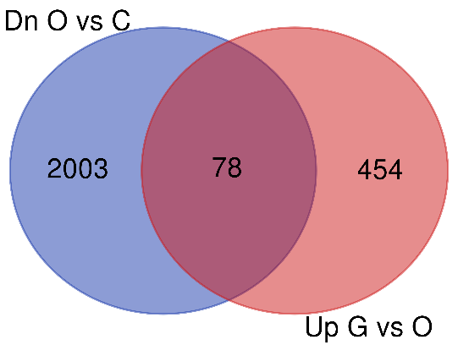

Supplementary Figure S4. A and B are volcano plots of IHH cell RNA-seq fold change and significance for differentially expressed genes. Transcripts with largest significance are indicated. A. Control versus Oleic acid treated cells, Up’ indicates genes with higher transcript levels in oleic acid treated cells. B. Oleic acid versus oleic acid plus Garcinol treated cells, Up’ indicates genes with higher transcript levels in garcinol plus oleic acid treated cells. C and D are venn diagrams comparing the significantly differentially expressed genes to reveal candidates for the reversal of epigenetic states. C. Genes upregulated in Oleic versus Control, and genes downregulated in Garcinol vs Oleic. The 120 common genes are potentially responsible for induction and reversal of epigenetic state. D. Genes downregulated in Oleic versus Control, and genes upregulated in Garcinol vs Oleic. The 78 common genes are also potentially responsible for induction and reversal of epigenetic changes.

