Additional file 4
Genomic analysis of the international high-risk clonal lineage Klebsiella pneumoniae sequence type 395
Shaidullina ER*, Schwabe M* et al.
*shared first authorship

Identification of large recombination events and putative donors
The complete genome of the PBIO1951 isolate was used as the reference genome. All other ST395 genomes from the dataset were mapped to the reference genome using Snippy. The putative regions of recombination were predicted by Gubbins. The Gubbins output files were used to calculate the mean recombination count per base, and to extract and annotate large (>100 kbp) recombination regions in the chromosome. The method described by Comandatore et al. (Genome Biol Evol. 2019;11(11):3240-3251) was then used to identify the putative donors of the large recombination events detected within ST395. Briefly, a total of 1,303 complete genome assemblies of K. pneumoniae isolates representing different STs were retrieved from the Patric database (https://www.patricbrc.org). They were merged to the ST395 dataset and aligned to the reference genome of PBIO1951. The core SNPs were called again using Snippy and those corresponding to each recombination region of >100 kbp predicted by Gubbins were extracted and subjected to separate phylogenetic analyses using the FastTree tool (http://www.microbesonline.org/fasttree/) with 100 resamples. Each resulting tree was manually analyzed as follows: i) the ST395 recipients of the recombination were identified on the tree and ii) when a monophylum including all the recipients and one or more non-ST395 strains was detected, the latter were considered as putative donors of the recombination (see below: Table S4, Figure S1).

Table S4. Large (>100 kbp) chromosome recombination events predicted by Gubbins and the putative donors identified by core-SNP phylogenetic analysis from the expanded genome dataset.

Recomb. event | Genome position,  start – end | Length [bp] | Neg log  likelihood | SNP  count | ST395  subclade | Putative  donor
68 | 1,092,537 – 1,259,900 | 167,363 | 17,373.31 | 1206 | C | ST147 (CG147)
70 | 1,265,104 – 1,460,425 | 195,321 | 9,935.42 | 1005 | C | ST147 (CG147)
69 | 1,575,484 – 1,753,682 | 178,198 | 13,579.09 | 1135 | C | ST147 (CG147)
432 | 1,610,810 – 1,864,778 | 253,968 | 10,750.43 | 2334 | D3 | ST15
13 | 1,652,788 – 2,041,774 | 388,986 | 9,548.28 | 1473 | D2 | ST437
19 | 1,729,056 – 1,979,109 | 250,053 | 1,661.32 | 478 | A2 | ST377
433 | 1,901,126 – 2,194,712 | 293,586 | 3,658.95 | 1199 | D3 | ST11
24 | 1,936,995 – 2,038,031 | 101,036 | 2,271.78 | 415 | D1 | ST896
14 | 2,048,115 – 2,236,105 | 187,990 | 4,784.78 | 812 | D2 | ST11

A
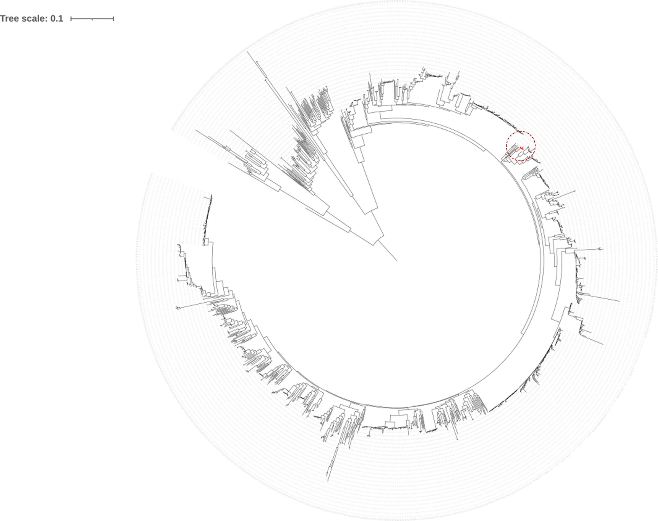
B
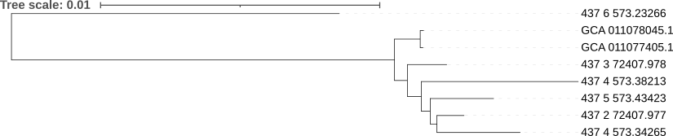
Figure S1. An example tree (A) and subtree (B) used to identify the ST437 as a putative donor for recombination event 13 in ST395 subclade D2.

