Supplementary Figures

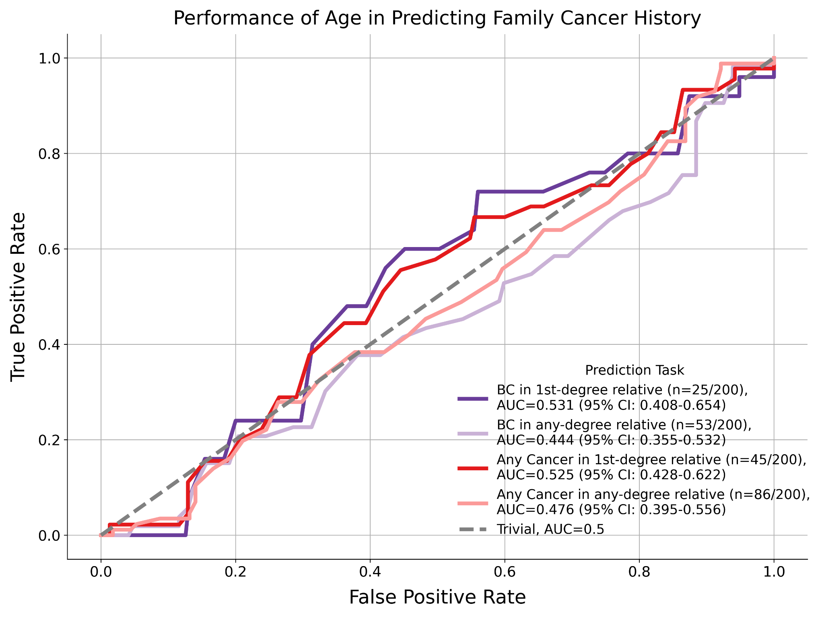
Figure S1: The AUC curve of using age as a predictor of family breast cancer history. As expected from a negative control, age as a predictor achieves poor performance and the relative ranking of performances is not consistent

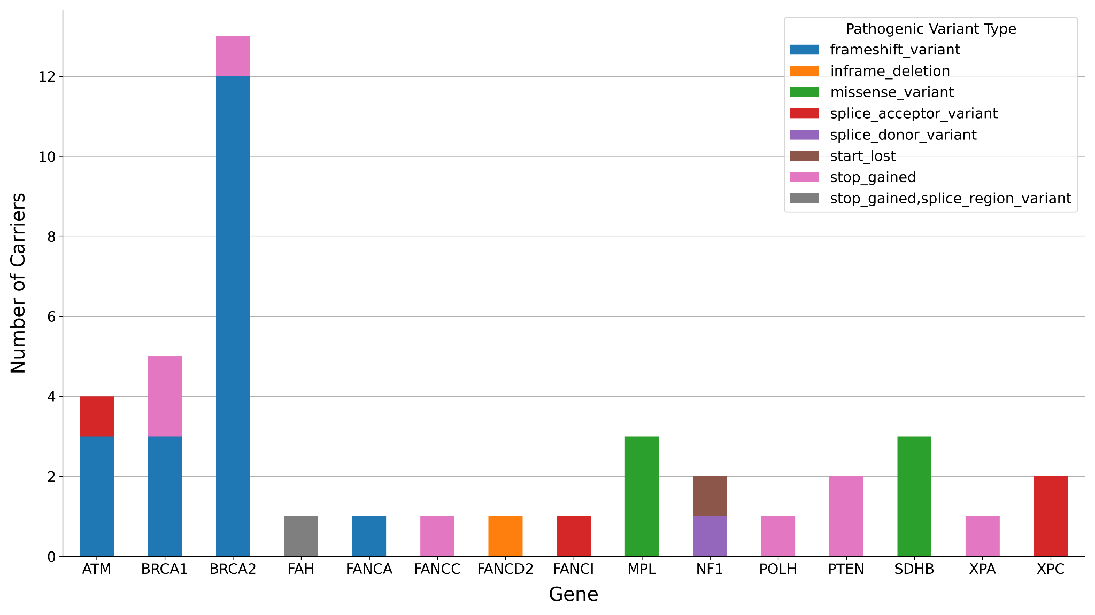
Figure S2. The number of pathogenic variant carriers (n=34) in known cancer-predisposition genes as defined by COSMIC (germline tier 1 genes) and the type of pathogenic variants.

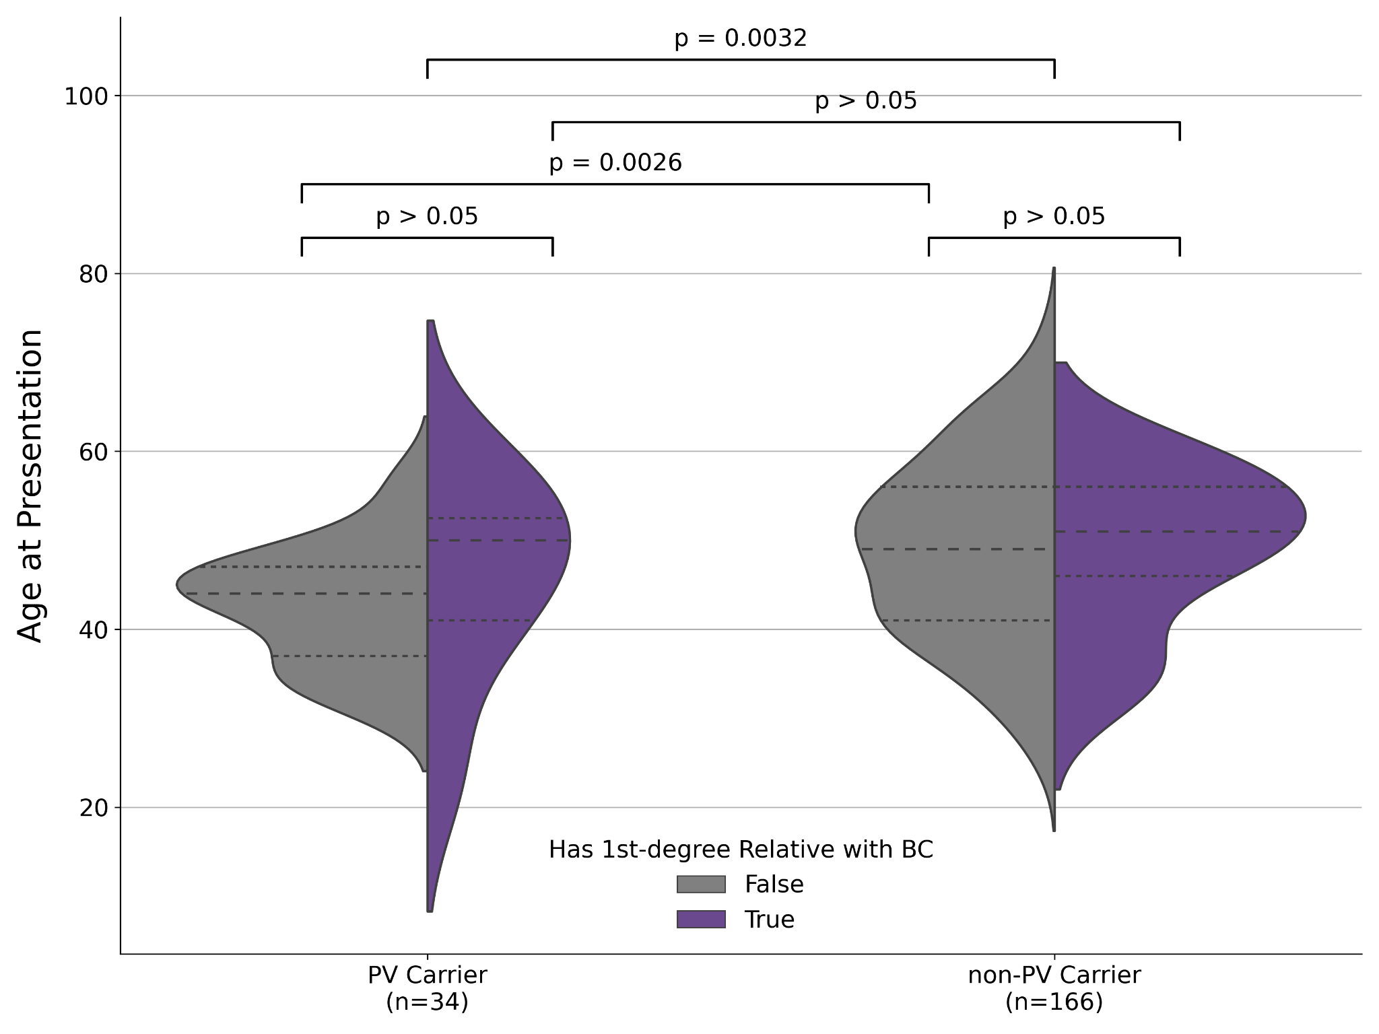
Figure S3. Violin plot of the distributions of age of onset between patients carrying rare pathogenic variants, stratified by whether the patient has a first-degree relative diagnosed with breast cancer (Patients with no first-degree relative with breast cancer: n=175, PV carriers: n=27, non-PV carriers: n=148. Patients with first-degree relatives with breast cancer: n=25, PV carriers: n=7, non-PV carriers: n=18). The dotted line indicates the first and third quartiles and the dashed line indicates the median

