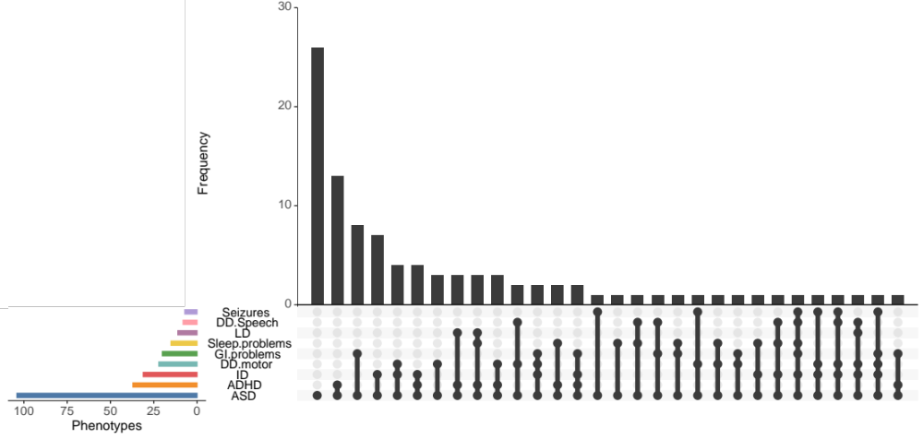

Figure S1: Co-morbidities of Autism. Frequency of co-occurrence of phenotypes in individuals with ASD

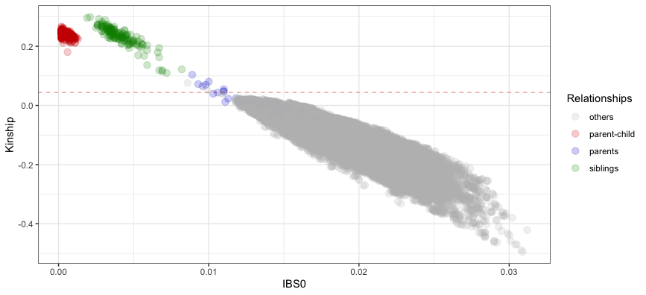
Figure S2: Pairwise relationship of individuals. Related parents are in blue and above the threshold of kinship (>0.044) (dashed red line).

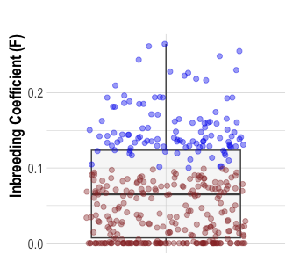

Figure S3: Inbreeding coefficient (F). Per sample estimate of inbreeding of all individuals included. Individuals from inbred families are in blue.

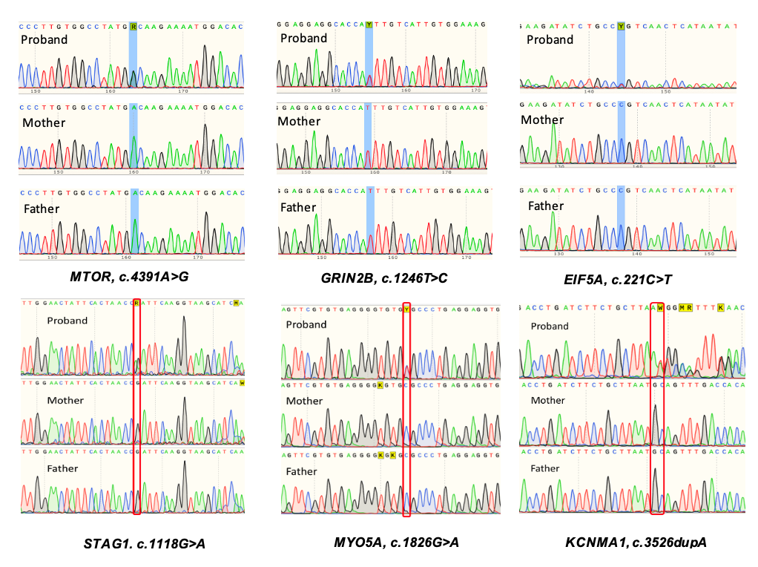

Figure S4: Sanger Sequencing. Validation of de novo variants

