Supplementary figures
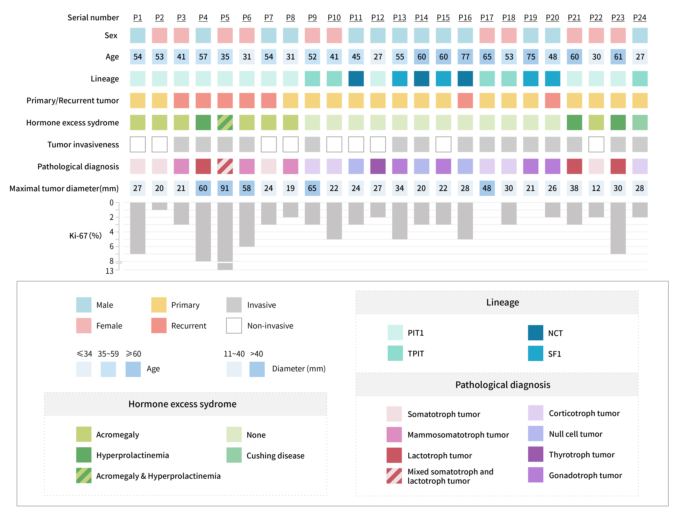
Figure S1 Clinical details of the 24 pituitary neuroendocrine tumor (PitNET) patients. The lineage of PitNET is labelled according to the 2022 WHO classification criteria of pituitary tumors. Specifically,
- PIT1-lineage PitNET: including somatotroph tumor, mammosomatotroph tumor, lactotroph tumor and thyrotroph tumor. (PIT1)
- TPIT-lineage PitNET: including corticotroph tumor. (TPIT)
- SF1-lineage PitNET: including gonadotroph tumor. (SF1)
- Null cell tumor (NCT).

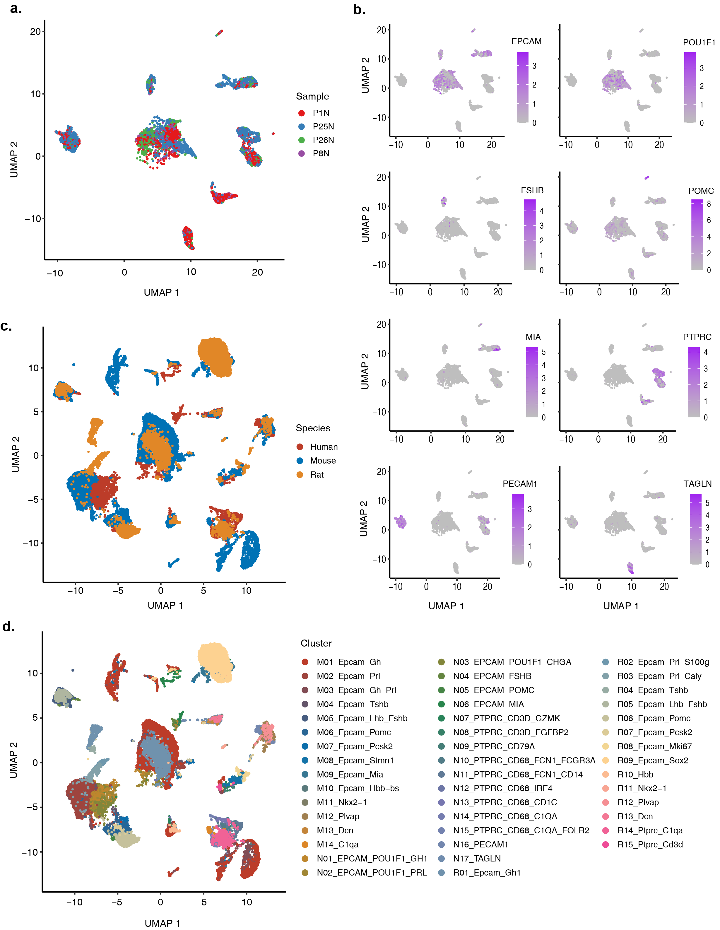
Figure S2 Single-cell landscape of normal human pituitary and comparison with mouse and rat pituitary. a UMAP plot showing the batch label of normal pituitary cells. b Expression level of specific marker genes on UMAP plot. c UMAP plot showing the batch label of the integrated pituitary atlas. d UMAP plot showing the annotated cell type in the integrated pituitary atlas.

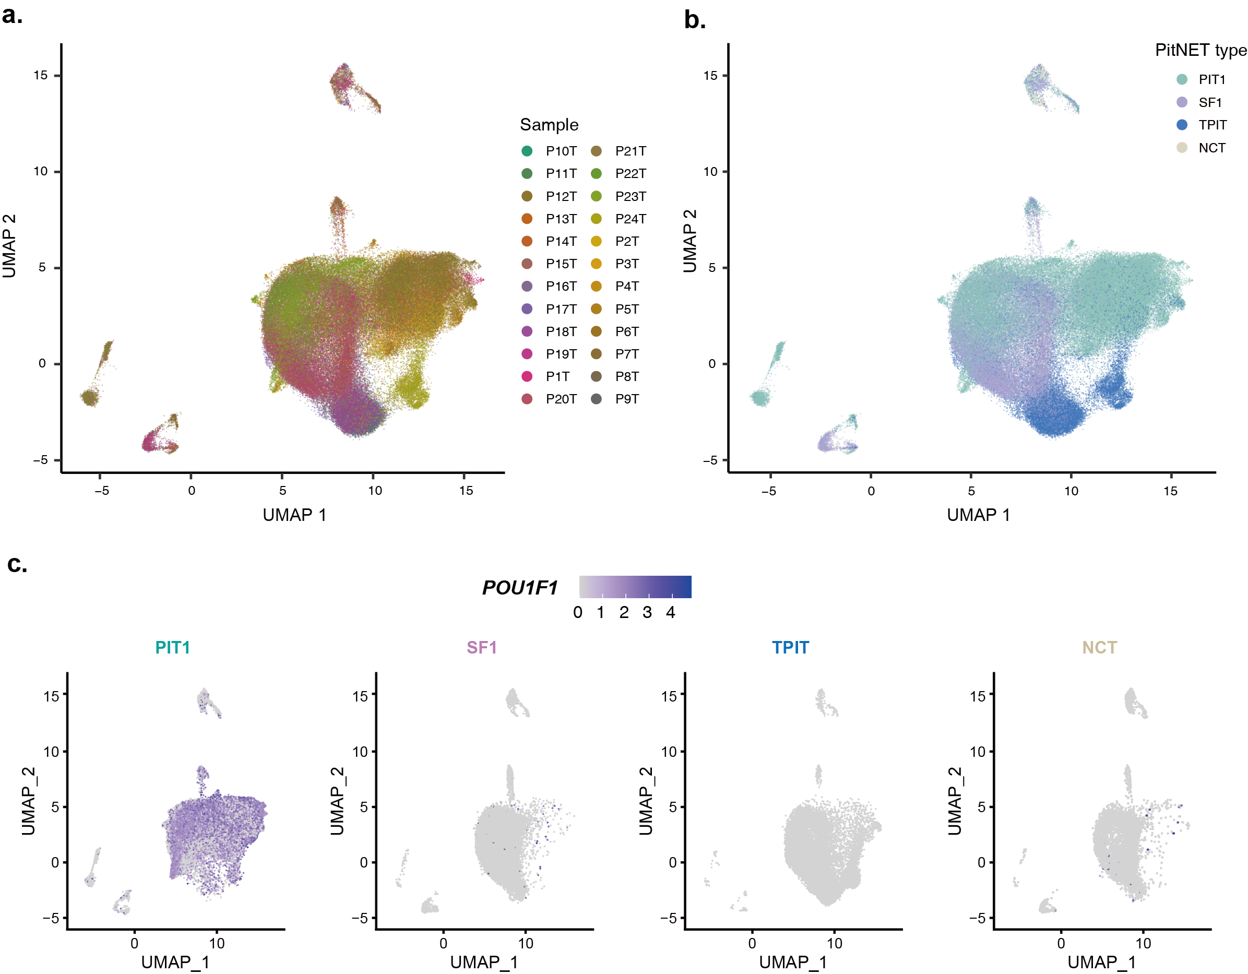
Figure S3 Characteristics of PitNET samples. a UMAP plot showing the batch label of PitNET cells. b UMAP plot showing the PitNET types of pituitary tumor cells. c UMAP plot showing the expression of POU1F1 across four types of PitNET samples.

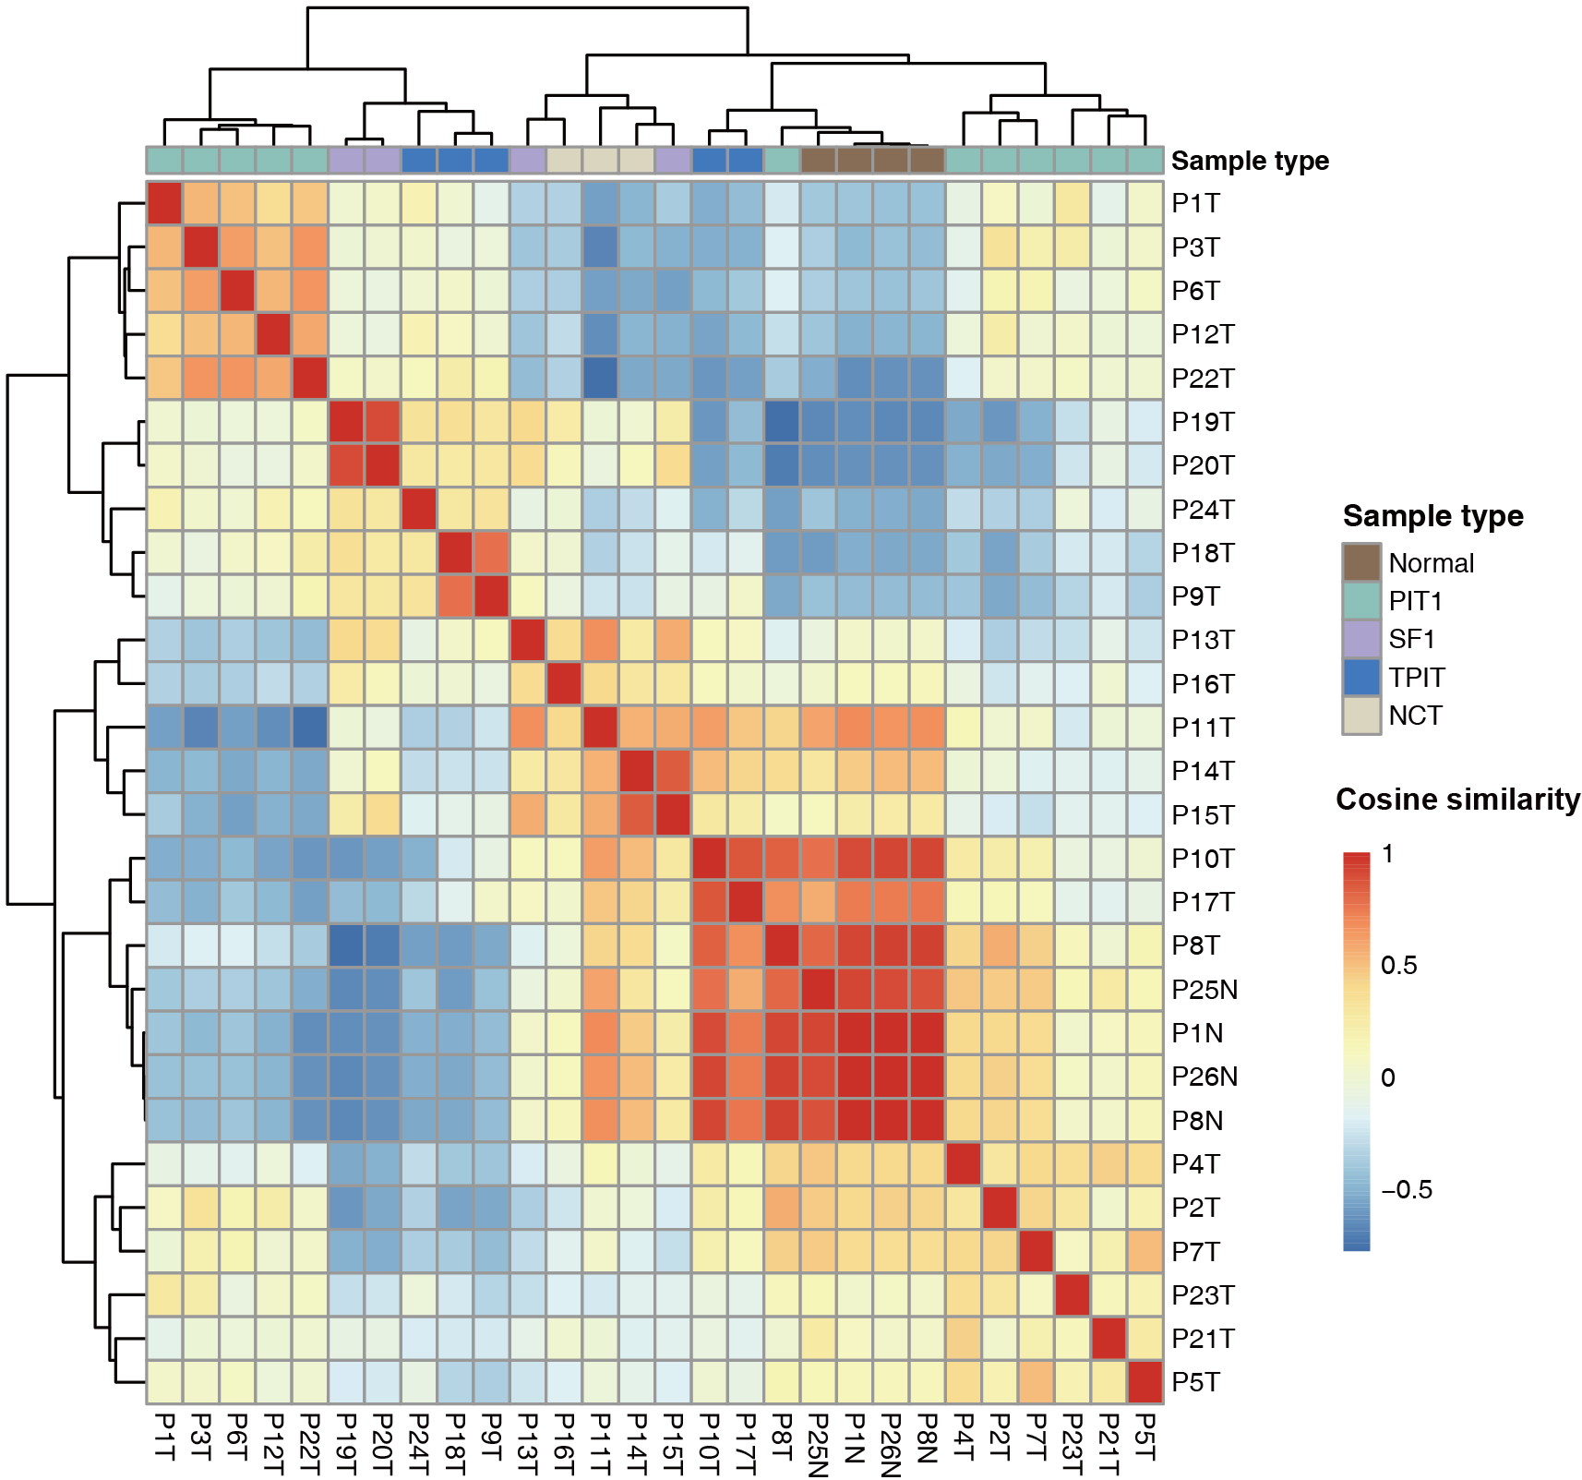
Figure S4 Pairwise cosine similarities of all pituitary samples. The rows and columns are arranged based on hierarchical clustering.

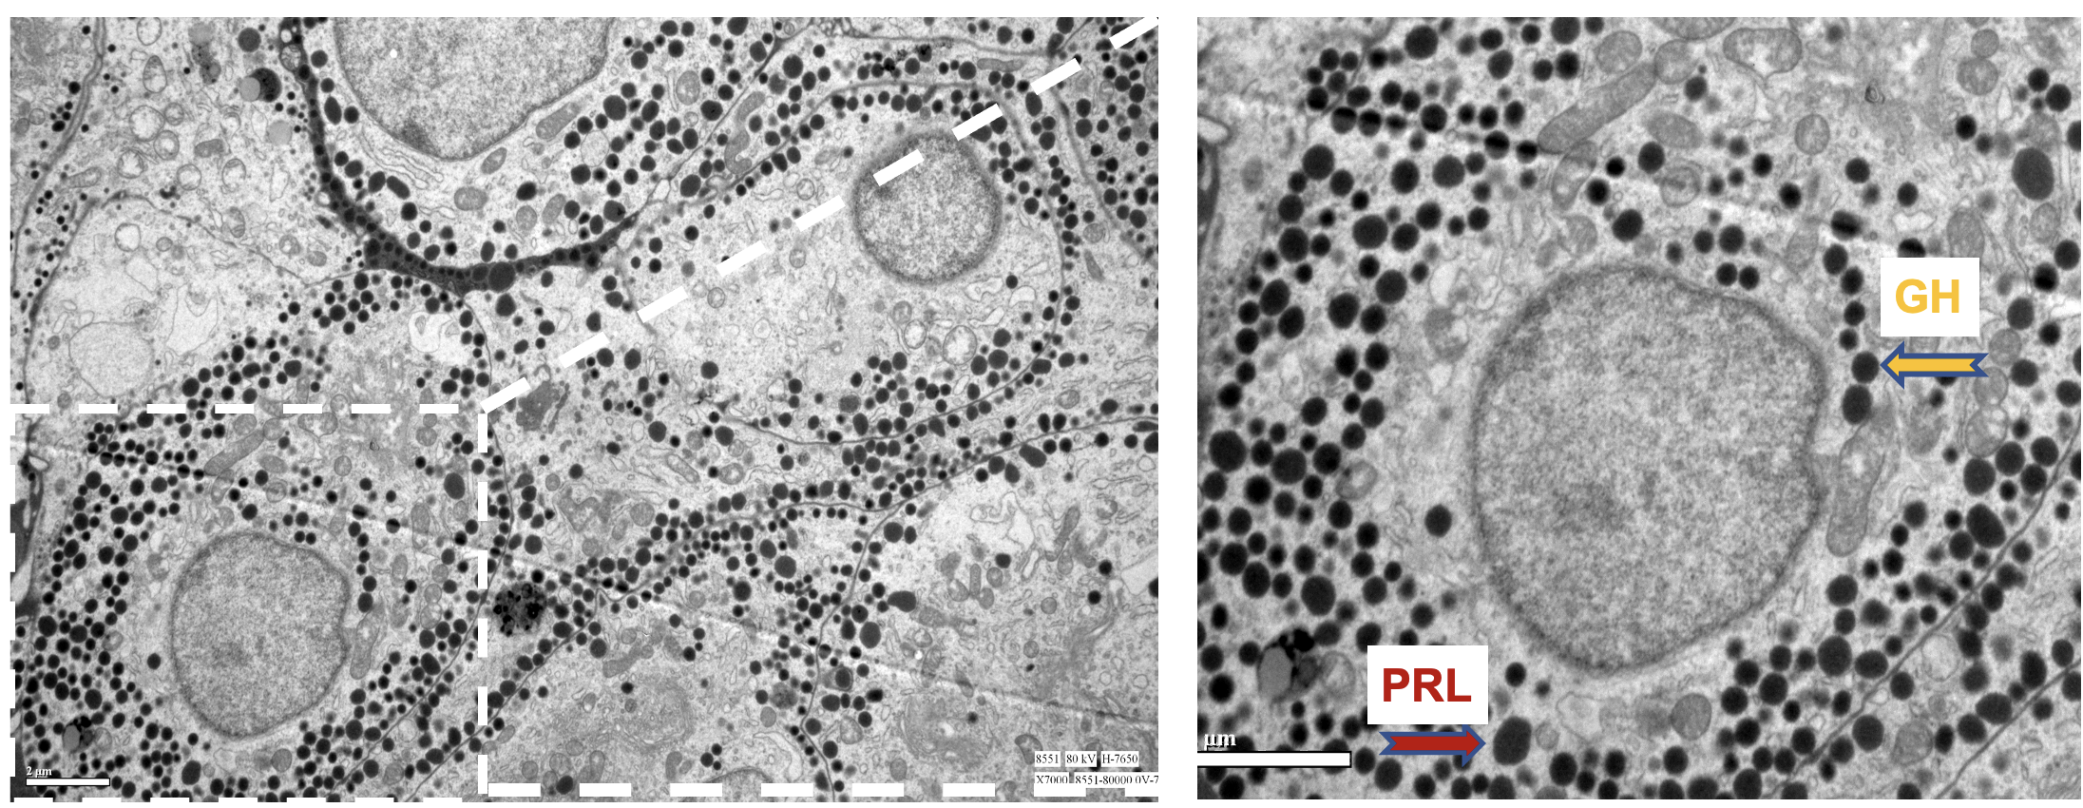
Figure S5 The electron micrograph of typical lactotrophs and somatotrophs secretory granules of P3T PitNET. Prolactin (PRL) cells: The granules typically have diameters ranging from 350 to 550 nm. They are irregular in shape. Growth Hormone (GH) cells: The granules in these cells have a diameter ranging between 250 to 400 nm and are round in shape. Scale bar: 2 µm

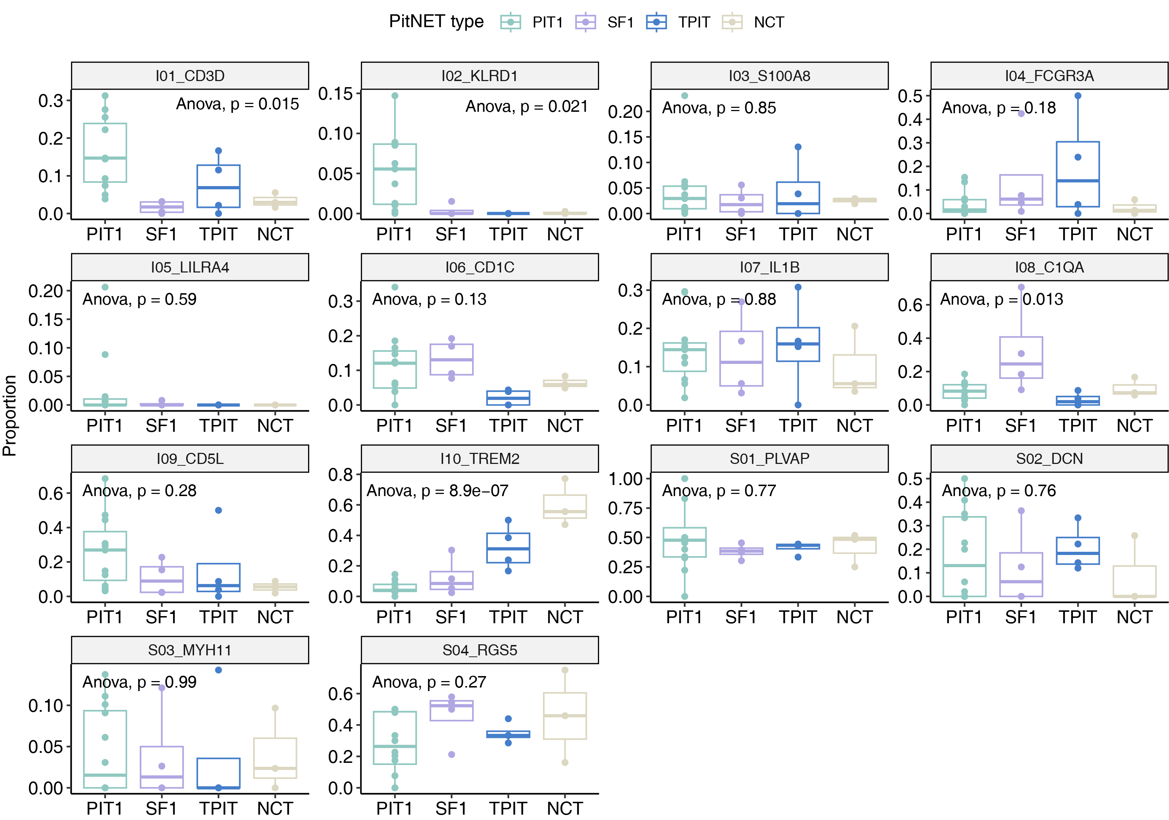
Figure S6 Box plot showing the proportion of immune and stromal subpopulations across four types of PitNETs.

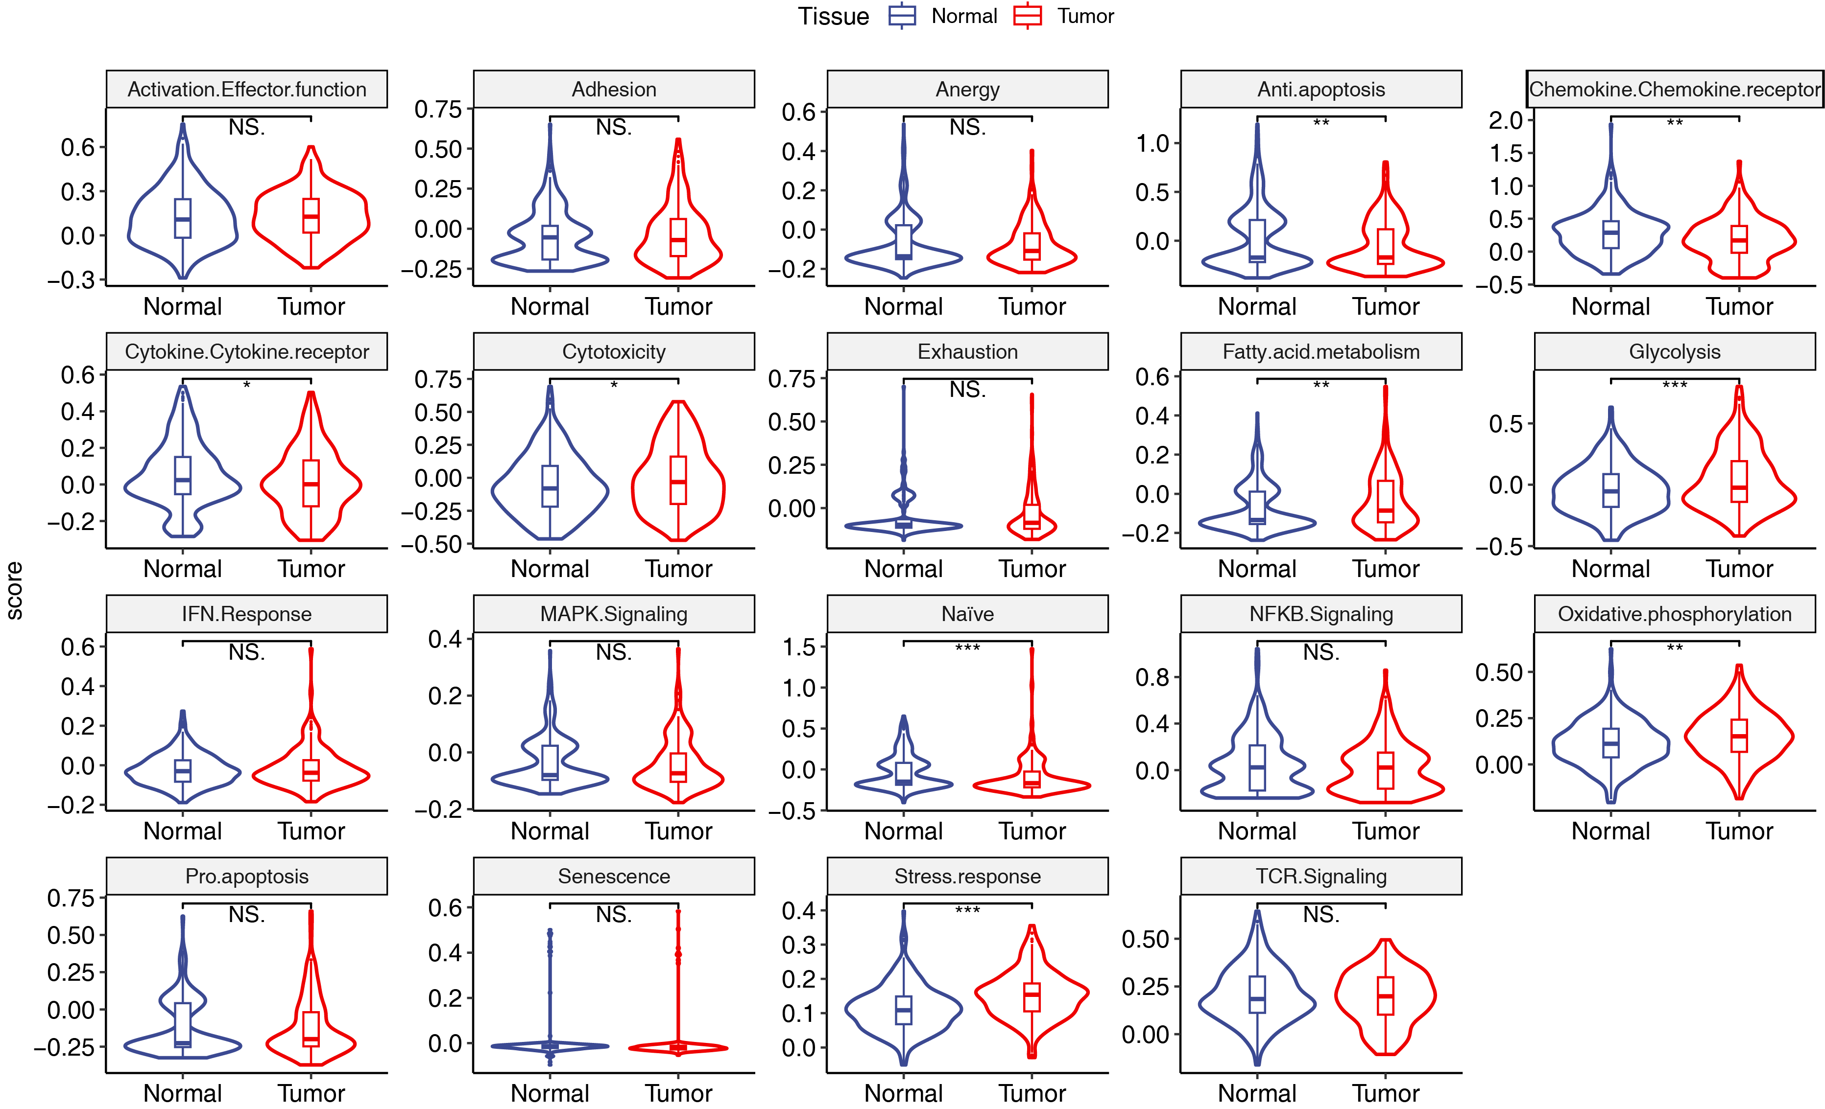
Figure S7 Box plot showing the functional signature scores of T cells between normal pituitary and PitNETs. * p < 0.05, ** p < 0.01, *** p < 0.001. NS., not significant. Student’s t-test.

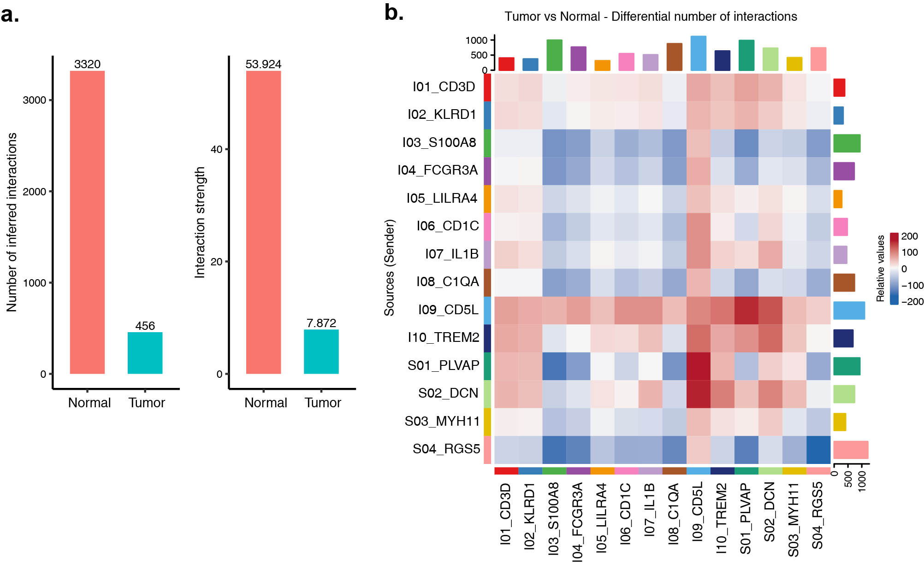
Figure S8 Difference of cellular interaction between normal pituitary and PitNETs. a Bar plot showing the number of inferred interaction and strength. b Heatmap showing the differential number of interactions between tumor and normal pituitary. Top and right bars show the cumulative signal strength in each cellular population.

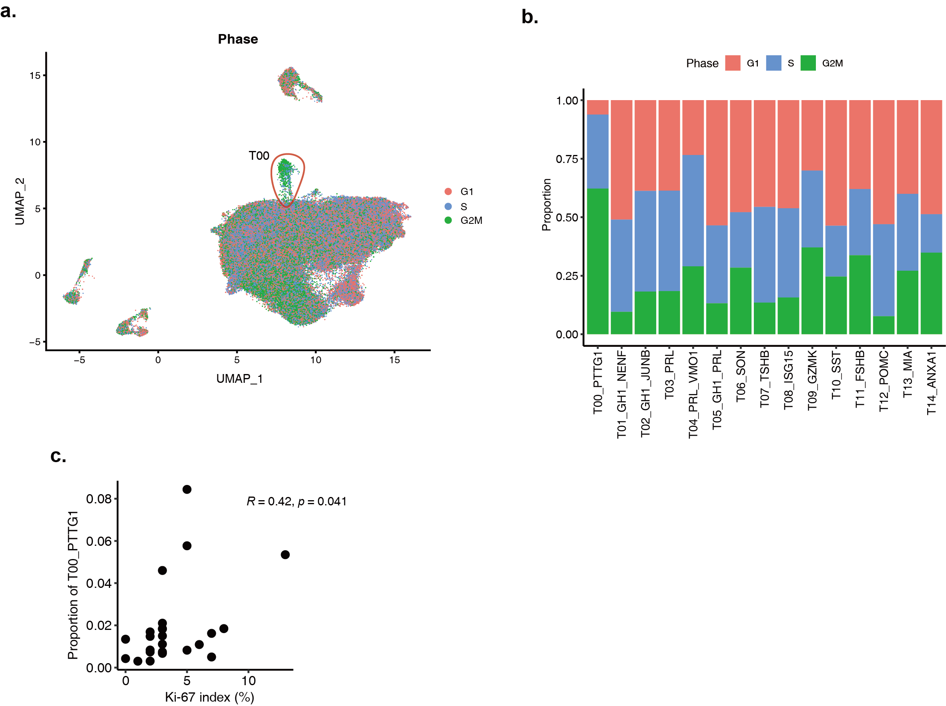

Figure S9 characterization of the aggressive cellular subpopulation. a UMAP plot labeled by inferred cell cycle. b Histogram showing the proportion of different cell cycle in all clusters. c Scatter plot showing the relationship between the proportion of Cluster T00 and the Ki-67 index examined in clinical. Pearson correlation.

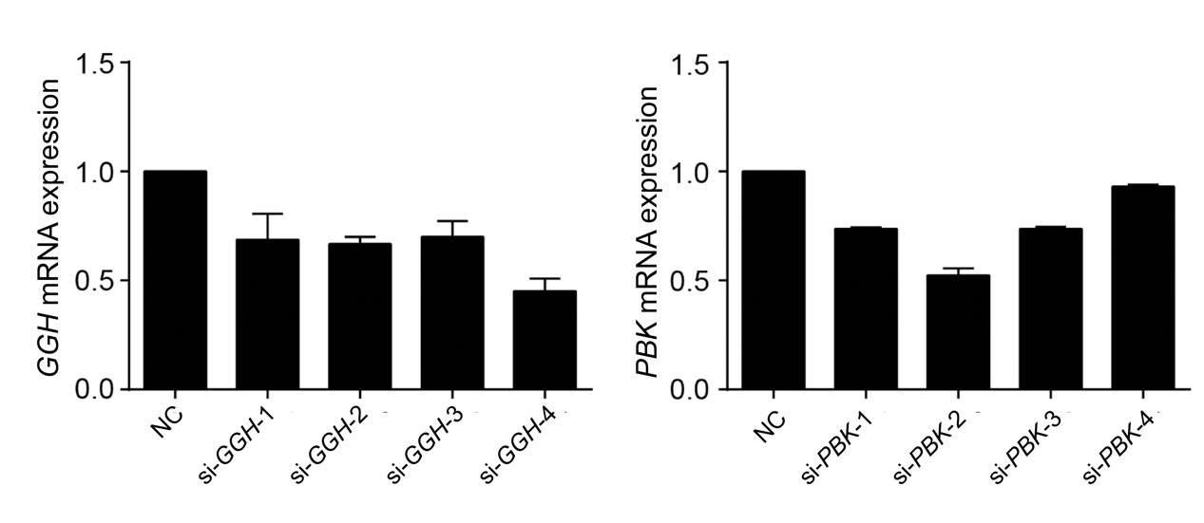
Figure S10 Expression levels of GGH and PBK after different siRNAs’ transfections in the experiment of cell proliferation. (normalized by NC)

Figure S11 Validation of transwell experiment for cell migration in GH3 cells. a Transfection efficiency of PBK gene was assessed by western blot, versus control. b Quantification of the protein expression levels of PBK by Western blot. Band intensities were quantified and standardized to tubulin. c Transfection efficiency of PBK gene was assessed by western blot. ** p < 0.01, *** p < 0.001. One-way ANOVA.

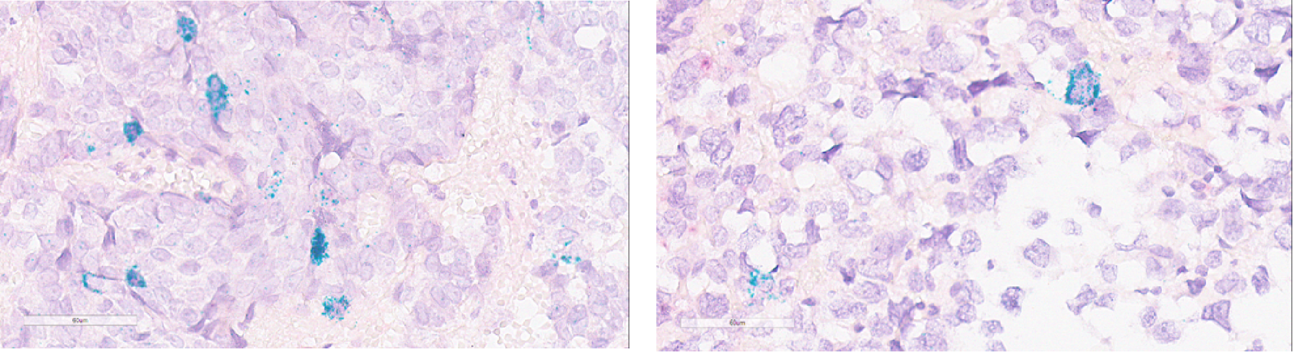
Figure S12 RNAscope staining of PBK in PitNET tissues. Representative images illustrating the RNAscope staining of PBK in PitNET samples. Green granules indicate pituitary tumor cells that were positively stained for PBK RNA using RNAscope. Scale bars, 60 µm.

