SUPPLEMENT

Table S1. Detailed Cause of Death
Cause of Death |  | Number of Decedents (%)
Unexplained (n=104, 49%)
 | Sudden unexplained death | 90 (43)
 | Possible SUDEP | 6 (3)
 | Cardiac findings of uncertain significance | 5 (2)
 | Concerning family history | 3 (1)
Explained (n=48, 23%)
 | Infant suffocation | 15 (7)
 | Systemic viral or bacterial infection | 13 (6)
 | Asthma | 3 (1)
 | Cardiomyopathy | 3 (1)
 | Drowning | 3 (1)
 | Multisystem failure in complex medical patient | 3 (1)
 | Major vascular malformation | 2 (1)
 | Myocarditis | 2 (1)
 | Congenital heart disease | 2 (1)
 | Diabetic ketoacidosis | 1 (<1)
 | Pulmonary embolism | 1 (<1)
*SDY Registry Review Completed |  | 59 (28)
TOTAL |  | 211

SUDEP = Sudden Unexplained Death in Epilepsy. Cardiac findings of uncertain significance included findings of cardiomyopathy without sufficient criteria for diagnosis (2 decedents), possible coronary artery disease (2), and aortic valve abnormality with left ventricular hypertrophy (1). Concerning family history included long QT syndrome, sudden unexplained death in a sibling, and family history of heart attack and stroke < 50 years of age, each in 1 decedent. Congenital heart disease included hypoplastic left heart syndrome (1) and anomalous left coronary artery (1). *Per DUAs, detailed cause of death is not eligible to be listed here, decedents met inclusion requirements for sudden death.

Table S2. Epilepsy Gene panels
Gene | Epilepsy n=191 | OMIM EIEE n=82
AARS1 |  | X
ABAT | X
ACTL6B |  | X
ADAM22 |  | X
ADSL | X
ALDH5A1 | X
ALDH7A1 | X
ALG13 | X | X
AMT | X
AP3B2 |  | X
ARHGEF9 | X | X
ARHGEF15 | X | X
ARV1 |  | X
ARX | X | X
ATP1A2 | X
ATP1A3 | X
ATP6AP2 | X
ATRX | X
BRAT1 | X
C12orf57 | X
CACNA1A | X | X
CACNA1E |  | X
CACNA1H | X
CACNA2D2 | X
CACNB4 | X
CAD |  | X
CARDS2 | X
CASK | X
CASR | X
CDKL5 | X | X
CERS1 | X
CHD2 | X
CHRNA2 | X
CHRNA4 | X
CHRNA7 | X
CHRNB2 | X
CLCN4 | X
CLN2 | X
CLN3 | X
CLN5 | X
CLN6 | X
CLN8 | X
CNTN2 | X
CNPY3 |  | X
CNTNAP2 | X
CPA6 | X
CPLX1 |  | X
CSTB | X
CTSD | X
CUX2 |  | X
CYFIP2 |  | X
DENND5A |  | X
DEPDC5 | X
DIAPH1 | X
DNAJC5 | X
DNM1 | X | X
DOCK7 | X | X
DYRK1A | X
EEF1A2 | X | X
EFHC1 | X
EHMT1 | X
EPM2A | X
FARS2 | X
FASN | X
FGF12 |  | X
FLNA | X
FOLR1 | X
FOXG1 | X
FRRS1L | X | X
GABBR2 | X | X
GABRA1 | X | X
GABRA2 | X | X
GABRB3 | X | X
GABRA5 |  | X
GABRB1 |  | X
GABRB3 |  | X
GABRD | X
GABRG2 | X | X
GAL | X
GAMT | X
GATM | X
GCSH | X
GLDC | X
GLRA1 | X
GLS |  | X
GNAO1 | X | X
GOSR2 | X
GPHN | X
GRIN1 | X
GRIN2A | X
GRIN2B | X | X
GRIN2D |  | X
GUF1 |  | X
HCN1 | X | X
HNRNPU | X | X
IER3IP1 | X
IQSEC2 | X
ITPA | X | X
JMJD1C | X
KANSL1 | X
KCNA1 | X
KCNA2 | X | X
KCNB1 | X | X
KCNC1 | X
KCND2 | X
KCNH2 | X
KCNH5 | X
KCNJ10 | X
KCNMA1 | X
KCNQ2 | X | X
KCNQ3 | X
KCNT1 | X
KCNT2 |  | X
KCTD7 | X
KPNA7 | X
LGI1 | X
LIAS | X
LMNB2 | X
MAGI2 | X
MBD5 | X
MDH2 |  | X
MECP2 | X
MEF2C | X
MFSD8 | X
MTOR | X
NECAP1 | X | X
NEDD4L | X
NEUROD2 |  | X
NEXMIF | X
NGLY1 | X
NHLRC1 | X
NPRL3 | X
NR2F1 | X
NRXN1 | X
NTRK2 |  | X
PACS1 | X
PACS2 |  | X
PARS2 |  | X
PCDH19 | X | X
PHACTR1 |  | X
PIGA | X | X
PIGB |  | X
PIGG | X
PIGN | X
PIGO | X
PIGP |  | X
PIGQ | X | X
PIGV | X
PIK3AP1 | X
PLCB1 | X | X
PNKD | X
PNKP | X | X
PNPO | X
POLG | X
PPT1 | X
PRDM8 | X
PRICKLE1 | X
PRICKLE2 | X
PRIMA1 | X
PRRT2 | X
PTEN | X
PURA | X
QARS | X
RANBP2 | X
RBFOX1 | X
RBFOX3 | X
RELN | X
RHOBTB2 |  | X
RNF13 |  | X
ROGD1 | X
RYR3 | X
SATB2 | X
SCARB2 | X
SCN1A | X | X
SCN1B | X | X
SCN2A | X | X
SCN3A | X | X
SCN8A | X | X
SCN9A | X | X
SERPINI1 | X
SETD2 | X
SGCE | X
SIK1 | X | X
SCL12A5 | X | X
SLC13A5 | X | X
SLC19A3 | X
SLC1A2 |  | X
SLC25A12 | X | X
SLC25A22 | X | X
SLC2A1 | X
SLC35A2 | X | X
SLC35A3 | X
SLC6A1 | X
SLC6A8 | X
SLC9A6 | X
SMC1A | X
SNAP25 | X
SNX27 | X
SPATA5 | X
SPTAN1 | X | X
SRPX2 | X
ST3GAL3 | X | X
ST3GAL5 | X
STRADA | X
STX1B | X
STXBP1 | X | X
SYN1 | X
SYNGAP1 | X | X
SYNJ1 | X | X
SZT2 | X | X
TBC1D24 | X | X
TBL1XR1 | X
TCF4 | X | X
TPK1 | X
TPP1 | X
TRAK1 |  | X
TSC1 | X
TSC2 | X
UBA5 |  | X
UBE3A | X
WDR45 | X
WWOX | X | X
YWHAG |  | X
ZDHHC9 | X
ZEB2 | X

Table S3. Cardiomyopathy and Arrhythmia Gene panels
Gene | CMAR1 n=118 | CMAR2 n=143
A2ML1 | X
ABCC9 | X | X
ACTC1 | X | X
ACTN2 | X | X
AGL |  | X
AKAP9 | X | X
ALMS1 | X
ANK2 | X | X
ANKRD1 | X | X
BAG3 | X | X
BRAF | X | X
CACNA1C | X | X
CACNA2D1 | X | X
CACNB2 | X | X
CALM1 | X | X
CALM2 | X | X
CALM3 | X | X
CALR3 |  | X
CASQ2 | X | X
CAV3 | X | X
CBL | X
CHRM3 | X | X
CRYAB | X | X
CSRP3 | X | X
CTF1 | X | X
CTNNA3 | X | X
DEPDC5 |  | X
DES | X | X
DMD | X | X
DOLK | X | X
DSC2 | X | X
DSG2 | X | X
DSP | X | X
DTNA | X | X
EMD | X | X
EYA4 | X | X
FBN1 | X
FHL1 | X | X
FHL2 | X | X
FKRP | X | X
FKTN | X | X
FLNC | X | X
GAA |  | X
GATA4 | X | X
GATA6 | X
GATAD1 | X | X
GJA5 |  | X
GLA | X | X
GPD1L | X | X
HCN4 | X | X
HRAS | X | X
ILK | X | X
JPH2 | X | X
JUP | X | X
KCNA5 |  | X
KCND3 | X | X
KCNE1 | X | X
KCNE2 | X | X
KCNE3 | X | X
KCNE5 | X | X
KCNH2 | X | X
KCNJ2 | X | X
KCNJ5 | X | X
KCNJ8 | X | X
KCNK3 |  | X
KCNQ1 | X | X
KCNQ2 |  | X
KCNQ3 |  | X
KCNT1 |  | X
KRAS | X | X
LAMA4 | X | X
LAMP2 | X | X
LDB3 | X | X
LMNA | X | X
LRRC10 |  | X
MAP2K1 | X | X
MAP2K2 | X | X
MOG1 | X
MTND1 |  | X
MTND5 |  | X
MTND6 |  | X
MTTD |  | X
MTTG |  | X
MTTH |  | X
MTTI |  | X
MTTK |  | X
MTTL1 |  | X
MTTL2 |  | X
MTTM |  | X
MTTQ |  | X
MTTS1 |  | X
MTTS2 |  | X
MYBPC3 | X | X
MYH6 | X | X
MYH7 | X | X
MYL2 | X | X
MYL3 | X | X
MYL4 | X | X
MYLK2 | X | X
MYOM1 | X | X
MYOZ2 | X | X
MYPN | X | X
NEBL | X | X
NEXN | X | X
NKX2-5 | X | X
NPPA |  | X
NRAS | X | X
PCDH19 |  | X
PDLIM3 | X | X
PKP2 | X | X
PLEKHM2 |  | X
PLN | X | X
PRDM16 | X | X
PRKAG2 | X | X
PRRT2 |  | X
PTPN11 | X | X
RAF1 | X | X
RANGRF |  | X
RASA1 | X
RBM20 | X | X
RIT1 | X
RYR2 | X | X
SCN10A | X | X
SCN1A |  | X
SCN1B | X | X
SCN2B | X
SCN3B | X | X
SCN4B | X | X
SCN5A | X | X
SCN8A |  | X
SCN9A |  | X
SDHA | X
SGCD | X | X
SHOC2 | X
SLC22A5 |  | X
SLC2A1 |  | X
SLMAP |  | X
SNTA1 | X | X
SOS1 | X | X
SPRED1 | X
TAZ | X | X
TCAP | X | X
TGFB3 | X | X
TMEM43 | X | X
TMPO | X | X
TNNC1 | X | X
TNNI3 | X | X
TNNT2 | X | X
TPM1 | X | X
TRDN | X | X
TRPM4 |  | X
TTN | X | X
TTR | X | X
TXNRD2 | X | X
VCL | X | X

Table S4. Pathogenic and Likely pathogenic, Mendelian variants as ranked by GEM
ID | Age (yrs) | Cause of Death | CV | GENE | gDNA | AA Change | gAD  Freq |  | MIM
HPO Term: Seizure
1098 | 9 | SUDEP | P  PVS1  PM2  PP5 | ANKRD11 | 16:89345623 G>A | Gln2443Ter | 0 |  | 148050
1079 | 0.3 | UnE | P  PVS1  PM2  PP5 | BCKDHA | 19:41916543 AC>A | Arg40GlyfsTer23 | 6.5E-05 |  | 248600
 |  |  | VUS  PM2  PP2 | BCKDHA | 19:41916645 A>G | Asn71Ser | 6.4E-05 |  | 248600
1199 | 1 | E | P  PS1  PM4  PM2  PP5 | CFTR | 7:117199645 TCTdel | Phe508del | 0.0019 |  | 219700
 |  |  | P  PM1  PP2  PM5  PP3  PP5 | CFTR | 7:117188877 G>T | Lys464Asn | 0.0072 | 219700
1048 | 10 | E | P  PM1  PP2  PM2  PP3  PP5 | DHDDS | 1:26764719 A>G | Lys42Glu | 0 | 617836
1172 | 0.25 | I.S> | P  PP3  PM2  PM5  PP2  PP5 | GJB2 | 13:20763626 C>T | Arg32His | 0 | 148210
1189 | NA | NA | P  PM2  PM4  PP5 | KISS1R | 19:920746 T>A | Ter399Argext*? | 0 | 176400
1139 | 1 | E | P  PVS1  PM2  PP5 | MC4R | 18:58038600 A>T | Leu328Ter | 0 | 618406
1152 | 0.03 | NA | P  PVS1  PM2  PP5 | MPDZ | 9:13126766 CT>C | Gln1490Arg  fsTer19 | 0.0007 | 615219
 |  |  | VUS  PM2  BP4 | MPDZ | 9:13175799 C>T | Glu1003Lys | 0.0006 | 615219
1190 | 0.3 | E | LP  PM2  BP6 | MYOCD | 17:12655857 A>G | Ile418Val | 0.0026 | 618719
1069 | 0.17 | I.S. | P  PVS1  PM2  PP5 | NEK1 | 4:170482671 C>T | Trp409Ter | 6.5E-05 | 617892
1035 | 0.08 | UnE | P  PM2  BS2 | SRPX2 | X:99917224 A>C | Tyr72Ser | 0 | 300643
1023 | 12 | UnE | P  PVS1  PM2 | TOR1A | 9:132576340 TCTCdel | Glu303Ter | 0 | 128100
1107 | NA | NA | LP  PM2  PP2  PP5 | TREX1 | 3:48508721 G>A | Ala223Thr | 0 | 192315
HPO Term: SDY
1209 | NA | NA | P  PVS1  PM2  PP5 | ANO5 | 11:22242647--A | Asn64Lys  fsTer15 | 0 |  | 166260
1019 | NA | NA | P  PVS1  PM2  PP5 | ANO5 | 11:22257823 G>A | splice donor | 6.5E-05 |  | 166260
1166 | NA | NA | P  PVS1  PM2  PP5 | BARD1 | 2:215595215 G>A | Arg641Ter | 0 | 114480
1180 | NA | NA | P  PVS1  PM2  PP5 | BARD1 | 2:215645402 A>C | Leu399Ter | 0 | 114480
1058 | 7 | UnE | LP  PM2  PM5  PM1  PP2  PP3  PP5 | CALM3 | 19:47112212 A>G | Asp132Gly | 0 | 618782
1203 | NA | NA | P  PVS1  PM2  PP5 | CAPN3 | 15:42695962 TG>T | Asp591IlefsTer4 | 0 | 618129
1059 | NA | NA | P  PM2  PP3  PP2  PP5 | CAPN3 | 15:42703497 C>A | Ala798Glu | 0 | 618129
1161 | 0.03 | UnE | P  PM1  PP2  PM2  PM5  PP3  PP5 | CAPN3 | 15:42693950 G>A | Arg489Gln | 0.0003 | 618129
1132 | NA | NA | P  PVS1  PM2  PP5 | DSP | 6:7571745 C>T | Gln611Ter | 0 | 607450
1085 | NA | NA | LP  PM2  PP3  PP2  PP5 | F11 | 4:187201717 T>C | Leu373Ser | 0 | 612416
1119 | NA | NA | P  PVS1  PM2  PP5 | FGA | 4:155508672 G>A | Arg168Ter | 0 | 105200
1050 | NA | NA | P  PP3  PM2  PP2  PP5 | G6PD | X:153761337 C>T | Val321Met | 0 | 300908
1026 | 0.3 | UnE | P  PVS1  PM2  PP5 | GDAP1 | 8:75275175 C>G | Ser194Ter | 0 | 214400
 |  |  | VUS  PM2  PM1  PP2  BP4 | GDAP1 | 8:75263650 A>G | Ile87Val | 0 | 214400
1140 | 0.3 | I.S. | LP  PP1  PS3  PS4  PP3  PM2  PP2  PP5 | ITGB3 | 17:45362012 C>T | Pro189Ser | 0 | 187800
1214 | NA | NA | P  PVS1  PM2  PP5 | KCNH2 | 7:150654393 C>CAG | Glu372Leu  fsTer63 | 0 | 613688
1077 | 0.08 | UnE | LP  PM1  PP2  PM2  PP3 | LDLR | 19:11230828 G>A | Gly636Ser | 0 | 143890
1133 | NA | NA | P  PP1  PS4  PS3  PM2  PM5  PP3  PP2  PP5 | LDLR | 19:11218160 G>A | Asp304Asn | 0 | 143890
1018 | 0.42 | UnE | P  PM1  PP2  PM2  PM5  PP5 | NALCN | 13:101944423 A>G | Ile322Thr | 0 | 616266
1034 | NA | NA | P  PVS1  PM2  PP5 | RYR1 | 19:38983277 G>A | splice donor | 0 | 255310
1107 | NA | NA | LP  PVS1  PM2  PP5 | SCN4A | 17:62026868 A>T | Tyr958Ter | 0 | 168300
1065 | 0.42 | NA | P  PVS1  PM2  PP5 | SPG7 | 16:89598370 G>GC | Gly352Arg  fsTer44 | 0.0003 | 607259
1028 | 0.5 | UnE | P  PM1  PP2  PM2  PM5  PP3  PP5 | TTR | 18:29178618 G>A | Val142Ile | 0.0172 | 105210
1117 | 0.17 | I.S. | P  PM1  PP2  PM2  PM5  PP3  PP5 | TTR | 18:29178618 G>A | Val142Ile | 0.0172 | 105210
1038 | 0.25 | I.S> | P  PVS1  PM2  PP5 | VIM | 10:17271434 TC>T | Val6CysfsTer26 | 0 | 116300
1010 | 0.25 | E, cardiac | LP  PM2  PP2  BP4  PP5 | VWF | 12:6080863 C>T | Val2484Ile | 6.5E-05 | 193400
NA= Not reported in case review. I.S. = infant suffocation; UnE = unexplained; E= explained; CV=ClinVar; AA = amino acid; gAD = gnomAD.

Table S5. Enrichment of variants in epilepsy or cardiac genes in the SDY cohort compared to an ancestry and sex matched 1000 genomes cohort.
GENE LIST | PHENOTYPE TERMS
 | Seizure
 | SDY | 1000 Genomes Project | Genes | Adjusted p-Value*
Epilepsy | 62 | 36 | 191 | 0.027
EIEE-OMIM | 38 | 16 | 82 | 0.019
 | Cardiac
CMAR1 | 55 | 27 | 118 | <0.001
CMAR2 | 58 | 31 | 143 | <0.001
*P values adjusted for multiple comparisons using the FDR adjustment.

Table S6. Linear regression of age at death against number of rare epilepsy variants*.
Model | Coefficient | P value
Adjusted (Ancestry PCs 1-6) | -0.647 | 0.0053
Unadjusted | -0.458 | 0.0387
Adjusted log | -0.159 | 0.0494
Extreme value sensitivity analysis
Removal of cases with more than 9 variants (Adjusted PCs) | -0.636 | 0.0113
Removal of cases with more than 9 variants and less than 1 (Adjusted PCs) | -0.638 | 0.0137
Removal of cases with 0 rare epilepsy(<0.001) variants (Adjusted PCs) | -0.650 | 0.0063
*Rare epilepsy variants = nonsynonymous variants identified in the Epilepsy gene panel with an allele frequency <0.001 in gnomAD.

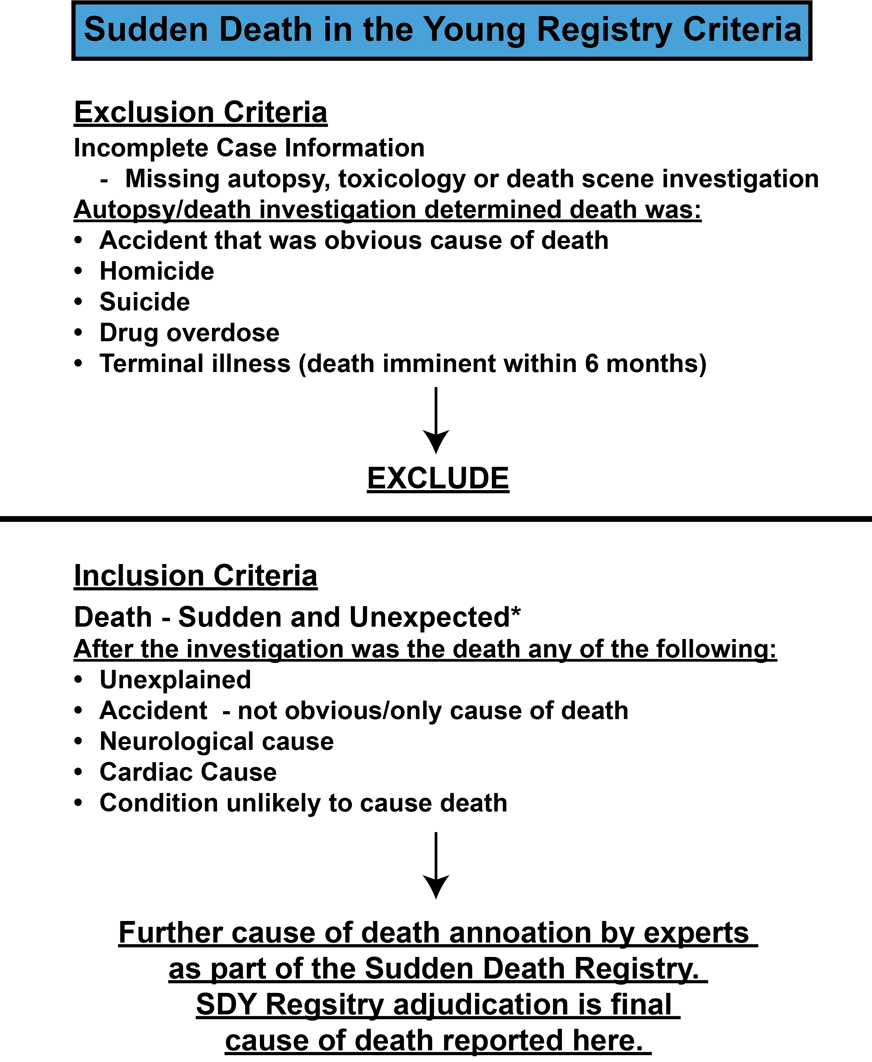

Figure S1. Summary of exclusion and inclusion criteria for the SDY Case Registry. The SDY Case Registry uses an algorithm to classify cases which relies on extensive information about the death (8). Basic inclusion/exclusion criteria are shown here. After inclusion, deaths are further categorized by a panel of experts assembled by the Sudden Death in the Young Case Registry (8). Categorized cause of death is considered a final adjudication and is reported here in Table S1. *Sudden and unexpected = within 24 hours of first symptom or death in a hospital setting after resuscitation from a cardiac arrest and unexpected which includes individuals in good health or with an illness not reasonably expected to cause death.

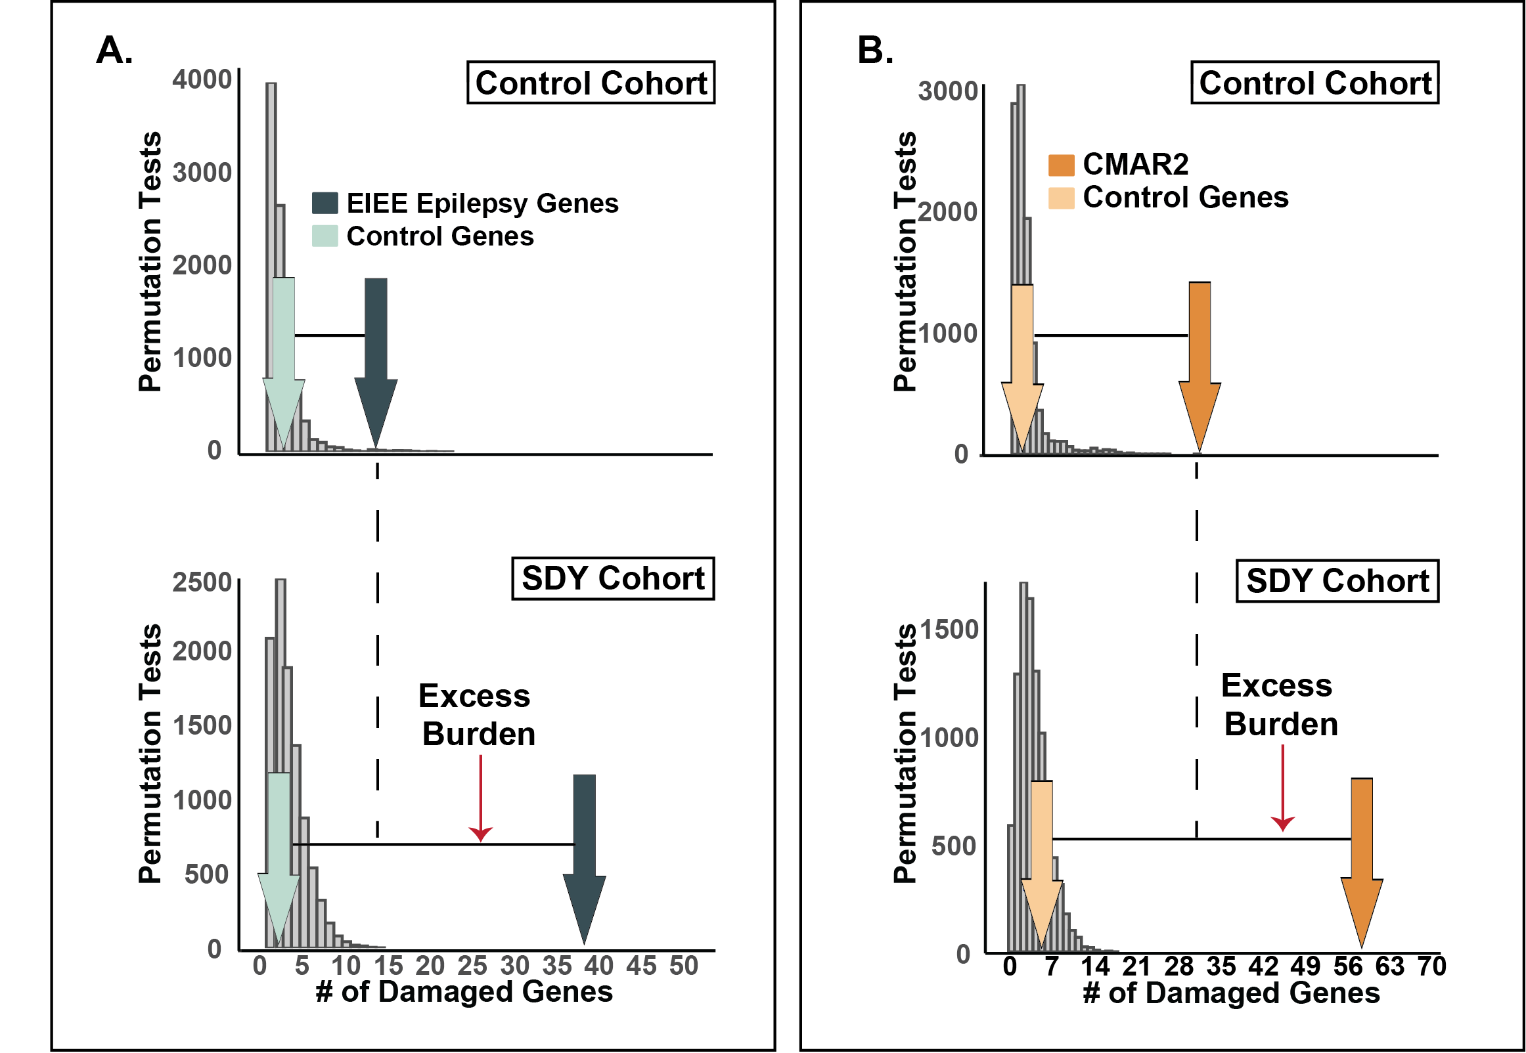

Figure S2. The SDY cohort had enriched GEM-damaging (A) epilepsy and (B) CMAR2 gene burden compared to a sex- and ancestry-matched control cohort. Histograms (gray bars) represent distributions of GEM-damaged genes (GEM Score >0.69) sampled randomly from RefSeq genes using a root phenotype from the SDY cohort (n=211) (bottom panels) and 1000 Genomes Project Cohort (control) matched for sex and ancestry (n=211) (top panels). GEM-damaged genes identified in the Epilepsy EIEE (n=82 genes, green) (A) and CMAR2 (n=143 genes, orange) (B) gene lists were significantly different between the SDY and control cohorts (dark arrows, epilepsy, p=0.019; cardiac p<0.001). Light arrows represent the number of GEM-damaged genes identified in a control gene set.

