Supplementary Figures
Fig S1. Diagram of selecting studies for the meta-analysis.
Fig S2. PCA analysis of the gut microbiota in MS and control across seven studies. Group (MS vs controls), country origin of microbiota data, study/project and DNA extraction methods are indicated in the PCA plot.

Fig S3. PCA analysis of the gut microbiota in MS across seven studies. Country origin of microbiota data, study, DNA extraction methods and sequencing region of 16S rRNA gene are indicated in the PCA plot.

Fig S4. PCA analysis of the gut microbiota in control samples across seven studies. Country origin of microbiota data, study, DNA extraction methods and sequencing region of 16S rRNA gene are indicated in the PCA plot.

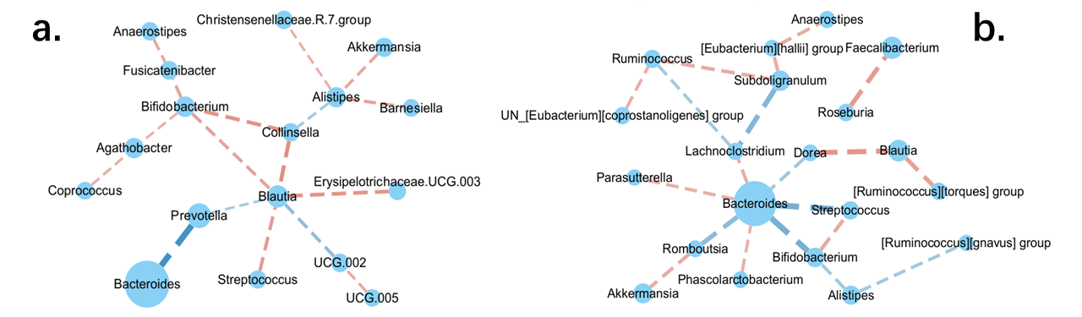

Fig S5. Leave-one-out sensitivity analysis. Leaving out study—Cantoni. Unique correlations in Control (a). Unique correlations in MS(b).

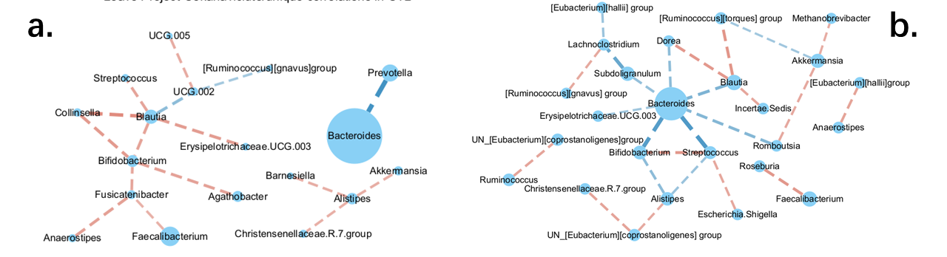
Fig S6. Leave-one-out sensitivity analysis. Leaving out study—Cekanaviciute. Unique correlations in Control (a). Unique correlations in MS(b).

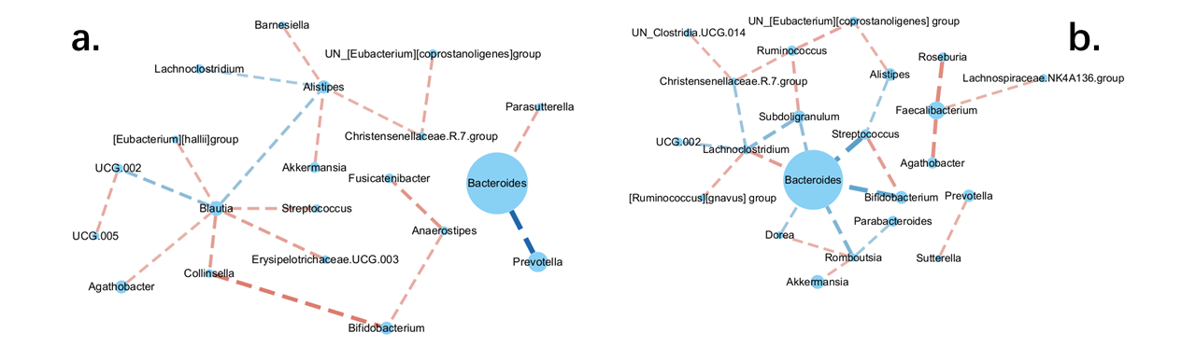
Fig S7. Leave-one-out sensitivity analysis. Leaving out study—Chen. Unique correlations in Control (a). Unique correlations in MS (b).

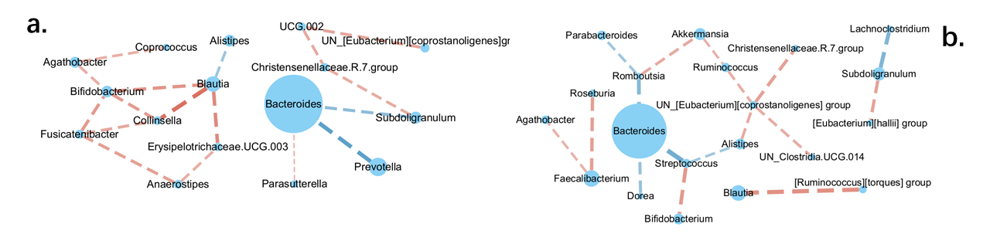
Fig S8. Leave-one-out sensitivity analysis. Leaving out study—Ni Choileain. Unique correlations in Control (a). Unique correlations in MS (b).

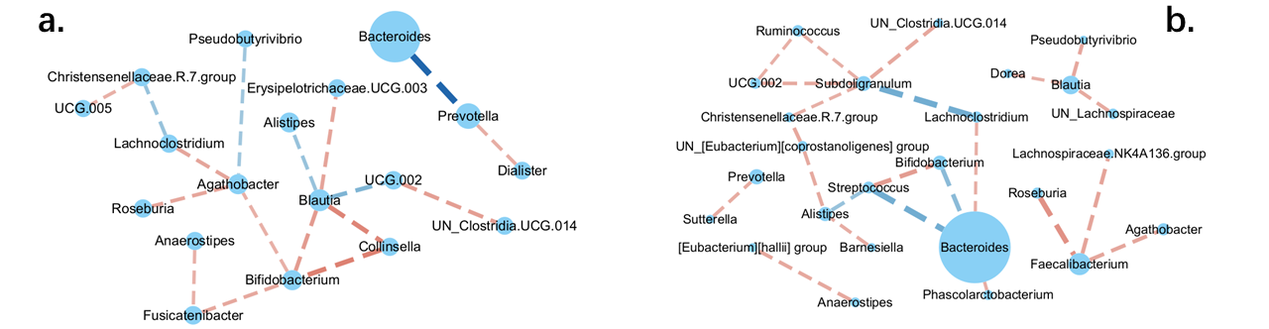

Fig S9. Leave-one-out sensitivity analysis. Leaving out study—Jangi. Unique correlations in Control (a). Unique correlations in MS (b).

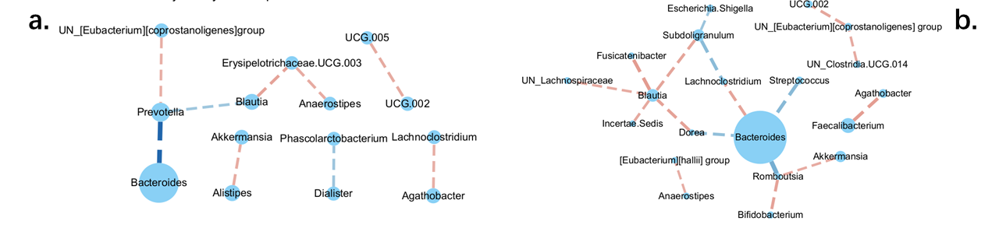
Fig S10. Leave-one-out sensitivity analysis. Leaving out study—Miyake. Unique correlations in Control (a). Unique correlations in MS (b).

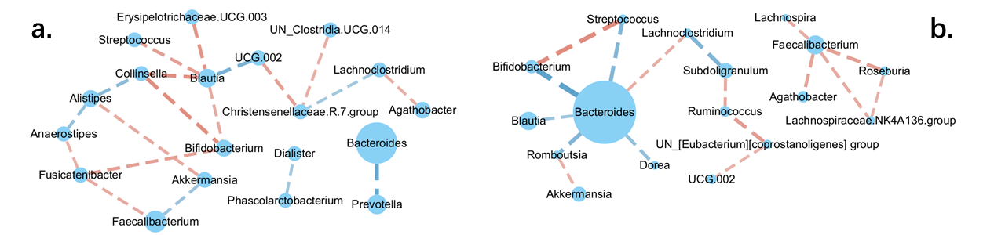

Fig S11. Leave-one-out sensitivity analysis. Leaving out study—Zeng. Unique correlations in Control (a). Unique correlations in MS (b).

Fig S12. MS classification using the gut microbiota. a. Accuracy of the microbiota classifiers and their prediction performance with one study as training set and six individual studies as testing sets. Values in the diagonal (from top left to bottom right), colored in blue, show accuracy (measured by confusion matrix) of each classifier itself trained by the microbiota data from each individual study. In each row, the classifier trained by the microbiota from one study is used to predict MS and controls for the rest of six studies. Off-diagonal values, colored in red, show prediction performance (measured by AUC) of 6 testing datasets. b. Accuracy of the microbiota classifiers (measured by a confusion matrix) and their prediction performance (measured by AUC) using six combined studies as training datasets and one left-out study as a testing set. The red bars indicate accuracy of model itself and the green bars indicate AUC of prediction performance for each test set (x-axis). c. Accuracy of the microbiota classifiers and their prediction performance using 3/4 of all seven combined studies as training datasets and the rest 1/4 as a testing set. The red bars indicate accuracy of model itself and the green bars indicate AUC of the test set (x-axis).
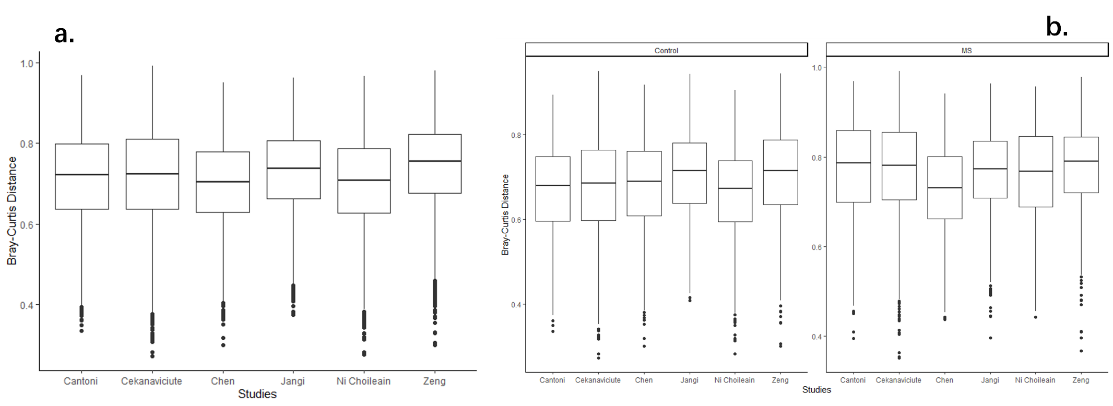
Fig S13. Bray-Curtis distance from Miyake to other 6 studies. Bray-Curtis distance from Miyake to other six studies, within and between MS and Control subjects (a). Bray-Curtis distance within groups from Miyake to other six studies (b).

Fig S14. Alpha diversity and beta diversity are not significantly different between active and remission MS patients (p=0.14 for Bray-curtis dissimilarity; p=0.69 for richness; p=0.34 for Shannon diversity) (a), and between treated and non-treated patients (p=0.07 for Bray-curtis dissimilarity; p=0.42 for richness; p=0.48 for Shannon diversity (b).

