Supplementary Methods

Validation of continental ancestry methods

We validated our ancestry inference methods by comparing the ancestry proportions obtained with our selected 654 Ancestry Informative Markers (AIMs) and methodology to the global ancestry proportions derived from the RFMix local ancestry inference method. These global proportions were obtained by summing the local ancestry segments predicted by RFMix from whole-genome sequencing (WGS) call data.

Initially, we compared our method using normal tissue WGS data for the 2,658 patients analyzed by the PCAWG Project (Campbell et al., 2020; https://doi.org/10.1038/s41586-020-1969-6), available in Synapse record syn4877977 (https://doi.org/10.7303/syn4877977). Supplemental Figure 1 illustrates plots comparing the values obtained for each of the five continental ancestry proportions for this sample set by our method and RFMix.

Considering the PCAWG project included few admixed individuals with AMR ancestry, we further compared our inferred ancestry proportions, using our AIMs and methods, to the global ancestry inferred by RFMix on admixed samples from the 1000 Genomes Project for the following Phase 3 populations: Afro-Caribbean from Barbados (ACB), African American from the Southwest US (ASW), Colombian (CLM), Mexican from Los Angeles (MXL), Peruvians from Lima (PEL), and Puerto Rican (PUR). The RFMix results were published by Martin et al. in 2017 (https://doi.org/10.1016/j.ajhg.2017.03.004).

We assessed our method by assuming the RFMix ancestry proportions as the truth set and computed the mean squared error as:
$$MSE = \sum_{k}{(x_{k}-μ_{k})^{2},}$$
Where $x_{k}$is the predicted proportion for population k and $μ_{k}$is the expected proportion for population k. A perfect prediction would have an MSE of 0. Supplementary Table 0 provides the MSE obtained by ancestry, and the average MSE across all ancestries evaluated, for each of the aforementioned test sets.

Supplementary Tables
Table S1. Normalized mean squared error (MSE) of the continental ancestry proportion inferred by our method and AIMs comparing to results obtained by the RFMix method in two WGS datasets: The PCAWG Project (Campbell et ql, 2020) and the admixed populations from the 1,000 Genomes Project (1kP; data from Martin et al, 2017) as per Supplementary Methods.

Evaluation set | AFR | AMR | EAS | EUR | SAS | Average MSE
PCAWG | 0.0084 | 0.3058 | 0.0138 | 0.0072 | 0.2716 | 0.1214
1kP Admix | 0.0062 | 0.0172 | N/A | 0.0188 | N/A | 0.0141

Table S2: Patient characteristics for MSS patients by imputed race ethnicity category.
Characteristic | Complex, N = 247¹ | Hispanic/ Latino  N = 896¹ | NH Asian,  N = 405¹ | NH Black,  N = 1,017¹ | NH White,  N = 5,432¹ | p-value²
Stated race |  |  |  |  |  | <0.001
White | 90 (78%) | 209 (58%) | 9 (4.3%) | 22 (3.4%) | 3,075 (97%)
American Indian or Alaska Native | 2 (1.7%) | 27 (7.5%) | 3 (1.4%) | 0 (0%) | 2 (<0.1%)
Asian | 10 (8.7%) | 1 (0.3%) | 176 (84%) | 0 (0%) | 2 (<0.1%)
Black or African American | 0 (0%) | 5 (1.4%) | 0 (0%) | 611 (94%) | 8 (0.3%)
Native Hawaiian or Other Pacific Islander | 2 (1.7%) | 1 (0.3%) | 4 (1.9%) | 0 (0%) | 1 (<0.1%)
Other Race | 11 (9.6%) | 118 (33%) | 17 (8.1%) | 19 (2.9%) | 72 (2.3%)
Race not stated | 0 (0%) | 1 (0.3%) | 1 (0.5%) | 0 (0%) | 6 (0.2%)
Unknown | 132 | 534 | 195 | 365 | 2,266
Stated ethnicity |  |  |  |  |  | <0.001
Not Hispanic or Latino | 58 (73%) | 63 (14%) | 117 (99%) | 266 (95%) | 1,625 (98%)
Hispanic or Latino | 21 (27%) | 387 (86%) | 1 (0.8%) | 13 (4.7%) | 36 (2.2%)
Unknown | 168 | 446 | 287 | 738 | 3,771
Age at specimen collection | 59 (50, 68) | 56 (47, 66) | 60 (50, 68) | 60 (50, 68) | 61 (52, 70) | <0.001
Unknown | 0 | 3 | 0 | 1 | 8
Age at onset | 57 (49, 67) | 55 (46, 64) | 58 (49, 66) | 58 (49, 67) | 59 (50, 68) | <0.001
Unknown | 46 | 135 | 60 | 177 | 948
Onset age group |  |  |  |  |  | <0.001
AOCRC | 147 (73%) | 483 (63%) | 247 (72%) | 612 (73%) | 3,427 (76%)
EOCRC | 54 (27%) | 278 (37%) | 98 (28%) | 228 (27%) | 1,057 (24%)
Unknown | 46 | 135 | 60 | 177 | 948
Gender |  |  |  |  |  | 0.3
Female | 109 (44%) | 391 (44%) | 170 (42%) | 462 (46%) | 2,281 (42%)
Male | 138 (56%) | 501 (56%) | 233 (58%) | 553 (54%) | 3,132 (58%)
Unknown | 0 | 4 | 2 | 2 | 19
xT assay version |  |  |  |  |  | 0.5
xT.v2 | 35 (14%) | 115 (13%) | 65 (16%) | 142 (14%) | 809 (15%)
xT.v3 | 43 (17%) | 181 (20%) | 64 (16%) | 198 (19%) | 1,035 (19%)
xT.v4 | 169 (68%) | 600 (67%) | 276 (68%) | 677 (67%) | 3,588 (66%)
Smoking status |  |  |  |  |  | <0.001
Never smoker | 83 (56%) | 353 (60%) | 178 (67%) | 378 (55%) | 1,895 (52%)
Ever smoker | 65 (44%) | 239 (40%) | 88 (33%) | 308 (45%) | 1,767 (48%)
Unknown | 99 | 304 | 139 | 331 | 1,770
Cancer stage |  |  |  |  |  | 0.055
Stage 1 | 2 (1.4%) | 5 (0.9%) | 1 (0.4%) | 7 (1.1%) | 22 (0.7%)
Stage 2 | 9 (6.2%) | 21 (3.9%) | 6 (2.5%) | 28 (4.2%) | 131 (3.9%)
Stage 3 | 20 (14%) | 94 (17%) | 36 (15%) | 82 (12%) | 398 (12%)
Stage 4 | 115 (79%) | 425 (78%) | 199 (82%) | 549 (82%) | 2,817 (84%)
Unknown | 101 | 351 | 163 | 351 | 2,064
Tumor grade |  |  |  |  |  | 0.006
Low | 6 (4.0%) | 74 (12%) | 30 (11%) | 54 (8.0%) | 349 (9.8%)
Medium | 108 (72%) | 453 (72%) | 195 (69%) | 486 (72%) | 2,435 (68%)
High | 36 (24%) | 102 (16%) | 56 (20%) | 134 (20%) | 779 (22%)
Unknown | 97 | 267 | 124 | 343 | 1,869
TMB count (mutations/Mb) | 3.46 (2.31, 5.00) | 3.33 (2.31, 4.23) | 3.46 (2.31, 5.00) | 3.46 (2.31, 5.38) | 3.07 (2.31, 4.60) | <0.001
Unknown | 0 | 0 | 1 | 2 | 3
Tumor/normal tissue status |  |  |  |  |  | 0.073
Tumor and normal | 148 (60%) | 583 (65%) | 237 (59%) | 634 (62%) | 3,289 (61%)
Tumor only | 99 (40%) | 313 (35%) | 168 (41%) | 383 (38%) | 2,143 (39%)
Cancer primary site |  |  |  |  |  | <0.001
Left colon | 34 (14%) | 97 (11%) | 52 (13%) | 84 (8.3%) | 500 (9.2%)
Not specified | 146 (59%) | 569 (64%) | 245 (60%) | 692 (68%) | 3,628 (67%)
Rectum | 44 (18%) | 157 (18%) | 71 (18%) | 125 (12%) | 833 (15%)
Right colon | 23 (9.3%) | 73 (8.1%) | 37 (9.1%) | 116 (11%) | 471 (8.7%)
Tumor tissue site |  |  |  |  |  | <0.001
CRC (primary) | 130 (53%) | 508 (57%) | 200 (49%) | 522 (51%) | 2,604 (48%)
Liver | 46 (19%) | 184 (21%) | 75 (19%) | 241 (24%) | 1,244 (23%)
Lung | 11 (4.5%) | 42 (4.7%) | 39 (9.6%) | 41 (4.0%) | 344 (6.4%)
Other | 59 (24%) | 160 (18%) | 91 (22%) | 211 (21%) | 1,220 (23%)
Unknown | 1 | 2 | 0 | 2 | 20

¹ n (%); Median (IQR)
² Fisher's Exact Test for Count Data with simulated p-value (based on 2000 replicates) for categorical variables with any expected cell count <5; Pearson's Chi-squared test for categorical variables with all expected cell counts ≥5; Kruskal-Wallis rank sum test for continuous variables

Table S3: Patient characteristics for MSI-high patients by imputed race ethnicity group.
Characteristic | Complex,  N = 10¹ | Hispanic/ Latino,  N = 56¹ | NH Asian,  N = 15¹ | NH Black,  N = 42¹ | NH White,  N = 322¹ | p-value²
Stated race |  |  |  |  |  | <0.001
White | 4 (67%) | 14 (50%) | 0 (0%) | 1 (4.0%) | 189 (98%)
American Indian or Alaska Native | 1 (17%) | 2 (7.1%) | 0 (0%) | 0 (0%) | 0 (0%)
Asian | 0 (0%) | 0 (0%) | 5 (71%) | 0 (0%) | 0 (0%)
Black or African American | 0 (0%) | 1 (3.6%) | 0 (0%) | 23 (92%) | 1 (0.5%)
Native Hawaiian or Other Pacific Islander | 0 (0%) | 0 (0%) | 0 (0%) | 0 (0%) | 0 (0%)
Other Race | 1 (17%) | 11 (39%) | 2 (29%) | 1 (4.0%) | 3 (1.6%)
Race not stated | 0 (0%) | 0 (0%) | 0 (0%) | 0 (0%) | 0 (0%)
Unknown | 4 | 28 | 8 | 17 | 129
Stated ethnicity |  |  |  |  |  | <0.001
Not Hispanic or Latino | 6 (100%) | 4 (13%) | 3 (100%) | 11 (92%) | 91 (99%)
Hispanic or Latino | 0 (0%) | 27 (87%) | 0 (0%) | 1 (8.3%) | 1 (1.1%)
Unknown | 4 | 25 | 12 | 30 | 230
Age at specimen collection | 67 (47, 77) | 56 (44, 73) | 61 (43, 74) | 61 (47, 72) | 70 (60, 79) | <0.001
Unknown | 0 | 0 | 0 | 0 | 2
Age at onset | 52 (41, 77) | 56 (43, 73) | 64 (50, 75) | 60 (47, 72) | 69 (59, 78) | <0.001
Unknown | 1 | 7 | 4 | 7 | 54
Onset age group |  |  |  |  |  | <0.001
AOCRC | 5 (56%) | 31 (63%) | 8 (73%) | 22 (63%) | 233 (87%)
EOCRC | 4 (44%) | 18 (37%) | 3 (27%) | 13 (37%) | 35 (13%)
Unknown | 1 | 7 | 4 | 7 | 54
Gender |  |  |  |  |  | >0.9
Female | 6 (60%) | 29 (52%) | 9 (60%) | 25 (60%) | 171 (53%)
Male | 4 (40%) | 27 (48%) | 6 (40%) | 17 (40%) | 149 (47%)
Unknown | 0 | 0 | 0 | 0 | 2
xT assay version |  |  |  |  |  | 0.3
xT.v2 | 1 (10%) | 5 (8.9%) | 3 (20%) | 7 (17%) | 48 (15%)
xT.v3 | 1 (10%) | 13 (23%) | 0 (0%) | 5 (12%) | 38 (12%)
xT.v4 | 8 (80%) | 38 (68%) | 12 (80%) | 30 (71%) | 236 (73%)
Smoking status |  |  |  |  |  | 0.3
Never smoker | 3 (43%) | 22 (58%) | 6 (86%) | 14 (48%) | 109 (47%)
Ever smoker | 4 (57%) | 16 (42%) | 1 (14%) | 15 (52%) | 123 (53%)
Unknown | 3 | 18 | 8 | 13 | 90
Cancer stage |  |  |  |  |  | 0.6
Stage 1 | 0 (0%) | 0 (0%) | 0 (0%) | 0 (0%) | 1 (0.6%)
Stage 2 | 2 (29%) | 3 (10%) | 1 (12%) | 4 (13%) | 32 (18%)
Stage 3 | 1 (14%) | 13 (43%) | 4 (50%) | 7 (23%) | 46 (25%)
Stage 4 | 4 (57%) | 14 (47%) | 3 (38%) | 19 (63%) | 102 (56%)
Unknown | 3 | 26 | 7 | 12 | 141
Tumor grade |  |  |  |  |  | 0.14
Low | 1 (14%) | 4 (10%) | 0 (0%) | 2 (5.6%) | 12 (5.0%)
Medium | 2 (29%) | 21 (52%) | 4 (44%) | 24 (67%) | 110 (46%)
High | 4 (57%) | 15 (38%) | 5 (56%) | 10 (28%) | 119 (49%)
Unknown | 3 | 16 | 6 | 6 | 81
TMB count (mutations/Mb) | 41 (29, 58) | 40 (31, 56) | 39 (24, 50) | 35 (21, 48) | 35 (26, 45) | 0.2
Unknown | 0 | 0 | 0 | 0 | 1
Tumor/normal tissue status |  |  |  |  |  | 0.1
Tumor and normal | 4 (40%) | 43 (77%) | 9 (60%) | 25 (60%) | 195 (61%)
Tumor only | 6 (60%) | 13 (23%) | 6 (40%) | 17 (40%) | 127 (39%)
Cancer primary site |  |  |  |  |  | 0.2
Left colon | 0 (0%) | 1 (1.8%) | 0 (0%) | 3 (7.1%) | 22 (6.8%)
Not specified | 6 (60%) | 40 (71%) | 8 (53%) | 19 (45%) | 189 (59%)
Rectum | 2 (20%) | 4 (7.1%) | 1 (6.7%) | 3 (7.1%) | 16 (5.0%)
Right colon | 2 (20%) | 11 (20%) | 6 (40%) | 17 (40%) | 95 (30%)
Tumor tissue site |  |  |  |  |  | 0.7
CRC (primary) | 7 (70%) | 46 (82%) | 11 (73%) | 33 (79%) | 234 (73%)
Liver | 0 (0%) | 1 (1.8%) | 0 (0%) | 1 (2.4%) | 22 (6.8%)
Lung | 0 (0%) | 1 (1.8%) | 0 (0%) | 0 (0%) | 2 (0.6%)
Other | 3 (30%) | 8 (14%) | 4 (27%) | 8 (19%) | 64 (20%)

¹ n (%); Median (IQR)
² Fisher's Exact Test for Count Data with simulated p-value (based on 2000 replicates) for categorical variables with any expected cell count <5; Pearson's Chi-squared test for categorical variables with all expected cell counts ≥5; Kruskal-Wallis rank sum test for continuous variables

Table S4. AOCRC patient characteristics by imputed race and ethnicity group.

Characteristic | Complex,  N = 153¹ | Hispanic/ Latino,  N = 514¹ | NH Asian,  N = 255¹ | NH Black,  N = 635¹ | NH White,  N = 3,664¹ | p-value²
Stated race |  |  |  |  |  | <0.001
White | 62 (84%) | 131 (58%) | 6 (4.4%) | 13 (3.2%) | 2,117 (98%)
American Indian or Alaska Native | 1 (1.4%) | 16 (7.1%) | 2 (1.5%) | 0 (0%) | 1 (<0.1%)
Asian | 5 (6.8%) | 1 (0.4%) | 113 (84%) | 0 (0%) | 2 (<0.1%)
Black or African American | 0 (0%) | 3 (1.3%) | 0 (0%) | 385 (95%) | 3 (0.1%)
Native Hawaiian or Other Pacific Islander | 1 (1.4%) | 0 (0%) | 2 (1.5%) | 0 (0%) | 1 (<0.1%)
Other Race | 5 (6.8%) | 74 (33%) | 12 (8.9%) | 9 (2.2%) | 44 (2.0%)
Race not stated | 0 (0%) | 0 (0%) | 0 (0%) | 0 (0%) | 1 (<0.1%)
Unknown | 79 | 289 | 120 | 228 | 1,495
Stated ethnicity |  |  |  |  |  | <0.001
Not Hispanic or Latino | 40 (78%) | 33 (13%) | 72 (99%) | 150 (96%) | 1,072 (98%)
Hispanic or Latino | 11 (22%) | 213 (87%) | 1 (1.4%) | 7 (4.5%) | 22 (2.0%)
Unknown | 102 | 268 | 182 | 478 | 2,570
Age at specimen collection | 63 (55, 72) | 62 (57, 70) | 64 (58, 71) | 64 (58, 71) | 65 (58, 73) | <0.001
Age at onset | 62 (55, 71) | 62 (56, 69) | 63 (57, 70) | 63 (57, 70) | 64 (57, 72) | <0.001
Gender |  |  |  |  |  | 0.8
Female | 62 (41%) | 218 (43%) | 99 (39%) | 274 (43%) | 1,549 (42%)
Male | 91 (59%) | 294 (57%) | 155 (61%) | 360 (57%) | 2,104 (58%)
Unknown | 0 | 2 | 1 | 1 | 11
xT assay version |  |  |  |  |  | 0.8
xT.v4 | 106 (69%) | 349 (68%) | 179 (70%) | 443 (70%) | 2,535 (69%)
xT.v2 | 20 (13%) | 65 (13%) | 37 (15%) | 94 (15%) | 513 (14%)
xT.v3 | 27 (18%) | 100 (19%) | 39 (15%) | 98 (15%) | 616 (17%)
Smoking status |  |  |  |  |  | <0.001
Never smoker | 52 (52%) | 206 (58%) | 113 (63%) | 231 (52%) | 1,260 (49%)
Ever smoker | 48 (48%) | 150 (42%) | 66 (37%) | 212 (48%) | 1,325 (51%)
Unknown | 53 | 158 | 76 | 192 | 1,079
Cancer stage |  |  |  |  |  | 0.6
Stage 1 | 1 (1.0%) | 3 (0.9%) | 1 (0.6%) | 6 (1.4%) | 14 (0.6%)
Stage 2 | 5 (5.2%) | 17 (5.3%) | 6 (3.7%) | 20 (4.6%) | 109 (4.8%)
Stage 3 | 11 (11%) | 57 (18%) | 26 (16%) | 56 (13%) | 310 (14%)
Stage 4 | 79 (82%) | 246 (76%) | 129 (80%) | 352 (81%) | 1,850 (81%)
Unknown | 57 | 191 | 93 | 201 | 1,381
Tumor grade |  |  |  |  |  | 0.01
Low | 3 (3.2%) | 47 (13%) | 17 (8.9%) | 35 (8.2%) | 227 (9.1%)
Medium | 67 (71%) | 261 (70%) | 135 (71%) | 318 (74%) | 1,690 (68%)
High | 24 (26%) | 66 (18%) | 38 (20%) | 76 (18%) | 573 (23%)
Unknown | 59 | 140 | 65 | 206 | 1,174
MSI status |  |  |  |  |  | 0.008
Low/Stable | 147 (97%) | 483 (94%) | 247 (97%) | 612 (97%) | 3,427 (94%)
High | 5 (3.3%) | 31 (6.0%) | 8 (3.1%) | 22 (3.5%) | 233 (6.4%)
Unknown | 1 | 0 | 0 | 1 | 4
TMB count (mutations/Mb) | 3 (2, 5) | 3 (2, 5) | 4 (2, 5) | 4 (2, 6) | 3 (2, 5) | 0.093
Unknown | 0 | 0 | 0 | 1 | 2
Tumor/normal tissue status |  |  |  |  |  | 0.067
Tumor and normal | 90 (59%) | 342 (67%) | 146 (57%) | 391 (62%) | 2,216 (61%)
Tumor only | 62 (41%) | 172 (33%) | 109 (43%) | 243 (38%) | 1,445 (39%)
Unknown | 1 | 0 | 0 | 1 | 3
Cancer primary site |  |  |  |  |  | 0.03
Left colon | 21 (14%) | 58 (11%) | 36 (14%) | 59 (9.3%) | 366 (10.0%)
Not specified | 88 (58%) | 315 (61%) | 143 (56%) | 411 (65%) | 2,280 (62%)
Rectum | 27 (18%) | 85 (17%) | 46 (18%) | 72 (11%) | 577 (16%)
Right colon | 17 (11%) | 56 (11%) | 30 (12%) | 93 (15%) | 441 (12%)
Tumor tissue site |  |  |  |  |  | <0.001
CRC (primary) | 83 (54%) | 306 (60%) | 143 (56%) | 366 (58%) | 1,935 (53%)
Liver | 34 (22%) | 113 (22%) | 43 (17%) | 152 (24%) | 828 (23%)
Lung | 2 (1.3%) | 19 (3.7%) | 16 (6.3%) | 21 (3.3%) | 209 (5.7%)
Other | 34 (22%) | 75 (15%) | 53 (21%) | 95 (15%) | 680 (19%)
Unknown | 0 | 1 | 0 | 1 | 12
¹ n (%); Median (IQR)
² Fisher's Exact Test for Count Data with simulated p-value (based on 2000 replicates) for categorical variables with any expected cell count <5; Pearson's Chi-squared test for categorical variables with all expected cell counts ≥5; Kruskal-Wallis rank sum test for continuous variables

Table S5. EOCRC patient characteristics by imputed race and ethnicity group.
Characteristic | Complex,  N = 58¹ | Hispanic/ Latino,  N = 296¹ | NH Asian,  N = 101¹ | NH Black,  N = 241¹ | NH White,  N = 1,096¹ | p-value²
Stated race |  |  |  |  |  | <0.001
White | 21 (75%) | 61 (62%) | 2 (4.4%) | 5 (3.4%) | 564 (97%)
American Indian or Alaska Native | 2 (7.1%) | 6 (6.1%) | 0 (0%) | 0 (0%) | 1 (0.2%)
Asian | 1 (3.6%) | 0 (0%) | 39 (87%) | 0 (0%) | 0 (0%)
Black or African American | 0 (0%) | 1 (1.0%) | 0 (0%) | 138 (95%) | 3 (0.5%)
Native Hawaiian or Other Pacific Islander | 0 (0%) | 1 (1.0%) | 1 (2.2%) | 0 (0%) | 0 (0%)
Other Race | 4 (14%) | 28 (29%) | 3 (6.7%) | 3 (2.1%) | 10 (1.7%)
Race not stated | 0 (0%) | 1 (1.0%) | 0 (0%) | 0 (0%) | 1 (0.2%)
Unknown | 30 | 198 | 56 | 95 | 517
Stated ethnicity |  |  |  |  |  | <0.001
Not Hispanic or Latino | 14 (74%) | 23 (14%) | 25 (100%) | 55 (92%) | 284 (98%)
Hispanic or Latino | 5 (26%) | 137 (86%) | 0 (0%) | 5 (8.3%) | 7 (2.4%)
Unknown | 39 | 136 | 76 | 181 | 805
Age at specimen collection | 45 (36, 48) | 44 (40, 47) | 45 (39, 49) | 45 (40, 49) | 45 (40, 49) | 0.056
Age at onset | 43.3 (35.2, 46.5) | 42.8 (38.5, 46.7) | 44.1 (37.9, 47.2) | 44.3 (39.5, 47.5) | 43.9 (38.5, 47.5) | 0.12
Gender |  |  |  |  |  | 0.033
Female | 33 (57%) | 145 (49%) | 49 (49%) | 123 (51%) | 471 (43%)
Male | 25 (43%) | 151 (51%) | 51 (51%) | 118 (49%) | 623 (57%)
Unknown | 0 | 0 | 1 | 0 | 2
xT assay version |  |  |  |  |  | 0.04
xT.v4 | 44 (76%) | 222 (75%) | 70 (69%) | 166 (69%) | 718 (66%)
xT.v2 | 7 (12%) | 26 (8.8%) | 17 (17%) | 28 (12%) | 167 (15%)
xT.v3 | 7 (12%) | 48 (16%) | 14 (14%) | 47 (20%) | 211 (19%)
Smoking status |  |  |  |  |  | 0.077
never_smoker | 23 (66%) | 132 (65%) | 53 (79%) | 90 (61%) | 464 (62%)
ever_smoker | 12 (34%) | 70 (35%) | 14 (21%) | 58 (39%) | 282 (38%)
Unknown | 23 | 94 | 34 | 93 | 350
Cancer stage |  |  |  |  |  | 0.025
Stage 1 | 1 (2.7%) | 2 (1.1%) | 0 (0%) | 0 (0%) | 5 (0.8%)
Stage 2 | 4 (11%) | 5 (2.8%) | 1 (1.8%) | 4 (2.8%) | 17 (2.6%)
Stage 3 | 7 (19%) | 36 (20%) | 10 (18%) | 23 (16%) | 73 (11%)
Stage 4 | 25 (68%) | 133 (76%) | 44 (80%) | 116 (81%) | 549 (85%)
Unknown | 21 | 120 | 46 | 98 | 452
Tumor grade |  |  |  |  |  | 0.14
Low | 4 (11%) | 20 (9.8%) | 10 (14%) | 10 (6.0%) | 71 (9.8%)
Medium | 21 (58%) | 153 (75%) | 44 (63%) | 118 (70%) | 519 (72%)
High | 11 (31%) | 32 (16%) | 16 (23%) | 40 (24%) | 135 (19%)
Unknown | 22 | 91 | 31 | 73 | 371
MSI status |  |  |  |  |  | 0.074
Low/Stable | 54 (93%) | 278 (94%) | 98 (97%) | 228 (95%) | 1,057 (97%)
High | 4 (6.9%) | 18 (6.1%) | 3 (3.0%) | 13 (5.4%) | 35 (3.2%)
Unknown | 0 | 0 | 0 | 0 | 4
TMB count (mutations/Mb) | 3.1 (2.3, 5.0) | 3.1 (1.9, 4.6) | 3.3 (2.3, 5.1) | 3.8 (2.6, 5.9) | 3.1 (1.9, 4.2) | <0.001
Unknown | 0 | 0 | 1 | 1 | 0
Tumor/normal tissue status |  |  |  |  |  | 0.7
Tumor and normal | 38 (66%) | 198 (67%) | 60 (59%) | 152 (63%) | 691 (63%)
Tumor only | 20 (34%) | 98 (33%) | 41 (41%) | 89 (37%) | 402 (37%)
Unknown | 0 | 0 | 0 | 0 | 3
Cancer primary site name |  |  |  |  |  | 0.087
Left colon | 5 (8.6%) | 32 (11%) | 13 (13%) | 22 (9.1%) | 113 (10%)
Not specified | 32 (55%) | 179 (60%) | 63 (62%) | 148 (61%) | 719 (66%)
Rectum | 15 (26%) | 72 (24%) | 17 (17%) | 46 (19%) | 197 (18%)
Right colon | 6 (10%) | 13 (4.4%) | 8 (7.9%) | 25 (10%) | 67 (6.1%)
Tumor tissue site |  |  |  |  |  | 0.016
CRC (primary) | 29 (51%) | 174 (59%) | 43 (43%) | 124 (51%) | 561 (51%)
Liver | 10 (18%) | 48 (16%) | 20 (20%) | 48 (20%) | 249 (23%)
Lung | 7 (12%) | 19 (6.4%) | 14 (14%) | 11 (4.6%) | 74 (6.8%)
Other | 11 (19%) | 54 (18%) | 24 (24%) | 58 (24%) | 206 (19%)
Unknown | 1 | 1 | 0 | 0 | 6

¹ n (%); Median (IQR)
² Fisher's Exact Test for Count Data with simulated p-value (based on 2000 replicates) for categorical variables with any expected cell count <5; Pearson's Chi-squared test for categorical variables with all expected cell counts ≥5; Kruskal-Wallis rank sum test for continuous variables

Table S6: Genes tested by mutation type and MSI status.
MSI status | Mutation type | Number of genes tested | Genes tested
MSS | Protein-altering | 79 | ABL1, ACVR1B, ALK, AMER1, APC, ARID1A, ARID1B, ATM, AXIN1, AXIN2, BCOR, BCORL1, BMPR1A, BRAF, BRCA1, BRCA2, CARD11, CDKN2A, CREBBP, CTNNB1, DICER1, EGFR, EP300, ERBB2, ERBB3, ERBB4, FAT1, FBXW7, FLT3, GNAS, GRIN2A, JAK2, KDM5A, KIT, KMT2C, KRAS, LRP1B, MAP2K1, MAP2K4, MAP3K1, MSH3, MTOR, NCOR1, NCOR2, NF1, NOTCH1, NOTCH2, NOTCH3, NRAS, NTRK1, NTRK2, NTRK3, PCBP1, PDGFRA, PIK3CA, PIK3CB, PIK3R1, POLE, PPP2R1A, PTEN, RASA1, RB1, RBM10, RET, RICTOR, RNF43, ROS1, RPTOR, SMAD2, SMAD3, SMAD4, SMARCA4, SOX9, SPEN, TBX3, TCF7L2, TGFBR2, TP53, TSC2
MSI-high | Protein-altering | 127 | ABL1, ACVR1B, AKT1, AKT2, AKT3, ALK, AMER1, APC, ARAF, ARID1A, ARID1B, ATM, AXIN1, AXIN2, BCOR, BCORL1, BMPR1A, BRAF, BRCA1, BRCA2, CARD11, CBL, CCDC6, CCND1, CCNE1, CDH1, CDKN1A, CDKN1B, CDKN2A, CDKN2B, CHEK2, CREBBP, CTNNB1, DICER1, EGFR, EP300, EPCAM, ERBB2, ERBB3, ERBB4, ERRFI1, FANCD2, FAT1, FBXW7, FGFR1, FGFR2, FGFR3, FGFR4, FLCN, FLT3, GNAS, GRIN2A, HDAC1, HRAS, INPP4B, JAK2, KDM5A, KEAP1, KIT, KMT2C, KRAS, LRP1B, MAP2K1, MAP2K2, MAP2K4, MAP3K1, MAX, MDM2, MET, MLH1, MSH2, MSH3, MSH6, MTOR, MUTYH, MYC, MYCN, NCOR1, NCOR2, NF1, NF2, NFE2L2, NOTCH1, NOTCH2, NOTCH3, NTHL1, NTRK1, NTRK2, NTRK3, PCBP1, PDGFRA, PDGFRB, PIK3CA, PIK3CB, PIK3R1, PIK3R2, PMS2, POLD1, POLE, PPP2R1A, PTEN, PTPN11, RAF1, RASA1, RB1, RBM10, RET, RICTOR, RNF43, ROS1, RPS6KB1, RPTOR, SMAD2, SMAD3, SMAD4, SMARCA4, SOX9, SPEN, SPRED1, STK11, TBX3, TCF7L2, TGFBR2, TP53, TSC1, TSC2, ZNRF3
MSS | Somatic copy number alterations | 9 | CCND2, CDKN2A, CDKN2B, ERBB2, FLT3, MYC, PTEN, SMAD3, SMAD4
MSI-high | Somatic copy number alterations | 2 | MLH1, MSH2
MSS | Actionable | 3 | BRAF, KRAS, PIK3CA
MSI-high | Actionable | 2 | BRAF, PIK3CA

Table S7: Somatic mutation associations with imputed race and ethnicity in MSS patients that differ by onset age or primary site.
Mutation type = type of mutation tested. “SCNA” refers to somatic copy number alterations, and “actionable” refers to protein-altering mutations that are classified with a OncoKB Therapeutic Level of Evidence V2 designation therapeutic level 1 or 2, or resistance level R1, irrespective of the solid cancer type. Gene = gene symbol of tested gene. N total = total number of patients included in models. N with mutation = number of patients included in models who have one or more of the mutation type in the gene. P LR (FDR) = P-value for the likelihood ratio test, adjusted for the number of genes tested (9 for SCNAs and 3 for actionable) to control the false discovery rate. Intxn. imputed r/e group = imputed race and ethnicity group with differing association by either onset age or primary site with the presence of mutations in this gene in logistic regression test (i.e., the group that shows an interaction effect). Intxn. group = the specific onset group or primary site for which an OR is estimated. OR (95% CI) = odds ratio compared to NH White category and 95% confidence interval for the given ancestry proportion in the logistic regression test. P Logistic = P-value for the specific ancestry proportion in the logistic regression test, not adjusted for multiple tests.
Mutation type | Gene | N total | N with mutation | P LR (FDR) | Intxn. imputed r/e group | P int. term | Intxn.  group | OR (95% CI) | P Logistic
SCNA | FLT3 | 6,413 | 199 | 0.033 | Hispanic  /Latino | 0.002 | AOCRC | 2.38 (1.53, 3.72) | 1.4e-04
 |  |  |  |  |  |  | EOCRC | 0.46 (0.18, 1.18) | 0.107
Actionable | BRAF | 2,604 | 116 | 0.005 | NH Asian | 0.031 | Colon | 0.12 (0.16, 0.86) | 0.035
 |  |  |  |  |  |  | Rectum | 1.84 (0.41, 8.32) | 0.426
 |  |  |  |  | NH Black | 0.001 | Colon | 0.10 (0.03, 0.42) | 0.002
 |  |  |  |  |  |  | Rectum | 2.12 (0.68, 6.59) | 0.192

Table S8: Somatic mutation associations with imputed race and ethnicity in MSI-high patients.

Mutation type = type of mutation tested. “SCNA” refers to somatic copy number alterations. Gene = gene symbol of tested gene. N total = total number of patients included in models. N genes tested = number of genes of specified mutation type tested for association. N patients total = total number of patients included in models. N patients with mutation = number of patients included in models who have one or more of the mutation type in the gene. P LR (FDR) = P-value for the likelihood ratio test, adjusted for the number of genes in the N genes tested column to control the false discovery rate. Imputed race and ethnicity group = imputed race and ethnicity group associated with the presence of mutations in this gene in logistic regression test. OR (95% CI) = odds ratio and 95% confidence interval for the given imputed race and ethnicity category compared to the NH White category in the logistic regression test. P Logistic = P-value for the specific ancestry proportion in the logistic regression test, not adjusted for multiple tests.
Mutation type | Gene | N Genes tested | N patients total | N patients with mutation | P LR (FDR) | Imputed race and ethnicity group | OR (95% CI) | P Logistic
Protein-altering | KMT2C | 127 | 270 | 153 | 0.005 | NH Black | 23.7 (3.1, 181) | 0.002
SCNA | MLH1 | 2 | 432 | 13 | 0.005 | NH Asian | 13.9 (1.9, 103) | 0.01
 |  |  |  |  |  | Hispanic/Latino | 11.4 (2.6, 49.6) | 0.001

Table S9: Somatic mutation associations with ancestry proportions and imputed race categories in MSS patients, additionally adjusting for TMB.
Mutation type: type of mutation tested. “Actionable” refers to protein-altering mutations that are classified as OncoKB Therapeutic Level of Evidence V2 designation of therapeutic level 1 or 2, or resistance level R1, irrespective of the solid cancer type. Gene: HGNC gene symbol of tested gene. N genes tested = number of genes of specified mutation type tested for association. N patients total: total number of patients included in models. N patients with mutation = number of patients included in models who have one or more of the mutation type in the gene. P LR (FDR): P-value for likelihood ratio test, adjusted for the number of genes in the N genes tested column to control the false discovery rate. Ancestry or imputed race group: ancestry or imputed race group associated with the presence/absence of mutations in this gene in logistic regression test. OR (95% CI): odds ratio per doubling of genetic ancestry proportion (in the case of ancestry) or odds ratio compared to NH White category (in the case of imputed race group) and 95% confidence interval in the logistic regression test. P Logistic = P-value for the specific ancestry proportion or imputed race group in the logistic regression test, not adjusted for multiple tests.

Mutation type | Gene | N genes tested | N patients total | N patients with mutation | P LR (FDR) | Ancestry or imputed race/ ethnicity group | OR (95% CI) | P Logistic
Protein-altering | APC | 79 | 4,870 | 3,557 | 0.029 | AFR | 1.04 (1.02, 1.06) | 6.2e-04
Protein-altering | BRAF | 79 | 4,870 | 365 | 0.022 | AFR | 0.92 (0.89, 0.96) | 2.8e-05
Protein-altering | KRAS | 79 | 4,870 | 2,343 | 0.022 | AFR | 1.04 (1.02, 1.06) | 2.4e-05
Actionable | BRAF | 3 | 7,959 | 402 | <1e-08 | AFR | 0.89 (0.86, 0.93) | 1e-08
 |  |  |  |  |  | EUR | 1.10 (1.05, 1.14) | 2.5e-05
Protein-altering | KRAS | 79 | 4,722 | 2,276 | 1.3e-04 | NH Black | 1.56 (1.31, 1.86) | 7.3e-07
Protein-altering | BRAF | 79 | 4,722 | 357 | 0.014 | NH Black | 0.44 (0.29, 0.67) | 1.1e-04
Protein-altering | ERBB4 | 79 | 4,722 | 183 | 0.022 | NH Black | 0.36 (0.19, 0.67) | 1.3e-03
Actionable | BRAF | 3 | 7,712 | 388 | <1e-08 | Hispanic/  Latino | 0.61 (0.42, 0.90) | 0.012
 |  |  |  |  |  | NH Black | 0.26 (0.16, 0.43) | 7e-08
Actionable | PIK3CA | 3 | 7,712 | 831 | 0.038 | NH Black | 1.30 (1.06, 1.59) | 0.010

Table S10: Somatic mutation associations with imputed race and ethnicity in MSI-high patients, additionally adjusting for TMB.
Mutation type = type of mutation tested. “SCNA” refers to somatic copy number alterations. Gene = gene symbol of tested gene. N total = total number of patients included in models. N genes tested = number of genes of specified mutation type tested for association. N patients total = total number of patients included in models. N patients with mutation = number of patients included in models who have one or more of the mutation type in the gene. P LR (FDR) = P-value for the likelihood ratio test, adjusted for the number of genes in the N genes tested column to control the false discovery rate. Imputed race and ethnicity group = imputed race and ethnicity group associated with the presence of mutations in this gene in logistic regression test. OR (95% CI) = odds ratio and 95% confidence interval for the given imputed race and ethnicity category compared to the NH White category in the logistic regression test. P Logistic = P-value for the specific ancestry proportion in the logistic regression test, not adjusted for multiple tests.
Mutation type | Gene | N Genes tested | N patients total | N patients with mutation | P LR (FDR) | Imputed race and ethnicity group | OR (95% CI) | P Logistic
Protein-altering | KMT2C | 127 | 269 | 153 | 0.045 | NH Black | 20.5 (2.6, 163) | 0.004
SCNA | MLH1 | 2 | 431 | 13 | 0.004 | NH Asian | 13.9 (1.9, 103) | 0.010
 |  |  |  |  |  | Hispanic/Latino | 12.1 (2.8, 53.2) | 9.3e-04

Table S11: Patients characteristics for those patients included in RNA-Seq analyses by sequenced tissue site. Only patients with a sequenced tissue site of colon/rectum were included in CMS subtype analyses. Only patients with MSI status of stable were included in differential expression analyses.

Sequenced tissue site: | Colon/Rectum  (N=1957) | Liver  (N=788)
Imputed race and ethnicity category
NH Black | 252 (12.9%) | 112 (14.2%)
NH Asian | 98 (5.0%) | 29 (3.7%)
Complex | 66 (3.4%) | 20 (2.5%)
NH White | 1254 (64.1%) | 544 (69.0%)
Hispanic/Latino | 287 (14.7%) | 83 (10.5%)
Age at diagnosis
Mean (SD) | 57.8 (13.6) | 57.3 (12.8)
Median [Min, Max] | 57.8 [1.39, 88.7] | 56.6 [16.2, 89.1]
Early or Average Onset
Early | 643 (32.9%) | 239 (30.3%)
Average | 1314 (67.1%) | 549 (69.7%)
Gender
Female | 846 (43.2%) | 318 (40.4%)
Male | 1111 (56.8%) | 470 (59.6%)
RNA assay version
RS | 658 (33.6%) | 259 (32.9%)
RS.v2 | 1299 (66.4%) | 529 (67.1%)
Stage
1 | 16 (0.8%) | 0 (0%)
2 | 88 (4.5%) | 0 (0%)
3 | 289 (14.8%) | 1 (0.1%)
4 | 786 (40.2%) | 544 (69.0%)
unknown | 778 (39.8%) | 243 (30.8%)
Grade
Grade 1 | 133 (6.8%) | 33 (4.2%)
Grade 2 | 1083 (55.3%) | 320 (40.6%)
Grade 3 | 333 (17.0%) | 83 (10.5%)
Unknown | 408 (20.8%) | 352 (44.7%)
MSI Status
High | 127 (6.5%) | 10 (1.3%)
Stable | 1830 (93.5%) | 778 (98.7%)
Tumor tissue Site
Colon | 1279 (65.4%) | 0 (0%)
Rectum | 678 (34.6%) | 0 (0%)
Liver | 0 (0%) | 788 (100%)

Table S12: Genes significantly under or over expressed in gene sets found significant. The “TMM” method corresponds to the inputs to mROAST and follows the workflow: Prevalence filtering -> TMM -> VOOM -> LIMMA linear model with eBayes and batch as a covariate. The “VST” method corresponds to the inputs to GSVA and follows the workflow: Prevalence filtering -> VST -> removeBatchEffects -> LIMMA linear model with eBayes. Genes reported here were required to have a p value <0.05 in at least one of the above workflows. All results reported in this table for the Non-Hispanic Black imputed category are in comparison to Non-Hispanic White; all results for AFR represent changes in gene expression as the dominance of AFR compared to other ancestries increases. Genes are presented ranked by decreasing fold change by the TMM method.

S12.1: NH Black Colon/Rectum
Gene | Log2 Fold change TMM | P Value TMM | Log2 fold change VST | P Value VST | Gene Set
SERPINC1 | 0.674 | <0.001 | 0.167 | <0.001 | Hallmark Coagulation
LEFTY2 | 0.501 | <0.001 | 0.273 | <0.001 | Hallmark Coagulation
HMGCS2 | 0.293 | 0.057 | 0.281 | 0.027 | Hallmark Coagulation
HRG | 0.254 | 0.029 | 0.031 | 0.29 | Hallmark Coagulation
ACOX2 | 0.193 | 0.002 | 0.173 | 0.001 | Hallmark Coagulation
MASP2 | 0.116 | 0.053 | 0.089 | 0.042 | Hallmark Coagulation
CD9 | 0.097 | 0.027 | 0.089 | 0.029 | Hallmark Coagulation
LGMN | 0.096 | 0.013 | 0.083 | 0.024 | Hallmark Coagulation
LTA4H | 0.09 | 0.012 | 0.082 | 0.014 | Hallmark Coagulation
CASP9 | 0.075 | 0.012 | 0.06 | 0.018 | Hallmark Coagulation
USP11 | -0.074 | 0.015 | -0.078 | 0.009 | Hallmark Coagulation
FYN | -0.089 | 0.049 | -0.089 | 0.043 | Hallmark Coagulation
BMP1 | -0.091 | 0.03 | -0.093 | 0.025 | Hallmark Coagulation
CAPN2 | -0.107 | 0.003 | -0.11 | 0.001 | Hallmark Coagulation
SLC25A18 | -0.109 | 0.066 | -0.049 | 0.034 | BioCarta Rhodopsin
CTSH | -0.109 | 0.008 | -0.112 | 0.005 | Hallmark Coagulation
CFP | -0.122 | 0.03 | -0.059 | 0.09 | BioCarta Alternative
CRIP2 | -0.122 | 0.017 | -0.087 | 0.026 | Hallmark Coagulation
LRP1 | -0.132 | 0.008 | -0.135 | 0.005 | Hallmark Coagulation
RCVRN | -0.134 | 0.076 | -0.039 | 0.042 | BioCarta Rhodopsin
SPARC | -0.138 | 0.036 | -0.143 | 0.029 | Hallmark Coagulation
CSRP1 | -0.14 | 0.011 | -0.141 | 0.009 | Hallmark Coagulation
THBS1 | -0.141 | 0.024 | -0.146 | 0.02 | Hallmark Coagulation
TIMP1 | -0.144 | 0.017 | -0.118 | 0.039 | Hallmark Coagulation, BioCarta RECK
PLAU | -0.147 | 0.033 | -0.118 | 0.057 | Hallmark Coagulation
PDE6B | -0.156 | 0.004 | -0.084 | 0.002 | BioCarta Rhodopsin
FBN1 | -0.165 | 0.02 | -0.163 | 0.02 | Hallmark Coagulation
PDE6A | -0.176 | 0.048 | -0.064 | 0.049 | BioCarta Rhodopsin
ITGB3 | -0.177 | <0.001 | -0.162 | <0.001 | Hallmark Coagulation
MMP14 | -0.178 | 0.001 | -0.18 | 0.001 | Hallmark Coagulation, BioCarta RECK
VWF | -0.181 | 0.001 | -0.184 | 0.001 | Hallmark Coagulation
MMP2 | -0.184 | 0.012 | -0.19 | 0.008 | Hallmark Coagulation, BioCarta RECK
F8 | -0.186 | 0.001 | -0.127 | 0.001 | Hallmark Coagulation
F2 | -0.194 | 0.033 | -0.074 | 0.03 | Hallmark Coagulation
TIMP2 | -0.203 | 0.001 | -0.204 | <0.001 | BioCarta RECK
CFI | -0.204 | 0.002 | -0.201 | 0.001 | Hallmark Coagulation
SERPING1 | -0.208 | 0.002 | -0.211 | 0.001 | Hallmark Coagulation
CFH | -0.209 | 0.008 | -0.207 | 0.005 | Hallmark Coagulation
RGN | -0.215 | 0.018 | -0.083 | 0.018 | Hallmark Coagulation
F2RL2 | -0.218 | 0.002 | -0.169 | 0.001 | Hallmark Coagulation
C1R | -0.22 | <0.001 | -0.223 | <0.001 | Hallmark Coagulation
TIMP4 | -0.224 | 0.001 | -0.098 | 0.003 | BioCarta RECK
DPP4 | -0.232 | 0.012 | -0.204 | 0.011 | Hallmark Coagulation
GSN | -0.233 | <0.001 | -0.235 | <0.001 | Hallmark Coagulation
TMPRSS6 | -0.235 | <0.001 | -0.104 | 0.001 | Hallmark Coagulation
C1S | -0.238 | <0.001 | -0.239 | <0.001 | Hallmark Coagulation
FN1 | -0.246 | 0.006 | -0.251 | 0.005 | Hallmark Coagulation
HTRA1 | -0.247 | <0.001 | -0.217 | 0.001 | Hallmark Coagulation
S100A13 | -0.248 | <0.001 | -0.221 | <0.001 | Hallmark Coagulation
S100A1 | -0.251 | <0.001 | -0.135 | <0.001 | Hallmark Coagulation
TF | -0.256 | 0.003 | -0.12 | 0.011 | Hallmark Coagulation
CTSK | -0.279 | <0.001 | -0.272 | <0.001 | Hallmark Coagulation
TIMP3 | -0.308 | <0.001 | -0.275 | <0.001 | Hallmark Coagulation, BioCarta RECK
MMP11 | -0.31 | 0.001 | -0.302 | 0.001 | Hallmark Coagulation
HPN | -0.319 | 0.02 | -0.166 | 0.007 | Hallmark Coagulation
MMP7 | -0.367 | 0.012 | -0.302 | 0.008 | Hallmark Coagulation
C3 | -0.378 | <0.001 | -0.379 | <0.001 | Hallmark Coagulation, BioCarta Alternative
F11 | -0.38 | 0.002 | -0.104 | 0.002 | Hallmark Coagulation
MMP8 | -0.382 | 0.008 | -0.106 | 0.016 | Hallmark Coagulation
MMP3 | -0.428 | 0.006 | -0.37 | 0.004 | Hallmark Coagulation
CFB | -0.52 | <0.001 | -0.403 | <0.001 | Hallmark Coagulation, BioCarta Alternative
MMP1 | -0.521 | 0.002 | -0.474 | 0.001 | Hallmark Coagulation
COMP | -0.526 | 0.008 | -0.342 | 0.024 | Hallmark Coagulation
CPN1 | -0.605 | 0.001 | -0.157 | 0.001 | Hallmark Coagulation
CTSE | -0.615 | 0.002 | -0.383 | <0.001 | Hallmark Coagulation
S12.2 AFR Liver
Gene | Log2 Fold change TMM | P Value TMM | Log2 fold change VST | P Value VST | Gene Set
FHL5 | -0.063 | <0.001 | -0.021 | <0.001 | BioCarta CREM
FSHR | -0.056 | 0.003 | -0.012 | 0.001 | BioCarta CREM
ADCY1 | -0.027 | 0.048 | -0.019 | 0.088 | BioCarta CREM

Table S13: Contingency table of CMS classification and imputed racial and ethnic category. Included in parenthesis are standardized residuals from a chi-square test of independence. Absolute standardized residuals >1.96 indicate significance at α = 0.05, with the sign of the residual indicating greater than expected count (+) or less than expected count (-).

 | CMS1 | CMS2 | CMS3 | CMS4 | IND | Total
NH Asian | 15 (1.03) | 26 (0.04) | 24 (1.51) | 26 (-1.56) | 7 (-0.71) | 98
NH Black | 18 (-2.55) | 63 (-0.53) | 66 (3.27) | 81 (-0.59) | 24 (0.22) | 252
Complex | 10 (0.80) | 22 (1.31) | 7 (-1.72) | 21 (-0.34) | 6 (-0.02) | 66
Hispanic/Latino | 31 (-0.68) | 81 (0.77) | 58 (0.71) | 81 (-2.15) | 36 (-2.16) | 287
NH White | 161 (1.51) | 324 (-0.71) | 211 (-2.84) | 452 (2.83) | 106 (-1.42) | 1254
Total | 235 | 516 | 366 | 661 | 179 | 1957

Table S14: Multinomial logistic regression for CMS and genetic ancestry proportions. Odds ratios ranked by ascending p value, CMS1 as reference category.

CMS Level | Genetic Ancestry | Odds Ratio | P Value | 95% CI Low | 95% CI High
CMS3 | EUR | 0.925 | 0.007 | 0.874 | 0.979
IND | AFR | 1.083 | 0.009 | 1.021 | 1.149
CMS3 | AFR | 1.056 | 0.038 | 1.003 | 1.111
CMS2 | AFR | 1.039 | 0.125 | 0.989 | 1.092
IND | SAS | 0.956 | 0.188 | 0.894 | 1.022
CMS4 | AFR | 1.024 | 0.329 | 0.976 | 1.075
IND | EUR | 0.966 | 0.33 | 0.902 | 1.035
CMS4 | EAS | 0.98 | 0.446 | 0.93 | 1.033
CMS2 | SAS | 0.983 | 0.511 | 0.932 | 1.036
CMS3 | AMR | 1.014 | 0.634 | 0.958 | 1.073
CMS2 | EUR | 0.987 | 0.644 | 0.933 | 1.044
CMS3 | SAS | 1.01 | 0.736 | 0.955 | 1.067
IND | EAS | 0.989 | 0.745 | 0.924 | 1.058
IND | AMR | 1.011 | 0.752 | 0.946 | 1.081
CMS2 | AMR | 0.992 | 0.767 | 0.94 | 1.047
CMS4 | AMR | 0.995 | 0.853 | 0.945 | 1.048
CMS4 | SAS | 1.004 | 0.868 | 0.955 | 1.056
CMS4 | EUR | 0.997 | 0.915 | 0.944 | 1.053
CMS3 | EAS | 1.001 | 0.975 | 0.947 | 1.058
CMS2 | EAS | 1 | 0.994 | 0.948 | 1.056

Supplementary Figures
Figure S1: Comparison of continental ancestry proportions inferred by our method and our set of 654 AIMs (Saru xT-654) and those obtained by summing all local ancestry segments inferred by the RFMix algorithm in WGS data from normal tissue of 2,658 cancer patients published as part of the PCAWG project (Campbell et al, 2020).

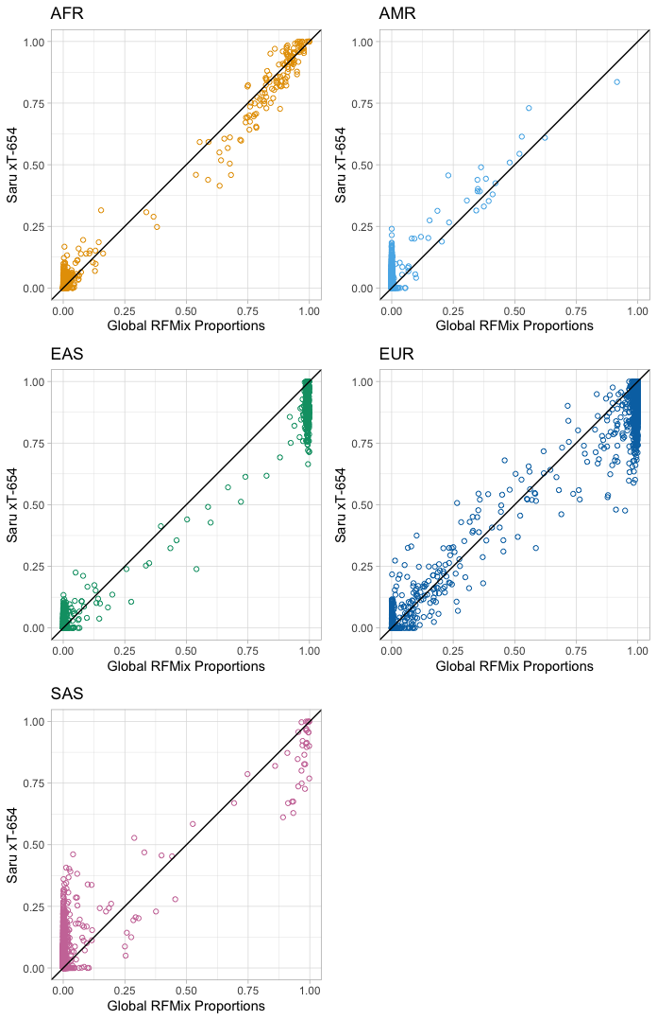
Figure S2: PCA Plots of expression data by sequenced tissue site.

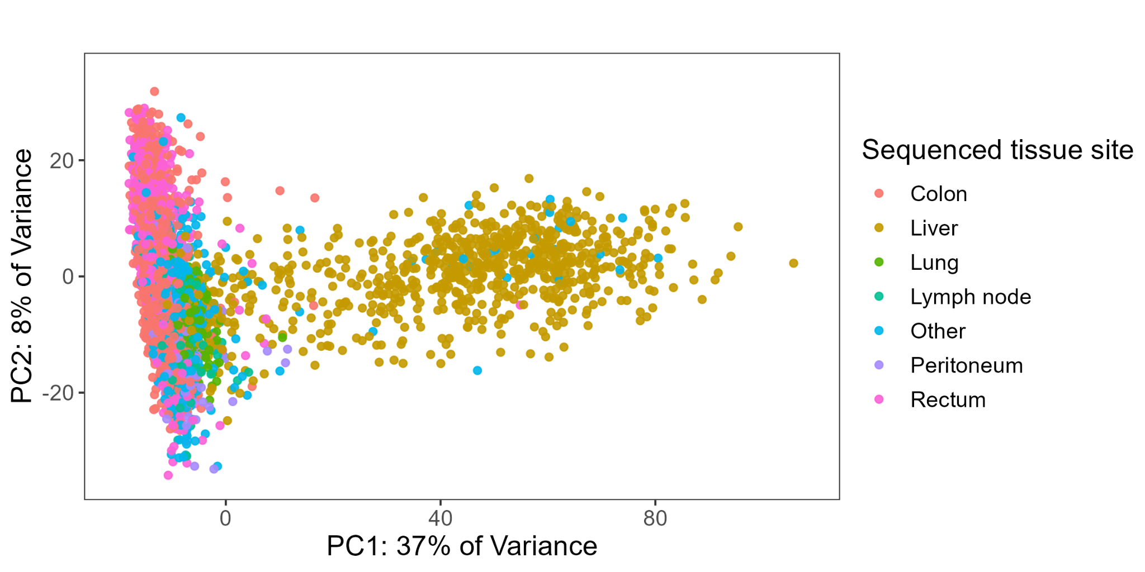

Figure S3: PCA Plots of expression data from only colon and rectum sequencing sites with 95% confidence interval ellipses colored by MSI Status (Multivariate normal distribution). Darker areas indicate a higher density of points.

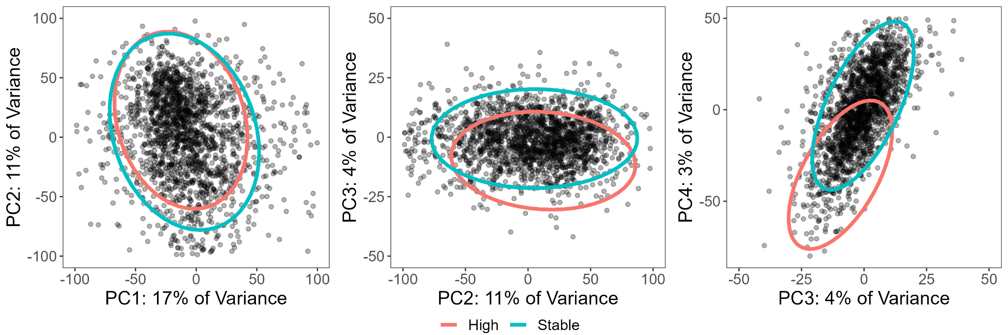

Figure S4: PCA Plot of expression data from colon and rectum sequencing site only with 95% confidence interval ellipses colored by tumor grade (Multivariate normal distribution).

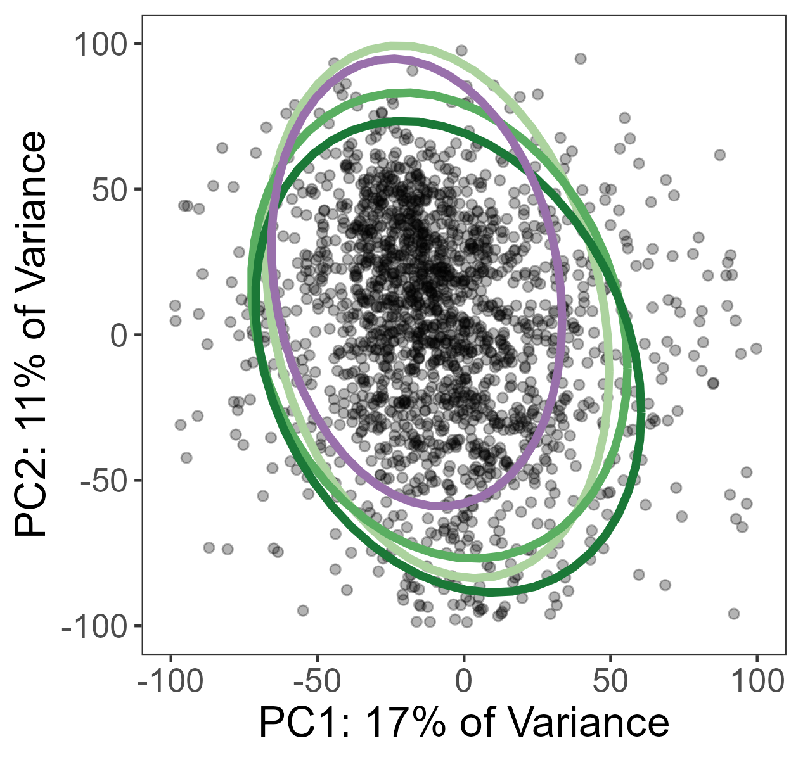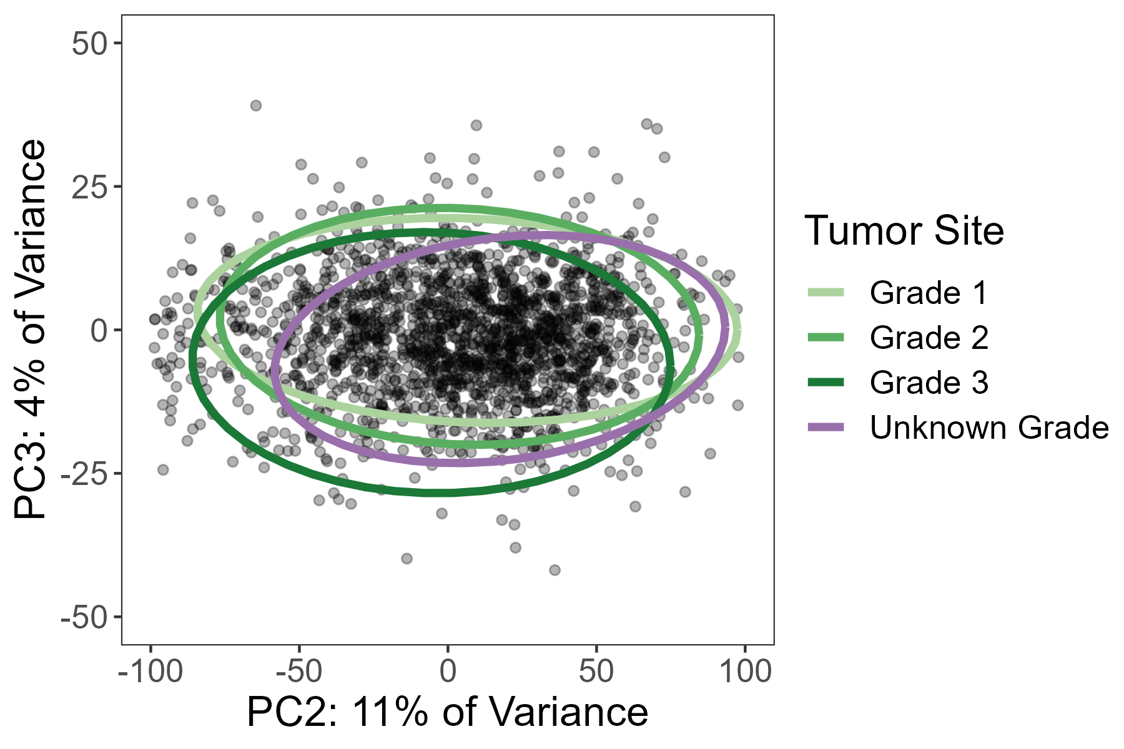

Figure S4: RNA analysis workflow diagram.
