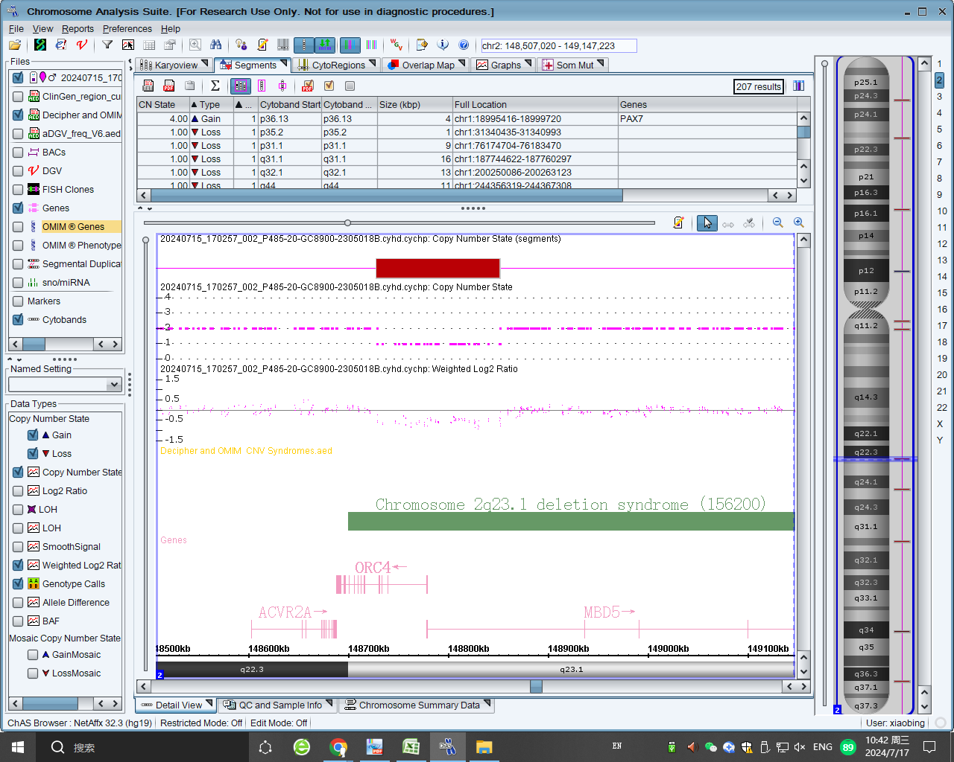

Fig S1. CMA analysis for P40 indicated the deletion involving partial ORC4 and MBD5.

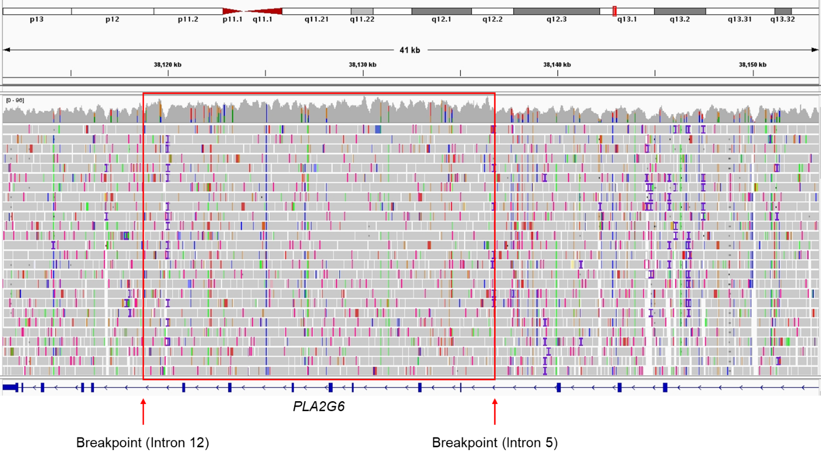
Fig S2a. IGV visualization of WGS bam file in P2 suggests exons 6-12 duplication of PLA2G6.
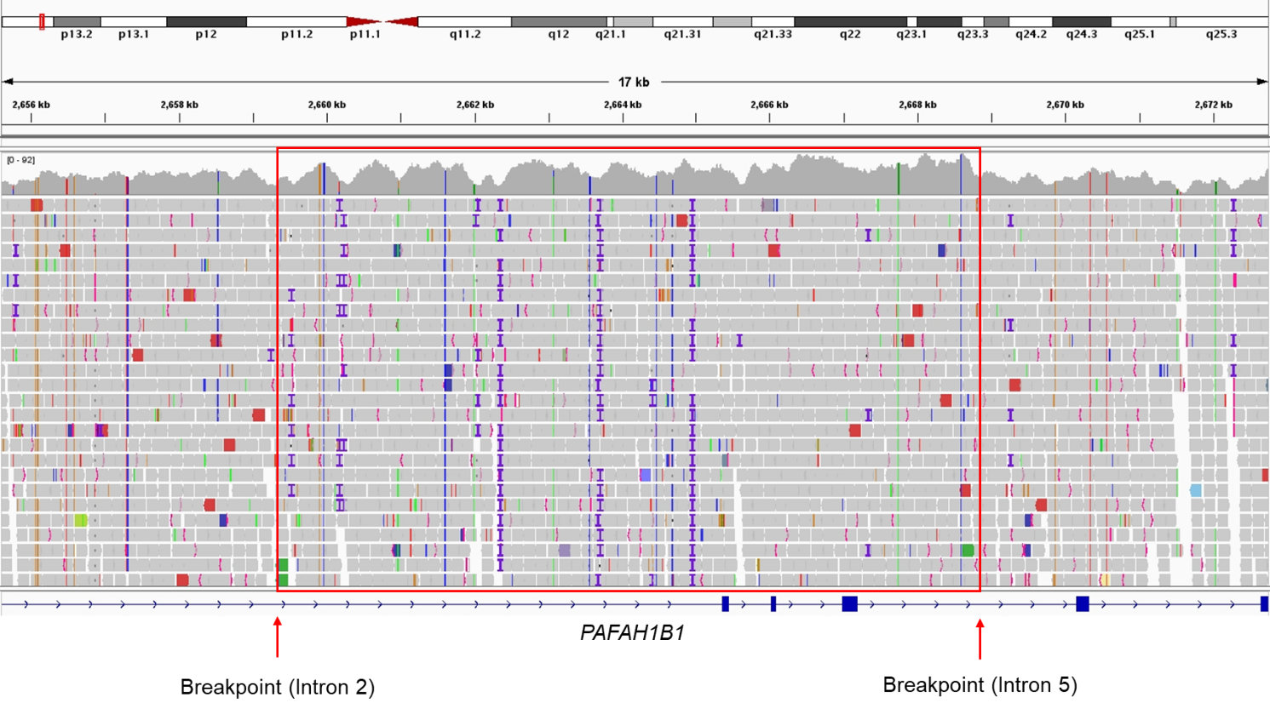
Fig S2b. IGV visualization of WGS bam file in P4 suggests exons 3-5 duplication of PAFAH1B1.

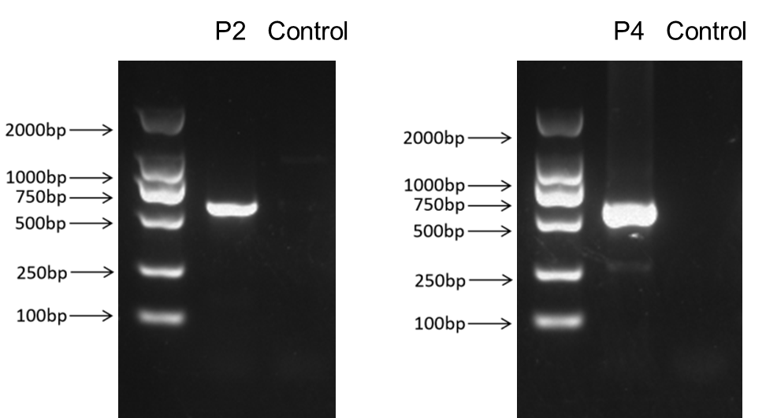
Fig S3. Agarose gel electrophoresis for PCR products of P2 and P4 using primers in Table S1.

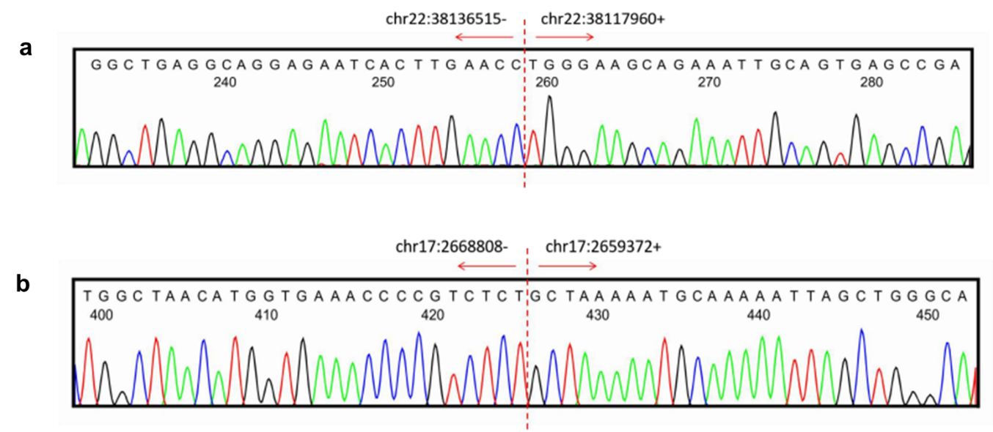

Fig S4. Sanger sequencing for P2 and P4 verified the breakpoints. (a) The breakpoints in intron 5 (chr22:38136515) and intron 12 (chr22:38117960) of PLA2G6. (b) The breakpoints in intron 2 (chr17:2668808) and intron 5 (chr17:2659372) of PAFAH1B1.

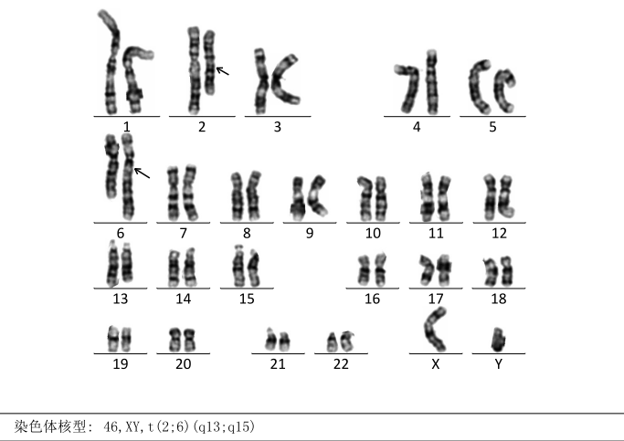
Fig S5a. G-banded karyotyping of patient 30 revealed a reciprocal translocation t(2:6)(q13;q15).

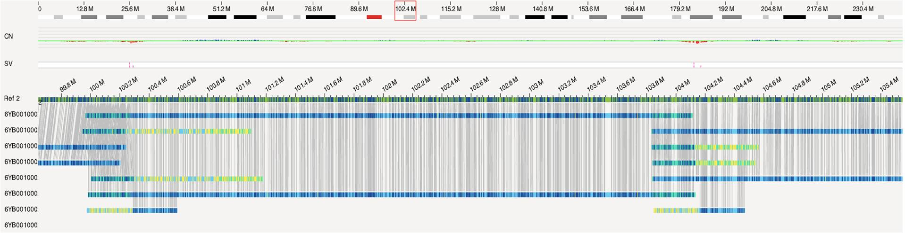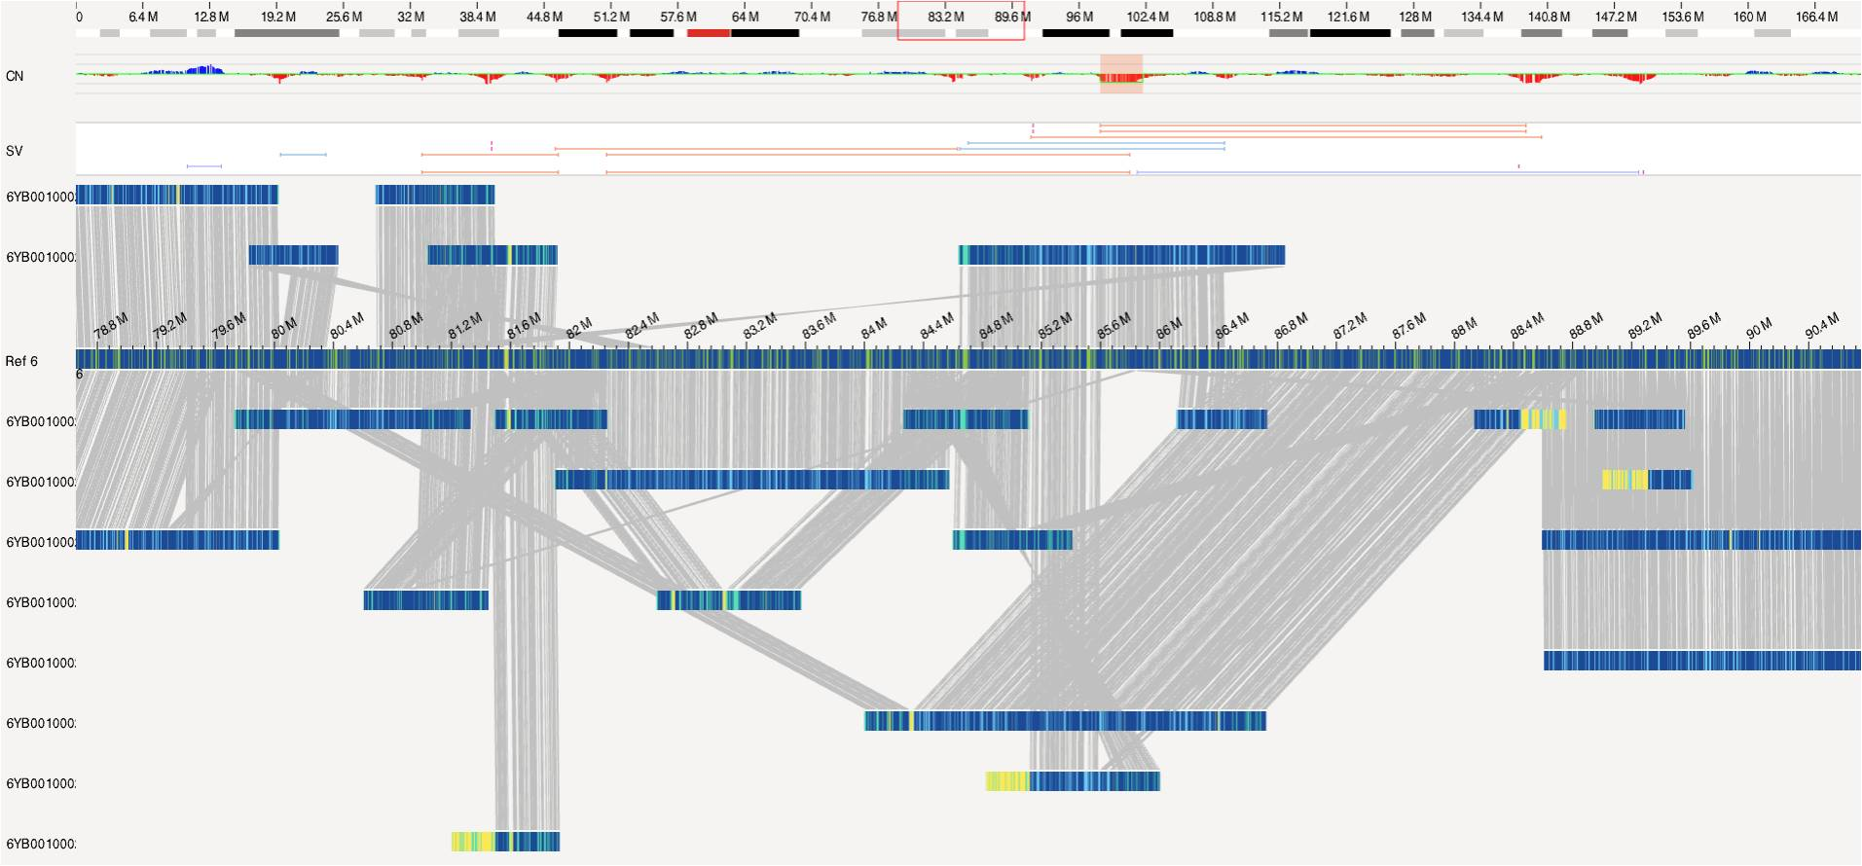Fig S5b. OGM results revealed multiple complex rearrangement events involving chromosomes 2 and 6 in patient 30.
Chr 6
Chr 2
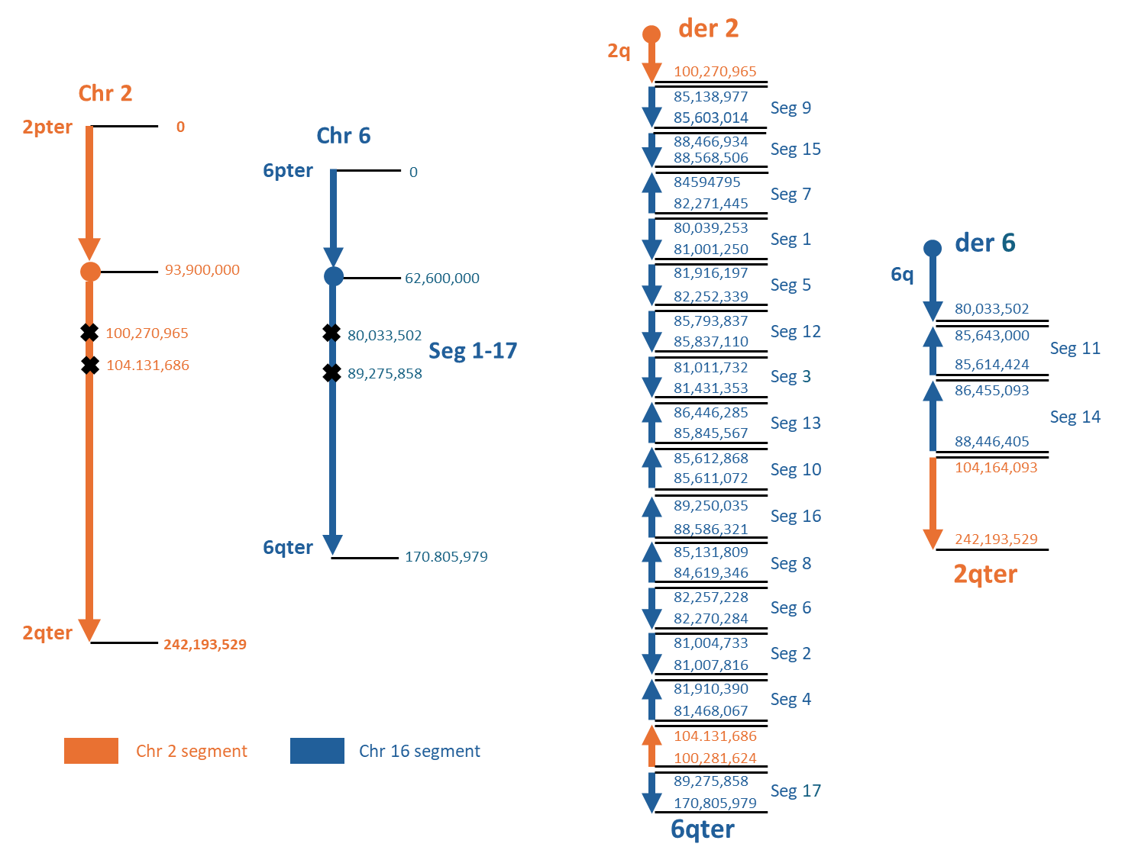
Fig S5c. A schematic diagram illustrating the pattern of recombination after the DNA double strands break of chromosome 2 and 6 in patient 30. LRWGS combined with OGM analysis shows chromoplexy events between long arm of chromosome 2 and 6 and multiple copy number loss. Chromosomes 2q12.1qter (chr2: 104.131,686-242,193,529) and 6q15qter (chr6: 89,275,858-170,805,979 ) showed reciprocal translocation. One chromosome 6 segment between 6q14.1q15(chr6: 80,033,502 -89,275,859 fragmented into 17 subsegments (1-17), with two of them (11 and 14) inversely rejioned with 6q14.1( chr6:80,033,502) at one side, and rejoined with the translocated 2q12.1qter (chr2: 104,131,686-242,193,529) at the other side, and the other fourteen subsegments (1-10,12-13,15-17) randomly rejoined with 2q 11.2 (chr2:100,270,965) starting from 6q14.3(chr6: 85,138,977), and at the terminal end between segment 4 and 17 rejoined with a segment from chromosome 2q12.1 (chr2: 100,281,624-104.131,686). Consequently, a derivative chromosome 2 and a derivative chromosome 6 are formed. Fragments from the same chromosome have the same color and the coordinates at which fragments are connected are indicated. Arrowheads at the end of each fragment indicate the orientation of chromosomal fragments. Seg, segment.

Fig S6. The exact coordinates and nearby sequence of all the breakpoints in P30.

Table S2. PCR primers for verification of the breakpoints in P2 and P4

Primers | Genomic location (hg38) | Gene | Fragment length
P2F- AGAAAGGGGTAATGGTTGGACA | chr22:38136230-38136251 | PLA2G6 | 552
P2R- CGTTGCAGGCCAGAGTTCTT | chr22:38118205-38118224 | PLA2G6 | 552
P4F- AACGACGGTTTGGCCTTACT | chr17:2668351-2668370 | PAFAH1B1 | 556
P4R- GCTCACCACAACCTCACGAT | chr17:2659449-2659468 | PAFAH1B1 | 556

Table S3. List of genes disrupted or deleted in the complex chromosomal rearrangements.
Affected region (GRCh38) | Gene name | OMIM morbid gene/ Phenotype | Protein coding gene | pLI | Blood Expression (TPM) | RNA-seq
chr2:100270965-100281624 | LONRF2 | No | Yes | 0 | 0.03 | Not sufficient for confident expression outlier calling
chr2:104131686-104164091 | /
chr6:80033502-80039253 | TTK | No | Yes | 0 | 0.75 | Not sufficient for confident expression outlier calling
chr6:81001250-81004733 | /
chr6:81007816-81011732 | /
chr6:81431353-81468067 | /
chr6:81910390-81916197 | LINC02542 | No | No | / | 0 | Not sufficient for confident expression outlier calling
chr6:82252339-82257228 | /
chr6:82270284-82271445 | /
chr6:84594795-84619346 | /
chr6:85131809-85138977 | /
chr6:85603014-85611072 | SYNCRIP | No, but indicated in NDD in literature | Yes | 1 | 7.79 | Fold change: 0.91;  pValue:0.038;  Z score:-2.11
chr6:85612868-85614423 | SYNCRIP | No, but indicated in NDD in literature | Yes | 1 | 7.79 | Fold change: 0.91;  pValue:0.038;  Z score:-2.11
chr6:85643000-85793837 | SYNCRIP | No, but indicated in NDD in literature | Yes | 1 | 7.79 | Fold change: 0.91;  pValue:0.038;  Z score:-2.11
chr6:85643000-85793837 | SNHG5 | No | No | / | 233.61 | Fold change: 0.36;  pValue:0.028;  Z score:-2.47
chr6:85837110-85845567 | /
chr6:86446284-86455092 | /
chr6:88446401-88466934 | /
chr6:88568506-88586321 | /
chr6:89250035-89275857 | GABRR2 | No | Yes | 0 | 0.43 | Not sufficient for confident expression outlier calling

