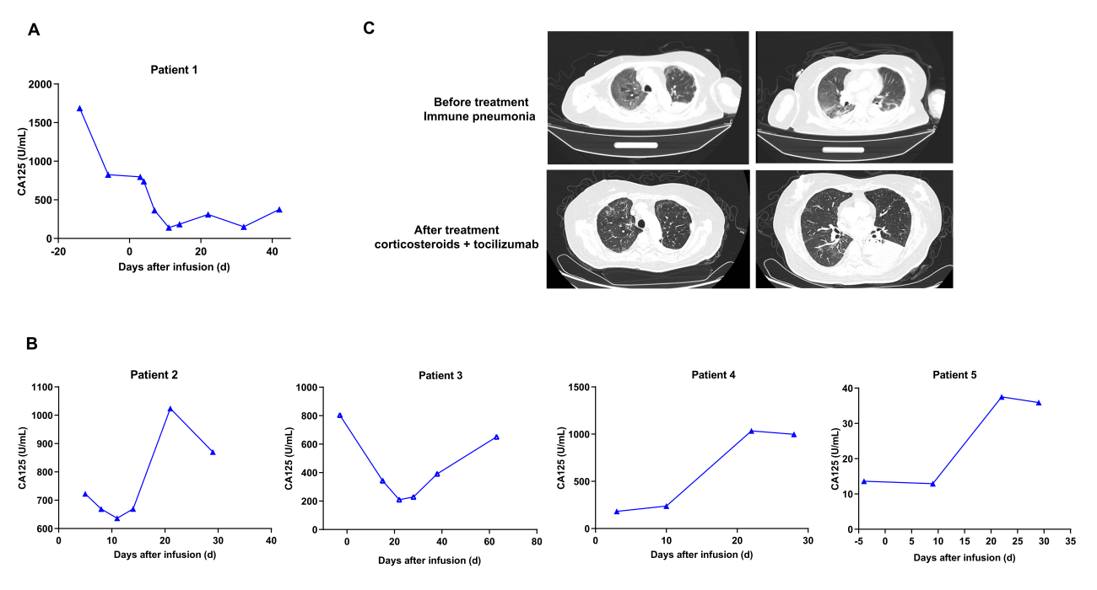
Fig S1. (A) Changes in CA125 levels in the peripheral blood of Patients 2 to 5 after KT032 treatment.
(B) Changes in CA125 levels in the peripheral blood of Patient 1 after KT032 treatment. (C) CT images showing the immune pneumonia of Patient 1 before and after KT032 therapy.

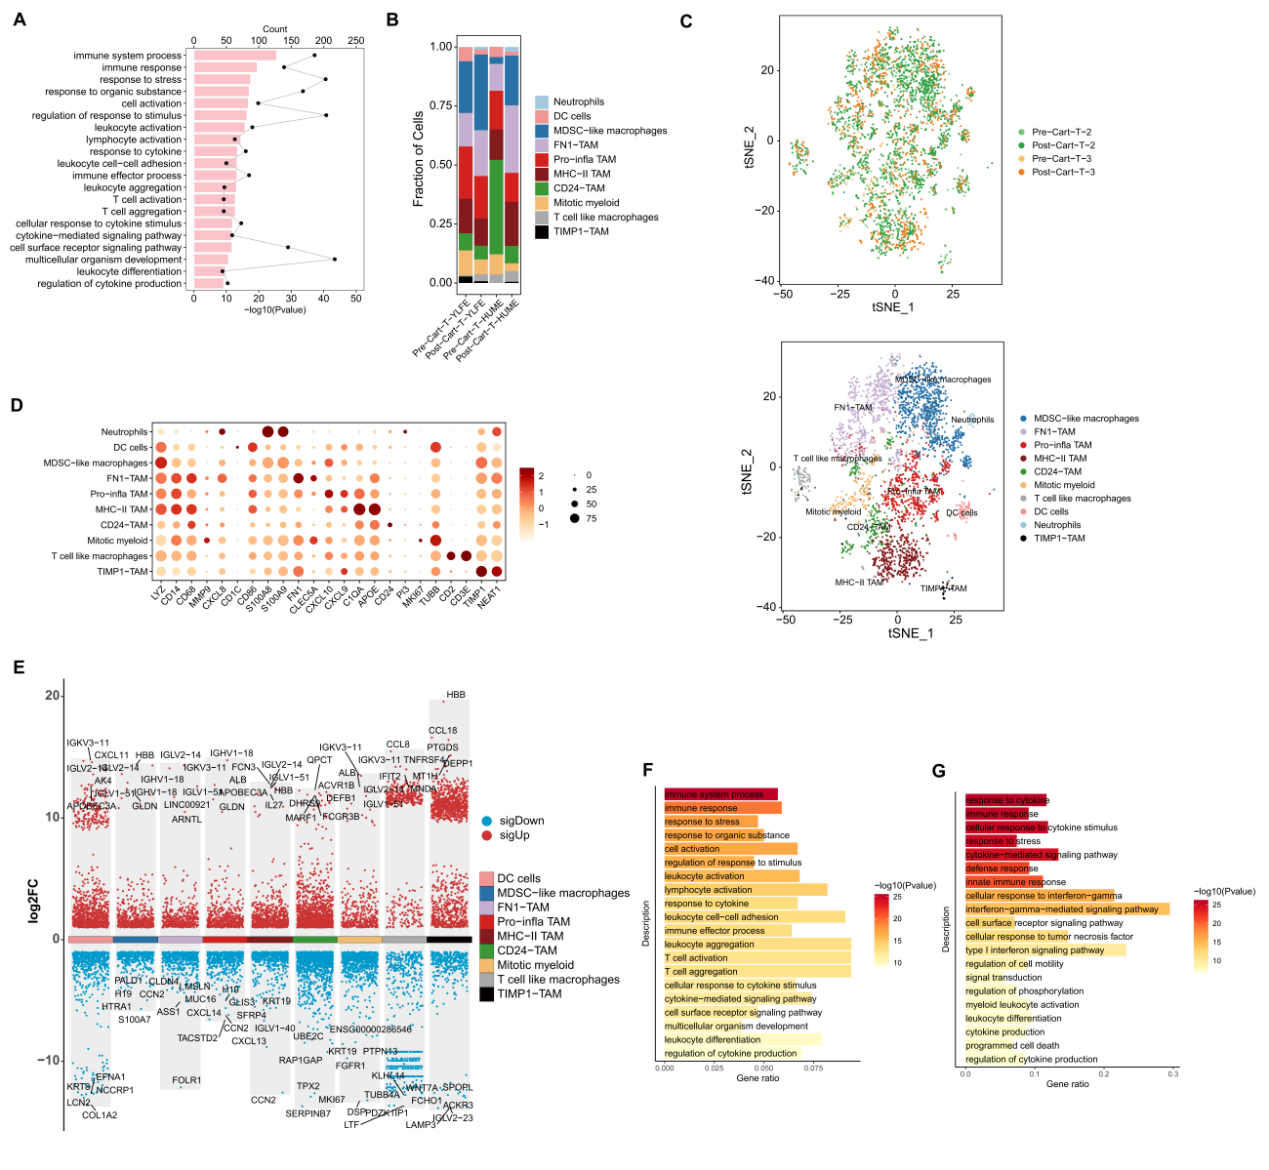
Fig S2. (A) The bar plot shows the top 20 enriched pathways (q-value) for dysregulated genes in CD4+Treg cells from tumor samples after KT032 therapy. (B) The bar chart shows the proportional distribution of various types of myeloid cell lineage in four cases with KT032 cell transfusion. (C) The distribution of various types of myeloid cell lineage in the tSNE plot for four cases with KT032 cell transfusion. (D) The bubble plot displays the expression levels of key marker genes in various types of myeloid cells with KT032 cell transfusion. The size of the bubbles represents the percentage of gene expression in the cells, while the color of the bubbles represents the average level of gene expression. (E) The volcano plot of the differential analysis shows the upregulated and downregulated genes of various myeloid cell clusters with KT032 cell transfusion compared with PR samples. Upregulated genes are shown in red, downregulated genes in blue, and the symbols of the top five genes with the largest differences in upregulation and downregulation are labeled. The differential threshold is set as FC > 2 and P <0.05. (F) The bar plot shows the top 20 enriched pathways (q-value) for dysregulated genes in the CD24+TAM cells from tumor samples after KT032 therapy. (G) The bar plot shows the top 20 enriched pathways (q-value) for dysregulated genes in the MDSC-like macrophages from tumor samples after KT032 therapy.

