Additional file 1
Content
Table S1 2
Fig. S1 3
Fig. S2 4
Fig. S3 5
Table S2 6
Table S3 7
Table S4 10
Table S5 12
Table S6 13

Table S1: B-age estimations in the sample
 | Characteristics of clocks |  | Proportion of missing CpGs |  | Correlation with C-age
 | Tissue | Number CpGs | 450K batch | EPIC batch | 450K batch | EPIC batch
Hannum | Blood | 71 | 2 (2.8%) | 8 (11.3%) | 0.82 | 0.82
Horvath | Multi-Tissue | 353 | 3 (0.8%) | 21 (5.9%) | 0.77 | 0.79
PhenoAge | Blood | 513 | 3 (0.6%) | 3 (0.6%) | 0.8 | 0.77
Zhang_{EN} | Blood & Saliva | 514 | 2 (0.4%) | 1 (0.2%) | 0.91 | 0.89
Zhang_{BLUP} | Blood & Saliva | 319,607 | 3,257 (1%) | 4,328 (1.4%) | 0.91 | 0.89
epiTOC | Blood | 385 | 0 (0%) | 32 (8.3%) | 0.11 | 0.16

Values represent frequencies (percentages).
Keywords: B-age, biological age; CpG, cytosine phosphate guanine; C-age, chronological age; 450K, Human Methylation 450K Beadchip; EPIC, Infinium Methylation EPIC Beadchip; EN, elastic net; BLUP, Best Linear Unbiased Prediction; epiTOC, Epigenetic Timer Of Cancer.

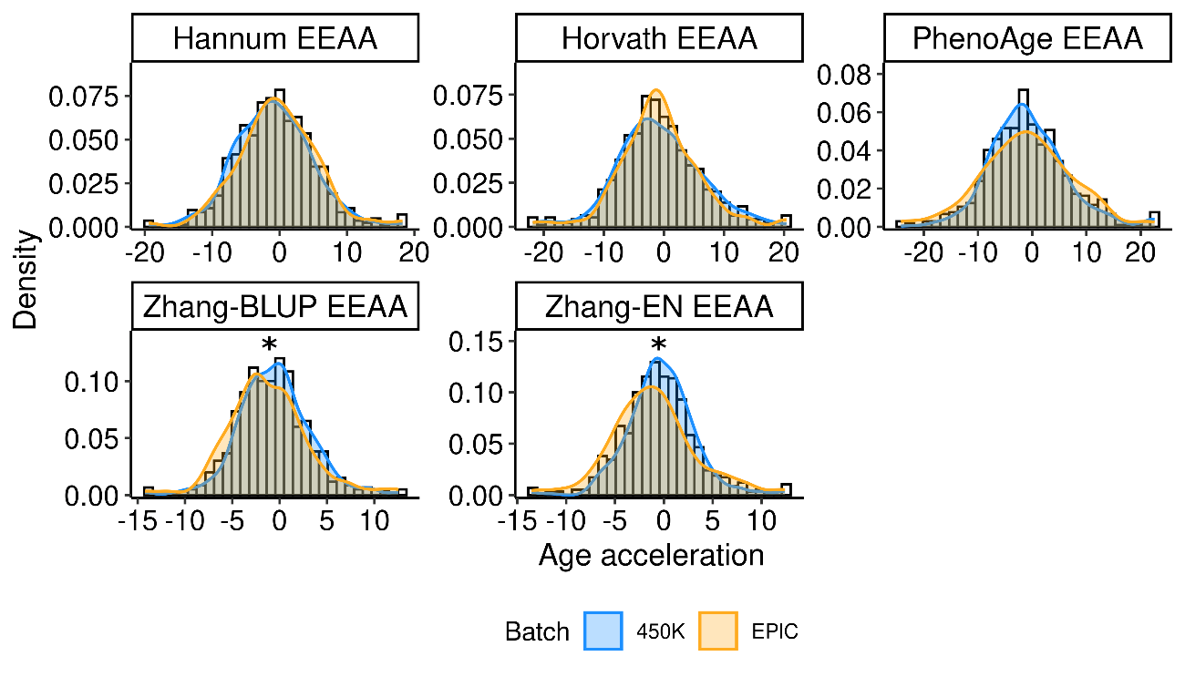 Fig. S1: EEAA distribution by batch. Values displayed on X axis represent the EEAA in years. Values displayed on Y axis represent the density function. We compared average age acceleration between batches with t-tests.
*: p-value<0.05, **: p-value<0.01.
Key: BLUP, Best Linear Unbiased Prediction; EN, elastic net; 450K, Human Methylation 450K Beadchip; EPIC, Infinium Methylation EPIC Beadchip.

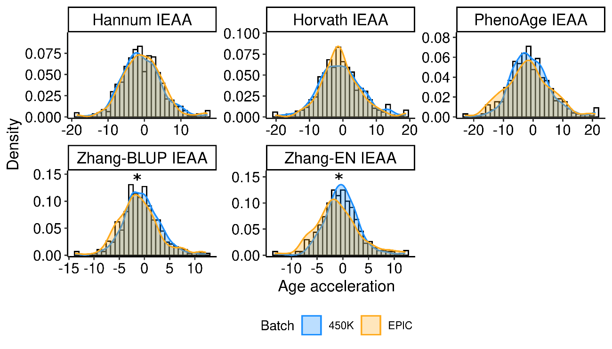
Fig. S2: IEAA distribution by batch. Values displayed on X axis represent the IEAA in years. Values displayed on Y axis represent the density function. We compared average age acceleration between batches with t-tests.
*: p-value<0.05, **: p-value<0.01.
Key: BLUP, Best Linear Unbiased Prediction; EN, elastic net; 450K, Human Methylation 450K Beadchip; EPIC, Infinium Methylation EPIC Beadchip.

Fig. S3: epiTOC distribution by batch. Values displayed on X axis represent the epiTOC estimations. Values displayed on Y axis represent the density function. We compared average epiTOC estimations with t-tests.
*: p-value<0.05, **: p-value<0.01.
Key: epiTOC, Epigenetic Timer Of Cancer; 450K, Human Methylation 450K Beadchip; EPIC, Infinium Methylation EPIC Beadchip.

Table S2. Distribution of cancer diagnoses
 | Whole-Sample | Males | Females
Cancer diagnosis | N=83 | N=59 | N=24
Urinary tract | 13 (15.7%) | 11 (18.6%) | 2 (8.3%)
Lung | 12 (14.5%) | 10 (16.9%) | 2 (8.3%)
Head and neck | 7 (8.4%) | 7 (11.9%) | 0 (0%)
Gastrointestinal | 34 (41.0%) | 23 (39.0%) | 11 (45.8%)
Breast and gynecological | 8 (9.6%) | 0 (0%) | 8 (33.3%)
Prostate | 4 (4.8%) | 4 (6.8%) | 0 (0%)
Other neoplasms | 5 (6.0%) | 4 (6.8%) | 1 (4.2%)

Values represent frequencies (percentages). Other neoplasms include one diffuse large B-cell lymphoma, one marginal zone lymphoma, one melanoma-type skin cancer, one retroperitoneal neoplasm, and one carcinoma of unknown primary origin.

Table S3. Associations between clinical variables and incidence of cancer and non-cancer related mortality over 15-year follow-up
Outcome | Variable | Group | 15-year incidence (95%CI) | Events | p-value | FDR_{BH}
Cancer incidence | Sex | Female | 13.5 (8.1;20.2) | 24/263 | 0.018 | 0.155
 |  | Male | 20.3 (15.1;26) | 59/385
 | Chronological Age (median) | ≤73 | 19.8 (13.8;26.4) | 47/327 | 0.503 | 0.777
 |  | >73 | 14.9 (10.5;20.1) | 36/321
 | Chronological Age (quartiles) | Q1 | 16.3 (10.1;23.7) | 21/164 | 0.730 | 0.827
 |  | Q2 | 22.0 (13.6;31.6) | 26/163
 |  | Q3 | 16.4 (10.6;23.2) | 23/172
 |  | Q4 | 12.6 (5.9;21.9) | 13/149
 | Hypertension | No | 12.5 (7.8;18.3) | 19/180 | 0.270 | 0.574
 | Hypertension | Yes | 19.6 (14.6;25.2) | 64/468
 | Diabetes | No | 16.7 (11.9;22.3) | 51/407 | 0.654 | 0.795
 | Diabetes | Yes | 18.6 (12.5;25.7) | 32/241
 | Dyslipidemia | No | 15.0 (8.5;23.1) | 20/209 | 0.125 | 0.397
 |  | Yes | 18.5 (13.9;23.7) | 63/439
 | Atrial fibrillation | No | 18.2 (13.6;23.3) | 65/483 | 0.558 | 0.790
 |  | Yes | 15.7 (9.1;23.9) | 18/165
 | Ischemic heart disease | No | 16.8 (12.8;21.3) | 70/566 | 0.140 | 0.397
 |  | Yes | 22.4 (11.7;35.3) | 13/82
 | Peripheral artery disease | No | 16.4 (12.7;20.4) | 73/586 | 0.357 | 0.607
 |  | Yes | 33.1 (7.2;62.9) | 10/62
 | Carotid atherosclerosis | No | 15.1 (10.6;20.3) | 44/393 | 0.027 | 0.155
 |  | Yes | 24.2 (15.0;34.7) | 29/173
 | Previous stroke | No | 18.7 (14.4;23.5) | 81/604 | 0.088 | 0.376
 | Previous stroke | Yes | 5.1 (0.9;15.4) | 2/44
 | Smoking habit | No | 17.0 (12.4;22.1) | 53/428 | 0.849 | 0.902
 |  | Yes | 18.7 (11.8;26.8) | 29/211
 | Alcohol abuse | No | 15 (10.9;19.8) | 49/453 | 0.027 | 0.155
 |  | Yes | 23.2 (15;32.4) | 34/195
 | Antiplateler treatment | No | 14.8 (8.3;23) | 23/225 | 0.214 | 0.520
 |  | Yes | 18.9 (14.2;24.1) | 60/423
 | Transient Ischemic atack | No | 18.1 (13.9;22.8) | 75/568 | 0.348 | 0.607
 | Transient Ischemic atack | Yes | 12.6 (5.4;23.1) | 8/80
 | Stroke etiology | AT | 22.8 (13.7;33.3) | 26/166 | 0.617 | 0.795
 | Stroke etiology | CE | 14.8 (8.6;22.6) | 17/161
 | Stroke etiology | LAC | 16.7 (10.3;24.4) | 25/199
 | Stroke etiology | UND | 15.9 (6.3;29.4) | 6/41
 | Stroke etiology | HEM | 13.5 (6.5;23.0) | 9/181
 | Batch | 450K | 17.4 (12.9;22.4) | 53/410 | 0.926 | 0.926
 | Batch | EPIC | 15.7 (10.7;21.5) | 30/238
Non-cancer mortality | Sex | Female | 57.6 (45.5;67.9) | 97/263 | 0.344 | 0.390
Non-cancer mortality | Sex | Male | 46.3 (38.4;53.9) | 125/385
Non-cancer mortality | Chronological Age (median) | ≤73 | 23.8 (17.8;30.3) | 56/327 | <0.001 | <0.001
Non-cancer mortality |  | >73 | 85.1 (73.8;91.8) | 166/385
Non-cancer mortality | Chronological Age (quartiles) | Q1 | 12.8 (6.9;20.6) | 15/164 | <0.001 | <0.001
Non-cancer mortality |  | Q2 | 34.3 (24.9;43.8) | 41/163
Non-cancer mortality |  | Q3 | 83.6 (68;92.1) | 89/172
Non-cancer mortality |  | Q4 | 81.2 (67.6;89.5) | 77/149
Non-cancer mortality | Hypertension | No | 44.9 (31.7;57.3) | 49/180 | 0.006 | 0.016
Non-cancer mortality |  | Yes | 53.5 (45.5;60.8) | 173/468
Non-cancer mortality | Diabetes | No | 47.7 (39.1;55.8) | 130/407 | 0.050 | 0.086
Non-cancer mortality |  | Yes | 56.6 (44.8;66.8) | 92/241
Non-cancer mortality | Dyslipidemia | No | 54.9 (43.4;64.9) | 78/209 | 0.098 | 0.141
Non-cancer mortality |  | Yes | 49.2 (40.8;57.0) | 144/439
Non-cancer mortality | Atrial fibrillation | No | 45.9 (38.1;53.4) | 144/483 | <0.001 | <0.001
Non-cancer mortality |  | Yes | 66.9 (53.5;77.2) | 78/165
Non-cancer mortality | Ischemic heart disease | No | 49.6 (42.5;56.3) | 190/566 | 0.014 | 0.029
Non-cancer mortality |  | Yes | 61.9 (39.1;78.2) | 32/82
Non-cancer mortality | Peripheral artery disease | No | 50.9 (43.6;57.6) | 197/586 | 0.107 | 0.141
Non-cancer mortality |  | Yes | 51.7 (35.5;65.7) | 25/62
Non-cancer mortality | Carotid atherosclerosis | No | 51.0 (42.8;58.6) | 142/393 | 0.721 | 0.721
Non-cancer mortality |  | Yes | 51.2 (36.9;63.8) | 55/173
Non-cancer mortality | Previous stroke | No | 50.0 (42.6;56.9) | 203/604 | 0.298 | 0.362
Non-cancer mortality | Previous stroke | Yes | 63.9 (39.6;80.6) | 19/44
Non-cancer mortality | Smoking habit | No | 58.8 (48.8;67.5) | 58/428 | 0.002 | 0.007
Non-cancer mortality |  | Yes | 37.3 (28.5;46.1) | 160/211
Non-cancer mortality | Alcohol abuse | No | 55.6 (47.2;63.2) | 169/453 | 0.004 | 0.012
Non-cancer mortality |  | Yes | 40.2 (29.3;50.8) | 53/195
Non-cancer mortality | Antiplateler treatment | No | 55.5 (44.1;65.5) | 84/225 | 0.105 | 0.141
Non-cancer mortality |  | Yes | 48.5 (40.2;56.4) | 138/423
Non-cancer mortality | Transient Ischemic atack | No | 52.6 (45.5;59.2) | 203/568 | 0.022 | 0.042
Non-cancer mortality | Transient Ischemic atack | Yes | 39.9 (16.0;63.1) | 19/80
Non-cancer mortality | Stroke etiology | AT | 52.3 (37.8;65) | 55/166 | <0.001 | <0.001
Non-cancer mortality | Stroke etiology | CE | 65.0 (52.0;75.4) | 77/161
Non-cancer mortality | Stroke etiology | LAC | 37.8 (26.9;48.7) | 48/199
Non-cancer mortality | Stroke etiology | UND | 50.5 (31.3;66.8) | 17/41
Non-cancer mortality | Stroke etiology | HEM | 52.4 (26.0;73.3) | 25/81
Non-cancer mortality | Batch | 450K | 51.8 (44.5;58.7) | 149/410 | 0.490 | 0.521
Non-cancer mortality | Batch | EPIC | 50.3 (26.1;70.4) | 73/238

The values presented indicate cumulative incidences (percentages) for each event and variable at 15 years of follow-up, along with corresponding 95% confidence intervals. Differences have been tested with Gray’s tests. Results have been corrected by multiple testing (false discovery rate) within each event of interest (cancer and the competing event). Missing data: Carothid atherosclerosis, 80; Smoking habit, 9.
Keywords: CI, confidence interval; Q, quartile; CVE, cerebrovascular event; AT, atherothrombotic; CE, cardioembolic; LAC, lacunar; UND, undetermined; HEM, hemorrhagic; 450K, Human Methylation 450K Beadchip; EPIC, Infinium Methylation EPIC Beadchip.

Table S4: Associations between EEAA and incidence of cancer and non-cancer related mortality over 15-year follow-up
Outcome | Variable | Tertile | 10 year incidence (95%CI) | Events | p-value | FDR_{BH}
Cancer incidence | Hannum | T1 | 8.4 (4.7;13.6) | 14/214 | <0.001 | 0.005
Cancer incidence |  | T2 | 16.3 (10.8;22.7) | 27/214
Cancer incidence |  | T3 | 26.3 (18.6;34.6) | 42/220
Cancer incidence | Horvath | T1 | 11.8 (7.6;17) | 22/214 | 0.414 | 0.494
Cancer incidence |  | T2 | 18.6 (12.8;25.3) | 31/214
Cancer incidence |  | T3 | 21.3 (13.5;30.2) | 30/220
Cancer incidence | PhenoAge | T1 | 17.4 (8.8;28.6) | 21/214 | 0.219 | 0.375
Cancer incidence |  | T2 | 17.5 (12.1;23.7) | 30/214
Cancer incidence |  | T3 | 19.0 (12.9;26.1) | 32/220
Cancer incidence | Zhang_{EN} | T1 | 13.4 (8.4;19.5) | 23/214 | 0.112 | 0.268
Cancer incidence |  | T2 | 14.0 (9.1;20) | 23/214
Cancer incidence |  | T3 | 22.8 (15.9;30.6) | 37/220
Cancer incidence | Zhang_{BLUP} | T1 | 15.8 (7.8;26.4) | 21/214 | 0.192 | 0.375
Cancer incidence |  | T2 | 17.3 (11.8;23.6) | 29/214
Cancer incidence |  | T3 | 19.5 (13.5;26.2) | 33/220
Cancer incidence | epiTOC raw | T1 | 14.7 (9.3;21.4) | 24/214 | 0.453 | 0.494
Cancer incidence |  | T2 | 17.1 (11.6;23.6) | 29/214
Cancer incidence |  | T3 | 23.7 (11.6;38.1) | 30/220
Cancer incidence | epiTOC C-adjusted | T1 | 13.5 (8.7;19.4) | 23/214 | 0.094 | 0.268
Cancer incidence |  | T2 | 16.8 (9.4;25.9) | 24/214
Cancer incidence |  | T3 | 22.6 (15.3;30.9) | 36/220
Non-cancer mortality | Hannum | T1 | 49.1 (36.9;60.2) | 66/214 | 0.181 | 0.310
Non-cancer mortality |  | T2 | 49.0 (39.9;57.5) | 79/214
Non-cancer mortality |  | T3 | 53.9 (40.3;65.7) | 77/220
Non-cancer mortality | Horvath | T1 | 53.4 (40.2;65.0) | 71/214 | 0.417 | 0.556
Non-cancer mortality |  | T2 | 43.9 (34.7;52.7) | 71/214
Non-cancer mortality |  | T3 | 56.8 (43.3;68.3) | 80/220
Non-cancer mortality | PhenoAge | T1 | 61.1 (41.2;76.0) | 80/214 | 0.643 | 0.701
Non-cancer mortality |  | T2 | 46.1 (36.5;55.1) | 69/214
Non-cancer mortality |  | T3 | 48.6 (37.9;58.6) | 73/220
Non-cancer mortality | Zhang_{EN} | T1 | 42.2 (31.5;52.5) | 65/214 | 0.092 | 0.223
Non-cancer mortality |  | T2 | 50.5 (38.5;61.3) | 69/214
Non-cancer mortality |  | T3 | 57.5 (46.2;67.4) | 88/220
Non-cancer mortality | Zhang_{BLUP} | T1 | 47.3 (36.0;57.8) | 72/214 | 0.003 | 0.017
Non-cancer mortality |  | T2 | 45.2 (33.2;56.5) | 57/214
Non-cancer mortality |  | T3 | 58.8 (47.8;68.3) | 93/220
Non-cancer mortality | epiTOC raw | T1 | 51.9 (41.1;61.6) | 79/214 | 0.272 | 0.408
Non-cancer mortality |  | T2 | 46.9 (35.1;57.8) | 66/214
Non-cancer mortality |  | T3 | 65.7 (35.0;84.6) | 77/220
Non-cancer mortality | epiTOC age-adjusted | T1 | 60.9 (48.1;71.5) | 90/214 | 0.008 | 0.033
Non-cancer mortality |  | T2 | 43.5 (31.8;54.6) | 60/214
Non-cancer mortality |  | T3 | 49.0 (36.7;60.2) | 73/220

The values presented indicate cumulative incidences (percentage) for each tertile split epigenetic clock variable at 15 years of follow-up, along with corresponding 95% confidence intervals. Differences have been tested with Gray’s tests. Results have been corrected by multiple testing (false discovery rate) within each event of interest (cancer and the competing event).
Keywords: EEAA, Extrinsic Epigenetic Age Acceleration; CI, confidence interval; T, tertile; BLUP, Best Linear Unbiased Prediction; EN, elastic net; epiTOC, Epigenetic Timer Of Cancer.

Table S5: Associations between IEAA and incidence of cancer and non-cancer related mortality over 15-year follow-up
Outcome | Variable | Tertile | 15 year incidence (95%CI) | Events | p-value | FDR_{BH}
Cancer incidence | Hannum | T1 | 10.7 (6.2;16.5) | 17/214 | 0.002 | 0.011
 |  | T2 | 13.3 (8.8;18.7) | 24/214
 |  | T3 | 27.3 (19;36.1) | 42/220
 | Horvath | T1 | 15.2 (10.1;21.2) | 26/214 | 0.925 | 0.925
 |  | T2 | 16.6 (11.2;22.9) | 29/214
 |  | T3 | 19.0 (12.2;27) | 28/220
 | PhenoAge | T1 | 16.2 (9.2;25) | 22/214 | 0.283 | 0.425
 |  | T2 | 16.5 (11.3;22.4) | 29/214
 |  | T3 | 19.6 (13.2;27) | 32/220
 | Zhang_{EN} | T1 | 13.6 (8.5;19.9) | 23/214 | 0.059 | 0.236
 |  | T2 | 13.1 (8.3;18.8) | 22/214
 |  | T3 | 24.4 (16.7;32.8) | 38/220
 | Zhang_{BLUP} | T1 | 17.4 (8;29.8) | 22/214 | 0.334 | 0.446
 |  | T2 | 19.8 (13;27.7) | 31/214
 |  | T3 | 17.4 (11.9;23.7) | 30/220
Non-cancer mortality | Hannum | T1 | 47.1 (34.9;58.4) | 65/214 | 0.002 | 0.017
 |  | T2 | 60.4 (49.4;69.7) | 90/214
 |  | T3 | 49.2 (34.1;62.7) | 67/220
 | Horvath | T1 | 50.2 (37.2;61.9) | 68/214 | 0.543 | 0.651
 |  | T2 | 49.5 (38.6;59.5) | 76/214
 |  | T3 | 53.0 (41.6;63.1) | 79/220
 | PhenoAge | T1 | 56.6 (43.2;68) | 80/214 | 0.754 | 0.754
 |  | T2 | 46.9 (36.7;56.4) | 69/214
 |  | T3 | 49.1 (38;59.3) | 73/220
 | Zhang_{EN} | T1 | 46.5 (35.2;57.1) | 71/214 | 0.171 | 0.310
 |  | T2 | 45.4 (34.8;55.4) | 65/214
 |  | T3 | 58.4 (46.2;68.8) | 86/220
 | Zhang_{BLUP} | T1 | 47.4 (35.1;58.7) | 70/214 | 0.093 | 0.223
 |  | T2 | 48 (36.9;58.3) | 66/214
 |  | T3 | 56.1 (44.7;66.1) | 86/220

The values presented indicate cumulative incidences (percentage) for each tertile split epigenetic clock variable at 15 years of follow-up, along with corresponding 95% confidence intervals. Differences have been tested with Gray’s tests. Results have been corrected by multiple testing (false discovery rate) within each event of interest (cancer and the competing event).
Keywords: EEAA, Extrinsic Epigenetic Age Acceleration; CI, confidence interval; T, tertile; BLUP, Best Linear Unbiased Prediction; EN, elastic net.
Table S6: Moderation effect of sex at birth on the relationship between Zhang-BLUP and incident cancer
Estimation | Sex at birth | HR (95% CI) | p-value
Zhang-BLUP EEAA | Males | 1.02 (0.95-1.08) | 0.623
 | Females | 1.15 (1.04-1.28) | 0.007
Zhang-BLUP IEAA | Males | 1.00 (0.93-1.07) | 0.947
 | Females | 1.15 (1.03-1.28) | 0.011

Values represent Hazzard ratios (HR), 95% confidence intervals and p-values. These estimationS reflect the moderation effect of sex at birth on the relationship between Zhang-BLUP age acceleration and long-term cancer. As observed, Zhang EEAA and IEAA estimations were only significant in female individuals.

