Genome-aware annotation of CRISPR guides validates targets in variant cell lines and enhances discovery in screens
Simon Lam^{1,#}, John C. Thomas¹, Stephen P. Jackson^{1,#}

¹ Cancer Research UK Cambridge Institute, University of Cambridge, Li Ka Shing Centre, Robinson Way, Cambridge, CB2 0RE, United Kingdom.
# Corresponding authors: simon.lam@cruk.cam.ac.uk (SL); steve.jackson@cruk.cam.ac.uk (SPJ).

Additional file 1

Fig. S1.
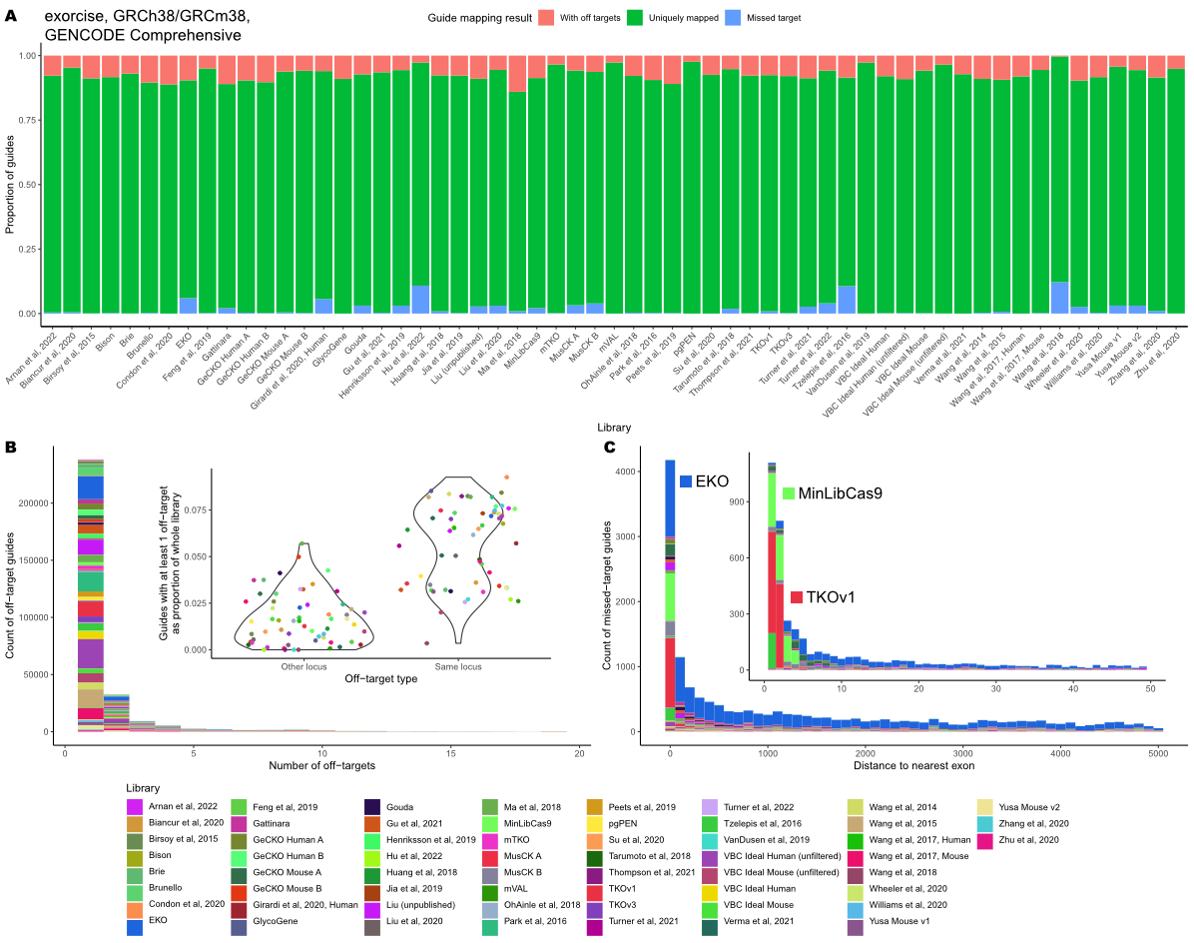

Fig. S2.
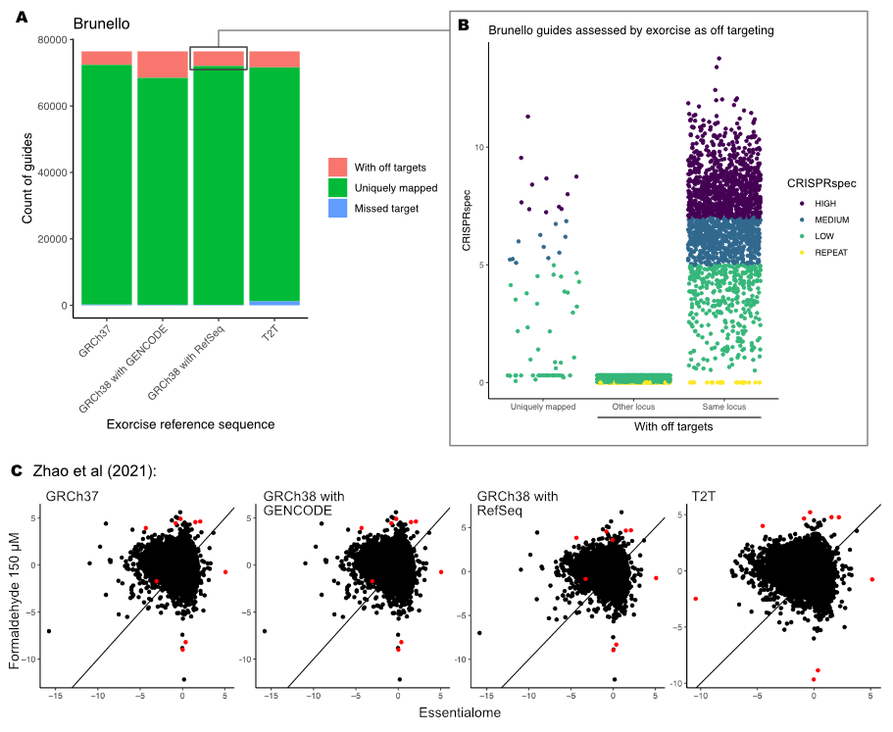
Fig. S3.
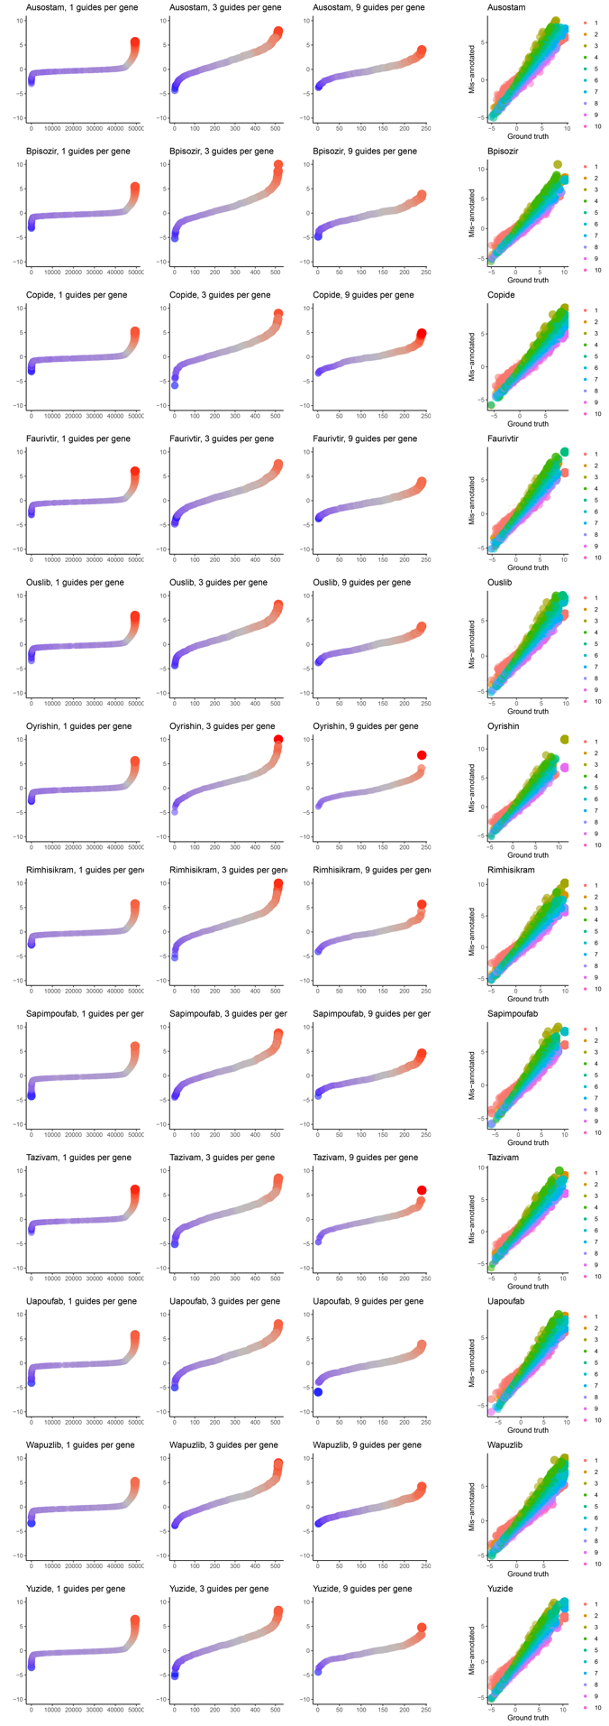

Fig. S4.
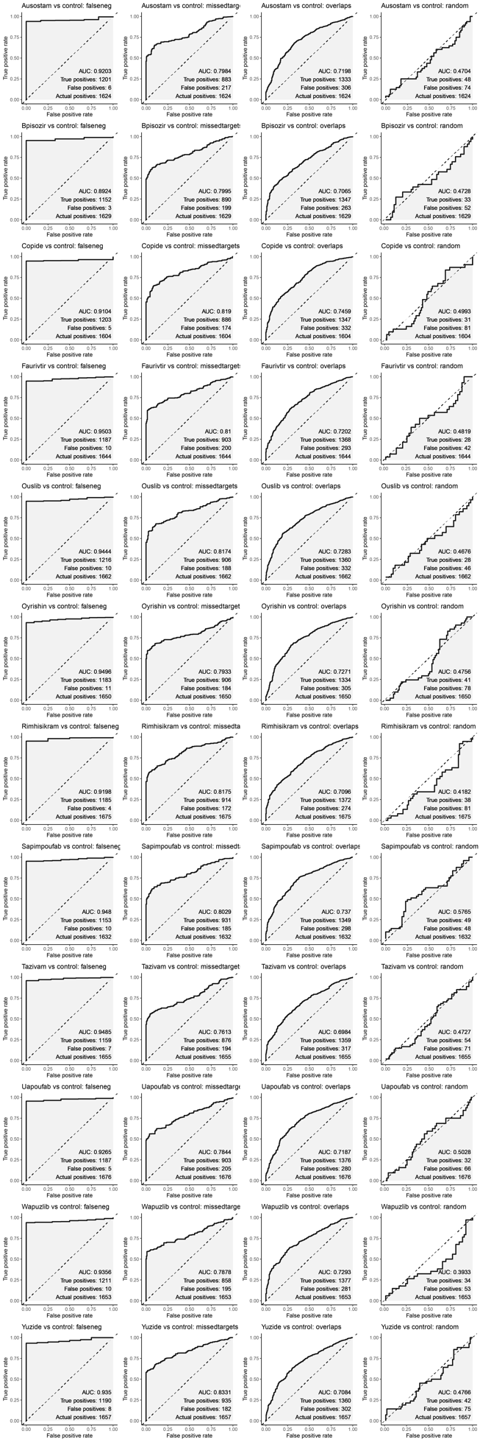

Fig. S5.
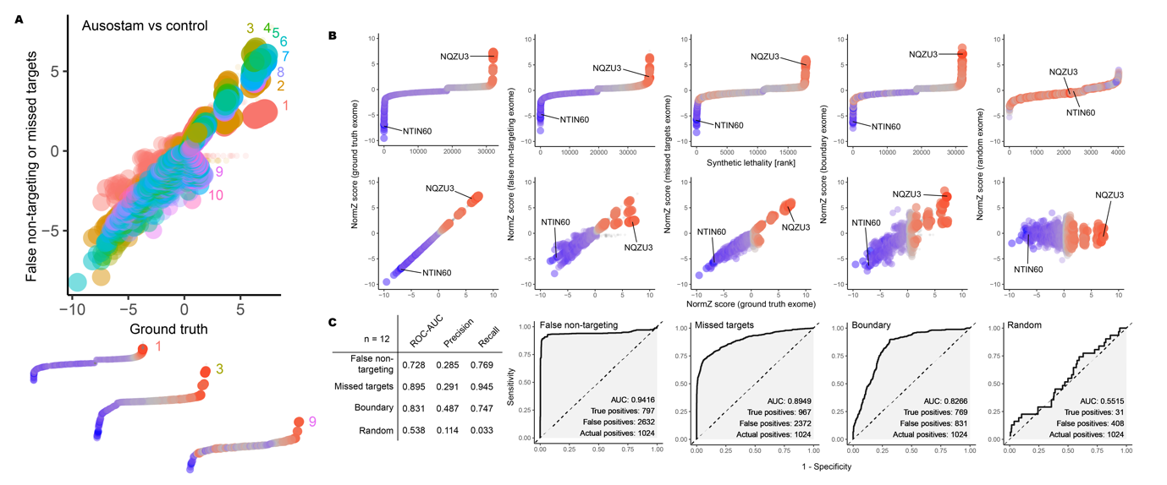

Fig. S6.
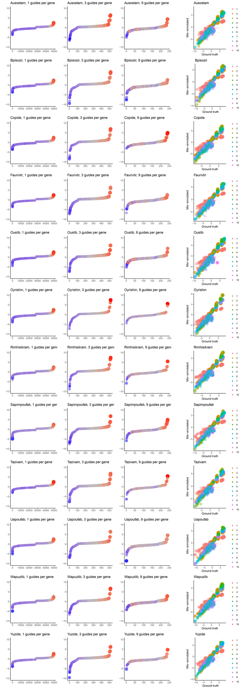

Fig. S7.
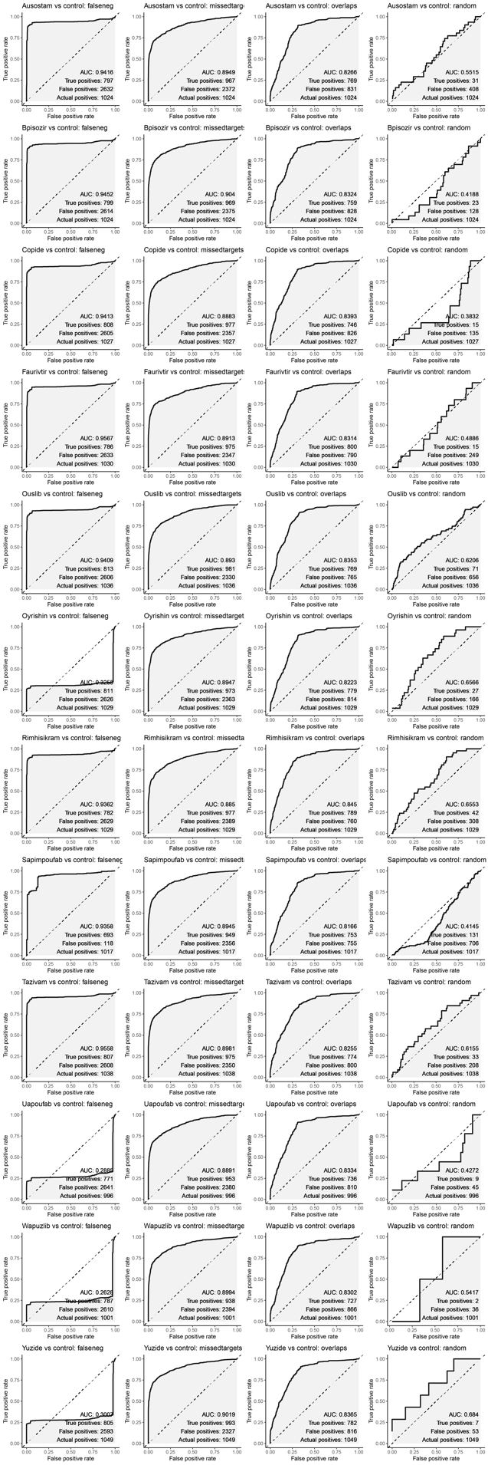
Figure legends

Fig. S1. Assessment of Addgene pooled CRISPR-spCas9 libraries for human and mouse using Exorcise with GENCODE Comprehensive. A) As in Fig. 2C. B) As in Fig. 2E. C) As in Fig. 2F.

Fig. S2. Brunello library benchmark. A) Exorcise re-annotation performance with different reference sequences, as in Fig. 2C. B) Comparison of Exorcise off-target identification with CRISPRoff analysis. A sample of on-target guides were included in the analysis as a reference. C) Hit-calling performance of a CRISPR screen by Zhao et al (2021)²⁰ with Exorcise with different reference sequences. Red points indicate the same genes in each plot.

Fig. S3. Rank plots and bundle analysis for the simulated mis-annotated CRISPR screen, DrugZ analysis. Rank plots as in Fig. 3C upper. Bundle analysis as in Fig. 3B upper.

Fig. S4. Receiver-operator characteristic (ROC) analysis for the simulated mis-annotated CRISPR screen, DrugZ analysis. As in Fig. 3D. Falseneg, false non-targeting mis-annotation scheme; missedtargets, missed targets mis-annotation scheme; overlaps, boundary mis-annotation scheme.

Fig. S5. Simulated CRISPR screen on synthetic data, MAGeCK analysis. A) As in Fig. 3B. B) As in Fig. 3C. C) As in Fig. 3D.

Fig. S6. Rank plots and bundle analysis for the simulated mis-annotated CRISPR screen, MAGeCK analysis. Rank plots as in Additional File 1: Fig. S4B upper. Bundle analysis as in Additional File 1: Fig. S4A upper.

Fig. S7. Receiver-operator characteristic (ROC) analysis for the simulated mis-annotated CRISPR screen, MAGeCK analysis. As in Additional File 1: Fig. S4C except that the positive classification threshold was 0.9 rather than 0.5.

Table S1. Source data for Fig. 2C.

Table S2. Source data for Fig. 2E.

Table S3. Source data for Fig. 2E inset.

Table S4. Source data for Fig. 2F.

Table S5. VBC Ideal Human CRISPR-spCas9 knockout guide library after Exorcise with RefSeq.

Table S6. VBC Ideal Mouse CRISPR-spCas9 knockout guide library after Exorcise with RefSeq.

Table S7. Simulated chemo-genetic interaction values, related to Fig. 3A.

Table S8. Synthetic guide sequences, related to Fig. 3A.

Table S9. Ground truth and mis-annotated exomes, related to Fig. 3A.

Table S10. Simulated CRISPR screen counts, related to Fig. 3A.

Table S11. Source data for Fig. 3B upper.

Table S12. Source data for Fig. 3B lower, trace 1.

Table S13. Source data for Fig. 3B lower, trace 3.

Table S14. Source data for Fig. 3B lower, trace 9.

Table S15. Source data for Fig. 3C upper, panel 1.

Table S16. Source data for Fig. 3C upper, panel 2.

Table S17. Source data for Fig. 3C upper, panel 3.

Table S18. Source data for Fig. 3C upper, panel 4.

Table S19. Source data for Fig. 3C upper, panel 5.

Table S20. Source data for Fig. 3C lower, panel 1.

Table S21. Source data for Fig. 3C lower, panel 2.

Table S22. Source data for Fig. 3C lower, panel 3.

Table S23. Source data for Fig. 3C lower, panel 4.

Table S24. Source data for Fig. 3C lower, panel 5.

Table S25. Source data for Fig. 4B upper.

Table S26. Source data for Fig. 4B lower.

Table S27. Source data for Fig. 5A and 5D.

Table S28. Source data for Fig. 5B panel 1.

Table S29. Source data for Fig. 5B panel 2.

Table S30. Source data for Fig. 5B panel 3.

Table S31. Source data for Fig. 5B panel 4.

Table S32. Source data for Fig. 5E.

Table S33. Source data for Additional File 1: Fig. S1A.

Table S34. Source data for Additional File 1: Fig. S1B.

Table S35. Source data for Additional File 1: Fig. S1B inset.

Table S36. Source data for Additional File 1: Fig. S1C.

Table S37. Source data for Additional File 1: Fig. S5B upper, panel 1.

Table S38. Source data for Additional File 1: Fig. S5B upper, panel 2.

Table S39. Source data for Additional File 1: Fig. S5B upper, panel 3.

Table S40. Source data for Additional File 1: Fig. S5B upper, panel 4.

Table S41. Source data for Additional File 1: Fig. S5B upper, panel 5.

Table S42. Source data for Additional File 1: Fig. S5B lower, panel 1.

Table S43. Source data for Additional File 1: Fig. S5B lower, panel 2.

Table S44. Source data for Additional File 1: Fig. S5B lower, panel 3.

Table S45. Source data for Additional File 1: Fig. S5B lower, panel 4.

Table S46. Source data for Additional File 1: Fig. S5B lower, panel 5.
Table S47. Source data for Additional File 1: Fig. S2A.
Table S48. Source data for Additional File 1: Fig. S2B.
Table S49. Source data for Additional File 1: Fig. S2C, panel 1.
Table S50. Source data for Additional File 1: Fig. S2C, panel 2.
Table S51. Source data for Additional File 1: Fig. S2C, panel 3.
Table S52. Source data for Additional File 1: Fig. S2C, panel 4.

