Additional file 5 – Supplementary Figures
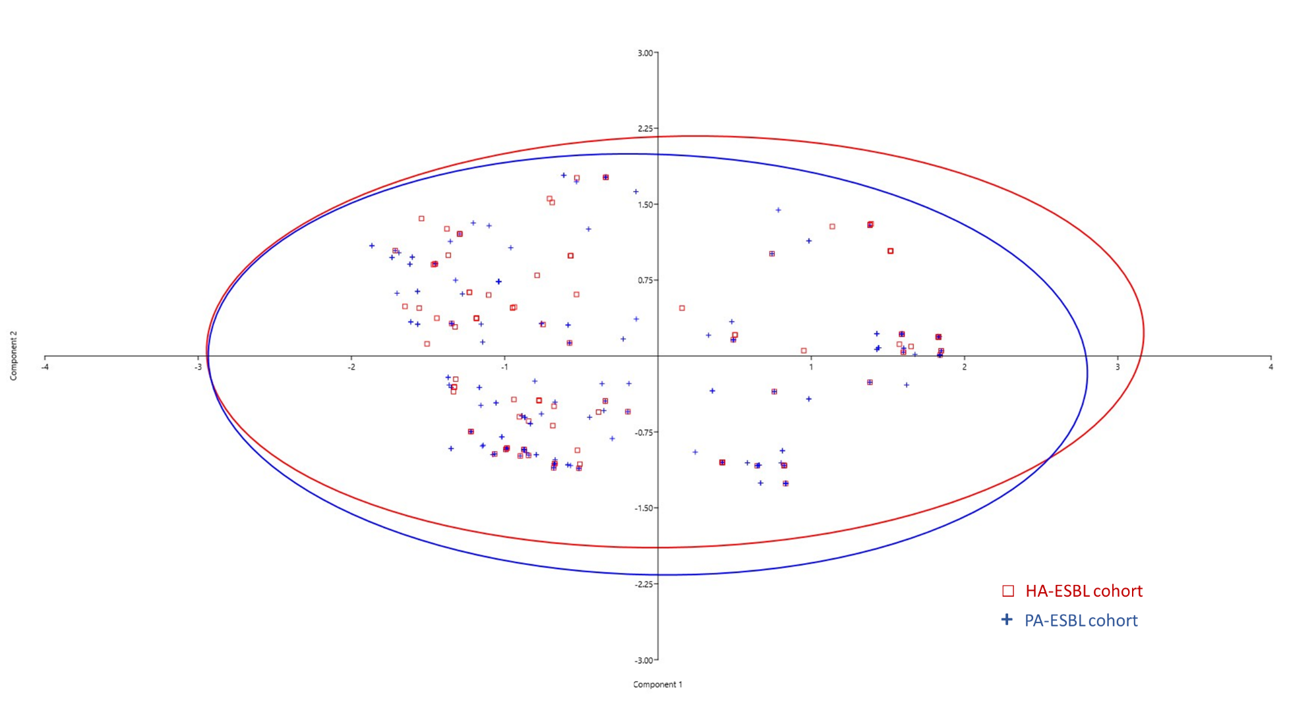

Fig S1. Principal component analysis of acquired antibiotic resistance genes in HA-ESBL (in red, n=136) and PA-ESBL (in blue, n=230) cohorts. The plot showed the first two components.
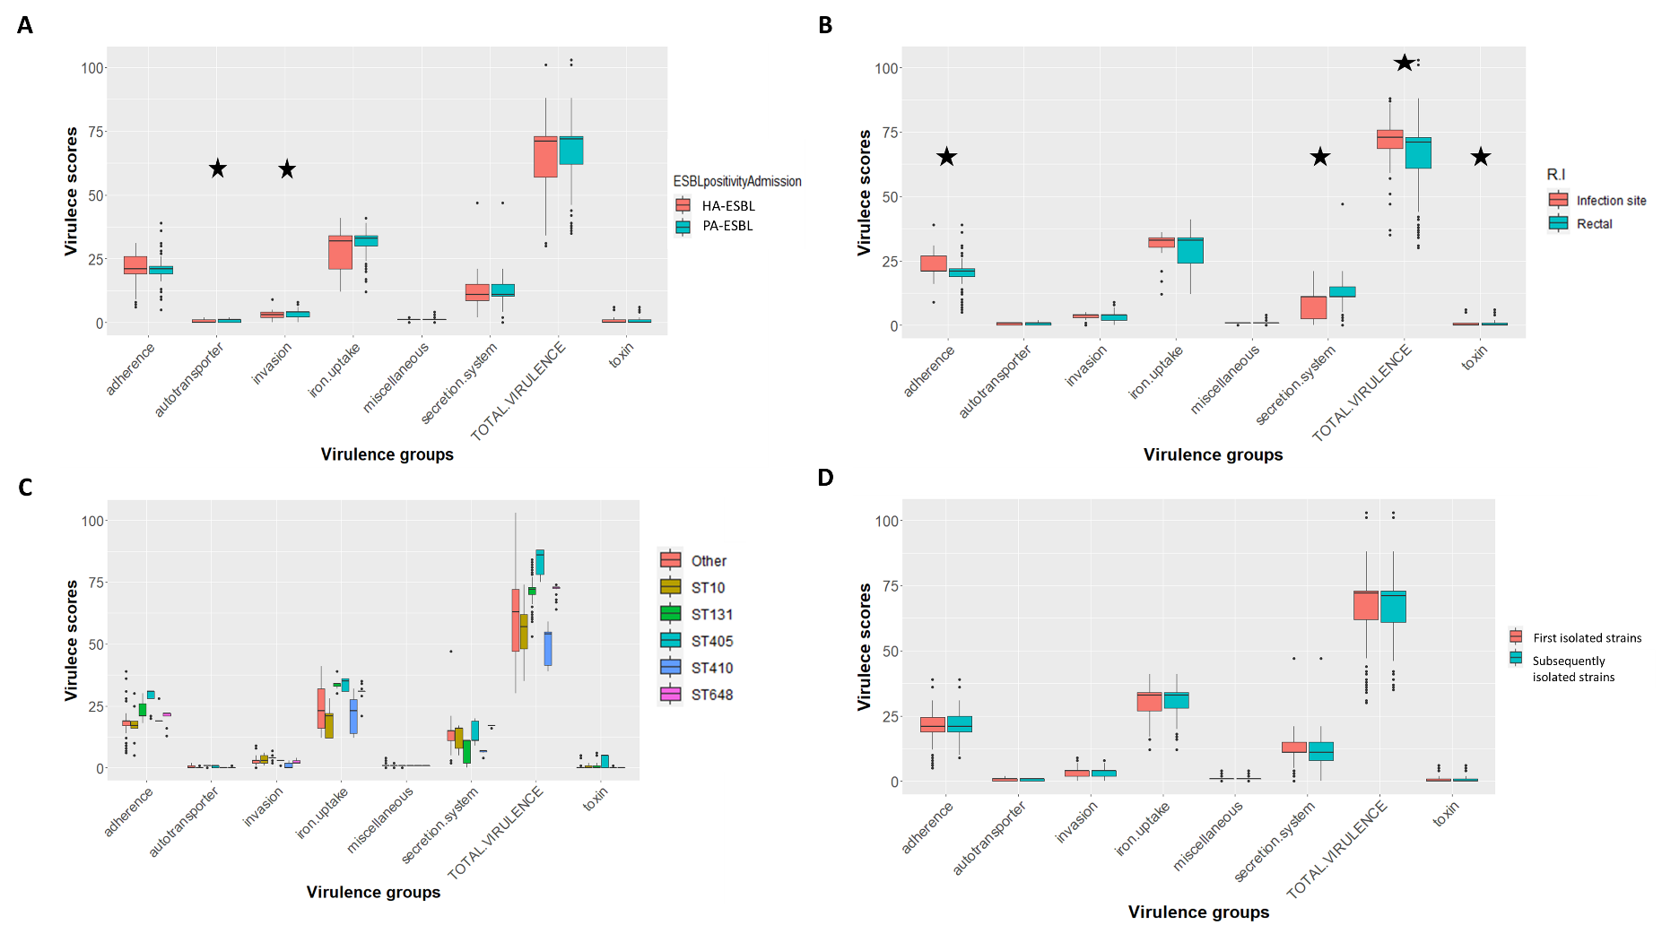

Fig S2. Distribution of virulence genes (A) between PA-ESBL-Ec isolates (n=230, mean: 68, median: 72 genes) and the HA-ESBL-Ec isolates (n=136, mean: 66, median: 71 genes, P = 0.27). (B) Between colonising (n=324) and infecting isolates (n=42). Although subtle, this difference between infecting and colonising ESBL-Ec was particularly significant in three virulence function groups: adherence (median: 21 vs 21 genes, mean: 23.9 vs 21.0, P = 0.0023), secretion system (median: 11 vs 11 genes, mean: 9.17 vs 11.4, P = 0.0112), and toxin (median: 0 vs 0 gene, mean: 1.52 vs 0.701, P = 0.0125). (C) Between the five most dominant STs: ST131 (n=178), ST10 (n=25), ST405 (n=21), ST648 (n=19), ST410 (n=11), and other STs (n=112), and (D) between the group of first-isolated isolates (n=215) and the group of subsequently isolated isolates (n=151). Significant differences are marked with stars.
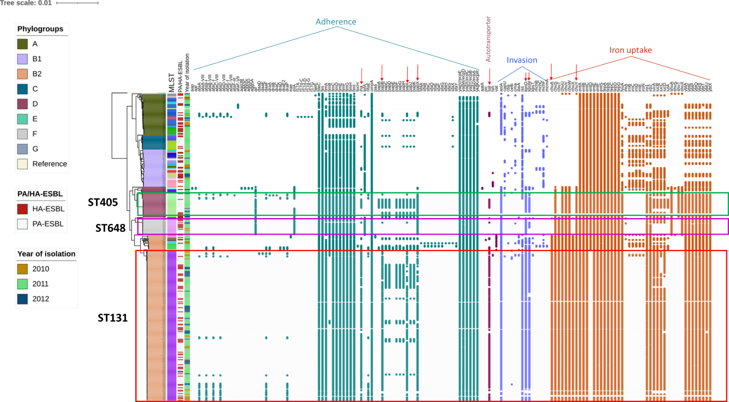

Fig S3A. Virulence profiles of ST131 and non-ST131 (with highlights on ST405 and ST648, the dominant STs following ST131). The presence of virulence genes belonging to function groups (adherence, autotransporter, invasion and iron uptake) was marked. Red arrows represent virulence factors that were exclusively associated with ST131.

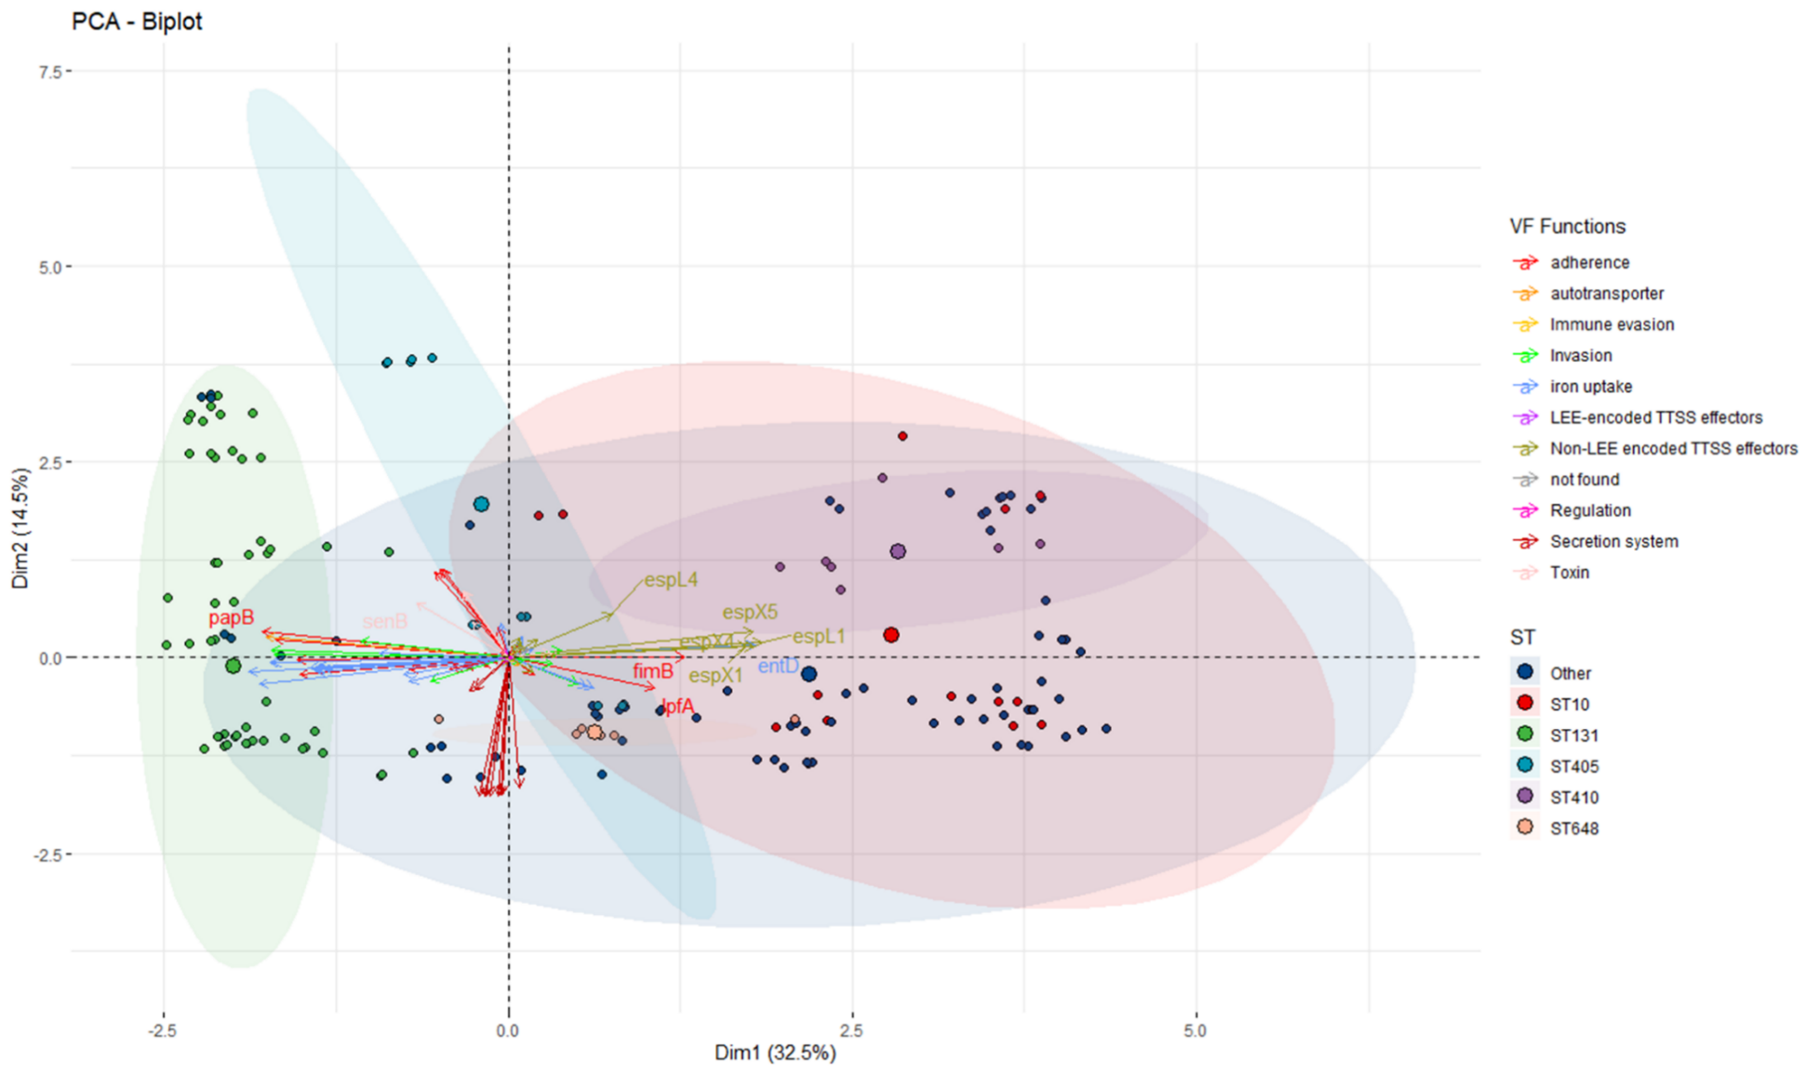 Fig S3B. PCA plot, generated based on the binary matrix of present/absent virulence genes, indicates a distinct virulence profile of ST131 ESBL-Ec in comparison to other dominant STs.

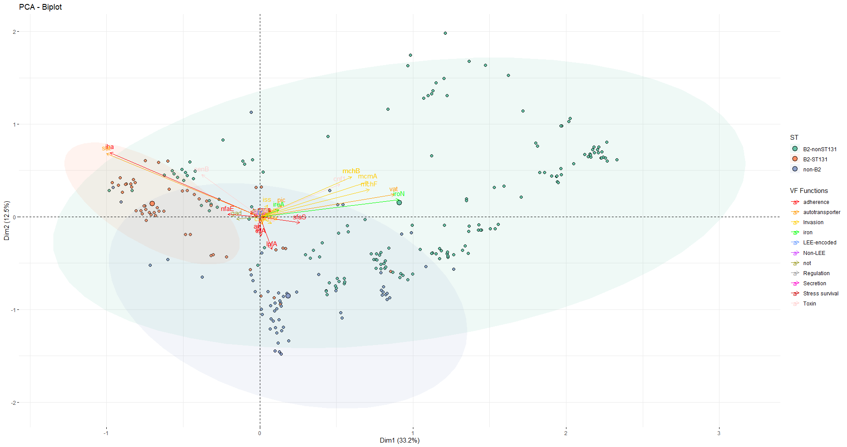

Fig S3C. Principal component analysis of local and global 1161 genomes belonging to phylogroup B2 (n=412 non-ST131, n=579 ST131) and non-phylogroup B2 (n=170), suggested that phylogroup B2 and ST131 represented distinct profiles from STs belonging to other phylogroups than B2. The plot showed the first two components.

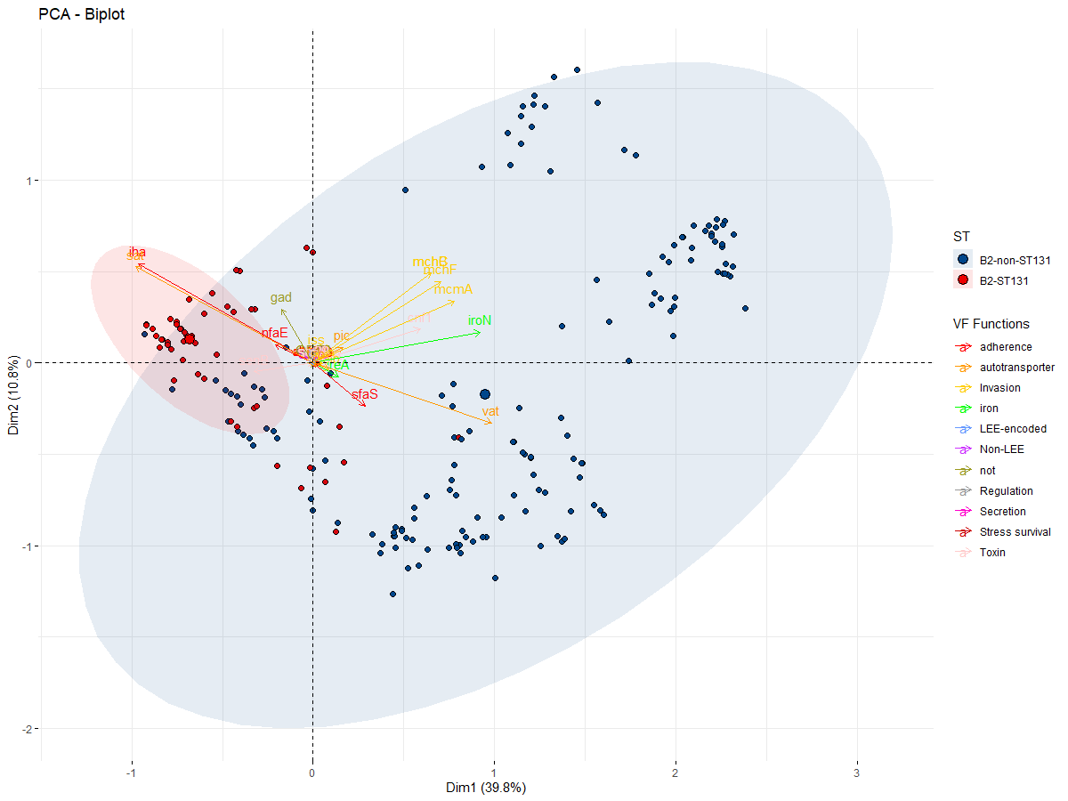

Fig S3D. Principal component analysis of local and global 991 genomes belonging to phylogroup of ST131 (n=579) and non-ST131 (n=412). The plot showed the first two components.

