Additional file 1
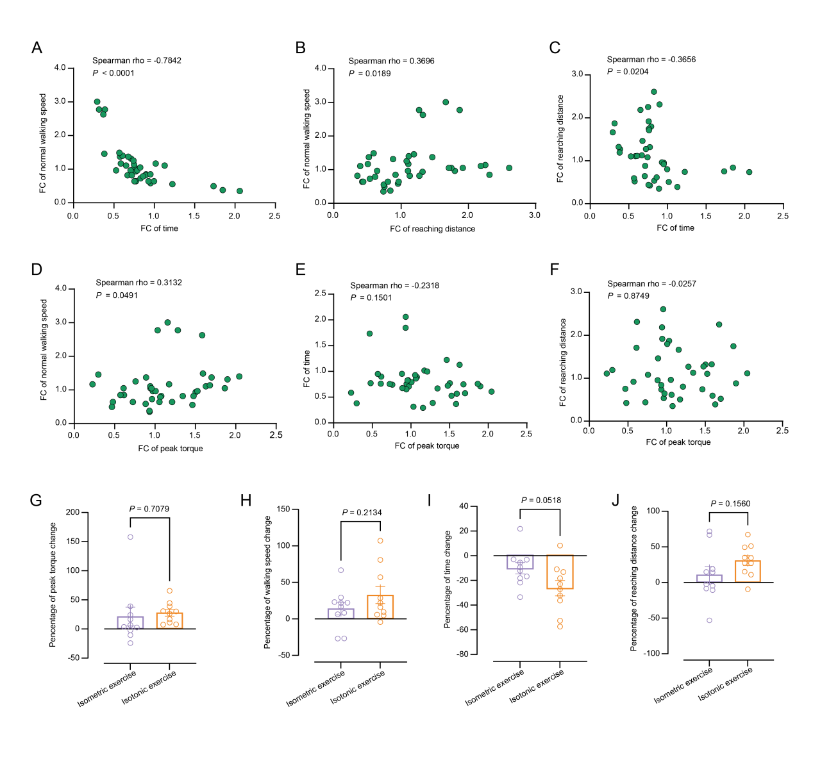
Fig. S1. The mutual relationships of clinical outcomes, and the ultimate impact of resistance exercise on clinical outcomes. A-C Spearman’s rank correlation scatter plots showing the consistency of changes in three locomotor-functional outcomes. (A) 10-m walk test (10MWT; Y-axis) and Timed Up and Go test (TUG; X-axis); (B) 10MWT (Y-axis) and Functional Reach Test (FRT; X-axis); (C) FRT (Y-axis) and TUG (X-axis). D-F Scatter plots showing Spearman’s rank correlation between changes of quadriceps muscle strength and three locomotor-functional outcomes. (D) 10MWT; (E) TUG; (F) FRT. G-J Bar plots displaying the mean proportional changes in four clinical outcomes following different resistance exercise treatments post 4 weeks. (G) Quadriceps muscle strength; (H) 10MWT; (I) TUG; (J) FRT. Dots represent the individual samples’ proportional changes compared to baseline (n = 10/group). Data are expressed as means ± SEM.

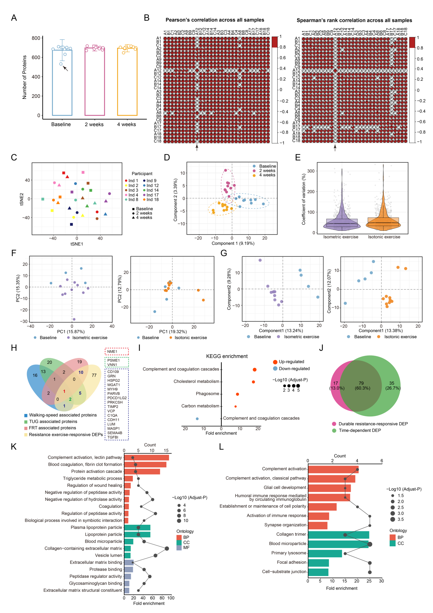
Fig. S2. Quality controls and analysis for proteomic data in human. A Bar plot showing the mean protein quantity measured at each time point, individual points representing protein quantities measured in each sample. The arrow indicates the outlier sample. Data are expressed as means ± SD. B Heatmap presenting Pearson’s correlation and Spearman’s rank correlation of proteomic profiling across the overall samples. The arrow indicates the outlier sample. C The t-distributed stochastic neighbor embedding (t-SNE) scatter plots indicating the heterogeneity of individual molecules. Each dot represents a sample. Colors represent different individuals, while shapes indicate different time points of detection. D 2D visualization of sparse partial least squares discriminant analysis (sPLS-DA) of proteomic data. Each dot represents a sample. E Violin plots showing inter-individual variability in response to exercise in subgroups. Boxes are median and interquartile range (IQR, 25th-75th percentile). Each dot (Light grey) represents coefficient of variation for each protein or gene in subgroups. F 2D visualization of principal component analysis (PCA) showing molecular changes in response to isometric or isotonic exercise. Each dot represents a sample. G 2D visualization of sPLS-DA of proteomic data in subgroups. Each dot represents a sample. H Venn diagram showing the overlap within three kinds of clinical outcome-associated proteins and resistance exercise-responsive DEPs. The red box represents DEPs associated with all three clinical outcomes, the green box represents DEPs associated with any two clinical outcomes, and the dark blue box represents DEPs associated with one clinical outcome. I Kyoto Encyclopedia of Genes and Genomes (KEGG) enrichment analysis showing key enriched pathways of resistance exercise-responsive DEPs. J Venn diagrams showing the overlap between durable resistance exercise-responsive DEPs and time-dependent DEPs. K Bar plot showing key enriched terms based on GO enrichment analysis of up-regulated DEPs among overlapping proteins between durable resistance exercise-responsive DEPs and time-dependent DEPs. L Bar plot showing key enriched terms based on GO enrichment analysis of down-regulated DEPs among overlapping proteins between durable resistance exercise-responsive DEPs and time-dependent DEPs.

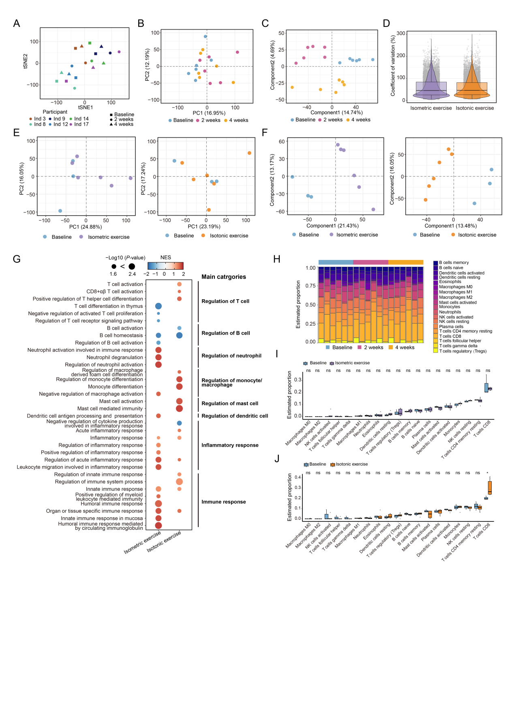
Fig. S3. Changes in the PBMC transcriptome in response to resistance exercise in human. A The t-distributed stochastic neighbor embedding (t-SNE) scatter plots indicating the heterogeneity of individual molecules. Each dot represents a sample. Colors represent different individuals, while shapes indicate different time points of detection. B 2D visualization of PCA showing molecular changes in response to resistance exercise across all samples. Each dot represents a sample. C 2D sPLS-DA of transcriptome data. Each dot represents a sample. D Violin plots showing inter-individual variability in response to exercise in subgroups. Boxes are median and interquartile range (IQR, 25th-75th percentile). Each dot (Light grey) represents coefficient of variation for each protein or gene in subgroups. E 2D visualization of PCA showing molecular changes in response to isometric or isotonic exercise. Each dot represents a sample. F 2D visualization of sPLS-DA of proteomic data in subgroups. Each dot represents a sample. G Bubble plots presenting the enriched pathways identified through GSEA of subgroups based on ontology gene sets, including both activated (Red) and suppressed (Blue) pathways. H Box diagram of immune cell fraction in all across PBMC sample. I Bar chart of the relative percentage of each type of immune cell in the isometric training group before and after exercise. NS: not significant. J Bar chart of the relative percentage of each type of immune cell in the isotonic training group before and after exercise. NS: not significant. NS: not significant, *P < 0.05.

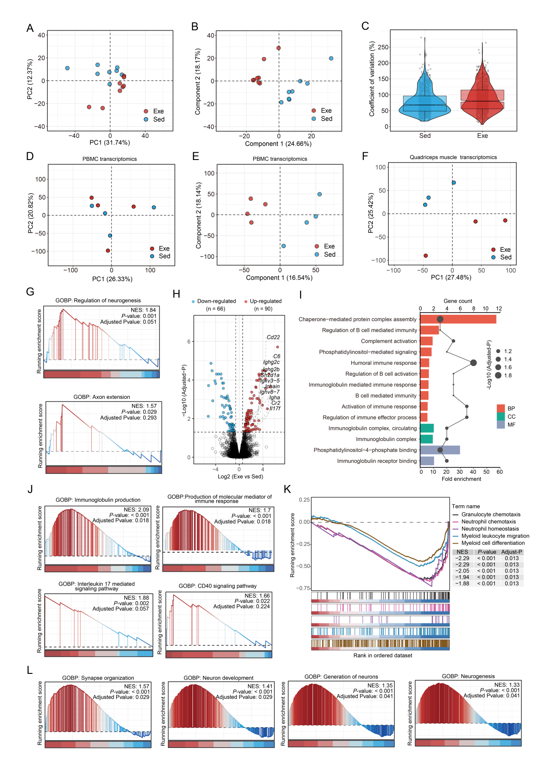
Fig. S4. Functional enrichment analyses in response to exercise in mice. A-B Scatter plots showing proteomic data in response to exercise, including (A) PCA and (B) sPLS-DA. Each dot represents a sample (n = 8). C Violin plots showing inter-individual variability of proteomic data in sedentary group (Sed; Blue) and exercise group (Exe; Red). Boxes are median and interquartile range (IQR, 25th-75th percentile). Each dot (Light grey) represents coefficient of variation for each protein. D-F Scatter plots showing dimension reduction of transcriptomic data, including (D) PCA of PBMC transcriptome, (E) sPLS-DA of PBMC transcriptome, and (F) PCA of quadriceps muscle transcriptome. Each dot represents a sample (n = 4 in PBMC transcriptome; n = 3 in quadriceps muscle transcriptome). G GSEA of exercise-responsive signaling pathways in plasma proteomic data based on ontology gene sets. H Volcano plot showing exercise-responsive DEGs across PBMC samples in mice. I Bar plot showing key enriched terms based on GO enrichment analysis of up-regulated DEGs in PBMC transcriptome. Bars represent the fold enrichment factor, and the line graph indicates the count of genes enriched by the pathways. J-L Visualization of GSEA based on ontology gene sets showing the key enriched pathways in response to exercise in the PBMC transcriptome, including (J) the activated immune signaling pathways, (K) the pathway involved in the suppression of myeloid cell function, and (L) the pathways related to neurogenesis.

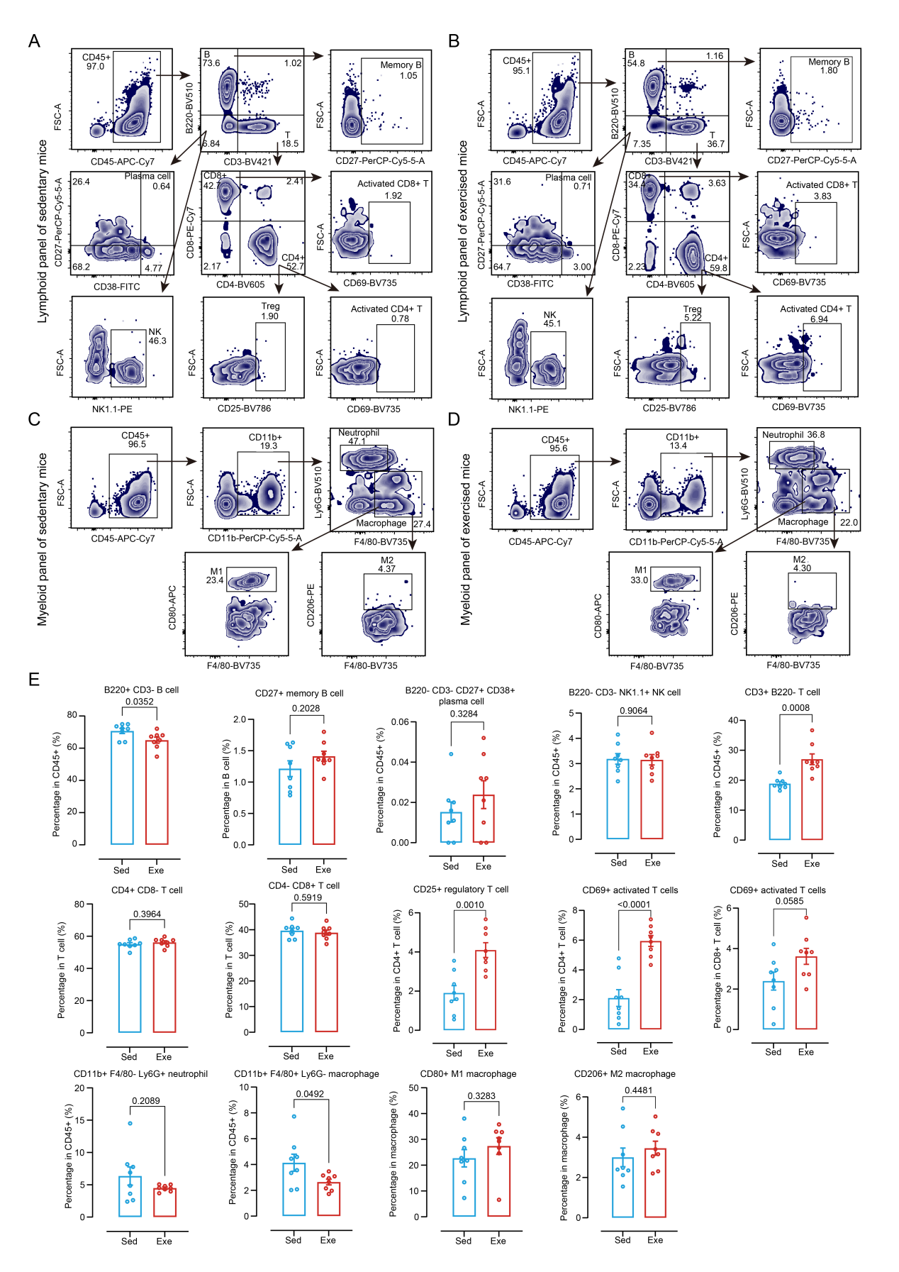
Fig. S5. Immune cells in response to exercise in mice. A Representative gating strategy for lymphoid cells from a sedentary mouse. B Representative gating strategy for lymphoid cells from an exercised mouse. C Representative gating strategy for myeloid cells from a sedentary mouse. D Representative gating strategy for myeloid cells from a exercised mouse. E Bar plots showing various types of immune cells. Blue represents sedentary mice, while red represents exercised mice (n = 8/group).

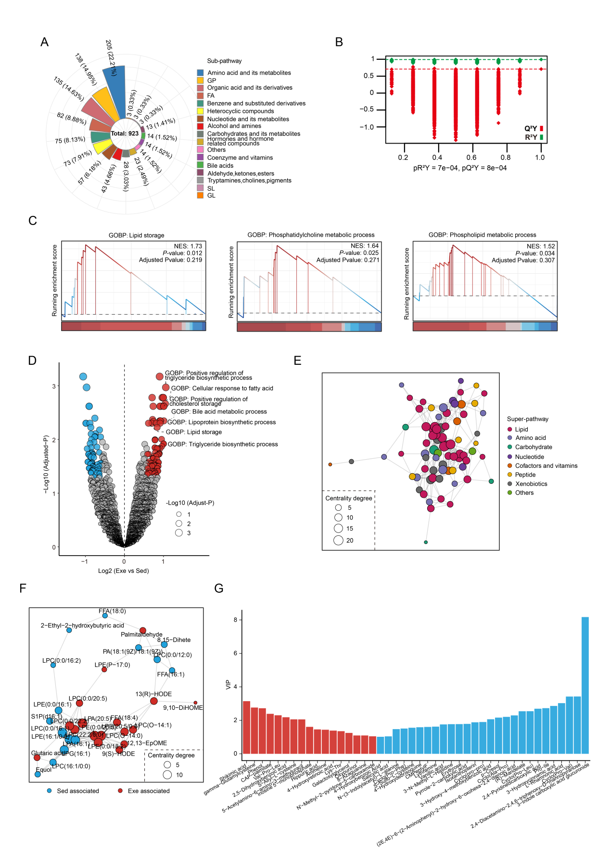
Fig. S6. Resistance exercise-induced lipid metabolism in mice. A Number and distribution of analyzed plasma metabolites according to their sub-pathway definition. B Scatter plot showing the results of the permutation test for the OPLA-DA of plasma metabolomic data. C Visualization of GSEA based on ontology gene sets showing the enriched pathways related to lipid metabolism in response to exercise in plasma proteome. D Volcano plot displaying the key enriched pathways related to lipid metabolism based on plasma proteome based on ontology gene sets through gene set variation analysis in plasma proteome. Red color represents up-regulated pathways, while blue color represents down-regulated pathways. E Spearman’s rank correlation networks of overall DEMs. Size of nodes represents connections (Centrality degree) with the other DEMs, colors represent super-pathways. F Spearman’s rank correlation networks of differentially expressed lipid molecules. Size of nodes represents connections with the other DEMs. Red color represents up-regulated lipids in response to exercise, while blue color represents down-regulated lipids in response to exercise. G Bar plot presenting variable importance in projection (VIP) scores of non-lipid DEMs generated by OPLS-DA. Red bars represent contributing to exercise group, and blue bars represent contributing to sedentary group.

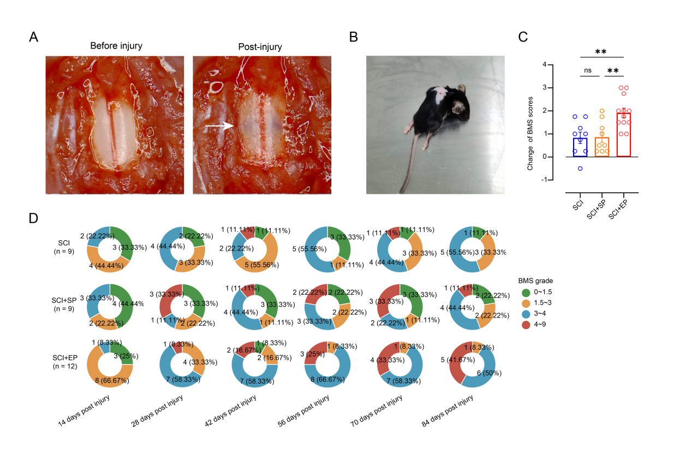
Fig. S7. Exercise plasma treating locomotor disability following SCI. A Typical images before and after spinal cord clip compression injury, with a white arrow indicating the site of compression, showing evident subdural hemorrhage. B Typical image of hind limb paralysis in a mouse following spinal cord injury. C Bar plot presenting the difference between the final BMS scores and the scores at 14 days post injury in plasma injection treatment experiment. Data are expressed as means ± SEM. One-way ANOVA with Tukey’s multiple comparisons test, n = 9-12. **P < 0.01. D Pie diagrams illustrating the proportions of various Basso Mouse Scale (BMS) states at 14, 28, 42, 56, 70, and 84 days post injury in SCI, SCI+SP, and SCI+EP groups during the plasma injection treatment experiment. Colors represent different BMS grades.

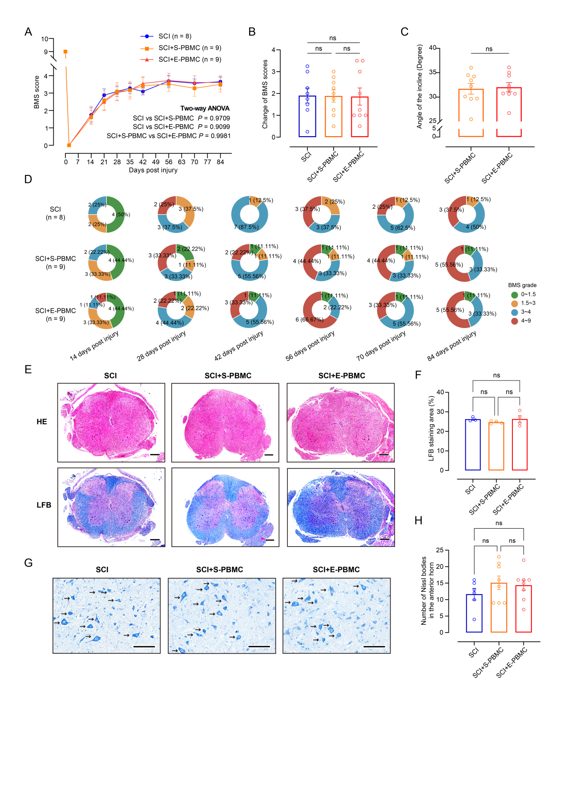
Fig. S8. Exercise-derived PBMC intravenous infusion in SCI mice with paralysis. A BMS scores were evaluated in an open field at different time-points (0, 14, 21, 28, 35, 42, 56, 70, and 84 days post injury). Two-way repeated-measures ANOVA with Tukey’s multiple comparisons test, n = 8-9. B Bar plot presenting the difference between the final BMS scores and the scores at 14 days post injury in PBMC injection experiment. Data are expressed as means ± SEM. One-way ANOVA with Tukey’s multiple comparisons test, n = 8-9. C Statistical results of inclined plate test at 84 days post injury in PBMC injection experiment. Data are expressed as means ± SEM. Unpaired Student’s t-test, n = 9. D Pie diagrams illustrating the proportions of BMS states at 14, 28, 42, 56, 70, and 84 days post injury in SCI, SCI+S-PBMC, and SCI+E-PBMC groups during the PBMC injection experiment. Colors represent different BMS grades. E Representative images showing HE and LFB staining of the transverse spinal cord sections at 84 days post injury. Scale bars: 200μm. F Statistical results of demyelination according to LFB staining. Data are expressed as means ± SEM. One-way ANOVA with Tukey’s multiple comparisons test, n = 3-4. G Representative images showing Nissl staining of the transverse spinal cord sections at 84 days post injury. The arrows indicate Nissl bodies. Scale bars: 100μm. H Statistical results of neuron survival in anterior horn according to Nissl staining. Statistical method: in each biological sample, two fields of view were selected on both the left and right sides of the spinal anterior horn (×40 objective, with an area size of 640×365µm). Data are expressed as means ± SEM. One-way ANOVA with Tukey’s multiple comparisons test, n = 6-8 fields.

