Additional file 2
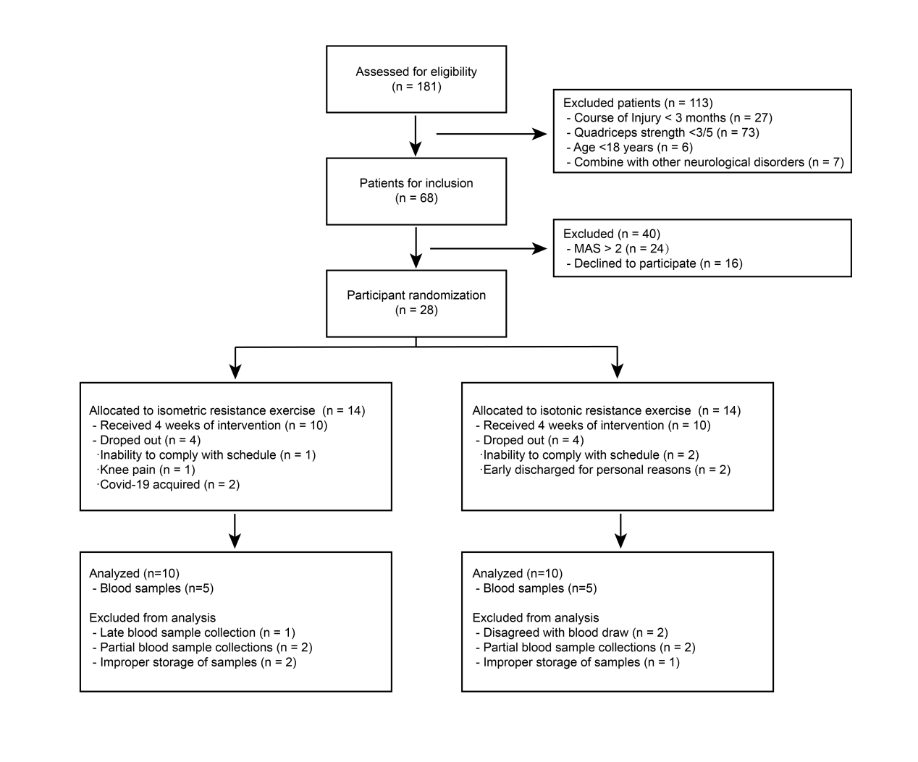
Fig. S1. CONSORT diagram. Only patients who fully completed the randomized trial were analyzed. The analyzed blood samples might not perfectly align with the clinical outcomes due to factors such as patient non-compliance and sub-optimal storage conditions.

 | Isometric exercise  (n=10) | Isotonic exercise  (n=10) | P-value
Age (Years) (median, IQR) | 47.00 (41.75-50.50) | 44.00 (31.74-49.00) | 0.28
Gender [N (%)] |  |  | 0.65
Male | 7 (70.0%) | 5 (50.0%)
Female | 3 (30.0%) | 5 (50.0%)
Injury level [N (%)] |  |  | 0.74
C4 | 2 (20.0%) | 2 (20.0%)
C5 | 1 (10.0%) | 0 (0.0%)
C7 | 0 (0.0%) | 1 (10.0%)
T10 | 1 (10.0%) | 1 (10.0%)
T11 | 3 (30.0%) | 1 (10.0%)
T12 | 2 (20.0%) | 3 (30.0%)
L2 | 1 (10.0%) | 2 (20.0%)
ASIA Impairment Scale category [N (%)] |  |  | 1.00
C | 2 (20.0%) | 2 (20.0%)
D | 8 (80.0%) | 8 (80.0%)
Months post injury (median, IQR) | 6.50 (3.75-11.00) | 4.50 (3.00-18.75) | 0.80
Weight (Kg) (mean ± SD) | 59.40 ± 9.83 | 57.90 ± 7.16 | 0.70
Table. S1. Characteristics of the participants ultimately included in the study.
IQR, interquartile range; ASIA, American Spinal Injury Association; SD, standard deviation.

