Additional file 3 Figure S1. PCA of miRNA Expression Levels Adjusted for Technical Variation.
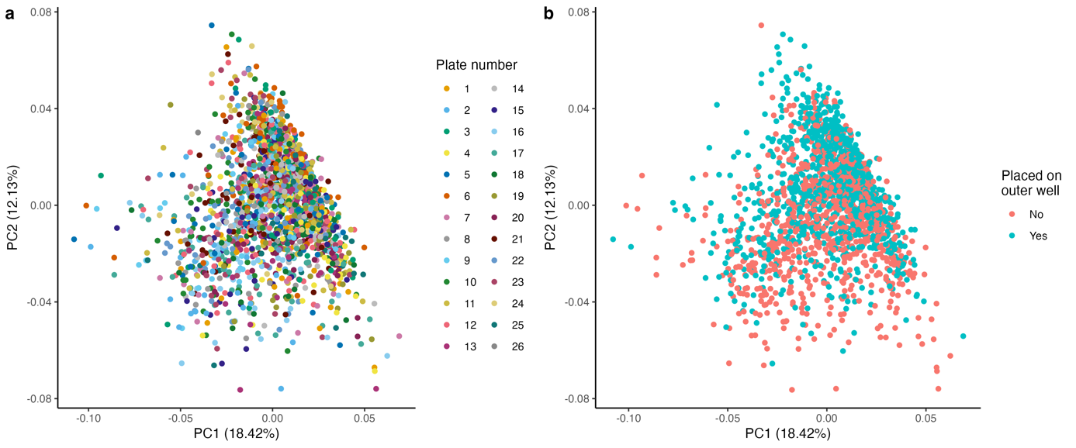
The figures display the first (x-axis) and second (y-axis) principal components from a principal component analysis of miRNA expression levels for the 591 well-expressed miRNAs, adjusted for sex, Rotterdam Study sub-cohort, monocyte, lymphocyte counts and red blood cell count, inner/outer well position, and sequencing plate number. Dots in a. are colored according to the sequencing plate number, and in b. according to whether the sample is positioned in the inner or outer well.

