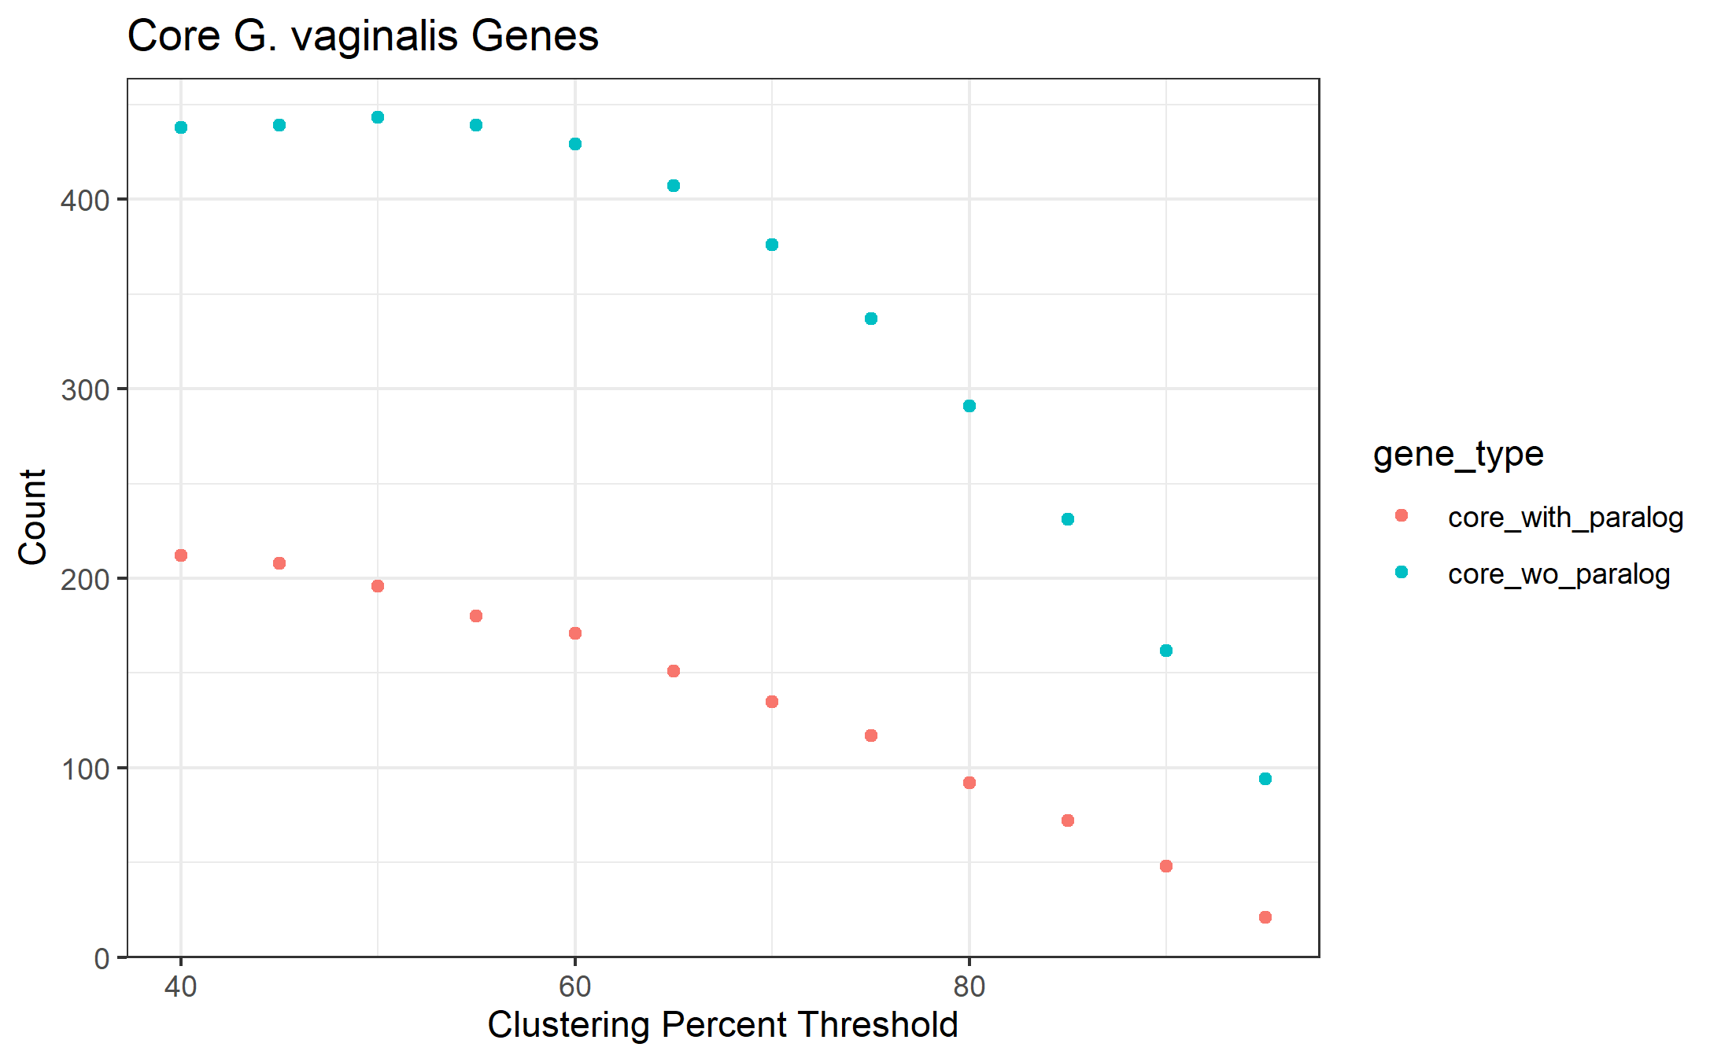
Figure S1. A plateau from 40% - 60% BlastP identity indicates the minimal rate of changes in gene cluster membership after core cluster count begins to drop. The gene clustering program Roary attempts to split gene clusters if the genes are identified as paralogous. Core gene cluster counts split according to Roary’s criteria for paralogous genes (where gene clusters are not collapsed with paralogous clusters) are blue, and core gene cluster counts where paralogous gene clusters are combined are in red.

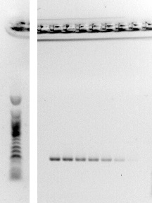
Fig. S2. Gradient PCR with strain BS615 and aruH primers to determine optimal annealing temperature, visualized on 2% agarose gel. Temperatures (°C) (L to R): 54.8, 55.9, 57.4, 58.9, 60.2, 61.7, 63.1, 64.3.

