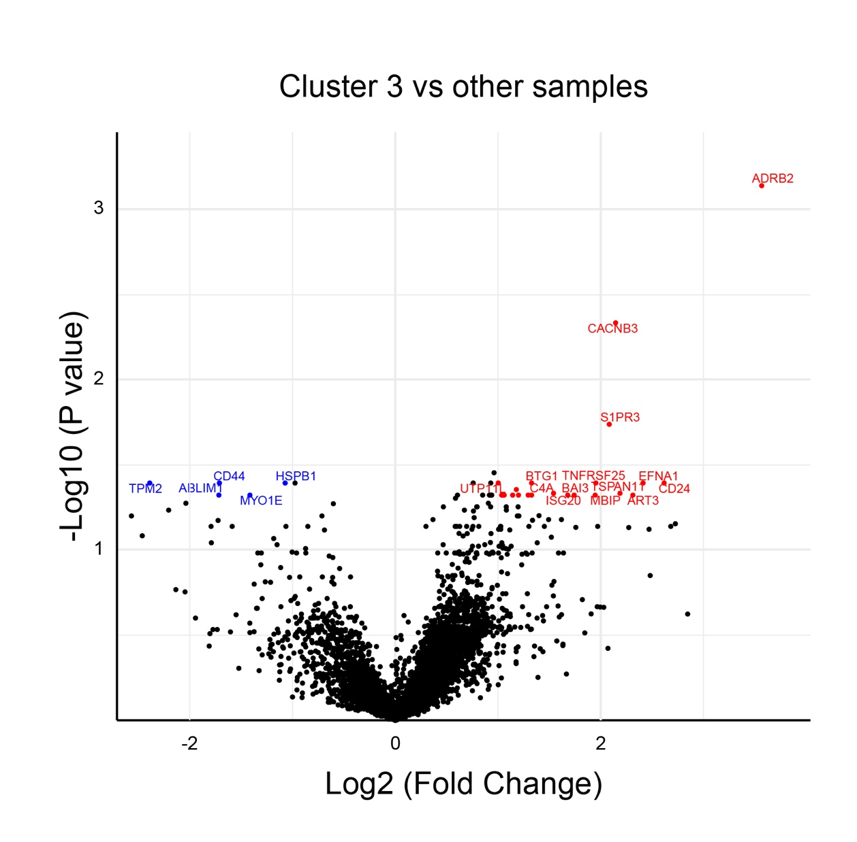
Additional file 11 - Fig. S4: Volcano plot comparing cluster 3 in Fig. 3a to the other clusters.

