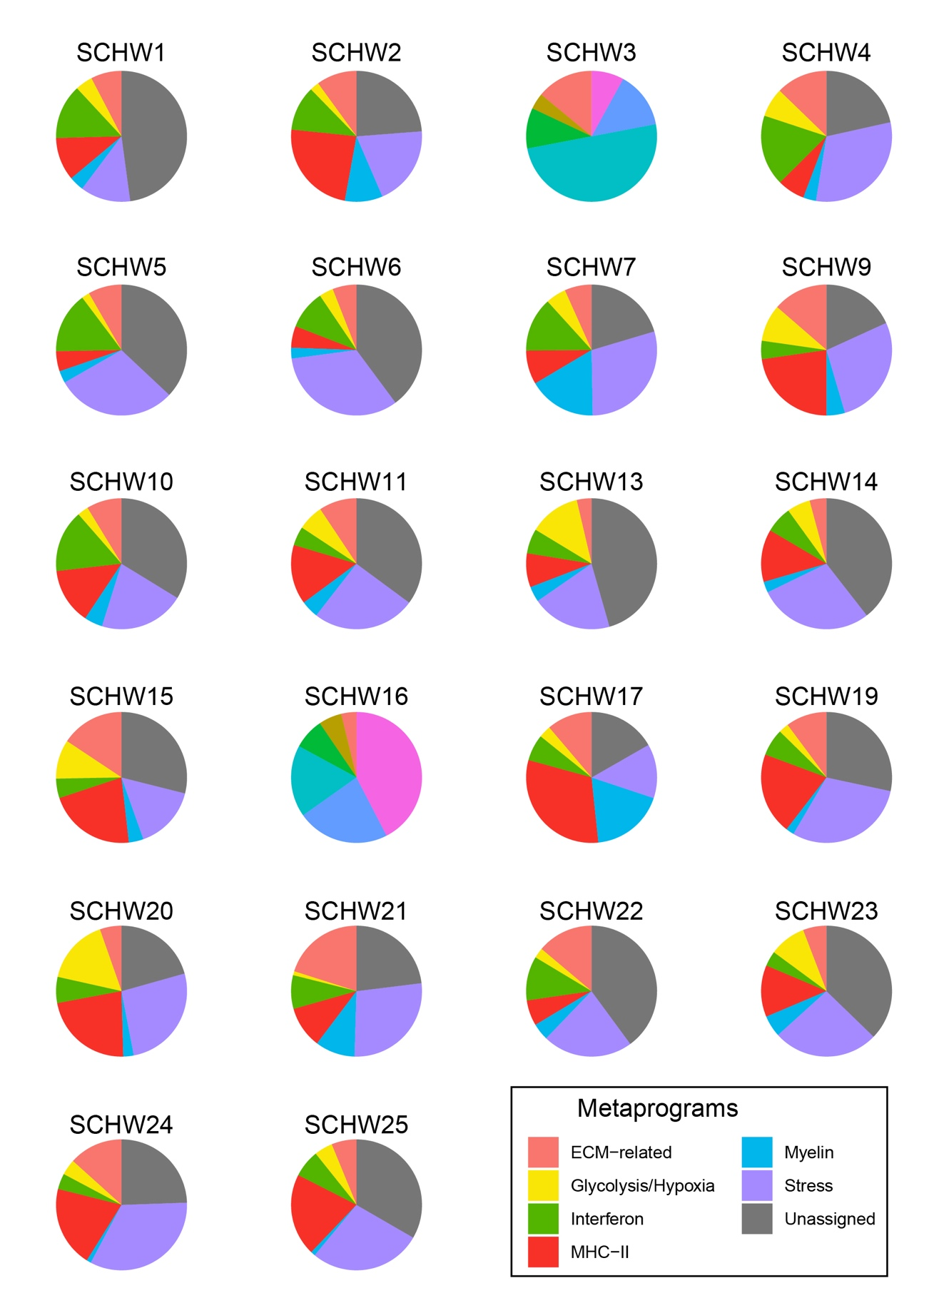
Additional file 12 - Fig. S5: Proportion of gene expression metaprograms by tumor.

